1.

(1)true

(2)false, An “is-a” relationship is implemented by inheritance.

(3)false,”is” should being modified into “has”.

(4)true

(5)false, friends of the base class’s derived classes can‘t access the base class’s friends.

2.

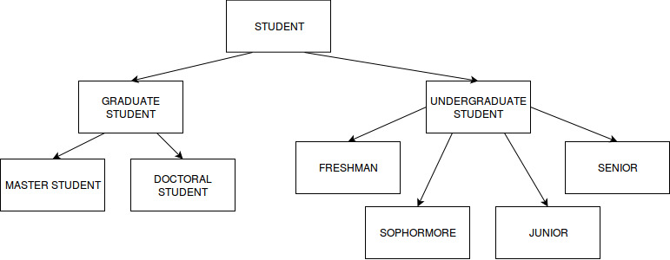

According to this picture , the “student” is the indirect base class,the “undergraduate student” and the “graduate student” are the direct base class inheriting from the student.

Besides, “freshman”、”sophomore”、”junior” and “senior” are the derived class who inheriting from “undergraduate student”. On the other hand, “Doctoral student” and “Master student” are the derived class inheriting from “graduate student”.