Project partners

IDC compiled lists of partner names for projects in phases 1, 2 and 3 from various sources. In these lists, some organisations appeared several times, but with slightly different names. While if was not possible to use a software tool to check partners repetitions, I was able to search for some string appearances in names by hands to obtain a list of distinct partners.

To see the cumulative list of partners as they appear in projects in all three phases, see the sheet titled ‘Partners’ in the partners Excel file. The other sheet in the Excel file lists all projects in the three phases.

From the cumulative list of partners, it is possible to obtain a network of connections between projects. The nodes are projects and each edge represents an organisation that was a partner in both projects.

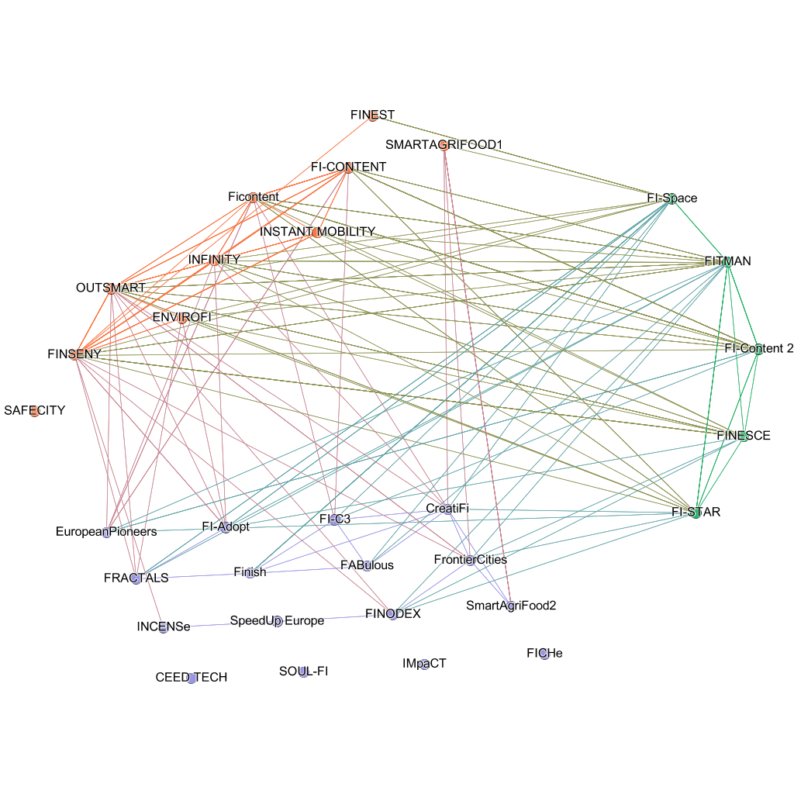

Purple nodes are projects from phase 3, green nodes are projects from phase 2 and orange nodes are projects from phase 1.

# Connectivity of accelerators

Connectivity of accelerators is summarised in sheet “Accelerators” and duplicated here for convenience.

The first two columns contain the number of accelerator partners which were partners in projects from Phase 1 or Phase 2. Partners are counted as many times as there are projects they participated in, for example, if a single partner in an accelerator participated in two projects from Phase 1, it is counted twice (and contributes 2 two the sum for Phase 1).

The third column contains the numbers of partners which also participated in other accelerators (again counted as many times as there are accelerators, similar to the first two columns).

The fourth column contains the number of partners which participated in Phase 1 and Phase 2. Here, each such partner is counted only once.

The last column is the sum of the first three.

| Accelerator | Phase 1 connections | Phase 2 connections | Phase 3 connections | Partners in 1&2 | All connections |
| --- | --- | --- | --- | --- | --- |
| CreatiFi | 4 | 2 | 5 | 0 | 11 |
| Finish | 0 | 5 | 4 | 0 | 9 |
| FINODEX | 2 | 3 | 2 | 1 | 7 |
| FRACTALS | 3 | 3 | 2 | 1 | 8 |
| FrontierCities | 4 | 3 | 3 | 1 | 10 |
| INCENSe | 1 | 0 | 1 | 0 | 2 |
| SmartAgriFood2 | 6 | 0 | 2 | 0 | 8 |
| EuropeanPioneers | 6 | 4 | 0 | 1 | 10 |
| SpeedUp_Europe | 0 | 0 | 2 | 0 | 2 |
| FABulous | 0 | 2 | 3 | 0 | 5 |
| FI-Adopt | 5 | 4 | 1 | 3 | 10 |
| FI-C3 | 2 | 2 | 3 | 1 | 7 |

# Correlation of scores with the number of partners in other accelerators

There does not appear to be a reliable correlation between scores and the number of partners in other accelerator.

|  |  |
| --- | --- |
| **Feasibility** | -0.03 |
| **Innovation** | 0.09 |
| **Market** | -0.07 |
| **Market needs** | -0.08 |
| **Matter mark Growth** | 0.01 |