***Software Requirements Specification***

***Document***

**UNIVERSITY DEPARTMENT INFORMATION SYSTEM**

**Team:** NexusBytes

|  |  |  |
| --- | --- | --- |
| **Name** | **ID No.** | **Mail Id** |
| G Nandini | R200735 | rr200735@rguktrkv.ac.in |
| T Shalini | R200912 | rr200912@rguktrkv.ac.in |
| C Yashmitha | R200670 | rr200670@rguktrkv.ac.in |
| M Hemanth Kumar | R200083 | rr200083@rguktrkv.ac.in |
| Y Tharun | R200591 | rr200591@rguktrkv.ac.in |
| G S S Mannar | R200182 | rr200182@rguktrkv.ac.in |

Table of Contents

Introduction 4

Purpose 4

Target Users 4

Stakeholders 5

Product Vision 5

Vision Statement 5

Technologies 5

System in Context 5

Students 6

Faculty 6

Non-Teaching Staff 6

Admin 6

HOD 7

Context Diagram 8

Requirements 9

Students 9

Faculty 10

Non-teaching staff 10

HOD 11

Admin 12

Non-functional requirements 12

Reliability 12

Usability 12

Availability 12

Accessibility 13

Performance 13

Security 13

Maintainability 13

Scalability 13

Platform Compatibility 13

# Introduction

This document provides us with the detailed information about the requirements of the University Department Information System. The UDI System is intended to be used in the University Departments in order to manage all the departmental activities with an ease.

# Purpose

The sole purpose of this document is to define the requirements of the UDI System to implement it in the department level. It focuses on the details of the project like project vision, functional and non-functional requirements, and overview of the project.

The UDI System is expected to give digital solutions for the old-school manual problems dealt in the University Departments.

# Target Users

The target users of the UDI System are Students, Faculty, Non-teaching Staff, Head of the Dept., and Admin.

## Stakeholders

Client: Engineering Dept. of RGUKT – RK Valley

Users: Individuals using the UDI System Application

# Product Vision

## Vision Statement

Development of the UDI System is fueled by the vision of providing a digital solution to the problems faced in all kinds of departmental activities.

# Technologies

HTML, CSS, JavaScript, Bootstrap, Advanced Java, Servlets, Java Server Pages (JSP), MySQL Database, Java Database Connectivity (JDBC), Apache Tomcat, GIT.

# System in Context

The UDI System provides digital solution to the problems faced in the departmental accomplishment of different departmental activities. It provides a personalized interface for each user ranging from student to the HOD and the admin.

## Students

* Can view their marks and attendance
* Can register for the courses in new Semester
* Can turn in the assignments given to them
* Can raise complaints

## Faculty

* Can view students’ data
* Can upload marks and attendance of each student
* Can assign and evaluate assignments
* Can raise complaints

## Non-Teaching Staff

* Can view and update the infrastructure details
* Can track Research & Publications
* Can update the Account Book
* Can raise complaints

## Admin

* Can add student details
* Can monitor the performance of the UDI System

## HOD

* Can manage the grants and funds of the department
* Can view details of students and staff
* Can manage the complaints received

# Context Diagram

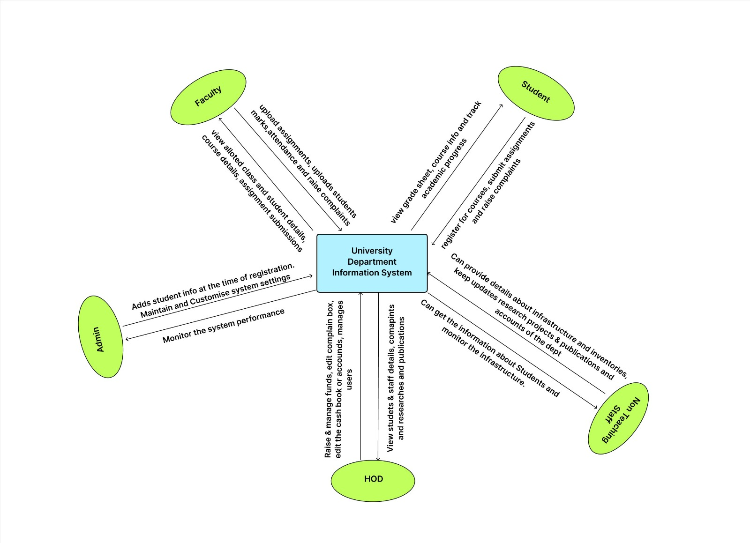

# Requirements

University Department Information System has various user categories that include –

* Student
* Faculty
* Non-teaching staff
* HOD
* Admin

## Students

* Student can login to the UDIS using their credentials, leading them to a personalised page.
* Student has a functionality of registering to the courses at the beginning of each semester. This is done by sending a request to the admin by submitting a form of semester registration.
* Student should be able to track his progress throughout the semester by accessing his grades and attendance in real time which is done through a separate section designed for it.
* Student should be notified about the assignments given to him/her and should be able to upload and turn in the assignments on completion.
* There should be a dedicated section to raise complaints of any kind which would be forwarded to the HOD’s notice upon submitting.

## Faculty

* Login functionality is to be given to each faculty on entering the credentials which leads to a personalised faculty page.
* Faculty should be able to view the details of the classrooms assigned to them at any given time.
* A dedicated section should be available in the faculty page where they can monitor the students’ details and their performances throughout the course.
* Faculty should be able to post assignments for the students with fixed deadlines.
* Each faculty should be given access to enter the marks and attendance of each student at the end of each mid-term.
* There should be a dedicated section to raise complaints of any kind which would be forwarded to the HOD’s notice upon submitting.

## Non-teaching staff

* Each user has to be navigated to the dedicated page upon on entering the valid credentials after performing the appropriate validation.
* They should be provided with the access to maintain and update the record regarding the infrastructural details of the department online.
* They are required to be able to update the research works and other publications of the department in the UDIS for end user availability.
* They must have an access to the financial accounts of the department and should be able to monitor them time to time seamlessly.

## HOD

* It is supposed to be a user of single account and no credentials can be allowed to this user category as there will only be one HOD at a time.
* HOD should be given access to financial accounts of the department and should be able to manage the funds raised.
* HOD should be able to review all the complaints received from each user and should be able to delete them upon solving.
* HOD should be provided with the ledger book kind of interface in the finance section of the department in order to maintain proper debit and credit transaction details.

## Admin

* Admin should be provided with a special highly restricted login page.
* Admin is the user who can manage all the root functionalities and some highly confidential and sensitive information regarding the page.
* Admin should be able to generate unique credentials for each student upon their admission.
* Admin should also be able to review the course registrations made by each student at the beginning of each semester.

# Non-functional requirements

## Reliability

The system should be trustworthy, secured and should be well developed for all the functionalities such that no error can occur during the deployment.

## Usability

The system should have a user-friendly interface and should be easy to handle without any prior technical knowledge.

## Availability

The website should be accessible for the end user at any given time round the clock with 24x7 efficient work time.

## Accessibility

This product should be able to support multi-user accessing such that each user can access their respective functionalities based on the user’s role.

## Performance

The website should be personalised and responsive to each user’s role and should be efficient in its operation without any errors or delays.

## Security

This product should be highly secured and it should inculcate high level authentication.

## Maintainability

The designing phase should strictly follow a proper architecture so that it can be maintained efficiently in the long run by the future developers.

## Scalability

It should support a large number of users. Thus, making it to manage large number of access requests.

## Platform Compatibility

This product is expected to support on all the most widely used browsers.