**Team**

**NexusBytes**

Team-13

**University**

**Department**

**Information System**

**Table of Contents**

About Team: - 3

Project Name: - 3

Objective (aim of the project): - 3

User Categories: - 4

Technologies: - 5

Work Assignment to Team NexusBytes: 5

Work Break Down Structure for UDI System: - 6

**About Team:**

NexusBytes is dedicated to developing the University Department Information System. Our team specializes in providing comprehensive consulting and IT services, focusing on creating robust and intricate software solutions. Our offerings encompass web-based applications, database design and consulting, client-server applications, and tailored information systems for academic departments. With a commitment to excellence, NexusBytes delivers reliable and scalable IT services to educational institutions, ensuring efficient and effective management of departmental information.

**Project Name:**

University Department Information System (UDIS)

**Objective (Aim of the Project):**

The aim of the University Department Information System project is to develop a comprehensive software solution that streamlines and optimizes the management of departmental information within a university. This system will facilitate efficient data handling, improve communication and coordination among various users within a department. By integrating various functionalities into a cohesive platform, the project aims to enhance the overall administrative efficiency and academic experience within the department.

**User Categories:**

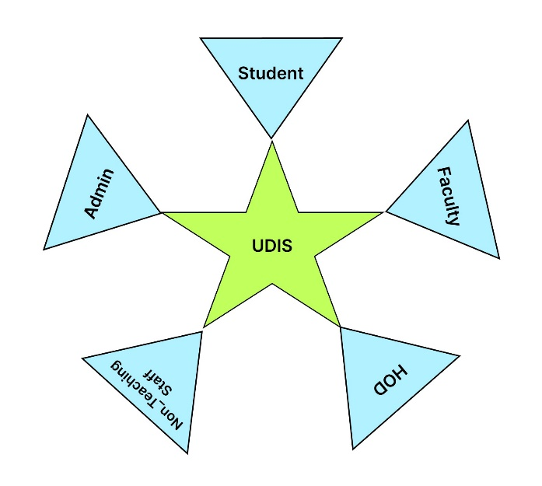

**Technologies:**

* HTML, CSS, JavaScript
* Bootstrap
* Advanced Java, Servlets
* Java Server Pages (JSP)
* MySQL Database
* Java Database Connectivity (JDBC)
* Apache Tomcat
* GIT

**Work Assignment to Team NexusBytes:**

|  |  |
| --- | --- |
| **Task** | **Assigned To** |
| Requirements Gathering | Entire Team |
| Interface |  |
| Story board |  |
| Work Breakdown Structure |  |
| User Requirements Document | Entire Team |
| Software Requirements Specification | Entire Team |
| Risk Analysis |  |
| Front end Design (HTML pages) |  |
| Backend Design (Database) |  |
| Code Integration |  |
| Testing | Entire Team |
| Final Demo | Entire Team |

# **Work Break Down Structure for UDI System:**

