CGS4144 Bioinformatics - Assignment 4

Directions: Following the directions below, analyze your data. Save the images and write a short summary of how they were made and what you discovered. Work and submit as a team. Create a work document with your teammates names at the top followed by your results, to be submitted on Canvas.

Team:
Add the full names, email addresses, and GitHub handles for each team member (1-3 people total) to this table:
Name | Email | GitHub
Ethan Klasky | eklasky@ufl.edu | github.com/E53klasky
Timothy Wang | timothy.wang@ufl.edu | github.com/timothyw8
<student3 name> | <student3@ufl.edu> | <github.com/student3>

Data: <Link to your dataset >

Scientific Question: < Question you will answer using the data you’ve selected >

GitHub Repository for Project: < Link to your team GitHub repository >

- Load the expression data and matching metadata that you processed in Assignment 2.
- Supervised Analysis
  - Subset your data to the 5,000 most variable genes
  - Using that subset of the data, select and run an algorithm from this list:
    - Support vector machine
    - Logistic regression Ethan
    - Random forest Tim
    - K nearest neighbors
    - Naïve Bayes
    - another method (with instructor permission only)
  - I recommend using the TidyModels, mlr3, or scikit-learn packages. Tutorials:
    - https://mlr3.mlr-org.com/
    - https://seandavi.github.io/ITR/machine_learning_mlr3.html
    - https://www.tidymodels.org/start/
    - https://scikit-learn.org/stable/supervised_learning.html
  - Have the algorithms predict the two groups from assignment 1 (e.g. tumor vs normal)
Logistic regression was trained to distinguish tuberculosis subjects from healthy controls using the 5,000 most variable genes. The model achieved an accuracy of 95.73% and an area under the ROC curve (AUC) of 1.000 on the held-out test data. This indicates that the model successfully distinguished the two groups in terms of their predicted probability rankings, although some samples were misclassified at the default classification threshold.

For Random Forest, it predicted whether the samples were in the tuberculosis or healthy group. Using 100 decision trees, the model achieved an accuracy of 91.46 percent. This suggests that Random Forest was able to determine which group the samples belonged in with high accuracy.
  - Retrain the algorithms to predict the clusters from assignment 3 (each person should use their own clustering results from assignment 3). If you are using a binary prediction model, train a 1 cluster vs all other clusters model. Justify your choice.

The K-means clustering approach from Assignment 3 was reproduced using k=2 and the 1,000 most variable genes. This configuration was selected because it showed the strongest association with TB versus healthy-control status in Assignment 3 (X^2 = 46.00, adjusted p = 4.73 × 10^-11). The resulting clusters contained 430 and 389 samples.

Logistic regression was then trained using the 5,000 most variable genes to predict membership in cluster 0 versus cluster 1. Because K-means produced two clusters, binary logistic regression was appropriate, with cluster 1 treated as the positive class and cluster 0 as the negative class. The model achieved 99.39% accuracy and an AUC of 1.000 on the held-out test samples. This demonstrates that logistic regression could reproduce the K-means cluster assignments with high accuracy using the gene expression features, although the clusters themselves were derived from the same dataset.

For Random Forest, I used three clusters from Gaussian Mixture and got a 98.17% accuracy when it used 80% of samples for training and the remaining 20 for testing. This high accuracy suggests that Random Forest is able to reproduce the clusters from gaussian Mixture.

  - Each student in your team should run a different supervised analysis method, with a minimum of 2 methods per team regardless of team size (e.g., if there are 3 students on the team, there should be results for 3 predictive methods in your assignment writeup. Teams of 1 must have 2 methods.).
Logistic regression was performed as Ethan's supervised learning method.

- Calculate sample-specific area under the ROC curve (AUC) across the predictive models created by each student on your team. To do this, generate a matrix of samples by models, where each cell is what class label the given model assigned to the given sample. For each sample,
  - How many models predict each class label, for that sample?
Logistic regression was used to predict disease labels for 164 test samples using the 5,000 most variable genes. Each sample was classified as either a healthy control (0) or a tuberculosis subject (1). The model correctly classified 157 out of 164 samples, achieving 95.73% accuracy and an AUC of 1.000. The predicted labels were saved for each sample so they could be combined with the other supervised learning models to count how many models predicted each class.

For the Random Forest model, it predicted whether a sample belonged to the healthy group or the tuberculosis group. In this case, 1 represents tuberculosis and 0 represents healthy. 164 samples were predicted to be tuberculosis while 1 sample was predicted to be healthy.
  - How many models predict the same cluster, for that sample?
Logistic regression was also used to predict the K-means clusters from Assignment 3. Each of the 164 test samples was assigned to either cluster 0 or cluster 1. The model correctly predicted 163 out of 164 cluster assignments, achieving 99.39% accuracy and an AUC of 1.000. The predicted cluster labels were saved for each sample so they could be compared with the other models to determine how many models agreed on each cluster.

  - Does the stability of the cluster and class label prediction correlate (calculate a statistical test to evaluate this. Don’t forget multiple test correction!)
To evaluate prediction stability, we generated disease and cluster predictions for the same 164 test samples using logistic regression. The predictions were saved so they could be compared with the other supervised learning methods. Once all models are combined, we will calculate the proportion of models agreeing on each sample's disease and cluster labels. Spearman's correlation test will then be used to determine whether disease prediction stability correlates with cluster prediction stability. If multiple statistical tests are performed, p-values will be adjusted using the Benjamini–Hochberg method. The correlation results will be reported after combining all team members' predictions.

- Retrain each predictive model using different numbers of genes. Try 10, 100, 1000, and 10000 genes.
  - How did the number of genes affect the results?
The number of genes affected logistic regression performance for both disease and cluster classification. For disease classification, accuracy increased from 90.85% with 10 genes to 98.78% with 1,000 genes, before decreasing to 90.85% with 10,000 genes. For cluster classification, accuracy increased from 68.90% with 10 genes to 100% with 1,000 genes, then decreased slightly to 98.78% with 10,000 genes. Overall, using more genes initially improved classification performance, but adding genes beyond 1,000 did not consistently improve accuracy.

Number of genes | Disease AUC | Cluster AUC
10 | 0.8336 | 0.7791
100 | 0.9911 | 1.0000
1,000 | 0.9920 | 1.0000
10,000 | 1.0000 | 1.0000

For the Random Forest classifier that uses 100 decision trees, testing with 10,100,1000, and 10,000 of the most variable genes produced the results in the table below. The accuracy increased from 93.3 percent to 94.4 percent going from 10 to 100 genes but only decreased from there. It went down to 93.9 percent then 92 percent from 1,000 genes to 10,000. Therefore, increasing the number of genes only increases the accuracy when going from 10, 100. The results suggest that drastically increasing the number of genes from there only decreases accuracy, but not by a significant amount.
Number of genes | Accuracy | AUC-ROC
10 | 0.9329268292682927 | 0.9668903803131991
100 | 0.9451219512195121 | 0.9939597315436242
1,000 | 0.9390243902439024 | 0.9939597315436242
10,000 | 0.9207317073170732 | 0.9682326621923938

  - What is the model performance (AUC) for each of the different versions of the model? Does it increase or decrease as the number of genes included in the model changes?
For disease classification, the AUC increased from 0.8336 with 10 genes to 0.9911 with 100 genes, 0.9920 with 1,000 genes, and 1.0000 with 10,000 genes. For cluster classification, the AUC increased from 0.7791 with 10 genes to 1.0000 with 100 genes and remained at 1.0000 for both 1,000 and 10,000 genes. These results show that increasing the number of genes generally improved AUC, although the improvement became smaller as more genes were included. Despite the high AUC values, classification accuracy did not consistently increase, indicating that additional genes did not always improve predictions at the default classification threshold.

For Random Forest classifier, the model with 100 genes produced the highest accuracy of 94.51, but the highest AUC-ROC score was from both 100 and 1,000 genes. Both 10 genes and 10,000 genes had roughly the same AUC-ROC score of about 96%. As a result, there is no clear indication that changing the number of genes significantly changes prediction performance for Random Forest.
- Heatmaps and Dendrograms
  - Create a heatmap of the genes identified by the predictive methods, with an annotation sidebar showing the sample groups from Assignment 1.
    - Include only the genes in any of the predictive modeling signatures.
    - Make sure to include a legend and axis labels.
    - Include row and column dendrograms.
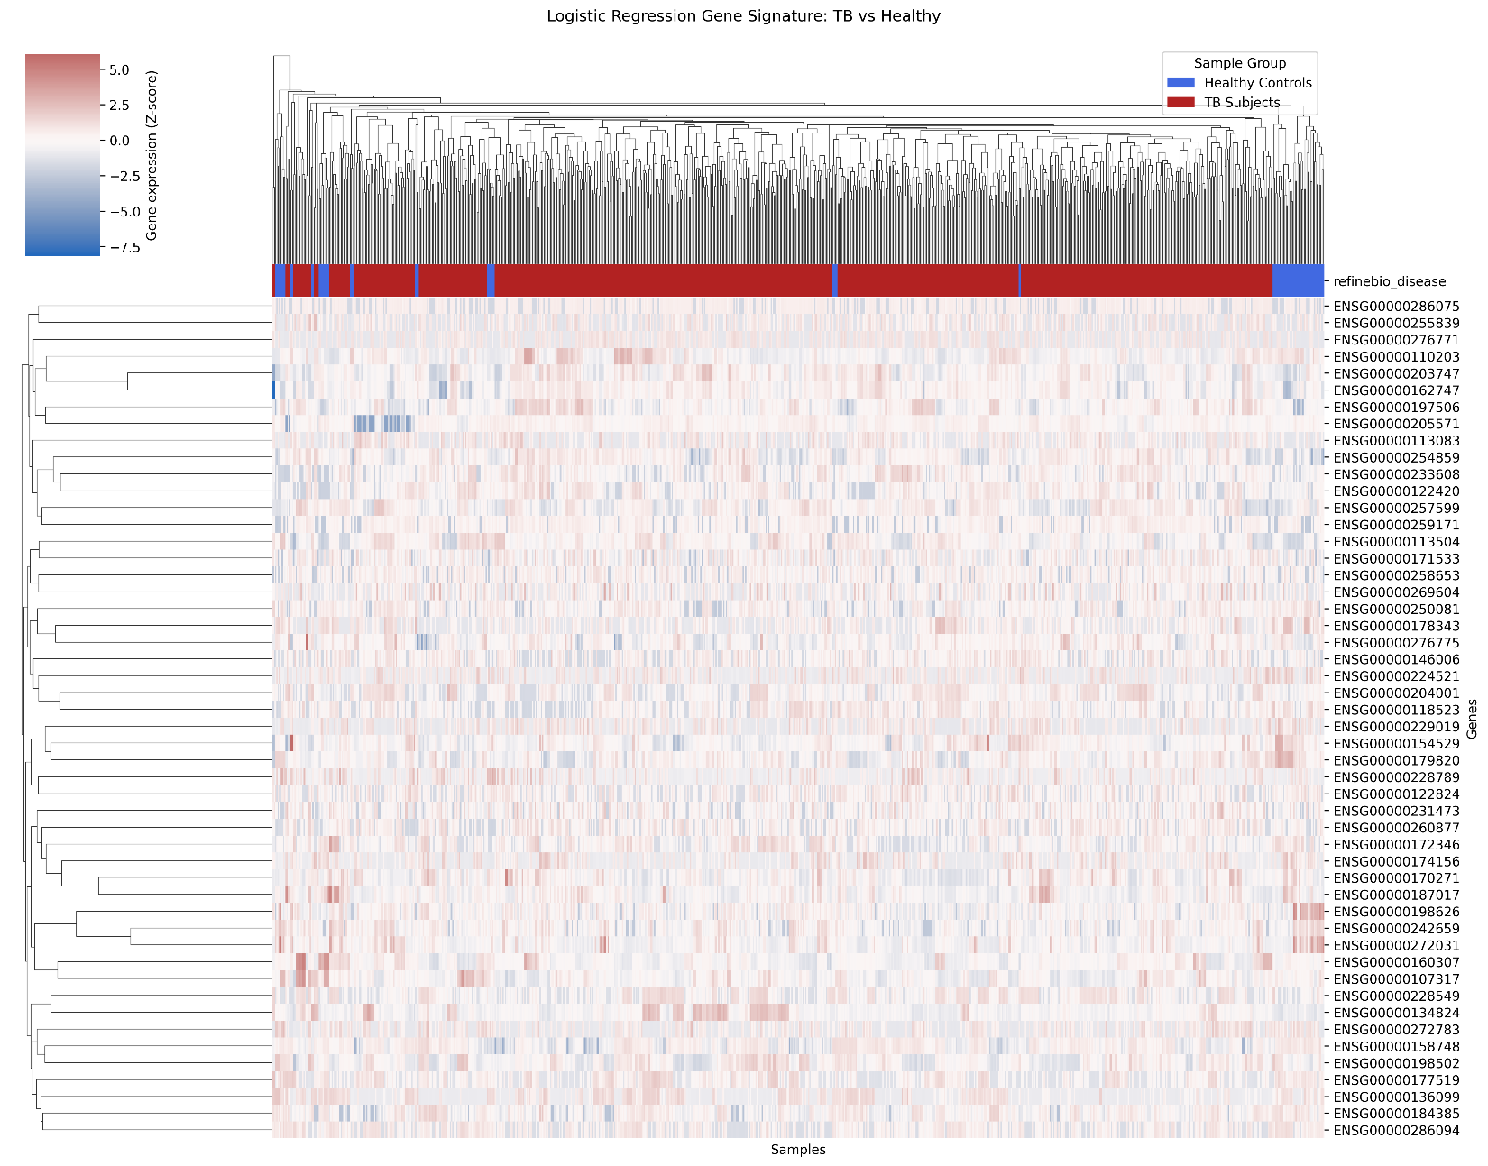

A heatmap was generated using the 50 genes with the largest absolute coefficients from the disease classification logistic regression model. Gene expression values were log2-transformed and standardized using Z-scores to compare expression patterns across samples. Samples were annotated according to their original disease groups, tuberculosis subjects and healthy controls. Hierarchical clustering was applied to both genes and samples, producing row and column dendrograms to visualize similarities in gene expression patterns. The heatmap includes a legend for the sample groups and standardized expression values.

- Write a short summary for each plot/table you created in this assignment. In 3-5 sentences for each, describe what you did, what parameters you used (if any) and an interesting result from it.
- Combine all results into a single file, submit on Canvas. Only one student on the team needs to submit. Make sure that all your code and results are added to your GitHub repository.

