CGS4144 Bioinform=atics - Assignment 3

Directions: Following the directions below, analyze your data. Save the images and write a short summary of how they were made and what you discovered. Work and submit as a team. Create a work document with your team’s name at the top followed by your results, to be submitted on Canvas.

Team:
Add the full names, email addresses, and GitHub handles for each team member (1-3 people total) to this table:
Name | Email | GitHub
Ethan | eklasky @ufl.edu | E53klasky
Amit Athi Kesavan | amit.athikesavan@ufl.edu | github.com/amitathik7
<student3 name> | <student3@ufl.edu> | <github.com/student3>

Data: https://www.refine.bio/dataset/31f09143-bf06-4a05-adcf-6c9c0e1d892f

Scientific Question: Can gene expression patterns in blood distinguish tuberculosis patients who have different treatment outcomes?

GitHub Repository for Project: https://github.com/E53klasky/CGS4144

- Load the expression data and matching metadata that you processed in Assignment 2.
- Unsupervised Analysis (e.g. using TidyClust in R or scikit-learn in Python)
  - Subset your data to the 5,000 most variable genes
  - Using that subset of the data, select and run a clustering algorithm from this list:
    - K-means (tutorial: https://www.tidymodels.org/learn/statistics/k-means/index.html) Ethan
    - Gaussian mixture models
    - PAM clustering
    - Hierarchical clustering (e.g. hclust)
Amit
    - Spectral clustering
    - Affinity propagation
    - ConsensusClusterPlus
    - another method (with instructor permission only)
  - Each student in your team should run a different clustering method, with a minimum of 2 methods per team regardless of team size (e.g., if there are 4 students on the team, there should be results for 4 different clustering methods in your assignment writeups. Teams of 1 must include results from 2 clustering methods). Report all results in your assignment writeup, unless specified otherwise.
  - How many clusters did your method find?

    - If you ran a method that requires you to select the number of clusters (k), how did changing this value change the results? Compare cluster membership at each k to investigate this.
    - If you ran a method that selects k for you, describe why it chose that k. Vary the method parameters to get different numbers of cluster. How did these changes impact your results?
  - Rerun each clustering method using different numbers of genes. Try 10, 100, 1000, and 10000 genes.
    - Compare your results. How did the number of genes affect clustering?
    - To do this, perform a chi-squared test on each pair of clustering results. Provide these results in a table in your writeup.
- Heatmaps and Dendrograms
  - Create a heatmap of the 5,000 genes used in clustering. Add an annotation sidebar showing one set of clusters you identified from each clustering method and the sample groups from Assignment 1.
    - You should have n+1 annotation columns, 1 per clustering method and 1 for the sample groups in Assignment 1.
    - Include a legend and axis labels
    - Include row and column dendrograms
The heatmap shows gene expression patterns for the 5,000 most variable genes across the samples. Hierarchical clustering was used to organize both the genes and samples, as shown by the row and column dendrograms. The K-means annotation shows that many samples assigned to the same K-means cluster are also grouped together by hierarchical clustering, although the clusters are not completely separated. The TB and healthy-control annotation also shows some relationship with the expression-based clustering, but the groups do not perfectly correspond to the K-means clusters.
Hierarchical Clustering Results:
d. The hierarchical clustering method reuslted in two clusters.
i. Changing the value from n=2 to other values decreased the accuracy significantly as there was a greater overlap between clusters after n=2.
ei. When I changed the number of genes I found that the lower the number of genes the greater accuracy there was in the hierarchical clustering means procedure.
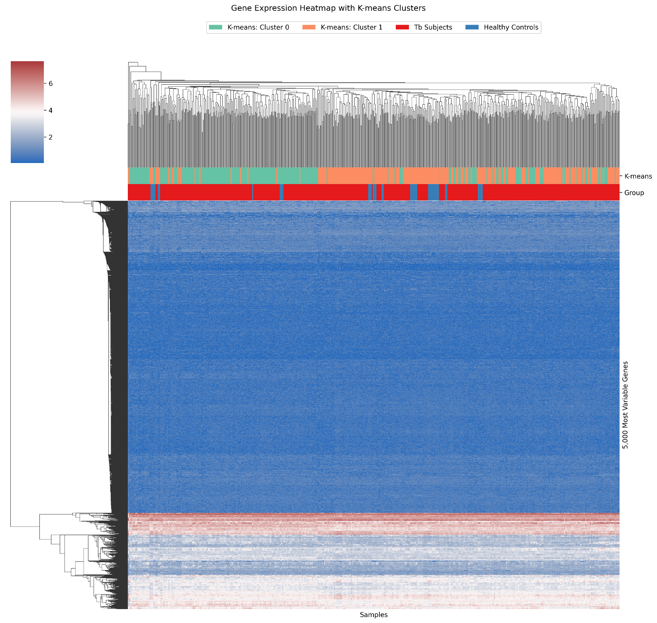

- Statistics
  - Does cluster membership correlate with the groups you chose in Assignment 1? Perform a chi-squared test of independence to statistically compare the two (assignment 1 groups vs the clusters you found). Repeat this for each clustering result you identified, for all versions of each clustering approach. Add these results to your table of chi-squared test results comparing the different versions of the clustering method that you ran.
  - Adjust all statistical test results for multiple hypothesis testing (adjusted p-value).
- Write a short summary for each plot/table you created in this assignment. In 3-5 sentences for each, describe what you did, what parameters you used (if any) and an interesting result from it.
- Combine all results into a single file, submit on Canvas. Only one student on the team needs to submit. Make sure that all your code and results are added to your GitHub repository.

