Case Study: Evercare Specialist Hospital (ESH)

1. Business Overview
Evercare Specialist Hospital (ESH) is a fictional private hospital located in Abuja, Nigeria. It provides medical consultations, laboratory investigations, prescription services, and general patient care.

2. Business Problem
The hospital uses paper records and spreadsheets to manage patient information, appointments, prescriptions, and laboratory results. This creates difficulties in retrieving medical histories, scheduling appointments, tracking test results, and maintaining accurate records.

3. Proposed Solution
The hospital intends to implement a centralised Hospital Management Database System (HMDS) to improve data accuracy, accessibility, security, and operational efficiency.

4. Key Database Entities
Entity | Description
Patients | Stores patient ID, name, date of birth, sex, contact details, and address.
Doctors | Stores doctor ID, name, specialization, and contact details.
Appointments | Records appointment ID, patient ID, doctor ID, appointment date, time, and status.
Prescriptions | Stores prescription ID, patient ID, doctor ID, medication details, dosage, and prescription date.
Laboratory Records | Stores laboratory record ID, patient ID, doctor ID, test type, test date, and test results.

5. Key Database Operations
- Register and retrieve patient records.
- Schedule and manage appointments.
- Record prescriptions issued by doctors.
- Store and retrieve laboratory results.
- Retrieve patients' medical histories.

Users of the Hospital Management Database and Their Responsibilities
Database User | Responsibilities
Receptionist | Registers patients, updates patient information, and schedules appointments.
Doctor | Accesses patient medical histories, manages appointments, issues prescriptions, and requests laboratory tests.
Laboratory Scientist | Records laboratory test results and retrieves laboratory requests.
Pharmacist | Reviews prescriptions and dispenses prescribed medications.
Database Administrator (DBA) | Manages database security, user access, backups, recovery, and performance.

ER Diagram
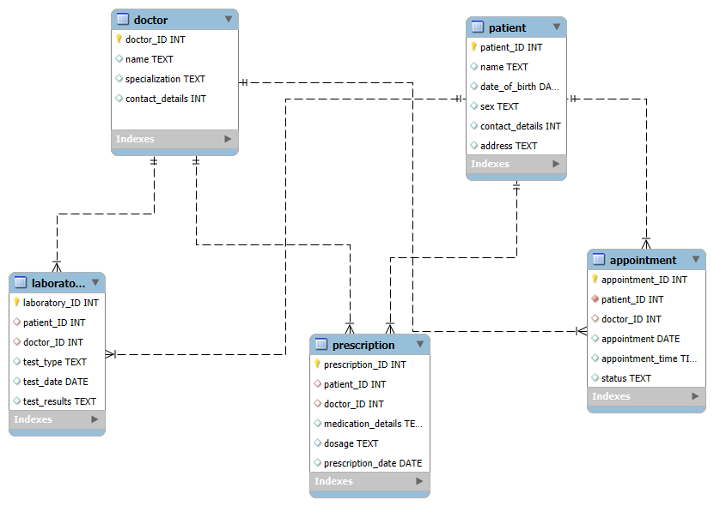

Relational Database Schema
The Evercare Hospital Management Database System comprises five relational tables designed to manage patient information, doctors, appointments, prescriptions, and laboratory records. These are:
- Doctors table
  - doctor_ID PK
  - name
  - specialization
  - contact_details
Constraints: doctor_ID (NOT NULL, auto_increment)
- Patients table
  - patient_ID PK
  - name
  - date_of_birth
  - sex
  - contact_details
  - address
Constraints: patient_ID (NOT NULL, auto_increment)
- Appointment table
  - appointment_ID PK
  - patient_ID FK
  - doctor_ID FK
  - appointment_date
  - appointment_time
  - status
Constraints: appointment_ID (NOT NULL, auto_increment), Patient_ID (Foreign key), doctor_ID (Foreign Key)
- Prescription table
  - prescription_ID PK
  - patient_ID FK
  - doctor_ID FK
  - medication_details
  - dosage
  - prescription_date
Constraints: prescription_ID (NOT NULL, auto_increment), Patient_ID (Foreign key), doctor_ID (Foreign Key)

- Laboratory table
  - laboratory_ID PK
  - patient_ID FK
  - doctor_ID FK
  - test_type
  - test_date
  - test_results
Constraints: laboratory_ID (NOT NULL, auto_increment), Patient_ID (Foreign key), doctor_ID (Foreign Key)

NORMALISATION
- 1NF – A table must have a primary key, and each field must contain a single value
All the tables in this database (Patient, Doctors, Appointments, Laboratory, and Prescription) adhere to this form. Each attribute depends entirely on the primary key column.
For example, on the Laboratory table, each field depends only on the Laboratory_ID field.
- 2NF – 1NF must be satisfied, and there must be no interdependency between fields
1NF is satisfied, and there are no interdependencies between fields. Each field within each entity is entirely dependent on the primary key column, with no interdependency with other columns.
- 3NF – 2NF must be satisfied, and there must be no transitive dependencies among its non-key attributes.
For example, the Doctors table stores each doctor's specialisation alongside the doctor's details. If additional information about specialisations is introduced, it may be appropriate to create a separate Specialisations table to avoid unnecessary duplication.

