| Section | Title |
| --- | --- |
| 1. Introduction | 1.1 Purpose |
| 1.2 Scope |
| 1.3 Definitions, Acronyms, and Abbreviations |
| 1.4 References |
| 2. Overall Description | 2.1 Product Perspective |
| 2.2 Product Functions |
| 2.3 User Characteristics |
| 2.4 Constraints |
| 2.5 Assumptions and Dependencies |
| 3. Specific Requirements | 3.1 Functional Requirements |
| 3.1.1 User Registration and Authentication |
| 3.1.2 Course Management |
| 3.1.3 Content Delivery |
| 3.1.4 Assessments and Grading |
| 3.1.5 Communication Tools |
| 3.1.6 Progress Tracking |
| 3.2 Non-Functional Requirements | Performance |
| Security |
| Usability |
| Availability |
| 4. Appendices | API Documentation |
| UI Wireframes |
| DFD Diagram |

Software Requirement Specification (SRS) Document

1. Introduction

1.1 Purpose

The purpose of this document is to define the functional and non-functional requirements for IntelliLearn, an AI-driven Web3 Metaverse university. IntelliLearn aims to provide an immersive, personalized, and verifiable learning experience by integrating AI, blockchain, and VR technologies.

1.2 Scope

IntelliLearn will be a next-generation learning platform that provides students, instructors, and administrators with real-time adaptive mentorship, immersive VR classrooms, verifiable blockchain certificates, and AI-powered study groups. The core functionalities include:

* AI-Powered Personalized Mentorship: Adaptive learning based on real-time emotion detection.
* Blockchain-Backed Certifications: Fraud-proof skills verification using NFTs and SBTs.
* Metaverse & VR Classrooms: Gamified, immersive learning experiences.
* EEG Brainwave-Controlled Learning: Hands-free interaction for accessibility.
* AI-Generated Real-World Challenges: Customized assignments based on industry needs.
* Multilingual AI Translation: Real-time language support for accessibility.
* AI-Powered Career Fair: Smart job matching and automated interview preparation.

1.3 Definitions, Acronyms, and Abbreviations

* LMS (Learning Management System): A system that enables course creation, delivery, and management.
* NFT (Non-Fungible Token): A unique digital asset stored on a blockchain.
* SBT (Soulbound Token): A non-transferable blockchain credential proving skills and learning.
* VR (Virtual Reality): Immersive, interactive 3D environments for learning.
* AI (Artificial Intelligence): Technology enabling personalized and automated learning experiences.

1.4 References

* Standard SRS template for software engineering
* Best practices for blockchain and AI-driven e-learning platforms
* Research papers on adaptive learning and AI-based emotion detection

2. Overall Description

2.1 Product Perspective

IntelliLearn is a cloud-based, AI-driven, Web3-powered learning platform designed for modern education. It integrates with decentralized storage, blockchain networks, AI APIs, and VR systems to provide an immersive and verifiable learning experience.

2.2 Product Functions

* User Registration & Authentication (Decentralized identity verification)
* Course Management (AI-driven course recommendations & VR integration)
* Content Delivery (Gamified and immersive learning experiences)
* Assessments & Grading (AI-generated assignments & adaptive testing)
* Progress Tracking (AI-driven analytics & real-time feedback)
* Career Matching (AI-based job and internship recommendations)

2.3 User Characteristics

* Students: Engage in immersive learning, receive AI-based mentorship, and earn blockchain-backed certifications.
* Instructors: Create VR-enhanced courses, monitor student progress, and generate adaptive learning paths.
* Administrators: Manage platform settings, course approvals, and blockchain-based credential verification.

2.4 Constraints

* Must support both desktop and VR-enabled devices.
* Blockchain integration must ensure security and data integrity.
* AI models require continuous training to adapt to user behaviors.

2.5 Assumptions and Dependencies

* Requires stable internet for real-time AI and VR interactions.
* Depends on third-party APIs for blockchain transactions and multilingual translation.

3. Specific Requirements

3.1 Functional Requirements

3.1.1 User Registration and Authentication

* Users register using email, biometric authentication, or blockchain-based decentralized identity.
* Secure login with Ethereum-based authentication (SIWE).

3.1.2 Course Management

* AI-assisted course creation tools for instructors.
* VR-enabled content creation for immersive learning.

3.1.3 Content Delivery

* Adaptive learning paths using AI emotion detection.
* Gamified learning experiences with VR integration.

3.1.4 Assessments and Grading

* AI-generated quizzes and real-world challenges.
* Automated grading for objective assessments.

3.1.5 Communication Tools

* AI-powered study groups with smart student matching.
* Real-time multilingual translation for seamless global communication.

3.1.6 Progress Tracking

* Blockchain-backed certificates (NFTs & SBTs) upon course completion.
* AI-driven analytics for performance evaluation.

3.2 Non-Functional Requirements

Performance

* System should handle over 10,000 concurrent users with seamless performance.
* AI models should process real-time data with minimal latency.

Security

* Blockchain ensures tamper-proof certification storage.
* End-to-end encryption for AI-driven mentorship sessions.

Usability

* Intuitive UI with accessibility features (voice commands, EEG control).
* VR-based classrooms should be user-friendly and immersive.

Availability

* 99.9% uptime with cloud-based redundancy and automatic failover.
* Decentralized storage (IPFS/Arweave) for permanent learning records.

4. Appendices

4.1 API Documentation

* Authentication API: Manages decentralized user authentication.
* Course Management API: Facilitates course creation and updates.
* AI Analytics API: Provides student engagement metrics.
* Blockchain API: Handles NFT and SBT transactions.

4.2 UI Wireframes

* Dashboard: Displays enrolled courses and progress.
* VR Classroom Interface: Interactive 3D learning environment.
* Instructor Panel: Course management and analytics tools.
* Career Matching Page: AI-driven job recommendations.

4.3 Data Flow Diagram

* Representation of AI-based learning adaption process.
* Blockchain verification flow for certification issuance.

This document outlines the Software Requirements Specification (SRS) for IntelliLearn: The Future of AI-Driven Education. The platform aims to redefine digital learning by integrating AI, blockchain, and immersive VR technologies.

4.3 FLOW CHART

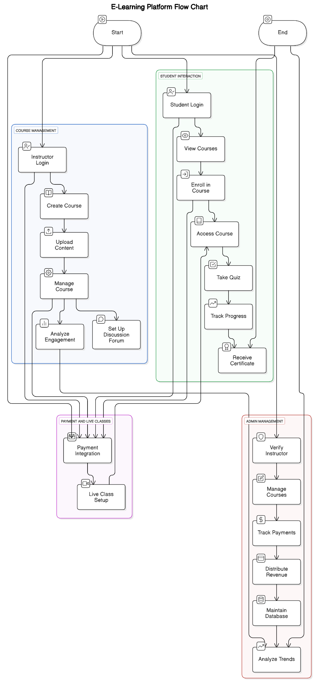

4.3 DATA FLOW DAIGRAM

