Assessment Agency Portal
Quick User Guide: end-to-end use cases
Screens in this guide were taken from a test copy loaded with demo data. Names, ids and dates are demo values.
October 2026

1. Signing in and who does what
Open the portal address in a browser and sign in with the email (or sign-in id) and password you were given. On your first sign-in you are asked to change the password. The menu on the left shows only the pages your role may open.
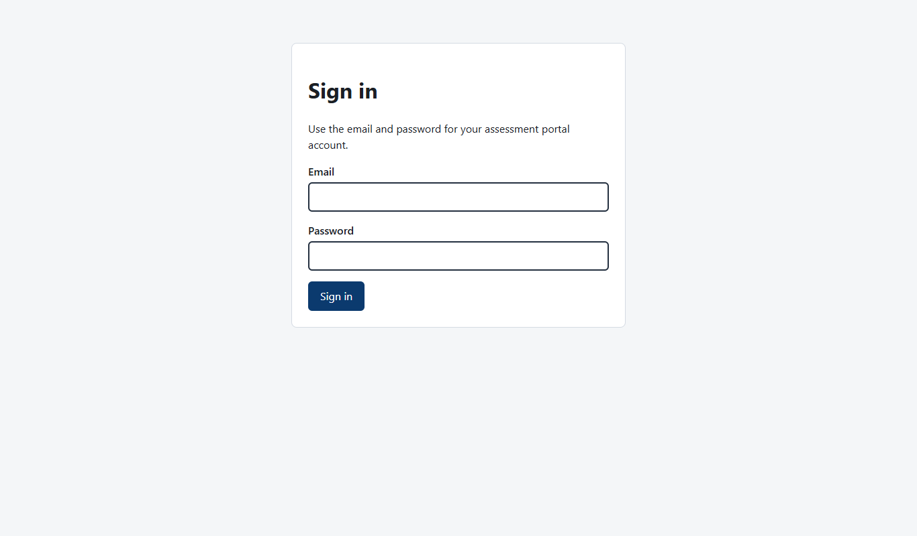
Sign-in page
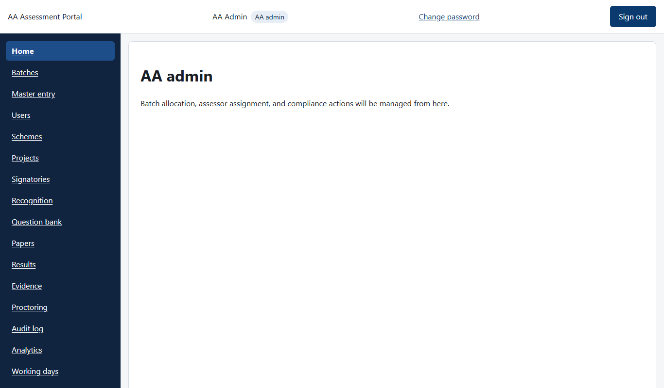
Home page of an AA admin, with the menu on the left
Role | Main work
AA admin | Everything: set-up, batches, assessor assignment, results, settings
MIS | Master records, users (training partners, assessors, proctors, students), working days, recognition
SME | Question bank and test papers
Assessor | Mobile app: attendance, logins, videos and checklist for the batch
Proctor | Watches online exams and reviews flags
Candidate (student) | Takes the online exam
Training partner (TP) | Sees its own batches and students
NCVET viewer | Read-only: analytics, audit log, recognition

Demo logins (test server only)
Staff emails: admin@aa.example, mis@aa.example, sme@aa.example, assessor@aa.example, proctor@aa.example, tp@aa.example, candidate@aa.example, ncvet.viewer@aa.example. Demo password: Dev-Password-1. Never use these on a live server.

One batch, start to finish
- Set up master records (once).
- Prepare questions and an approved test paper.
- Create the batch and add students.
- Accept the batch, then assign an assessor.
- Assessment day: assessor on the phone, students in the online exam.
- Mark the batch complete, enter and submit the result, publish.
- Download the candidate summary report.
Batch status moves: Allocated, Accepted, Assessor assigned, In progress, Assessment completed, Result submitted, AB validated, Published. A batch can also be Rejected, Cancelled or Disputed.

2. Use case: first-time set-up (AA admin or MIS)
Goal: have the people and places a batch needs.
- Sign in and open Master entry.
- Use the tabs to add awarding body, training partner, training centre, assessor, proctor, students and qualifications. For many records, open the “Add many… from an Excel file” link on the tab.
- Open Recognition and record the sectors, states (or PAN India) and dates the agency is recognised for.
- Open Working days and set weekend days and holidays. SLA due dates are calculated from these.
- Optional: Schemes, Projects and Signatories, if batches are funded under a scheme.
- Open Users to create logins and reset passwords. Every student gets a login automatically.
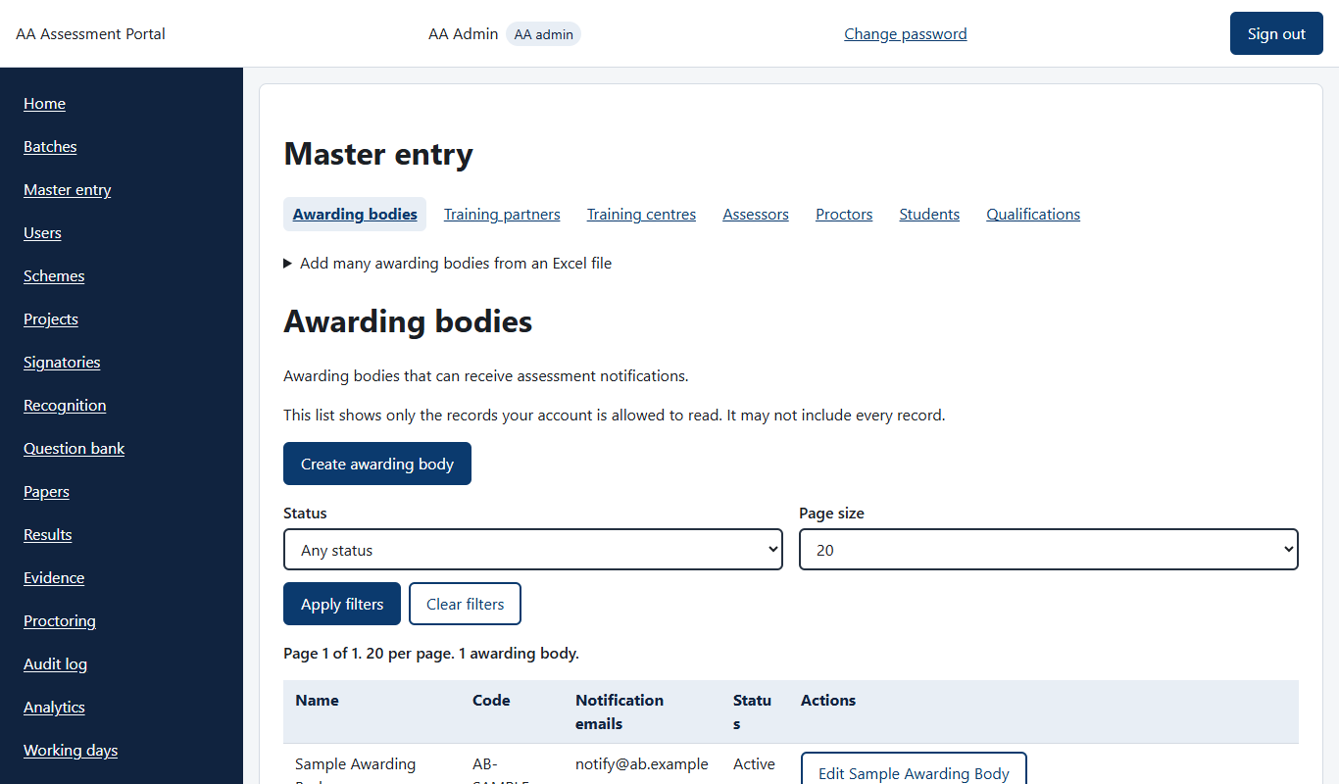
Master entry, with one tab for each kind of record
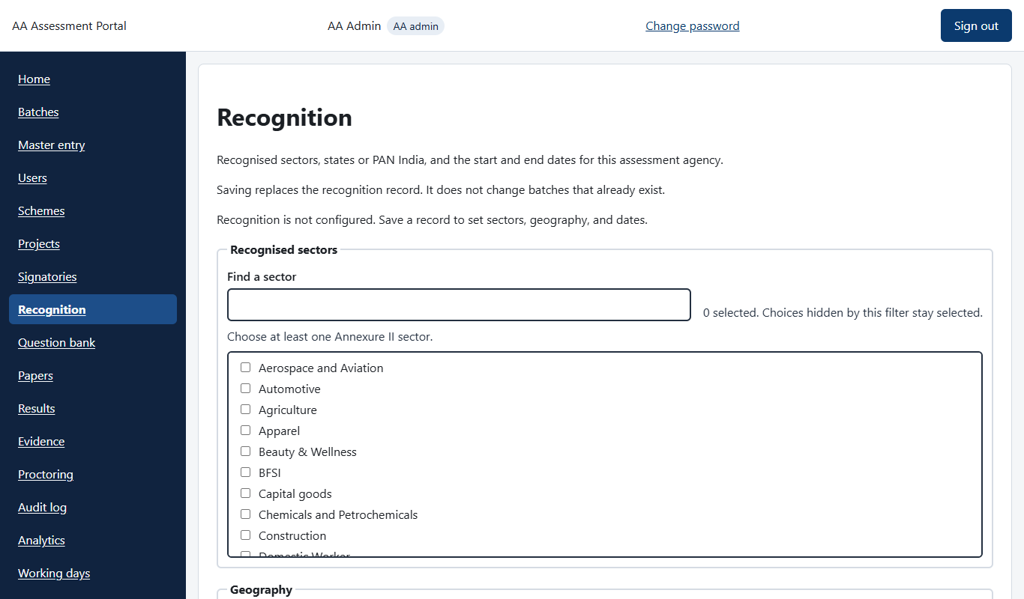
Recognition page
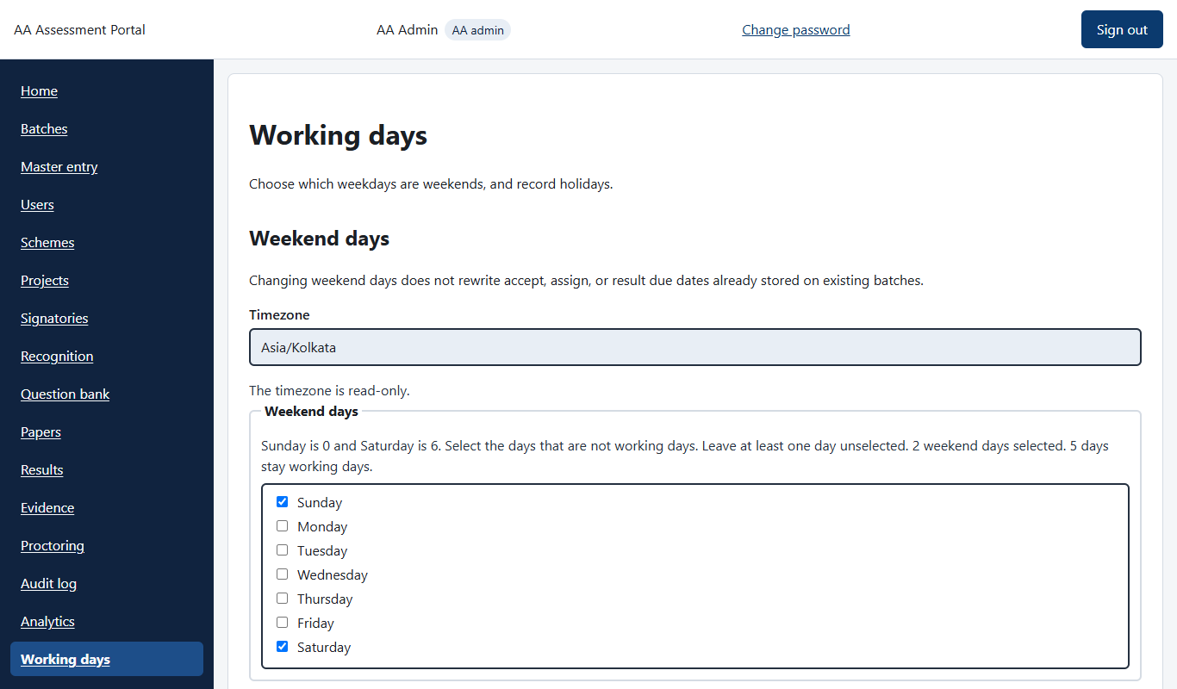
Working days: weekends and holidays
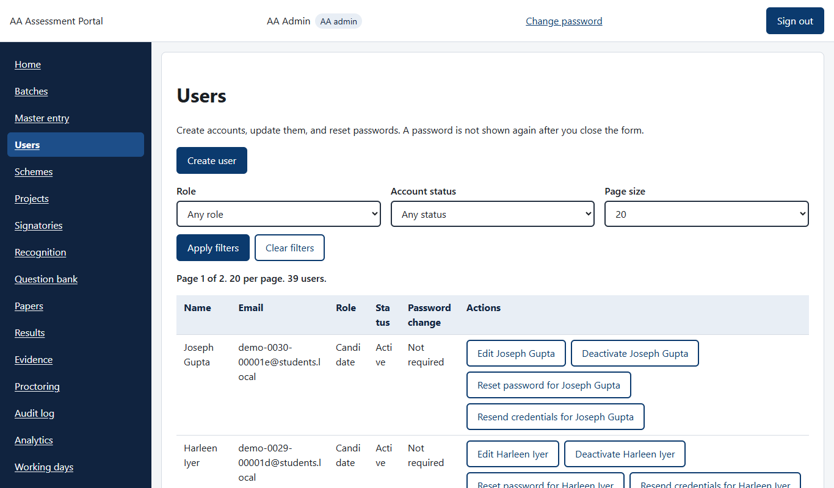
Users: create, deactivate, reset password
Check: the records appear under Master data, and assessors and proctors appear in the Registry.

3. Use case: question bank and test paper (SME)
- Open Question bank. Filter by qualification, NOS and PC.
- Add questions with New question, or use Import from Excel.
- Send questions for review. An approver approves each one.
- Open Papers and choose Create paper. Pick the language (for example English or Hindi) and generate it from approved questions.
- Send the paper for approval. The approver approves it or sends it back.
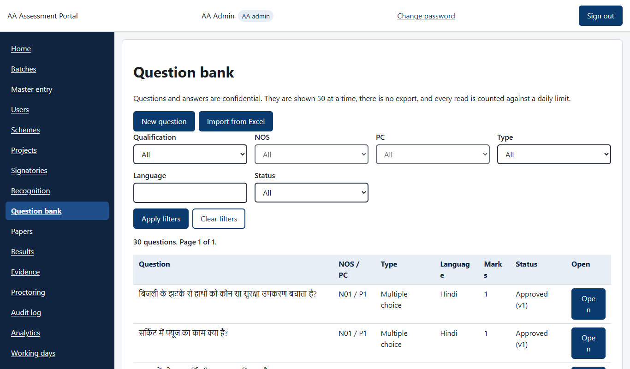
Question bank with the status of each question
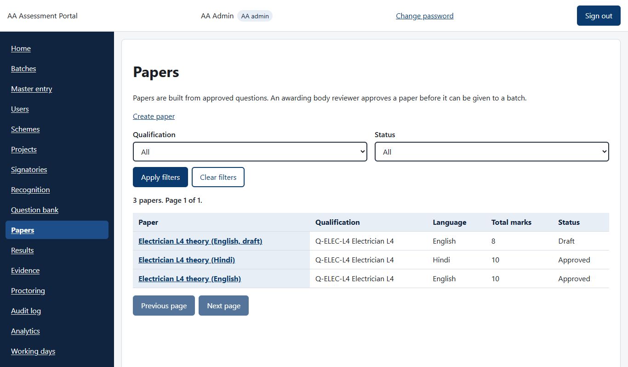
Papers: draft and approved papers by language
Check: the paper shows as Approved. A batch needs an approved, complete paper in its language before students can start.

4. Use case: create a batch and add students (AA admin)
- Open Batches and click Create batch.
- Fill in awarding body, qualification, STT or LTT, mode, assessment start and end dates, training partner and centre, and language. Optional: scheme and project.
- Choose the approved test paper now, or set it later on the batch page.
- Save. The batch starts as Allocated and its SLA due times show on the list.
- Open the batch. In the Candidate roster add students one by one (Add candidate) or use Import CSV.
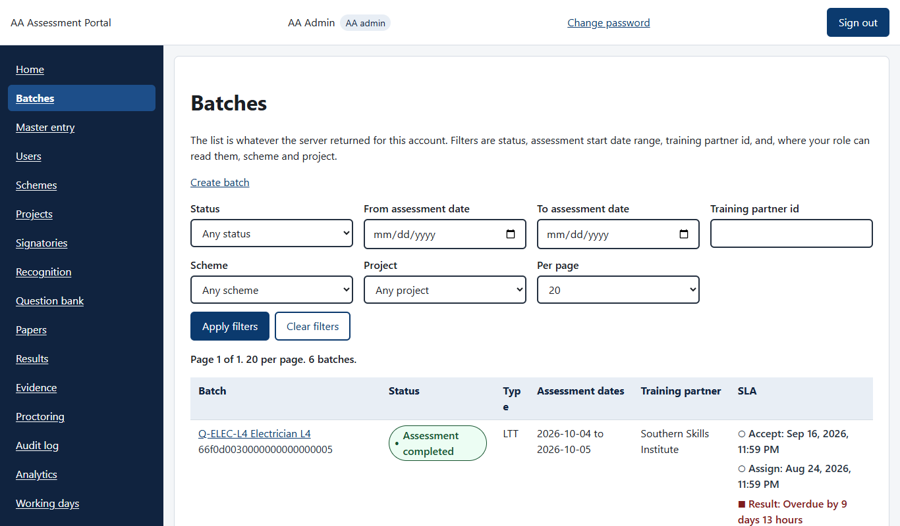
Batch list with status and SLA due times
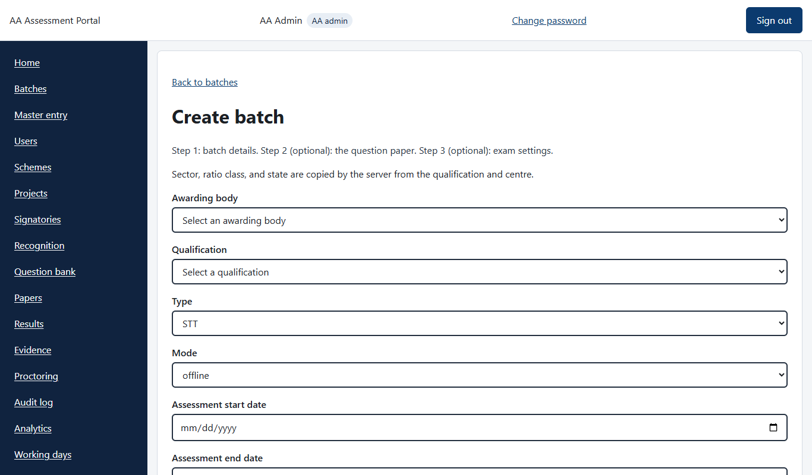
Create batch form
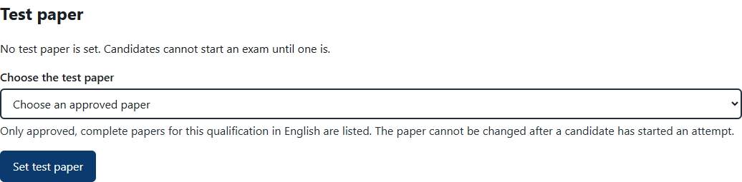
Setting the test paper on a batch
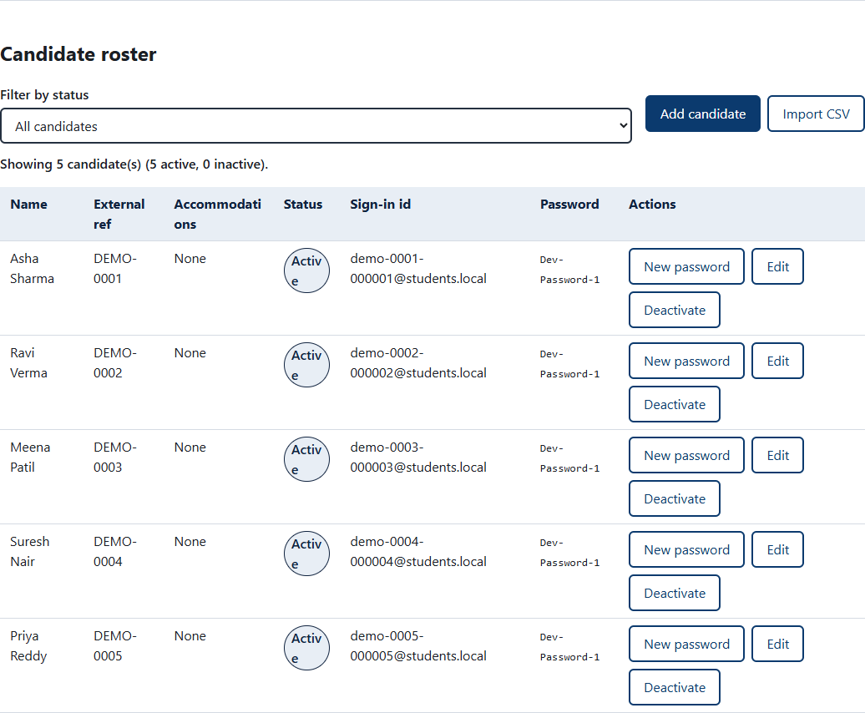
Candidate roster with sign-in ids
Check: the roster lists the students and the status badge shows Allocated.

5. Use case: accept the batch and assign an assessor (AA admin)
- Open the batch. The SLA timeline shows what is due and when.
- Click Accept (or Reject, with a reason). Do this within 2 working days. If it is late, the system asks for a late reason.
- Confirm in the dialog.
- Click Assign assessor and pick one. The system blocks the choice if the assessor is already booked at another centre on those days.
- If the assessor changes, use Reassign assessor while the status is Assessor assigned. Use Cancel (with a reason) if the batch will not run.
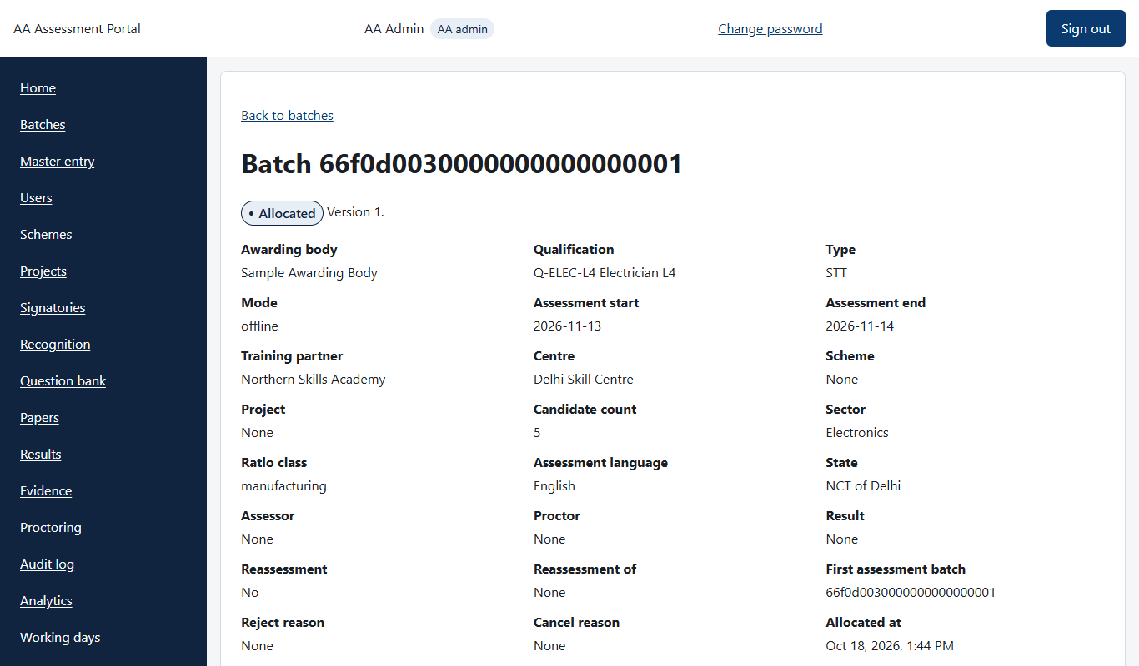
Batch page
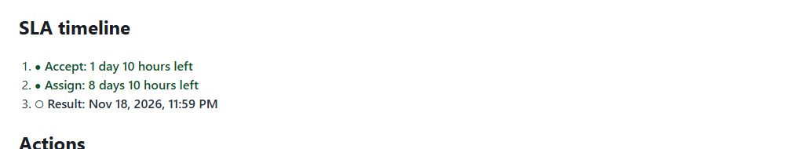
SLA timeline

Actions available on an Allocated batch
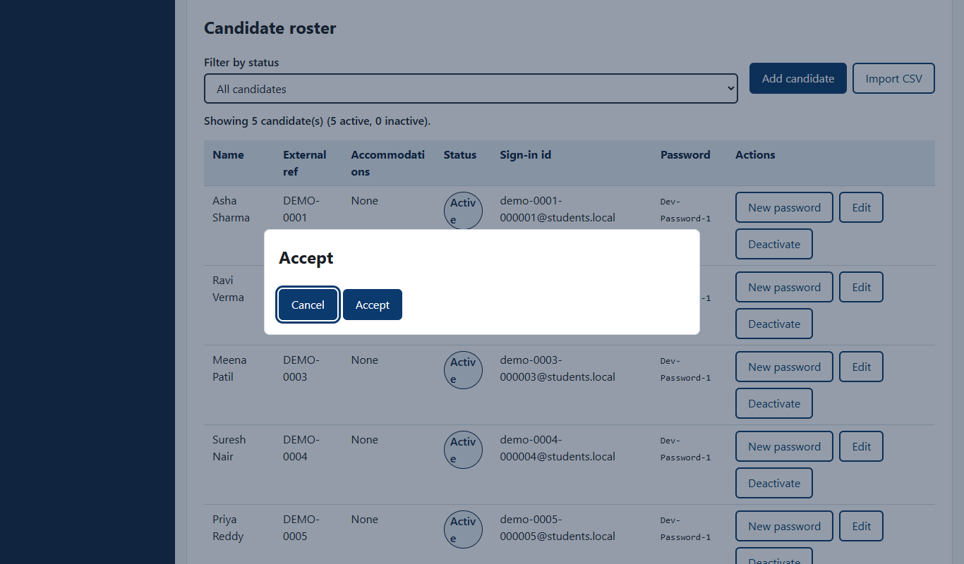
Confirming Accept
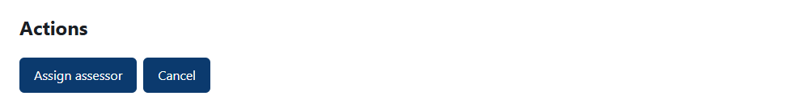
After accepting: Assign assessor and Cancel
Check: status becomes Accepted, then Assessor assigned.

6. Use case: assessment day, the assessor (mobile app)
The assessor uses the phone app. It works offline once the batch is downloaded. (Phone screens are not in this version of the guide.)
- Sign in on the phone and allow location. Download the batch.
- Batch tab: see the batch details.
- Attendance tab: mark who is present. Taking attendance records the assessor’s sign-in with location and time, and the awarding body is notified by email.
- Logins tab: shows each student’s sign-in id and first password, to hand out.
- Video tab: record the practical and viva. One complete video per student and part, with the viva questions stepped through on screen. Or record one group video for several students. Videos queue and upload when there is signal.
- Checklist tab: complete the assessor checklist.
- Session tab: shows sync status and sign-out.
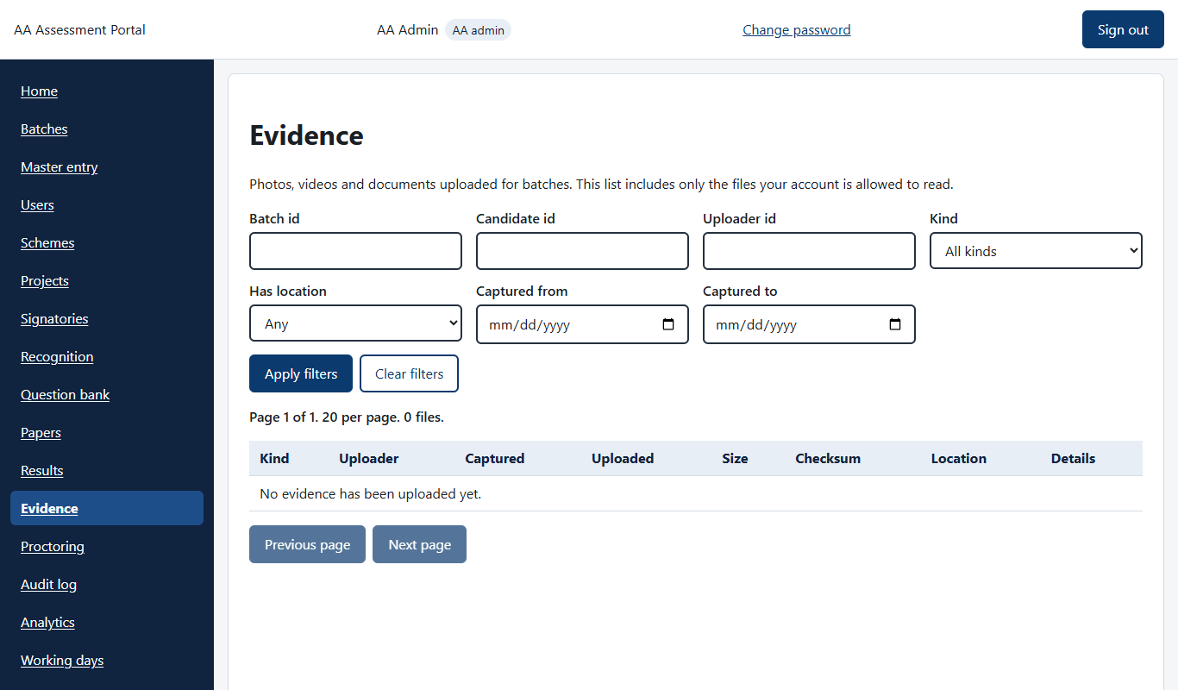
On the web, uploaded photos and videos appear under Evidence (empty here because the demo has none)
Check: evidence appears on the web under Evidence with checksum and location.

7. Use case: online exam, the student
- Sign in with the id and password given by the assessor or shown in the student list. Change the password on first sign-in.
- Open Exam. Tabs show Upcoming, Ongoing and Completed.
- Click Start on the exam. Complete the camera check. The exam opens in its own window, so allow pop-ups.
- Answer the questions and submit. If the connection drops, use Resume.
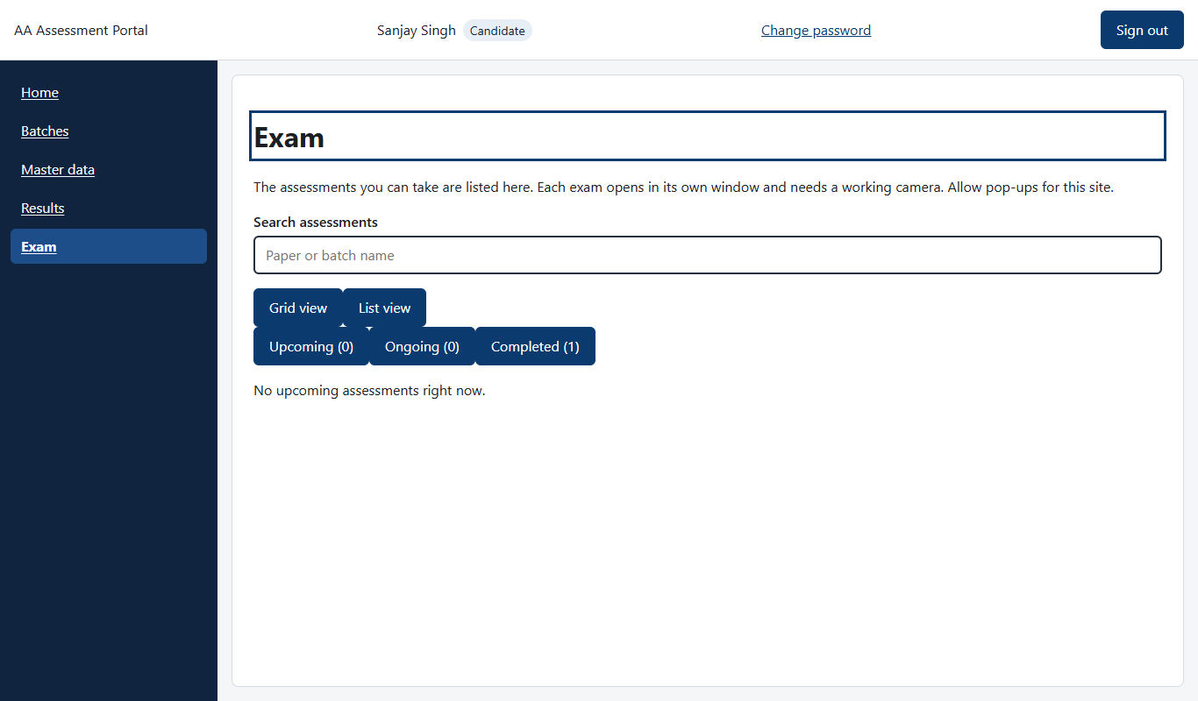
A student’s Exam page
Check: the exam moves to Completed.

8. Use case: watch an exam, the proctor
- Open Proctoring. The list shows running and finished attempts and refreshes every 10 seconds.
- Open one attempt to see flags (for example face not found) and snapshots.
- Record a decision on each flag: dismiss it, warn the candidate, or recommend invalidation.
- Open the proctoring report for the full story. The answer sheet is available from the attempt.
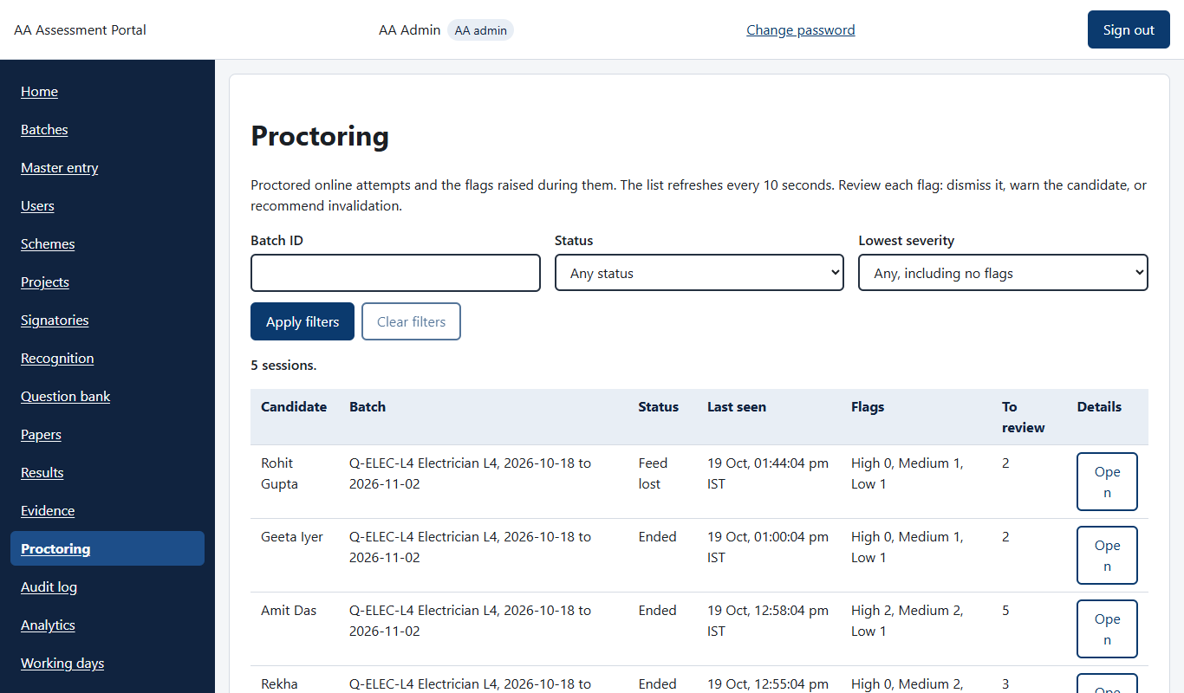
Proctoring list with flags to review

9. Use case: close the batch and publish the result (AA admin)
- After the assessment, open the batch and click Complete (a reason is needed). Status: Assessment completed.
- In the Result section, enter the marks for each candidate. Tick Absent where needed. Click Save draft, then Submit result. Due 3 working days after the end date (STT) or 5 working days after the exam date (LTT).
- Because the awarding body has no login, submit can also validate and publish in one go.
- If it was not auto-published, use Validate result and then Publish result.
- Open Results for the list of finished batches with pass, fail and absent counts. Open the batch report and use Print or Excel to export the candidate summary.
- On the batch page, Reports has Download marks (Excel).

Actions on an assessment-completed batch
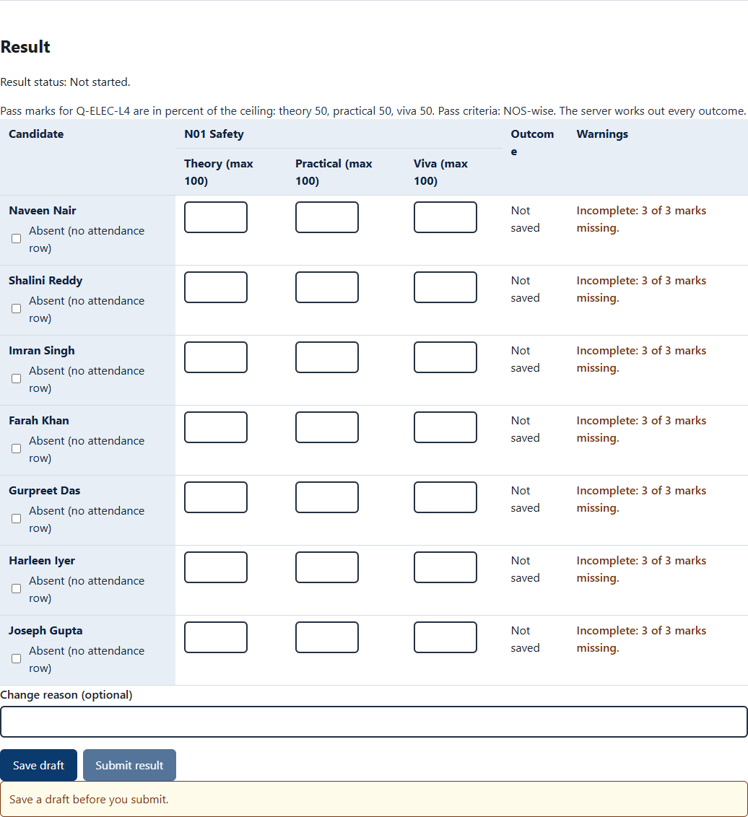
Result section: enter marks, save draft, submit
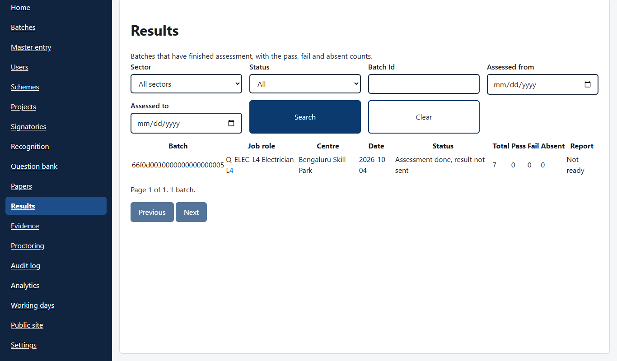
Results list with pass, fail and absent counts
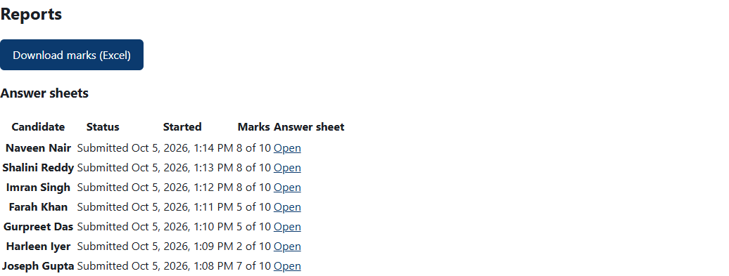
Reports section on the batch page
Check: status shows Published. Fail or Absent students can be given a re-assessment as a new batch within one year of publication.

10. Use case: monitoring and audit
- Analytics: counts by assessor, training partner, job role and state, and SLA performance.
- Audit log: who changed what and when. Personal data and question text are never in it.
- Batches: each row shows a countdown to the next SLA due time.
- Settings (AA admin): access and feature settings. Public site (AA admin): content for the public website.
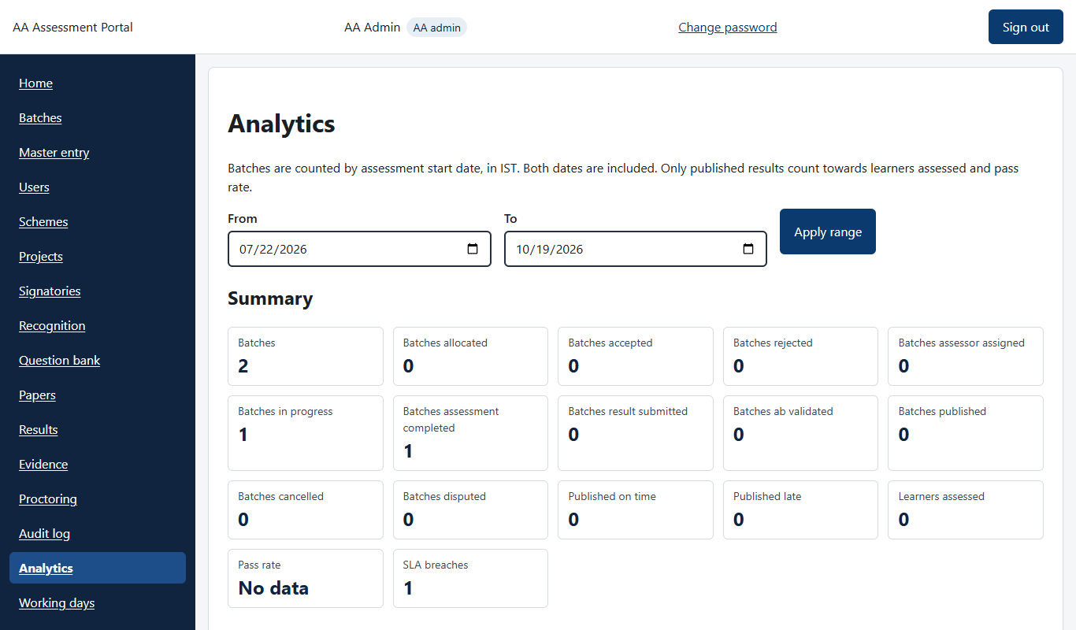
Analytics summary
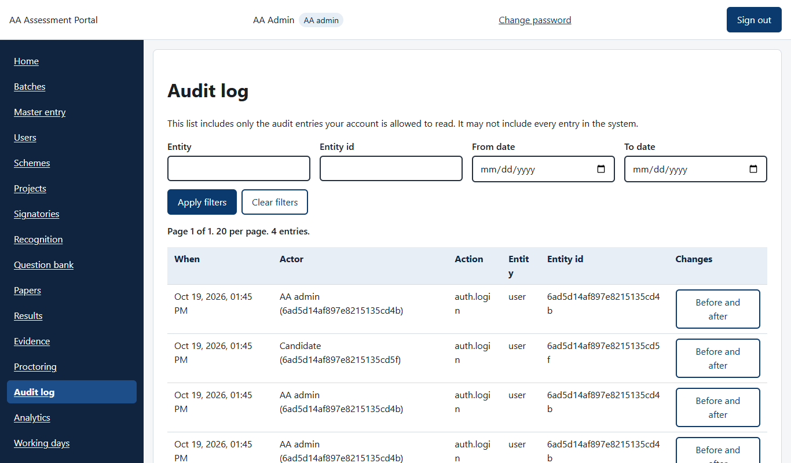
Audit log

Quick fixes
Problem | What to try
A menu item is missing | Your role does not have it. Ask the AA admin.
Student cannot start the exam | The batch has no approved paper in that language, or it is outside the exam window.
Cannot assign assessor | Assessor is booked on those dates at another centre, or the batch is not Accepted yet.
Student forgot password | Admin or MIS: Users, then Reset password. Or New password in the batch roster.
Action says it is late | You are past the SLA due time. Enter a late reason and continue.
Phone has no signal | Keep working. Attendance and videos queue and sync later.

