Task 2: Test log
Description of test | Test data to be used (if required) | Expected outcome | Actual outcome | Comments and intended actions
Navigation Bar
Navigation Bar: Black box testing/functional testing/integration testing | No data inputs required for this test. Navigation bar should be tested to see if all page’s load correctly | Navigation bar appears appropriately, contains the logo, links and primary buttons (book/signup). The buttons take you to the appropriate page | The navigation bar works as expected. All the links work and direct the user to the correct page | Accessibility to be integrated in final stages of development, so accessibility button will not be clickable yet  Program worked as expected
Navigation Bar: Product dropdown: Black box testing/functional testing/integration testing | No data inputs required for this test. Products dropdown of navigation bar should be tested to see if all buttons direct the user to the products page and the product details | Navigation bar should display products dropdown when the user hovers over the button, and allows them to click a product, taking them to the products page   | The navigation bar products dropdown works as expected. All the product links direct the user to the correct pages | Program worked as expected
Home Page
Home Page: White box testing/Black box testing/Functional testing/Integration & unit testing | No data needed. Ensuring all the buttons are functional. Test conducted to ensure home page operates by itself and when integrated altogether | Home page should display all information and buttons appropriately. All buttons should navigate the user to the correct destination, and nothing should be problematic | Home page displays information correctly. All the displayed buttons work as intended. For example, when the user clicks More Details on the products, it takes them to the product page | Program worked as expected
Products Page
Products Page: Dynamic product loading: Black box testing/functional testing/integration & unit testing | No data needed. Test assumes the database contains 3 products. These should dynamically load onto the products page | Products page should display the products from the database and allow the user to view information about the product via the button provided   | Products page accurately displays the products from the database and allows the user to access more details of each product via the “View details “button | Program worked as expected
Database (Products): Black box testing/functional testing/integration testing | Adding new record in database.db (products table):  (Normal Data)  id = 4  type = “Example”  description = “Desc”  details = “Details”  image = /static/assets/smarthome.png | After updating the database, there will be 4 total products. The page should display all the products (after refreshing) and display the correct and relevant information for the user  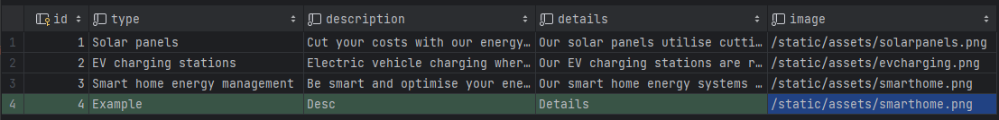 | The products page accurately shows 4 of the 4 products stored in the database   | This dynamic inserting of elements allows the client to add products to the market with ease. This product database will be integrated into the consultations, so when they add them to the products table – they will be accessible on the rest of the site  Program worked as expected
About Page
About Page: White/black box testing/functional testing/integration testing | No data needed. Ensuring all elements are visible, testing integration with the site | The about page should display various sections, such as traits, accreditation, and a company timeline | The about page accurately shows meaningful information about Rolsa Technologies, including sections on traits, accreditation, and a company timeline | Program worked as expected
Carbon Footprint Page
Carbon Footprint: Submitting Valid Form: Functional testing | (Normal Data)  current_type = “individual”  transport_miles = 1000  electricity_kwh = 200,  meat_meals = 5 | Submit form, results should appear, and valid data for carbon footprint should appear | Form successfully submitted, and results appeared  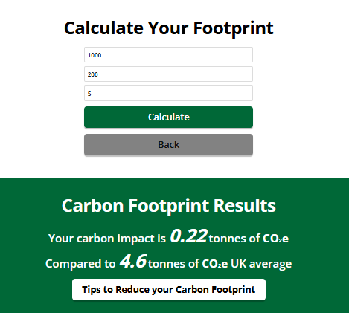 | Testing for accurate and correct carbon impact data to be completed further within tests  Program worked as expected
Carbon Footprint: Submitting Invalid Data: Functional testing | (Erroneous Data)  current_type = “individual”  transport_miles = -10  electricity_kwh = “e+”  meat_meals = 0  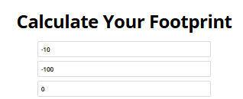 | Form should display an error, or invalid inputs should be handled correctly. Form should not be submitted | Form was submitted successfully, however due to the nature of the <input> element and its attributes, I was not able to enter anything other than a number (except e and +). However, negative numbers were accepted.  Form showed negative data, invalid   | Added client side and server-side validation for user inputs (version v.2.1)  Program will now check for any invalid data and will display an error message
Carbon Footprint: Fixing Negative Data: Regression testing – ensuring previous issue was fixed | (Erroneous Data)  current_type = “individual”  transport_miles = -10  electricity_kwh = “e+”  meat_meals = 0 | Form should now display an error, or invalid inputs must be handled correctly. Form should not be submitted | Form accurately displayed an error message, and does not process any of the data due to it being invalid  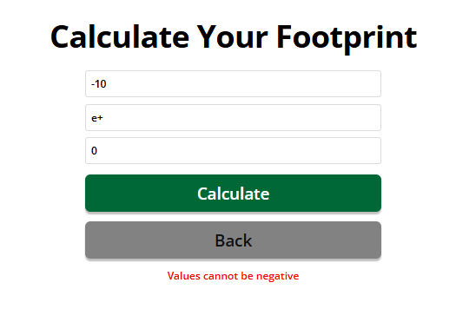 | Latest app.py change is available from v.2.0 to v.2.1 for this fix  Server-side: try/except condition, checking negative values  Client-side checking:
Carbon Footprint: Submitting Empty Data: Functional testing | (Absent Data)  No data entered; however, data is required. All fields left blank  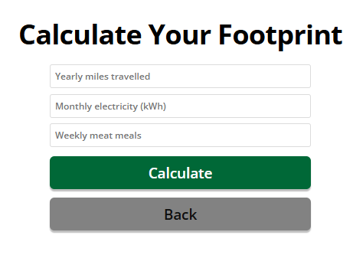 | Form should not be submitted due to no inputs being entered. All fields will be left blank to test to see if the form processed. Appropriate messages should appear to fix the form inputs | Form was submitted, and no errors appeared in the output. Form submits with all inputs left empty.   | Added client-side verification for user inputs  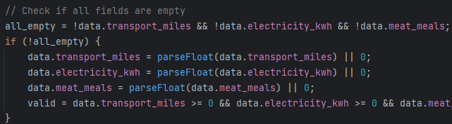  Program will now display an appropriate error message if at least one field is blank
Carbon Footprint: Fixing Empty Data: Regression testing – ensuring previous issue was fixed | (Absent Data)  No data entered; however, data is required. All fields left blank | Form should not be submitted due to no inputs being entered. All fields will be left blank to test to see if the form processed. Appropriate messages should appear to fix the form inputs | When at least one field is left blank, an error message now appears for the user  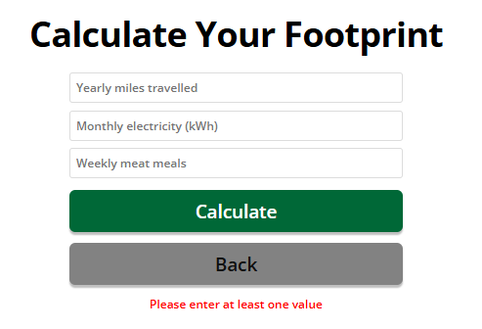 | Latest app.py change is available in version v2.1 for this fix.  Client-side changes are available in carbonfootprint.html  Server-side change includes changing data.get(“”, 0) to data.get(“”), without the 0
Carbon Footprint: Results: Functional/integration testing | (Normal Data)  current_type = “individual”  transport_miles = 1000  electricity_kwh = 200,  meat_meals = 5 | Displays user impact correctly, and server should calculate the carbon impact accurately. Server-side calculation should match external calculation or estimate | Result shows 0.22 tonnes of CO2e, compared to 4.6 tonnes for assumed yearly average for UK individual  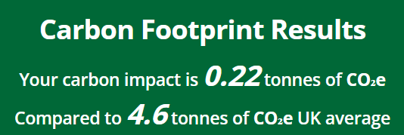 | Due to the result likely being inaccurate, adjustments have been made for consistency.  Available in app.py version v2.1  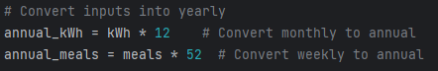  Changes have also been made to commercial/business impact calculations, to convert to annual
Carbon Footprint: Results: Regression testing – ensuring previous issue with calculations was fixed | (Normal Data)  current_type = “individual”  transport_miles = 1000  electricity_kwh = 200,  meat_meals = 5 | Displays user impact correctly, and server should calculate the carbon impact accurately. Server-side calculation should match external calculation or estimate | Result now shows 1.2 tonnes of CO2e, compared to 4.6 tonnes. Calculation appears more accurate and reliable  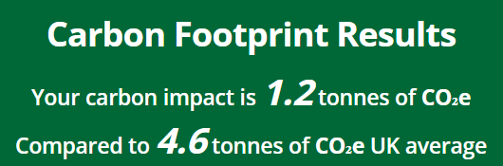 | Calculation simulation:  transport_miles = 1000 (annual)  = 1000 * 0.171 = 171 kg CO2e  electricity_kwh = 200 (monthly)  = 200 * 0.212 * 12 = 508.8 kg CO2e  meat_meals = 5 (weekly)  = 5 * 2.0 * 52 = 520 kg CO2e  Total = 171 + 508.8 + 520 = 1199.8 kg CO2e  In tonnes CO2e  = 1199.8 / 1000 = 1.20 CO2e  Program worked as expected
Sign Up Page
Sign Up: Invalid Form: Functional/integration testing/database | (Boundary Data)  email = user@example.com  password = “secure123”  repeat_password = “secure123” | Account should be created – however due to security measures implemented in the system, the user must enter at least one uppercase, lowercase, number and special character. System should tell the user to include this data. No data entry should be created. | The system displayed the user an error message asking them to include the password requirements  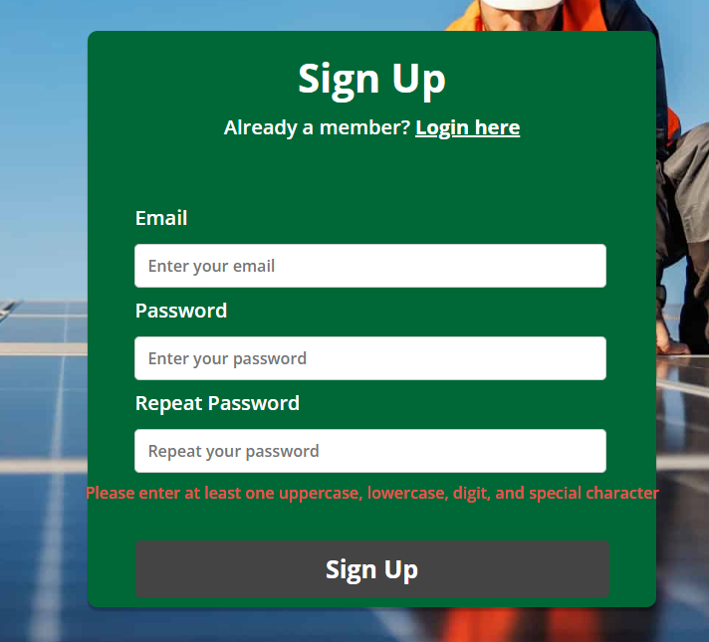 | The system requires one uppercase, lowercase, number and special character for appropriate security measures  A full valid test with secure passwords will be conducted further on
Sign Up: Invalid Passwords: Functional/integration testing/database | (Normal Data)  email = user@example.com  password = “Test123!@”  repeat_password = “Test123!?” | User should be informed that the password they entered is not the same as the repeat password. No data entry should be created. | An appropriate error message appeared, informing the user that their passwords don’t match   | This additional measure was put into place to prevent the user from entering a password incorrectly, and as a result be unable to obtain the password if they spelt it incorrectly. This is an additional security measure  Program worked as expected
Sign Up: Empty Fields: Functional/integration testing/database | (Absent Data)  email = “”  password = “”  repeat_password = “” | System should detect empty fields and show an error message on the input box when submitted or while focused. No data entry should be created. | System detects the empty fields and presents built-in error message on input boxes  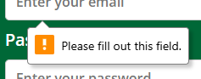 | Program worked as expected
Sign Up: Invalid field inputs: Functional/integration testing/database | (Erroneous Data)  email = “123”  password = “abc”  repeat_password = “abc” | System should reject invalid email format and weak password. System should display error message/input validation issue such as “Email must include @” | System rejected invalid email format and weak password. System displayed input error message  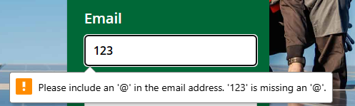 | After checking email input validation, I replaced email with 123@example.com so I could test the other fields  The other fields caused the weak password error popup to appear as a result  Program worked as expected
Sign Up: Valid Form: Functional/integration testing/database | (Valid Data)  email = user@example.com  password = “SecurE123!@”  repeat_password = “SecurE123!@” | System should accept the inputs and send it to the backend. The user should be redirected to the login page where the success message is displayed. | System accepted the inputs and redirected the user to the login page where they were told to login  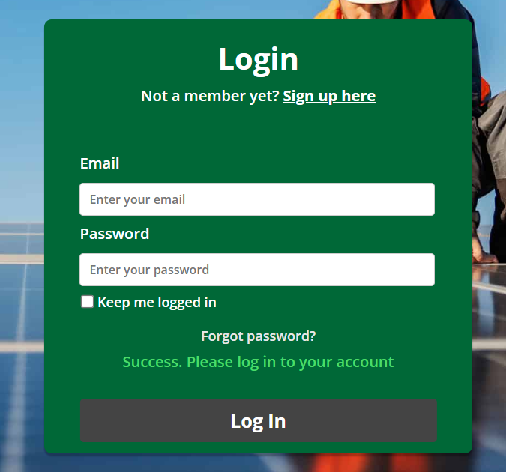 | Program worked as expected
Database (Customers) Storing Data: Database/unit testing | (Valid Data)  email = user@example.com  password = “SecurE123!@”  repeat_password = “SecurE123!@” | Database should store record with email and hashed password accurately | Database accurately stored the record with the email address and hashed password into the customers table of the Rolsa database  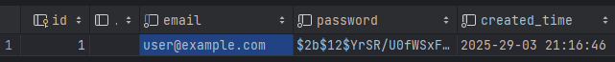 | Program worked as expected
Sign Up: Invalid/Duplicate: Functional/integration testing, database | (Valid Data – Already exists)  email = user@example.com  password = “MyPassword2#!@”  repeat_password = “MyPassword2#!@” | System processes the data and identifies if the email already exists in the database. No duplicate entry should be added. Error message should appear that the email already exists | System processed the data as expected, however failed to create the account due to the email address already being used on the database  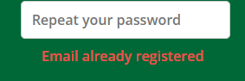 | Program worked as expected
Consultation Page
Consultation Page: White/black box testing, functional testing, integration testing/unit testing | No data required. Testing if content appears correctly with integration into the main website. | All content on the consultation page should be visible, following appropriate stylesheet | Consultation page is functional in collaboration with the main website. All of the content appears correctly | Program worked as expected
Consultation Page: Submitting Valid Form  Functional testing | (Normal Data)  full_name = User Name  product_id = 1 (Solar panels)  property_type = Residential  postcode = AAA 111  preferred_date = 31/03/2025 | App should successfully write consultation to database. Program should temporarily display “consultation submitted successfully” | System saved the consultation details and displayed successfully message   | Program worked as expected  Note: Full integration with dashboard will take place further within development. System simply writes data to database for now  Program also updates customers full_name gathered from the consultation form and sends it to customers database
Consultation Page: Missing Fields  Functional testing, validation testing | (Absent Data)  No data entered; however, data is required. All fields left blank | System should prevent form submission. Error message should be displayed. | Form was not submitted, and an appropriate error message appeared as expected   | Program worked as expected
Consultation Page: Dynamic Product Loading  Integration testing & API testing | API returns JSON:  {“Solar panels”: {…}, “EV charging”: {…}, “Smart home energy management”: {…} } | System should dynamically populate the product type dropdown with the names of each product (Solar panels, EV charging, Smart home energy management) | System showed all of the products appropriately  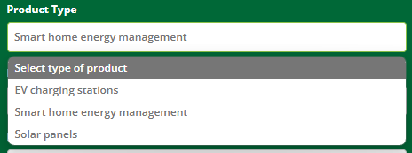 | Program worked as expected  Note: The JSON that is returned contains all of the data on each product, including desc, details and image file path  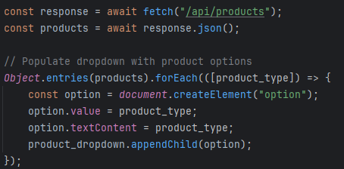
Consultation Page: No User Logged in  Authentication testing | No data required. Page will be loaded while there is no user logged in | System should redirect the user to the login page as they must be logged in to be able to submit a consultation request | System redirects the user to the login page appropriately when trying to access the schedule consultation page  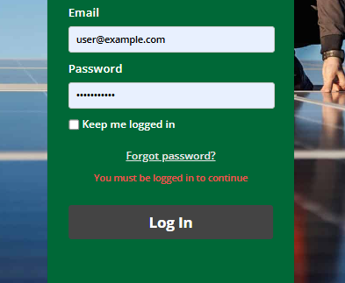 | Program worked as expected  The system verifies if the user is in the session, if not – they will be redirected to the login webpage and an error message will appear telling them to login  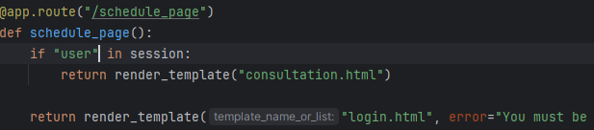
Consultation Page: Database: Full Name Update  Database testing | (Normal Data)  full_name = “Test” | System should update the full_name field in the customers table for the user that is logged in | System successfully update the full_name field in the customers record  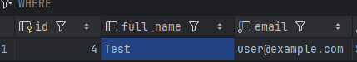 | Program worked as expected  The full name data is only requested at a point where it is necessary for contacting the individual by full name. The full name data is not required upon sign up, so it is collected during consultation process for data minimisation.
Consultation Page: Input: Invalid Full Name  Black box testing, validation testing | (Erroneous Data)  full_name = “Test12345” | System should reject the input and display an error saying full name should only contain letters | System accepts the invalid full name input | Client side input validation to only allow alphabetical characters or spaces
Consultation Page: Input Validation
Regression testing – ensuring previous issue with was fixed
Consultation Page: Input: Postcode Limit  Black box testing, validation testing | (Erroneous Data)  postcode = 123456789012” | System should reject the input and display an error saying postcode should be 8 characters or less | System accepts the invalid postcode length input | Client side input validation to allow a maximum of 8 characters for the postcode input
Consultation Page: Input Validation
Regression testing – ensuring previous issue with was fixed
Consultation Page: Input: Enter date before today  Validation testing, functional testing | (Erroneous Data)  preferred_date = “01/01/2023” | System should reject the date and display an error, saying the date must be in the future | Date input was accepted and did not throw an error to the user | Validation on the client and server to ensure the date cannot be before today
Consultation Page: Input Validation
Regression testing – ensuring previous issue with was fixed
Consultation Page: Input: Not Selecting Product Type  Validation testing, integration testing | (Erroneous Data)  No data submitted for product_id, no selection made for the product type input | System should not allow the product type selection to be the default (no product selected) | System does not allow the product type to be empty, as it requires all inputs to be filled  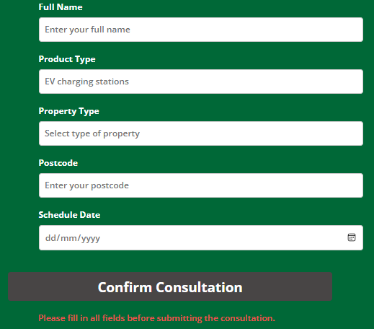 | Program worked as expected
Consultation Page: Input: Not Selecting Property Type  Validation testing, integration testing | (Erroneous Data)  No data submitted for property_type, no selection made for the property type input | System should not allow the property type selection to be the default (no property type selected) | System does not allow the product type to be empty, as it requires all inputs to be filled | System worked as expected
Consultation Page: Input: Spaces in Full Name  Validation testing, white box testing | (Erroneous Data)  full_name = “ “ | System should reject the input and display an error message saying full name cannot be empty or contain just spaces | System accepts the input as valid, and does not give an error message | Ensure the client/server does not accept just white space as a full name input
Consultation Page: Input Validation
Regression testing – ensuring previous issue with was fixed
Consultation Page: Submit Form: Products API Failure  Error handling, integration testing | (Erroneous Data)  product_id = “” | System should prevent submission of form when the product API fails. This is a error handling verification in case the products API fails or does not fetch correct data. Error message should appear | System prevents submission of form when the product API returns empty JSON table {}  Error message appears as expected | 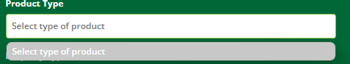  
Booking page: White box testing, Black box testing > Functional testing: Integration testing, Unit testing | No Data needed. Testing if all the buttons are functional, testing booking page unit, testing integration of booking page within the website.
Booking System: Test the room booking process. | Test Data: Normal: -Single - From 25/04/2024 To 28/04/2024 - Yes | If user is signed in than he/she can access the booking process, once the test data is entered, new record should be created in the room_bookings table in the database.
Booking System:  Test the ticket booking  process. | Test Data: -Double - From 29/04/2024 To 30/04/2024 - No
Regression testing.
Booking System: Test the room booking process. | Test Data: Normal: -Adult - Visit date: 05/06/2024 - Yes
Login page: White box testing, Black box testing > Functional testing: Integration testing, Unit testing | No Data needed. Testing if all the buttons are functional, testing login unit, testing integration of login page within the website.
Login system : Backend-> database testing In this test I will be testing validation and thus robustness of the system. | Invalid data: no data or error=emptyinput
Regression testing. Testing to see if the changes work. | Invalid data: no data or error=emptyinput
Login system : Backend-> database testing In this test I will be testing validation and thus robustness of the system | Invalid data(user does not exist): Jhon1234 7777
Regression testing | Invalid data(user does not exist): Jhon1234 7777
Login system : Backend-> database testing In this test I will be testing against valid data, to test if the user is actually logged in when correct credientils are entered | Valid data: anastasia1234 1234
Testing if logout button works | No data needed
Sign up page: White box testing, Black box testing -> Functional testing: Integration testing, Unit testing | No Data needed. Testing if all the buttons are functional, testing sign up unit, testing integration of sign up page within the website
Sign up system : Backend > database testing In this test I will be testing against invalid data so that we can see if the system catches the errors. | Invalid data: no data or error=emptyinput
Sign up system : Backend > database testing In this test I will be testing against invalid data so that we can see if the system catches the errors. | Invalid data (user already exists): anastasia1234 1234
Sign up system : Backend
> database testing
In this test I will be testing
against valid data to see if
the account is actually
created and the record is
added to the database
Regression testing

