Class05.R

Erica

Fri Jan 25 13:21:27 2019

#Class 5 Graphics and Plots

This is some narrative text that I can style **bold** or *italic* and add links [webpages](https://rmarkdown.rstudio.com/articles_report_from_r_script.html)

#Section 2A: line plot  
  
weight <- read.table("bimm143_05_rstats/weight_chart.txt", header = TRUE)  
plot(weight, pch=15, cex=1.5, lwd=2, ylim=c(2,10), xlab="Age (months)", ylab="Weight (kg)", main="Baby Weight")

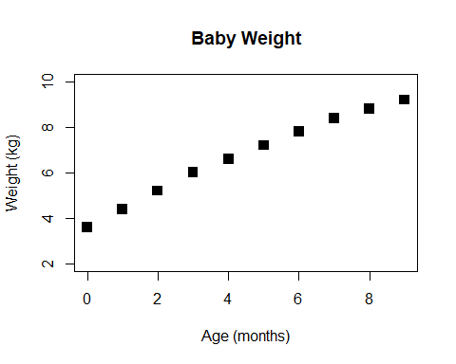

plot(weight, typ="o", pch=15, cex=1.5, lwd=2, ylim=c(2,10), col="magenta", xlab="Age (months)", ylab="Weight (kg)", main="Baby Weight")

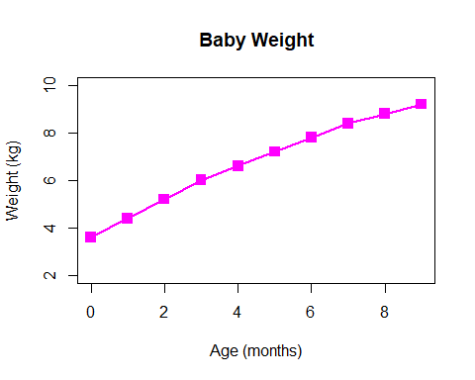

#Section 2B: Barplot  
  
feat <- read.table("bimm143_05_rstats/feature_counts.txt", header=T, sep="\t")  
par(mar=c(3, 11, 4, 2))  
barplot(feat$Count, horiz=T, ylab="Features", names.arg = feat$Feature, main="Mouse Features", las=1, xlim=c(0,80000))

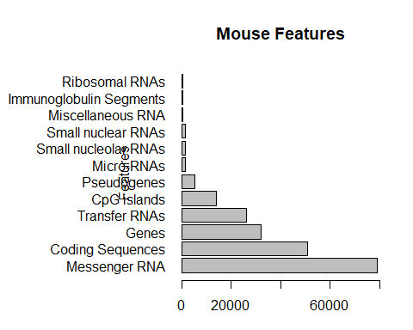

#Section 2C: Histograms  
  
tenthou <- c(rnorm(10000), rnorm(10000)+4)  
par(mar=c(3, 5, 4, 2))  
hist(tenthou, breaks=30)

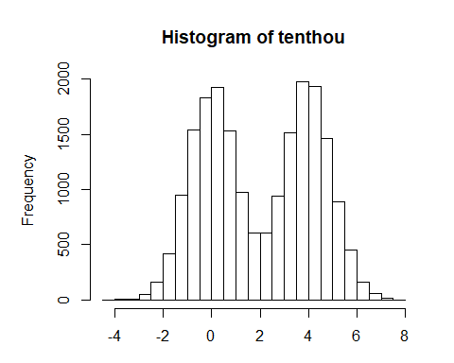

#Section 3A: Color  
mf <- read.table("bimm143_05_rstats/male_female_counts.txt", header=T, sep="\t")  
par(mar=c(6, 4, 4, 2))  
barplot(mf$Count, col=c("blue2", "red2"), main="Male and Female", ylim=c(0,20), names.arg=mf$Sample, las=2)

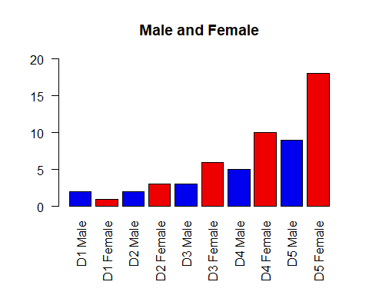

#Section 3B: Color by Value  
  
genes <- read.table("bimm143_05_rstats/up_down_expression.txt", header=T, sep="\t")  
table(genes$State)

##   
## down unchanging up   
## 72 4997 127

palette(c("magenta", "cyan", "yellow"))  
par(mar=c(5, 5, 4, 2))  
plot(genes$Condition1, genes$Condition2, col=genes$State, xlab="Condition 1", ylab="Condition 2", main="Gene Expression")

