Algorithm:

For this project I made a graph using 2 sets. One for the towns and Road. They served as a vertices and edges for the graphs respectively. Although the graph is not the most efficient implementation in terms of Big O, it has reduced logic complexity and is streamed line to avoid bugs and errors.

I also used Dijkstra short path for the past find algorithm. Dijkstra sets up the path and another recursive method called geteshortestpath gets the path. If the path is not found or is unreachable/disjointed it only returns the message and not the attempted path.

Experience and learning:

I ran into a problem after making the graph. The issues were with townmanager caused by using copies rather the town or road nodes already in the graph. I was able to fix it but in the future, I would probably use a hash table with linked lists to avoid this issue

Test cases:

Used MD cities .txt that was provided as the base graph. Screenshot below:

|  |  |  |  |
| --- | --- | --- | --- |
| INPUT | ACTUAL | EXPECTED | PASSED? |
| IMPORT THE MD CITIES | [Bethesda, Boyds, Clarksburg, Darnestown, Frederick, Gaithersburg, Germantown, Olney, Poolesville, Potomac, Rockville] | Bethesda, Boyds, Clarksburg, Darnestown, Frederick, Gaithersburg, Germantown, Olney, Poolesville, Potomac, Rockville | yes |
| Path form Rockville to Rockville | Error | error | yes |
| Path form Rockville to Frederick | Rockville via I270-SC to Gaithersburg 7 mi  Gaithersburg via I270-C to Germantown 6 mi  Germantown via I270-NC to Clarksburg 5 mi  Clarksburg via I270-N to Frederick 14 mi | Rockville via I270-SC to Gaithersburg 7 mi  Gaithersburg via I270-C to Germantown 6 mi  Germantown via I270-NC to Clarksburg 5 mi  Clarksburg via I270-N to Frederick 14 mi | yes |
| Path form Rockville to Frederick  After adding a new road called test with weight 1 between Rockville and frederick | Rockville via test to Frederick 1 mi | Rockville via test to Frederick 1 mi | yes |
| Add a new town called rajashow | Done | Done | yes |
| Check for a path to Rajashow form rockville | No such path found | No such path found | yes |
| Add a road between Gaithersburg and Rajashow with a weight of 100000 and named called home | Done | Done | yes |
| Get a path from Rajashow to gaitherburg | rajashow via home to Gaithersburg 100000 mi | rajashow via home to Gaithersburg 100000 mi | yes |
| Get a path from Rajashow to Rockville | rajashow via home to Gaithersburg 100000 mi  Gaithersburg via I270-SC to Rockville 7 mi | rajashow via home to Gaithersburg 100000 mi  Gaithersburg via I270-SC to Rockville 7 mi | yes |
| Path between Rockville and Gaithersburg | Gaithersburg via I270-SC to Rockville 7 mi | Gaithersburg via I270-SC to Rockville 7 mi | yes |
|  |  |  |  |

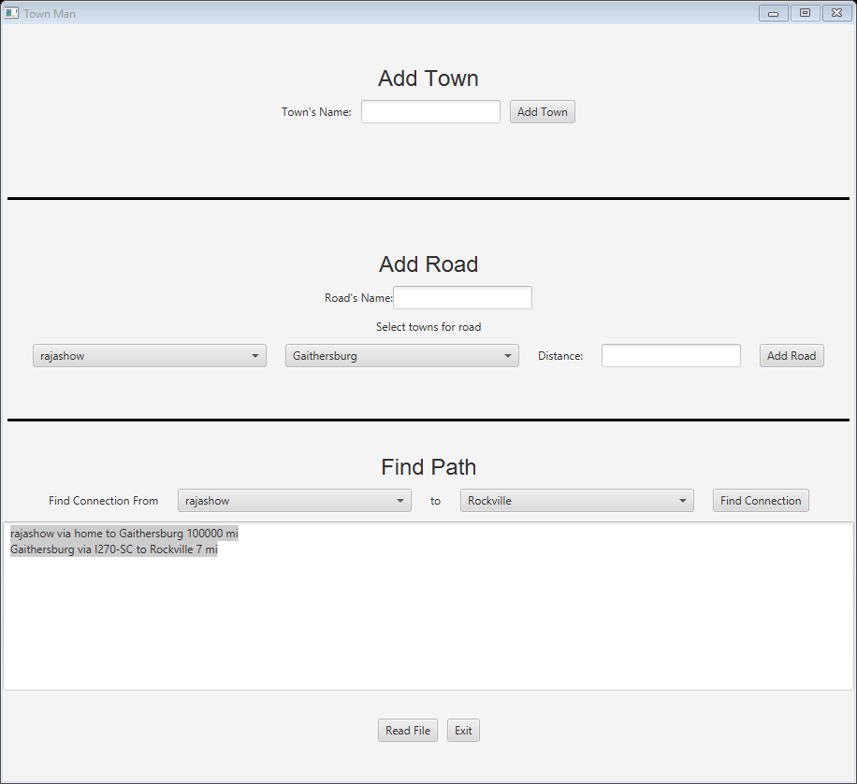

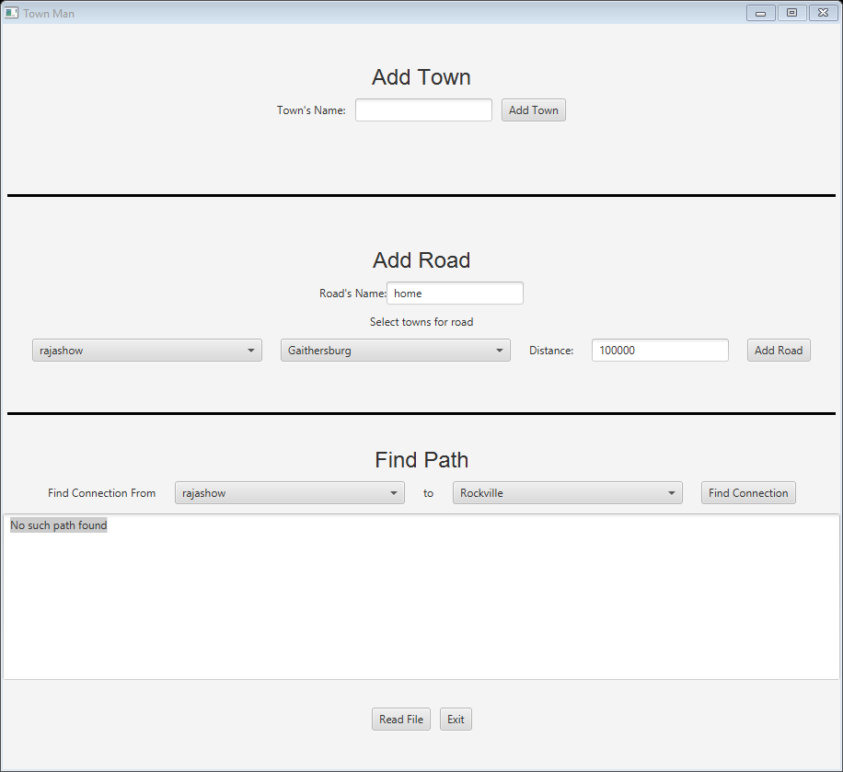

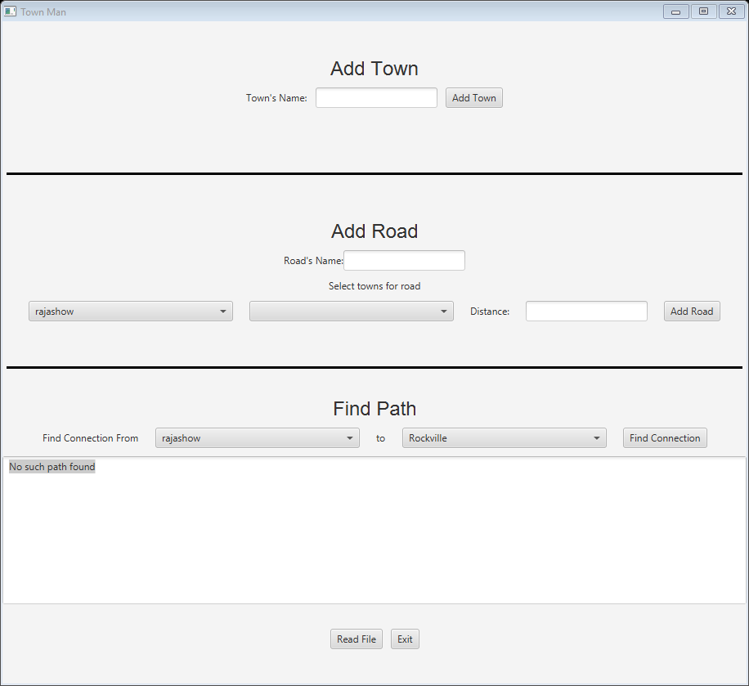

A screenshot of a social media post

Description generated with very high confidence