Abstract

1. **Trismegistos Places, a geographical index for all Latin inscriptions**

Verreth Herbert

Trismegistos Project, Katholieke Universiteit Leuven, Belgium

Email: Herbert.Verreth@arts.kuleuven.be

The Trismegistos database has recently created a geographical index for all Latin inscriptions. For the moment we have 67.820 geographical references attested in Latin documentary texts, but this rough starting material still has to be refined. This paper describes how we undertook this task, which problems we encountered while doing so, and the choices we made for the presentation of the material.

Keywords

Imperium Romanum, Latin, epigraphy, topography, geography, Trismegistos.

The Trismegistos (TM) database (http://www.trismegistos.org) of the Katholieke Universiteit Leuven in Belgium gathers the metadata for all documentary and literary texts from Egypt and the Ancient World in general written in whatever language or script between 800 BC and 800 AD. In this respect we try to collaborate as much as possible with other scientific databases all over the world. We started some ten years ago with the papyrological material from Egypt (both Greek and Egyptian), and the last few years - through the collaboration with EAGLE - we have also been incorporating Latin epigraphical texts from the whole Roman word. For the moment TM shows the metadata for 479.629 texts, 306.925 of them written in Latin or containing Latin passages, but the number keeps on growing. Our direct EAGLE partners Epigraphic Database Heidelberg (EDH), Epigraphic Database Roma (EDR), Hispania Epigraphica Online Database (HEp) and Epigraphic Database Bari (EDB) mainly focus on inscriptions on stone and other important texts from the regions they cover, but they usually omit the inscriptions and stamps on instrumentum domesticum or other minor materials. Since TM also wanted to incorporate these texts, we were glad to find them in the Epigraphik-Datenbank Clauss-Slaby (EDCS), which contains virtually all published Latin inscriptions, to fill in the missing gaps, a process which is still going on.

Trismegistos is a relational database created within the computer program Filemaker (with as latest version Filemaker Pro 14). Its contents are uploaded weekly to an online MySQL / PHP environment. Attached to the main TM Text file are numerous other files, such as Collections, Archives, People, Names and Places. These files automatically copy the relevant information for every card from the main file, so that no double work is needed. With the help of the Papyrological Navigator (PN) (http://www.papyri.info) we developed a PHP environment with the assistance of a programmer (Jeroen Clarysse), to tag all words starting with a capital occurring in the published papyrological texts, which yielded in the end a full index of all personal names and toponyms in every Greek and Latin papyrus. This process is nowadays called Named-Entity Recognition [NER][1]. These TM files within People and Places are freely accessible online and can be looked up, questioned and investigated in a number of ways. But that is a different story. Here we want to focus on our project to do the same for all published Latin inscriptions.

The main credits for the whole set-up of this new project go to Mark Depauw, the Trismegistos director. The general idea remained the tagging of all words starting with a capital, but this time Depauw tried a new approach, which was completely imbedded within Filemaker. Since the Roman 'tria nomina' hardly occur in the Greek papyri, also a new onomastical structure had to be devised for the automatic recognition. As a test case we choose the full text corpus of the EDCS. All these texts were 'cut up' in capital clusters, i.e. strings of consecutive words all starting with a capital. Words as filius, nepos and libertus were added to the string so that in most cases the full identification of a person could be grouped together, e.g. Quintus Caecilius Quinti filius Quirina Mustacus (TM 332260), Caio Annioleno Cai filio Arnensi Karthaginiensi Galliano (TM 349961) or Maesiaes Cai libertae Chrysidis (TM 244384). A minor disadvantage of this corpus was the capitalisation of the first word of every inscription (which is not done in the PN), which yields quite a significant number of mere nouns in the group of expected personal names and toponyms. Also other words starting with a capital were not our prime goal: names of gods, religious festivals, months, army units, ships, animals, mythological persons and Roman numbers. Excluded (for the moment) are also the names of the emperors and the members of the imperial family, often occurring in a complicated titulature which is not easy to standardise. In the end this yielded 898.134 capital cluster cards. From our previous projects we already had a fairly elaborated reference corpus of Roman personal names, which was now expanded and used by Depauw to match every word in the capital clusters with the names in the reference corpus. If there was a match, the case of the ending was added, e.g.

Caio Annioleno Cai filio Arnensi Karthaginiensi Galliano

dat dat gen filius tribus origo dat

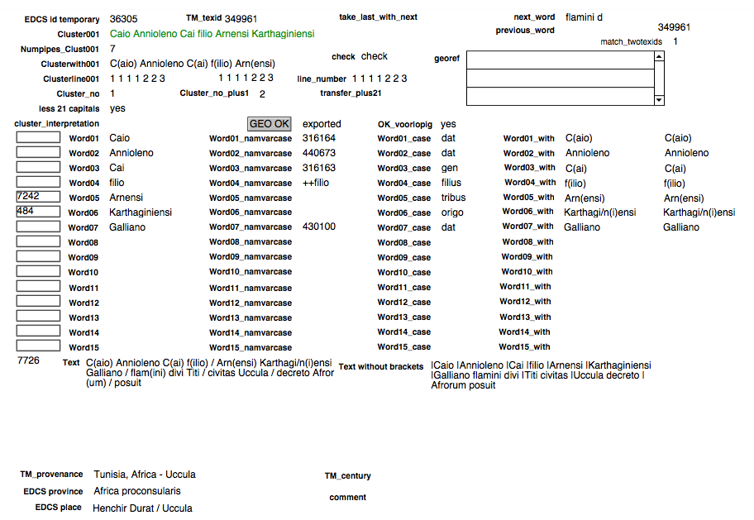

The technical details of this complicated process are better discussed by Depauw himself at some other occasion. On the basis of this matching all capital cluster cards were split up in two groups: (1) 'yes', this card contains a personal name [454.183], and (2) 'no', this card does not contain a personal name [443.951]. Within the second group also other labels have been added, e.g. army [23.201], god [15.663], emperor [41.944], which will be useful for future research.

This is also the phase where the toponyms come in (which can occur both in the first and in the second group). Within the EAGLE project we created already a fairly large reference corpus for toponyms from the Roman empire, but this corpus was enlarged by entering the toponyms occurring in the *Itinerarium provinciarum Antonini Augusti* [3.434] and the *Tabula Peutingeriana* [3.287]. The TM Geo file now contains 46.277 toponyms from all over Egypt and the Roman empire, both ancient and modern, which cover most of the places where ancient texts have been found, and most of the toponyms mentioned in Egyptian papyrological and Latin epigraphical sources.[2] We played with the idea of automatic matching, like we did for the personal names, but except for the case of the relatively straightforward tribus names, this yielded no satisfactory results. A lot of toponyms resemble personal names (e.g. Florentia, Venusia, (Fundus) Bassianus), and the automated identification of strings such as Colonia Ulpia Traiana Augusta Fidelis Lepcis Magna (TM 198383) or Municipium Augustum Hipponiensium Regiorum (TM 200133) seemed too cumbersome. In the end, we settled for plan B, which shows that in 'Digital Humanities', the human component is still essential: we had to go through all 900.000 capital cluster cards manually, identifying the toponyms in every cluster, adding the corresponding TM Geo number and - whenever necessary - correcting the indications for yes/no and the automatic identification of the cases of the personal names. It was six months of tedious work, resulting in 61.139 capital clusters with at least one toponym. No doubt some toponyms escaped our attention, but we do hope to have identified the majority of the names involved. In this process, however, we also encountered some set backs, especially in the longer texts and in the more complicated wooden or metal tablets: in the beta version on which we worked, the creation of the capital cluster strings was not always so perfect as we had hoped for, and also the line numbers automatically assigned to each cluster string have sometimes gone astray. Mark Depauw is developing a new and improved version, especially in preparation for the much larger batch of personal names, where it is virtually impossible to manually correct everything that has gone wrong. Due to these problems I guess that we now have about only 80 to 90 % of the toponyms occurring in all Latin inscriptions, but on the whole we are quite pleased with the result and in due time the remaining toponyms no doubt will find their way into the database also.

Phase 1, the identification of toponyms in the capital cluster strings, was finished in the beginning of July 2015, and we have now entered phase 2, the incorporation of the capital cluster file into the 'real' TM Georef file. For every place listed in TM Geo we try to list all the ancient text references where that place is attested. The file of these geographical references (TM Georef) is directly linked with the main TM Text file, so that every reference automatically receives a chronological and a geographical context. Every toponym found in the capital cluster file is exported to a separate Georef card. When a toponym exists out of several consecutive elements, like the colonia and municipium examples mentioned before, they are automatically grouped on one card. Twofold toponyms such as 'Bythina et Ponthus', which cannot belong to the same capital cluster string because of the intermediary 'et', are exported double and then afterwards joined manually. For the moment TM Georef lists 67.820 geographical references attested in Latin documentary texts and 10.474 references attested in Latin literary texts (but except for Egypt the latter have not yet systematically been entered). The Latin references make out almost 40 % of the total of 196.794 Georef cards.

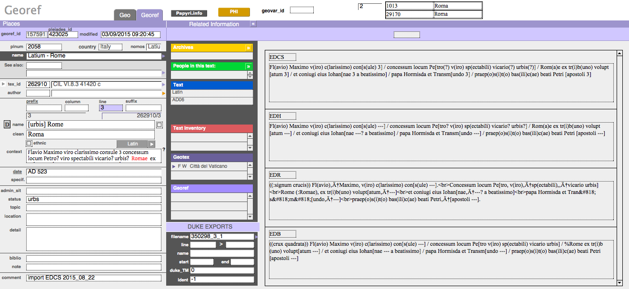

In this phase we also start comparing the reading of the toponym in EDCS with the readings of the same passage in EDH, EDR, HEp and EDB, which can all be shown simultaneously in the Filemaker database. In theory it is possible to automatically look for differences in readings among all these databases, but because each of them has its own approach, there will be so many small differences in line numbering, punctuation, the use of uncertainty dots and the way unconventional spelling in an inscription is indicated, that we doubt that there will be many exact matches. We therefore think that it will not be worth the enormous amount of work that it would involve. Human observation is again the answer and we do hope that our partners and the users of the geographical index will point out to us any mistakes we have made or obsolete readings we have kept. For the online version we have to talk with our partners whether they want to have their texts also shown on the TM page (like TM does for the texts from PN) or not. For the Open Access CC-0 texts in the Europeana EAGLE portal, this will in any case be implemented in the future. Anyway it is always possible to put a direct link on the Georef page to every partner that has the text in its corpus.

Since the users of TM must be able to look for specific spelling variants of each toponyms, all these references are presented the way they are on the stone, with as little additions or emendations as possible, except of course for any abbreviations at the end of the word; e.g. T(h)ra[c(um)] becomes Tra[c(um)], and Rom(a)e becomes Rome. In another field the standardized nominative case is given, without brackets or uncertainty dots; e.g. Trax and Roma.

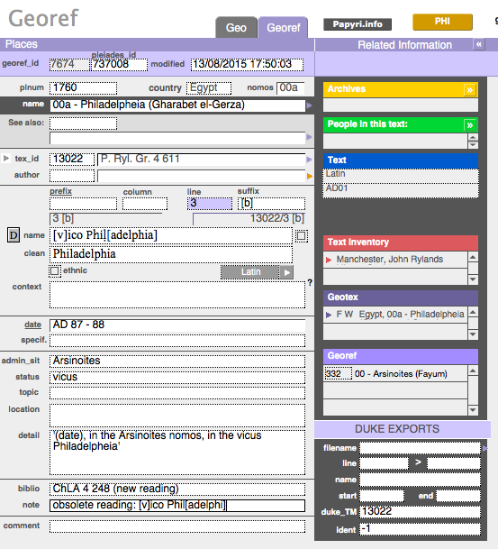

[Fig. 3]

For every text in TM we try to give a reference to the most authoritative edition, where the user can find the best and most up to date reading and interpretation of that text. As authoritative editions we preferably use CIL, *Année épigraphique* and more recent major editions such as RIB, ILAlg, ICUR or I. Alex. Imp. Any corrections to the reading of the toponym with regard to that edition are to be listed in the field Bibliography, while the obsolete reading is recorded in the field Note. If the correction comes from one of the online full text databases, we add a reference to the number of the text in that database.

A major problem is the dating of the texts. Unfortunately not every edition provides a date for each inscription. Even if the scholar who publishes the text, has a fairly good idea of the century or range of time to which the text might belong, it is not always mentioned explicitly in the edition. For every Latin text for which TM did not receive a date from its partners, we added the broad range of 199 BC till AD 799, hoping that this dating will become more refined in the future.

The third and final phase involves the context of the toponym. In the field Detail we give a plain translation of the immediate phrase to which the toponym belongs. The translation should be a standardised as possible, with termini technici preferably added in Latin, so that the users can easily search for them in the database; e.g. 'Tiberius Iulius Martialis son of Tiberius of (the tribus) Claudia from Savaria, soldier (miles) of legio XV Apollinaris', 'praefectus Aegypti', 'cohors I Tungrorum'. If the place is explicitly ascribed to a provincia or a region, this provincia is listed in the field 'Administrative situation'. If a town is explicitly called an oppidum, a vicus or a civitas, this information is listed in the field Status. By adding this information in searchable fields we hope that the user can start asking quite specific questions; e.g. the first and last attestation of a place in the sources; the periods in which a town was called a colonia or a municipium; the places in which the 'ala I Thracum Mauretana' has been attested.

TM is a relational database, which implies that is possible to get to the information from different angles. If someone is studying a certain text, he can get a list of all toponyms mentioned in that text. On the other hand, if someone is examining a certain place, he can find the list of all attestations for that place, in the order that he wants. In some cases a scholar can have very specific questions, which are difficult to search through the online TM search interface; it is quite well possible, however, that these questions can be easily answered in the more complex Filemaker structure we have at our disposal; just contact us and we will try to solve the problem for you.

We are aware that this is a very succinct presentation of the new and exciting developments in Trismegistos Places, but everybody interested is always more than welcome to ask for more information. Please feel free to provide us with any addenda or corrigenda to the database you might have.

1. For more information on NER, cf. Broux, Yanne - Depauw, Mark, *Developing onomastic gazetteers and prosopographies for the ancient world through named entity recognition and graph visualization: some examples from Trismegistos people*, in *2nd International workshop on computational history. 2. Barcelona, 11 November 2014* (*Lecture notes in computer science*, 8852), Berlin - Heidelberg, 2015, p. 304-313.
2. For more information on TM Geo, cf. Verreth, Herbert, *Topography of Egypt online*, in *Proceedings of the 27th International Congress of Papyrology in Warsaw, July-August 2013 (forthcoming).*