Abstract

1. AUGMENTING THE WORKSPACE OF EPIGRAPHISTS  
An interaction design study

Angelos Barmpoutis1, Eleni Bozia2

Digital Worlds Institute, University of Florida1

Department of Classics, University of Florida2

Email(s): angelos@digitalworlds.ufl.edu, bozia@ufl.edu

This paper presents the results of an interaction design study that focuses on the use of natural user interfaces for professionals in the fields of epigraphy and archaeology. This study proposes solutions for utilizing the sensors that can be found in popular handheld devices, such as tablets and smart phones, in order to naturally perform common tasks from the typical workflow of epigraphists. The developed interface allows the users to naturally hold digitized inscriptions, interact with them in order to relight or manipulate them as if they were real physical objects, and interact with metadata or other multi-modal data, such as text and images.

Keywords

Mobile Applications, Interaction Design, Natural User Interfaces, 3D models, Archaeology

1.1. Introduction

The technological advances in the last decade have equipped the general public with several handheld electronic commodities that changed significantly daily routine in a personal and professional level and contributed to the user's quality of life not only in developed countries but also in developing economies in Africa and Asia [Osman 2011]. Handheld devices, such as tablets and smart phones, not only connect the users with tremendous amount of information through the internet, but also offer interfaces for natural user interaction that enable non-technology-oriented populations to use computers intuitively.

In the fields of epigraphy and archaeology, the areas of digital epigraphy and computational archaeology have benefit from the use of several of the sensors available in hand-held devices. Crowd-sourcing of photographic data and geo-spatial information, augmented-reality navigation in archaeological spaces and museums, and 3D scanning of historical artifacts, using smart phones and tablet computers,, are few of the exemplar applications of hand-held sensors in epigraphy and archaeology. One common component in all the aforementioned applications is the ability to record tridimensional data either in the form of geo-spatial coordinates, or in the form of local 3D point coordinates needed for augmented-reality interaction, or for the construction of triangular meshes of 3D models.

There are several examples in literature that present 3D digitization projects that have been undertaken by museums including the Epigraphical Museum of Athens [Sullivan 2011, Papadaki et al. 2015], Museo Arqueológico Nacional de Madrid [Ramírez-Sánchez et al. 2014], Museo Nazionale Romano di Palazzo Altemps [Barmpoutis et al. 2015], Museo Geologico Giovanni Capellini di Bologna [Abate & Fanti 2014], National Museums Liverpool [Cooper et al. 2007], Smithsonian Institution [Wachowiak and Karas 2009], and several other museums and institutes [Gonizzi Barsanti and Guidi 2013, Landon and Seales 2006, Levoy et al. 2000].

Several novel methods for scanning, processing, and analyzing 3D models of inscriptions have been developed, including methods for text extraction from inscriptions [Aswatha et al. 2014, Sullivan 2011], accurate 3D scanning of inscriptions [Papadaki et al. 2015], visualization of inscriptions [Bozia et al. 2014], as well as 3D applications for other archaeological artifacts [Babeu 2011, Pollefeys et al. 2001, Malzbender et al. 2001, Esteban & Schmitt 2004]. Comparative studies of 3D scanning methods for cultural herirage can be found in [Pavlidis et al. 2007] and [Böhler & Marbs 2004].

The aforementioned examples show that the use of 3D technologies in epigraphy and archaeology has been a well-studied topic over the past two decades. However, there is a notable disconnect between the research on these technologies and the actual use in the professional epigraphic and archaeological practice as it has been hard for non-technology-oriented audiences to handle and manipulate tridimensional data, using conventional computer equipment. Furthermore, without mechanisms for proper user interaction, a 3D model that is projected on a 2D screen is not significantly advantageous compared to a set of 2D photographs.

The recent advances on Natural User Interfaces (NUI) along with their marketing as low-cost general-purpose devices (smart phones and tablets) have created a nurturing environment for integrating them in cultural heritage applications. Popular low-cost NUIs, such as touch screens, marker-less position trackers, motion sensors, and head-mounted displays have been recently studied and employed by museums as mechanisms for multi-sensory virtual experiences [Ujitok & Hirota 2015, Soile et al. 2013, Ikei et al. 2015].

This paper tries to fill the gap between the 3D technologies and their actual professional application in the field of epigraphy by proposing innovative uses of NUIs specially designed to serve epigraphists. This is, to the best of our knowledge, the first systematic interaction design study in the field of epigraphy. This study proposes solutions for utilizing the sensors that can be found in popular handheld devices to naturally perform common tasks from the typical workflow of epigraphists. The developed interface allows the users to naturally hold digitized inscriptions and interact with them in order to relight or manipulate them, as if they were real physical objects, and also interact with metadata or multi-modal data, such as text and images.

1.2. Understanding the workflow of epigraphists

Understanding the users is one of the integral steps of interaction design, which is an iterative process during which representative users interact with preliminary designs and provide useful feedback [Preece et al. 2015]. For the purposes of this study, our team interacted with early adopters of our prototype system, who were epigraphists and conservation specialists from Cornell University, the University of California, Berkeley, the University of Lyon 2, the Berlin-Bradenburg Academy of Sciences and Humanities, the U.K. National Archives, and the University of Florida. The goals of our interaction were twofold: a) to study the various forms of physical interaction that epigraphists have with an inscription as a real physical object and b) to expose epigraphists to a digital interface that imitates their interaction routine, using digital replicas of physical objects.

The first part of our study revealed 3 common types of interaction with the inscriptions as physical objects:

1. Change of point of view: Observation of the inscription from different viewing angles assists epigraphists understand better the shape of the inscribed letterforms.
2. Change of lighting conditions: Relighting the inscription by introducing artificial shadows or additional light sources from different angles may reveal details that were not legible in the original lighting conditions.
3. Magnification of inscribed details: Close observation of an inscribed region of interest, with or without artificial magnification, may assist epigraphists in assessing weathered fragments and make a better informed decision regarding the deciphering of the original text.

It should be noted that in addition to the above 3 types of interaction, there are two additional interactions that are special cases of I and II. More specifically, the physical object can be either portable (such as a small fragment of stone or other material) or not (when the inscription is on an inscription bearer). In the case of a handheld object, interactions I and II involve manual movement of the inscription with respect to the fixed observer (case I) or the fixed light source (case II), while in the case of large rigid objects the observer and the light source move with respect to the fixed inscription.

According to the above analysis, in the case of digitized inscriptions a NUI should provide the means for an epigraphist to "hold" the virtual object, "move" the point of view with respect to the virtual object, "manipulate" the virtual object with respect to the virtual light source, and "focus" on details of interest. The next section presents a NUI-based interaction design that proposes natural solutions to the aforementioned forms of interaction that seamlessly imitate the typical workflow of epigraphists.

1.3. Natural User Interface design for epigraphy

Natural User Interfaces consist of sensors that track the natural behavior of users and provide a natural form of interactivity with computers and other electronic devices. The common forms of NUI sensors are: pressure sensors for sensing touch gestures (e.g. touch screens and touch pads), motion sensors for sensing user-initiated changes in the orientation and acceleration of the device (e.g. accelerometer, gyroscope, and compass), and position sensors for tracking changes in the relative position of the user with respect to the device, such as body motions (e.g. Microsoft's Kinect), finger motions (e.g. Occipital's Leap Motion), eye movements, and others.

An optimal interaction design solution should be intuitive, minimalistic, and non intrusive [Preece et al. 2015]. Therefore, in order to design interaction for epigraphy one should choose devices that are easily accessible by epigraphists and do not interfere with their workspace (e.g. avoid introducing new devices or external sensors). All forms of interaction described in Sec. 1.2 can be implemented, using motion and pressure sensors, which can be easily found in tablet computers or smart phones. In both types of handheld devices the virtual object can also be assumed handheld, without loss of generality, in order to generate a multi-sensory experience for the user (i.e. holding the device = holding the digital inscription). Hence, NUI design is possible by utilizing accessible devices and without the use of external sensors as it is described in details in the following sections.

1.3.1. Natural interactive relighting of 3D models

In order to achieve natural interactive relighting of an inscription, the system should imitate the process of relighting a handheld physical object (such as a paper cast of inscription) by reorienting the object with respect to the light of the environment. Without loss of generality, we can assume that the default virtual lighting source is located on the ceiling, right above the device, which is also very intuitive choice as it is the most probable real-world lighting condition. Under this assumption, a gyroscope, a sensor that tracks the orientation of the device with respect to the gravitational vector, is enough to track the slope of the device with respect to the virtual light. The top row of Fig. 1.1 shows the approximated real-world orientation of a tablet computer as it was estimated using the gyroscope of the device. The orientation is updated in real-time as the user moves the device.

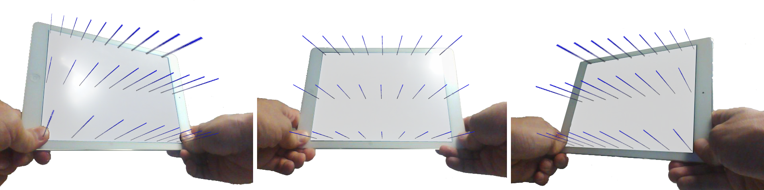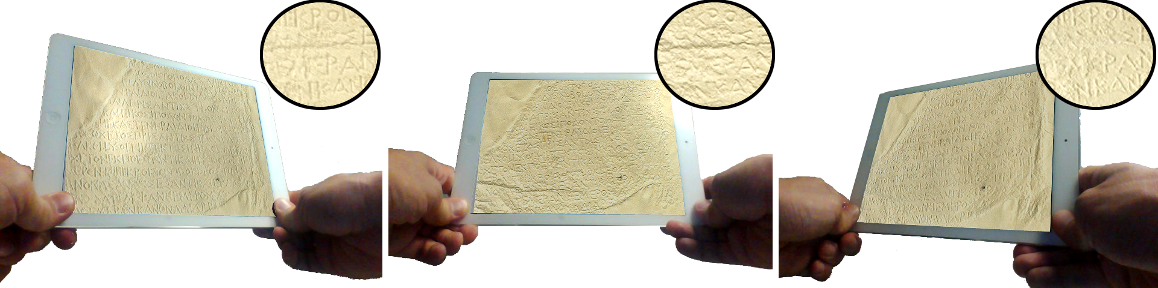

Fig. 1.1. Top row: Illustration of interactive manipulation of the virtual lighting by moving the device. The figures show the corresponding field of normal vectors in the 3D space as computed using the gyroscope of the device. Bottom row: Demonstration of interactive relighting of a 3D digitized inscription. Different virtual lighting angles reveal different inscribed details.

The estimated orientation of the device can be used in order to relight the depicted 3D model of inscription using the angle of the device with the direction of the virtual light source. The bottom row of Fig. 1.1 demonstrates interactive relighting of a digitized paper cast. Epigraphists can relight an inscription by reorienting the tablet as if it were a real physical object. This process matches perfectly with the physical interaction of epigraphists with real inscriptions and can be intuitively extrapolated to the case of 3D models of large inscriptions that were not handheld in the real world (see Fig. 1.3).

1.3.2. Natural interactive manipulation of 3D models

Another important form of interaction in the epigraphic routine is the change of the point of view in order to understand better the structural details of the inscribed letterforms. Assuming that the model of the inscription is parallel to the screen of the device, the change of point of view involves only change of the perspective projection of the digital object without any virtual rotation. In such case the rotation of the object is equivalent to the physical rotation of the device without any virtual rotation of the object.

Figure 1.2 shows 15 different projections of the same virtual cube that correspond to the change of perspective caused by moving the observer's head parallel to the screen. Note that all cubes are parallel to each other.

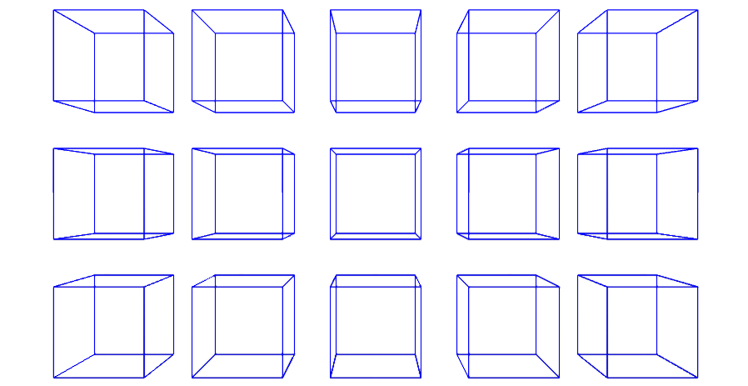

Fig. 1.2. Visualization of same-size boxes using 15 different perspective projections with the same FOV angle and different cropping parameters. None of the boxes is rotated in the space.

In the case of a tablet computer, the change of perspective can be implemented using the accelerometer of the device, which senses non-gravitational accelerations in the 3D space. With the logical assumptions that: a) the tablet is initially facing the user, and b) the user's eyes remain in a relatively fixed position in the 3D space (otherwise an eye-tracker should be required), the change of perspective can be realistically achieved by naturally reorienting the tablet as shown in the top row of Fig. 1.3. The superimposed boxes in this figure were estimated, using the accelerometer reading of the device for three different orientations of the tablet.

Interactive manipulation of a 3D digitized inscription bearer is shown in the bottom row of Fig. 1.3. Different sides of the bearer can be observed by reorienting the tablet naturally. In this example a large inscription model with its bearer was chosen in order to demonstrate that the proposed interaction design remains intuitive independently of the scale. It should also be noted that the interactive manipulation of the perspective can be optionally performed simultaneously with the interactive relighting as shown in Fig. 1.1 (bottom) in order to perform a more realistic interaction that causes relighting and change of point of view at the same time.

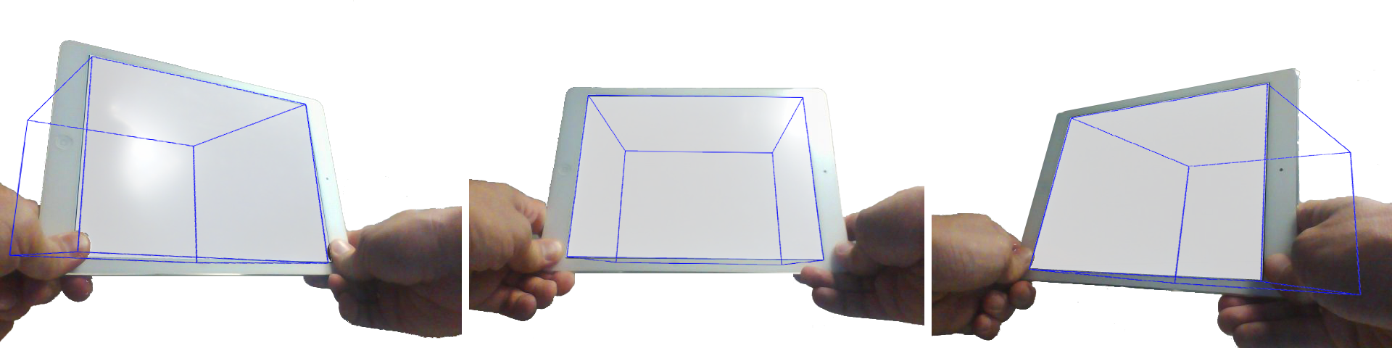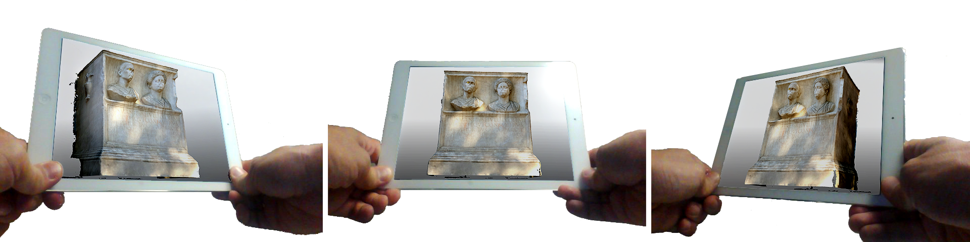

Fig. 1.3. Top row: Illustration of interactive manipulation of the perspective projection by moving the device and using the "fixed eye" assumption. Bottom row: Demonstration of interactive visual inspection of a 3D digitized inscription along with the inscription bearer. The user can view the object from different perspectives, using natural motions.

1.3.3. "Touching" the metadata: Interacting with multi-modal data

The forms of interactions presented in 1.3.1 and 1.3.2 involved only the motion sensors of a tabled computer without utilizing the pressure sensors of the screen of the device. The commonly used touch gestures (such as 2-finger twist to rotate, 2-finger pinch to zoom, and 2-finger translate to move) can be employed in order to enhance the proposed NUI design. In addition to the aforementioned gestures, a tap gesture could activate regions of interest with additional modalities of information such as text, images, and metadata. The user can interactively browse the different forms of data by using intuitive touch gestures as shown in Fig. 1.4. This set of 2D interactions along with the 3D NUI design presented earlier can compose an intuitive yet powerful workspace for an epigraphist who can now perform digitally several parts of the epigraphic workflow.

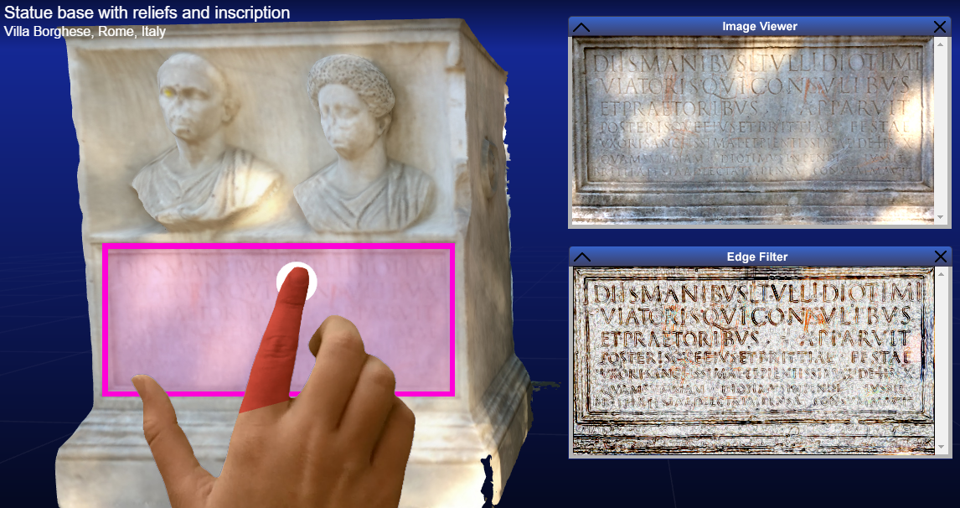

Fig. 1.4. Screenshot of our interactive environment. The user interacts with the 3D object, using touch gestures and selects one of the regions of interests. This action initiates other data tools such as the image viewer or the edge filter as shown in this example.

1.3. Conclusions and future directions

In this pilot study, a complete set of natural user interactions was designed based on the physical interactions of epigraphists with real inscriptions. The proposed interactions utilize the existing sensors in a typical tablet computer or smart phone in order to interactively relight a digitized inscription and manipulate the user's perspective, using a set of intuitive gestures that imitate the natural interaction with a physical object. In the proposed design, the epigraphist can "hold" a digital inscription, relight it by reorienting it as a tangible object, observe it from different perspectives, and finally interact with other modalities by following a set of 2D touch gestures. The prototype system was developed as part of the Digital Epigraphy and Archaeology (DEA) project using the open-source library VisiNeat for 3D visualization and interaction and is compatible with iOS, Android, and Microsoft RT tablet and smart phone devices. The interface is available through the web-site of the project: http://www.digitalepigraphy.org

In the future we plan to quantitatively evaluate the designed interface by tracking the user activities and analyze their motion patterns in the 3D space while they are interacting with their handheld device.

Bibliography

Abate, D., & Fanti, F. (2014). *La valorizzazione digitale del Museo Geologico Giovanni Capellini di Bologna.* Archeomatica, 5(1).

Aswatha, S. M., Talla, A. N., Mukhopadhyay, J., & Bhowmick, P. (2014). *A Method for Extracting Text from Stone Inscriptions Using Character Spotting*. In ACCV 2014 Workshops, 598-611.

Babeu, A. (2011). "*Rome Wasn't Digitized in a Day": Building a Cyberinfrastructure for Digital Classics.* Council on Library and Information Resources.

Barmpoutis, A., Bozia, E., & Fortuna, D. (2015)*. Interactive 3D Digitization, Retrieval, and Analysis of Ancient Sculptures, Using Infrared Depth Sensors for Mobile Devices.* In Universal Access in Human-Computer Interaction. Access to the Human Environment and Culture, 3-11.

Böhler, W., & Marbs, A. (2004). *3D scanning and photogrammetry for heritage recording: a comparison.* In Proceedings of the 12th International Conference on Geoinformatics, 291-298.

Bozia, E., Barmpoutis, A., & Wagman, R. (2014). *Open-Access Epigraphy: Electronic Dissemination of 3D-digitized Archaeological Material.* In Proceedings of the International Conference on Information Technologies for Epigraphy and Digital Cultural Heritage in the Ancient World, 421-435.

Cooper, M., La Pens´ee, A., and Bryan, P. (2007). *Chiswick House, London: Laser scanning tests on a gilded 18th century table.* English Heritage Research Department Series Report 19/2007. Swindon, England: Historic Buildings and Monuments Commission for England.

Esteban, C. H., & Schmitt, F. (2004). *Silhouette and stereo fusion for 3D object modeling*. Computer Vision and Image Understanding, 96(3), 367-392.

Gonizzi Barsanti, S. and Guidi, G. (2013). *3D digitization of museum content within the 3D icons project*. ISPRS Annals of Photogrammetry, Remote Sensing and Spatial Information Sciences, II-5/W1, 151–156.

Ikei, Y., Shimabukuro, S., Kato, S., Komase, K., Hirota, K., Amemiya, T., & Kitazaki, M. (2015). *Experience Simulator for the Digital Museum*. In Human Interface and the Management of Information. Information and Knowledge in Context, 436-446.

Landon, G. V. and Seales, W. B. (2006). *Petroglyph digitization:enabling cultural heritage scholarship.* Machine Vision and Applications, 17, 361–371.

Levoy, M. et al. (2000). *The digital Michelangelo project: 3D scanning of large statues*. In Procedings of the SIGGRAPH.

Malzbender, T., Gelb, D., and Wolters, H. (2001). *Polynomial texture maps*. In Computer Graphics, In Proceedings of ACM Siggraph.

Osman, M. A., Talib, A. Z., Sanusi, Z. A., Yen, T. S., & Alwi, A. S. (2011). *An exploratory study on the trend of smartphone usage in a developing country*. Digital enterprise and information systems, 387-396.

Papadaki, A. I., Agrafiotis, P., Georgopoulos, A., & Prignitz, S. (2015). *Accurate 3d Scanning of Damaged Ancient Greek Inscriptions for Revealing Weathered Letters*. International Archives of Photogrammetry, Remote Sensing and Spatial Information Sciences, 1, 237-243.

Pavlidis, G., Koutsoudis, A., Arnaoutoglou, F., Tsioukas, V., & Chamzas, C. (2007). *Methods for 3D digitization of cultural heritage.* Journal of cultural heritage, 8(1), 93-98.

Pollefeys, M., Van Gool, L. J., Vergauwen, M., Cornelis, K., Verbiest, F., and Tops, J. (2001). *Image-based 3D acquisition of archaeological heritage and applications.* In Proceedings of the 2001 conference on Virtual reality, archeology, and cultural heritage, 255–262.

Preece, J., Sharp, H., & Rogers, Y. (2015). *Interaction Design beyond human-computer interaction*. John Wiley & Sons.

Ramírez-Sánchez, M., Suárez-Rivero, J. P., & Castellano-Hernández, M. Á. (2014). *Epigrafía digital: tecnología 3D de bajo coste para la digitalización de inscripciones y su acceso desde ordenadores y dispositivos móviles.* El profesional de la información, 23(5), 467-474.

Soile, S., Adam, K., Ioannidis, C. and Georgopoulos, A. (2013). *Accurate 3d textured models of vessels for the improvement of the educational tools of a museum*. ISPRS-International Archives of the Photogrammetry, Remote Sensing and Spatial Information Sciences, 1(1), 211–217.

Sullivan, S. M. (2011). *Analytical methods for the extraction of content from high resolution 3D data sets: Epigraphical applications to the Drakon Stele.* Doctoral dissertation, University of Arkansas.

Ujitoko, Y., & Hirota, K. (2015). *Application of the Locomotion Interface Using Anthropomorphic Finger Motion.* In Human Interface and the Management of Information. Information and Knowledge in Context, 666-674.

Wachowiak, M. J. and Karas, B. V. (2009). *3D scanning and replication for museum and cultural heritage applications*. Journal of the American Institute for Conservation, 48(2), 141–158.

Acknowledgement

We would like to acknowledge our collaborators for their invaluable interaction and feedback during the past three years. We would also like to thank the UF College of the Arts and the UF Center for Greek Studies for providing continuous funding support for this project.