1.1. Introduction

Our project is working with informal, handwritten wall-inscriptions, or ancient graffiti, which were scratched into the wall-plaster of ancient towns. Several hundred of these handwritten inscriptions have been documented at Herculaneum and more than 6000 are known from Pompeii. We are contributing these inscriptions to the Epigraphic Database Roma (www.edr-edr.it), and are creating a linked resource, the Ancient Graffiti Project (ancientgraffiti.wlu.edu), that will allow users to conduct location-specific searches for graffiti.

Among the many texts written on the walls of these two cities, there sometimes also appear graffiti drawings, or figural graffiti **[Fig. 1]**.

**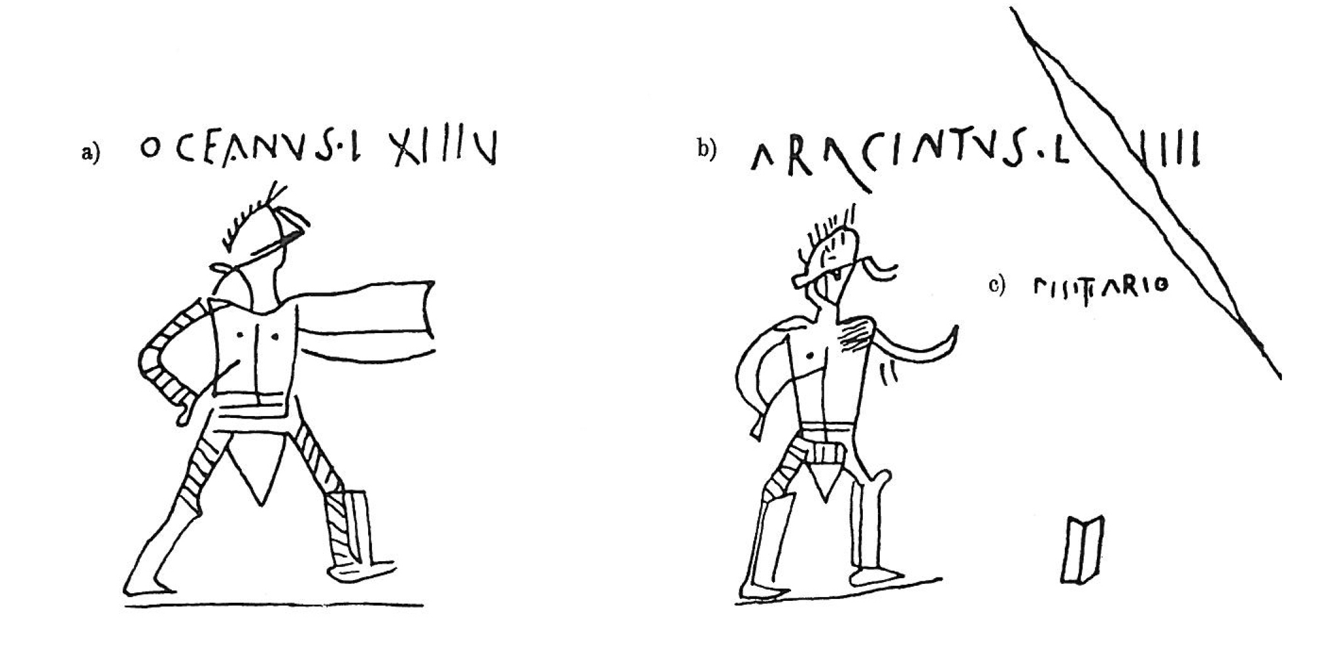  
Fig. 1** Graffito from Pompeii [*CIL* 4, 5215]

This graffito depicts a pair of gladiators, where the two figures are identified with their names and the number of their victories. The inscription therefore includes both text and image. It was much more common in Pompeii for someone to write a message on a wall than to sketch a drawing: people wrote their names, greetings to friends, quotations of literature, and other types of messages. However, we do find a smaller, but not insignificant number of drawings also inscribed on the wall plaster throughout the town. It is very rare to find a large scene, like the illustration of a gladiatorial contest with athletes, musicians, and perhaps magistrates, sketched by hand on a funerary monument just outside the Porta Nocera of Pompeii (*CIL* 4, 10237; D31 in Cooley and Cooley 2014; cf. also *CIL* 4, 10236 and 10238 drawn nearby). More commonly, people made small sketches on the walls around them choosing from roughly a handful of popular designs: heads in profile, boats, gladiators, birds, and geometric designs (Langner 2001).

Figural graffiti have provided us with several challenges as we digitize them for the Epigraphic Database Roma and as we design a way to search for and retrieve such drawings via the Ancient Graffiti Project search engine. In this paper we will discuss the challenges we face and some of the strategies we have developed in response.

2. Our Material

First, a little background on figural graffiti and our sources for this data. In Herculaneum, we are fortunate that a significant number of graffiti are still extant and *in situ*, as roofing has been reconstructed for many buildings to protect them from the elements. Due to the fragile nature of wall plaster, however, especially in Pompeii, many graffiti that were recorded previously and published in *CIL* 4, have now been lost. Much of our data, therefore, comes from verbal descriptions of graffiti that have since disappeared. Furthermore, the different editors of *CIL* 4 and its supplements used different methods to denote that a drawing was present, and their practices changed over time. Working with this legacy data, therefore, presents a range of difficulties.

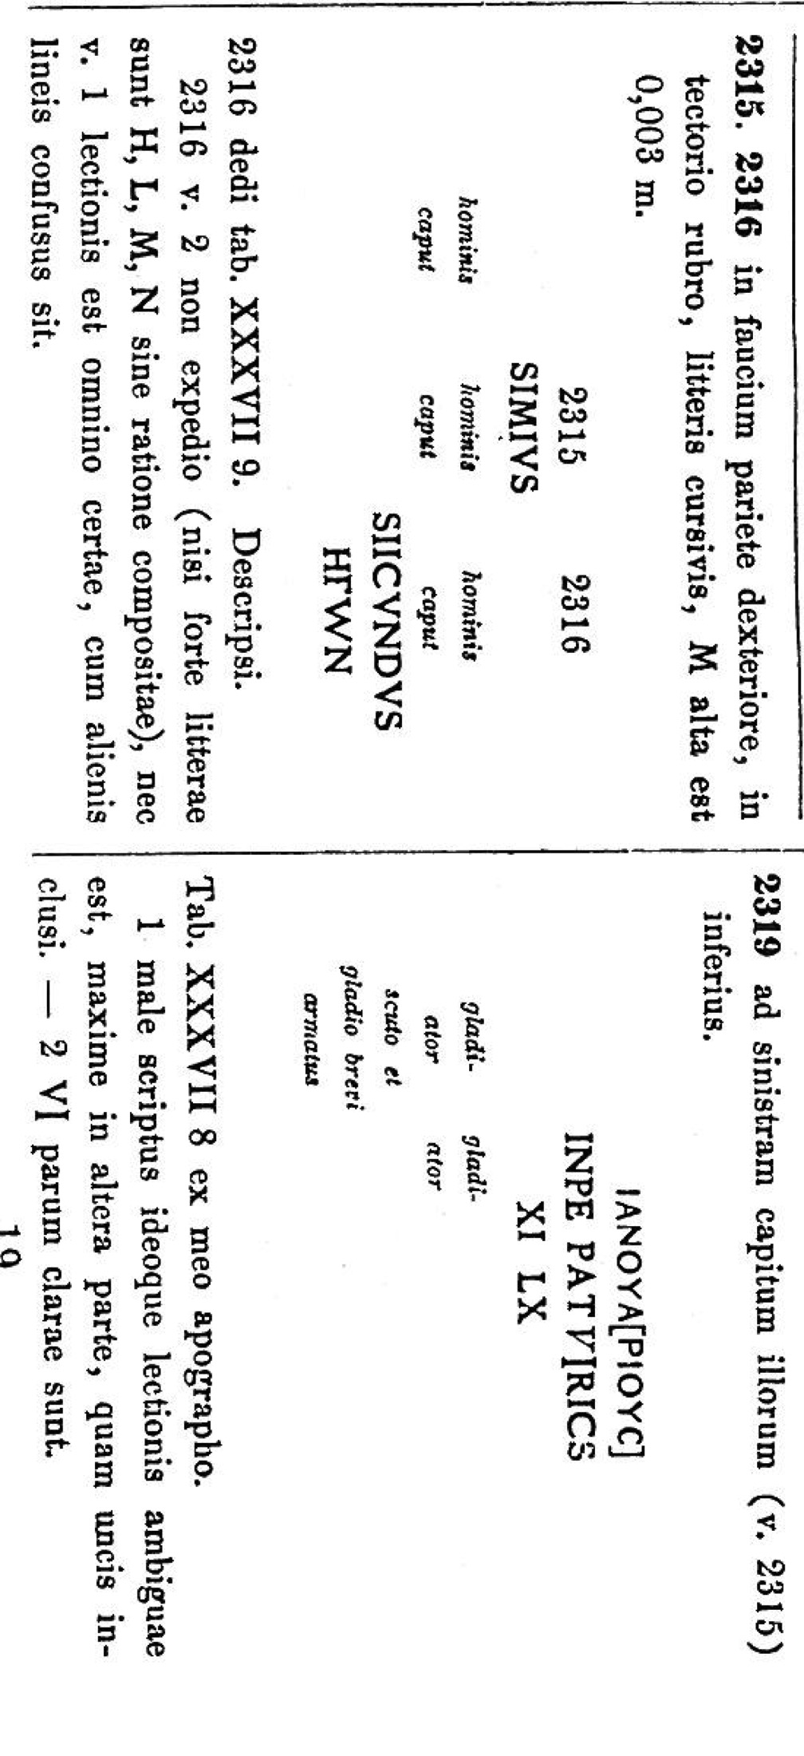**2.1 Verbal Descriptions of Figural Graffiti Found With Text**

A drawing could, for example, be described in the text field of an entry in *CIL* 4. This occurs in the entries below, where three drawings of human heads [*CIL* 4, 2315-2316] and two drawings of gladiators [*CIL* 4, 2319] are described in small italics, placed where the images occur alongside the textual inscriptions **[Fig. 2]**.

**Fig. 2** The entries of *CIL* 4, 2315-2316 and 2319, representing figural graffiti via brief description

The italics make clear that those descriptions are not part of the texts of the inscriptions themselves, which are represented in capital letters.

This practice is common in the original volume of *CIL* 4, when it seems that the editors documented textual and figural graffiti that were in close proximity, or that were in some way related to each other. In later supplements, line-drawings for figural graffiti were sometimes included when the drawings and text were obviously understood as one inscription, as shown in Fig. 1 above. Perhaps due to the complications with preparing and printing such illustrations, however, it also remained common practice to represent figural graffiti with very brief description in italics (e.g. *CIL* 4, 4822, 4823, 5264, 5275, 6624, 6672, 6889).

**2.2 Figural Graffiti described in notes or apparatus**

The most common strategy, however, for documenting figural graffiti in *CIL* 4 is by including brief mention of a drawing in the editorial note that introduces a graffito or in the apparatus that follows it **[Fig. 3]**.

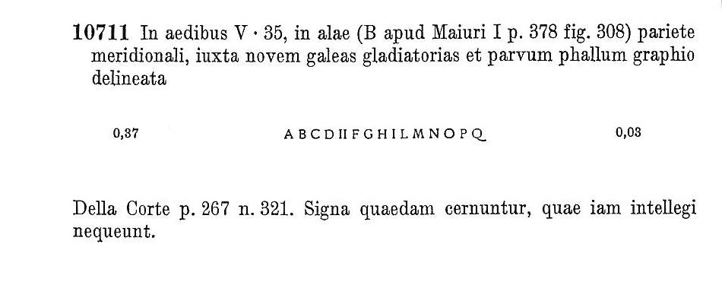

**Fig. 3** *CIL* entry for an alphabet near figural graffiti [*CIL* 4, 10711]

Note that the editorial note above the entry mentions drawings nearby (*novem galeas gladiatorias et parvum phallum*), but the text is presented without illustration. This mode becomes more common in the fascicles of *CIL* 4 produced in the later twentieth century and so the figural graffiti from Herculaneum are usually represented this way (cf. *CIL* 4, 10532, 10568, 10586).

**2.3 Figural graffiti omitted by *CIL***

A fourth possibility exists as well, namely, when figural graffiti were not even mentioned in *CIL*. In each of the previous scenarios, the editors of *CIL* include a description of a figural graffito when it was close to a textual inscription. In contrast, figural graffiti found in isolation tended to be excluded altogether due to the focus of the *Corpus* on text. Fortunately there is now a useful resource devoted to figural graffiti: Martin Langner’s *Antike Graffitizeichnungen*, a monograph and accompanying database of figural graffiti from across the Mediterranean. His catalog includes some 600 graffiti drawings from Pompeii and 60 from Herculaneum, including 200 that are not mentioned in *CIL*.In addition, whenever possible, Langner will provide a line-drawing of the graffito, either his own or one found in an earlier source; therefore, his database includes many line drawings that are not included in *CIL* even when a drawing is described. However, certain motifs are omitted from Langner’s catalog. While he does catalog the more interesting *Phalluskopfen* examples, he generally omits simple drawings of *phalli*. He also leaves aside the decorative elements of *coronae* and *palmae*, which are sometimes mentioned in *CIL*. This means that an accurate total of all figural graffiti in Pompeii and Herculaneum can only be reached by working through the collections of both Langner and *CIL*. To create the most comprehensive resource possible for figural graffiti, we include *all* known drawings in the AGP search engine.

**2.4 Documenting extant figural graffiti**

Since the verbal descriptions of figural graffiti provided by legacy data are limited and vague or exceedingly general (e.g. *caput*), the best circumstance under which to digitize a graffito is when the drawing itself still remains extant. In such cases, we will use any published data as a starting point, but we are also able to make our own editorial decisions about the subject matter of the drawing, how to describe it, and its relation to any text that is nearby. The material with which we are working, therefore, includes a range of different information about the figural graffiti of Pompeii and Herculaneum: from brief verbal descriptions to line-drawings, to the best case scenario when an inscription is still extant.

3.1 Challenges in working with text and images

Several challenges, therefore, arise when making decisions about how to edit and digitize figural graffiti. These can depend on how a drawing may or may not relate to a textual graffito, whether or not a drawing is extant, and how to interpret and standardize legacy data.

Three of our main questions are:

1. **How to define an entry?** (Where for example does one entry stop and another begin? Do we catalog series or clusters of graffiti, or individual images? How do we account for or represent the larger context?)
2. **How to describea drawing?** (Here, there arise issues both of standardization and of interpretation, or over interpretation.)
3. **How can we make drawings searchable?** (Ideally, we would like to make it possible for users both to browse and to locate specific images.)

**3.2 How to define an epigraphic entry?**

One of the first challenges we face in working with figural graffiti is deciding how to define an entry, that is, to consider whether or not multiple elements should be part of the same EDR record or should be given separate entries. First, we must ask: *can we be assured* that certain elements were meant to be understood together? There might be an issue of accretion or accumulation, where additional graffiti have been added subsequently. A related challenge is then, if we create individual entries for separate elements, how do we avoid losing information about the relationship among the graffiti? This collection of drawings including six textual graffiti illustrates our challenge **[Fig. 4]**.

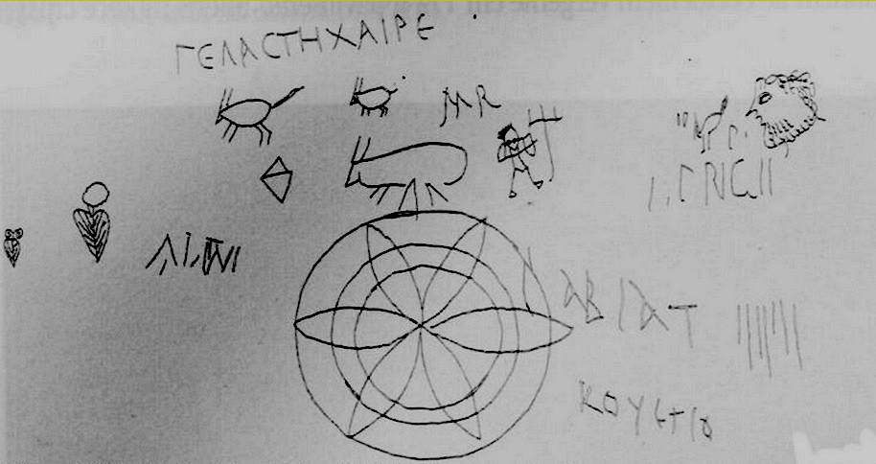

**Fig. 4** Line-drawing displaying a collection of textual and figural graffiti [*CIL* 4, 8383-8386; EDR148730]; unpublished sketch of Matteo Della Corte from the archives of the *Corpus Inscriptionum Latinarum* at the Berlin-Brandenburg Academy of Science and Humanities.

You can see a number of different images here including a small gladiator with trident, a face in profile, leaves, several animals, and geometric shapes as well as the name “Atini” and the greeting “Γελαστὴ χαῖρε.” Such a collection raises many interpretive questions. What is the relationship, if any, between the figural and the textual graffiti? How should that relationship be best represented? Fortunately, we have available with this sketch an overall view of the spatial relationships of this group of graffiti. Because the *CIL* entries are focused on text, the figural graffiti are associated with and described in the entry of nearby textual inscriptions. For this cluster, we have decided, instead, to give each element on the wall a unique identifier. First, it is not clear that the texts are clearly linked to any of the drawings. Secondly, if we create individual entries, the field for measurements in EDR permits us to give the measurements for each individual element. Thirdly, EDR has provided an additional solution to the issue of representing context with the use of hyperlinks to other nearby inscriptions, created by including EDR record numbers in the apparatus field. Additionally, we have decided to upload a series of images to EDR, including detail illustrations and the composite sketch of all graffiti, to give the context of the entire cluster and the relationship of the graffiti to each other.

In an example from Herculaneum (Fig. 3, above), the entry for *CIL* 4, 10711 notes that in addition to a graffito of the alphabet, a series of nine gladiator helmets and a small phallus were also drawn on the wall.During our field season in Herculaneum in 2014, we were not successful in finding the graffiti of the alphabet or small phallus, but we did locate eight of the nine helmets. Here too we have devoted a separate database entry for each helmet. By making individual records, we have a unique identifier for each image, in the form of the EDR number, so that users can cite a *specific* parallel precisely**.** Again, we can record the precise measurements for each image. Yet, since separating each image can obscure how the images relate to one another in the group, as with the previous example, we also upload to EDR an overall image of the group of helmets together for every individual entry (cf. EDR143634).

In these two cases, we are fortunate to have contextual data that informs our understanding of how text and image may relate. More often, we are left with only legacy data, with brief mention of a figural graffito in the apparatus of a *CIL* entry and without illustration. Yet, proximity does not always indicate a relationship between the text and image. Indeed, there may be no relationship at all between the figural and textual graffiti; therefore, putting the two graffiti in the same EDR record may suggest a relationship where none exists. Given these circumstances, we prefer to create separate EDR entries for the text and the image and to use the EDR hyperlinks to note that each is found near the other.

**3.3.1 How to describe drawings?**

A second challenge occurswhen we must decide how much interpretation to offer when we describe a graffito for a database entry. When *CIL* has included mention of a drawing, we generally incorporate that description directly into our entry. With figural graffiti documented by Martin Langner, we must create a summary in Latin and when doing so, we attempt to give as full as possible a description of the elements of the image.With this camel (Langner 2001, n. 1443), for instance, we offer a full description in Latin that accounts for all the features of the drawing: *camelus dromedarius cum cauda, lodicem gerens, ad dextram incedens* **[Fig. 5].**

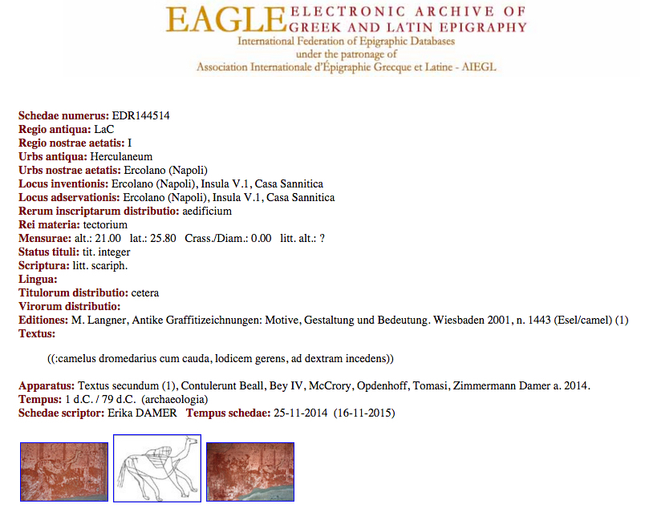

**Fig. 5** Example of an entry for a figural graffito not found in *CIL* (EDR144514)

**3.3.2 Questions of interpretation through description**

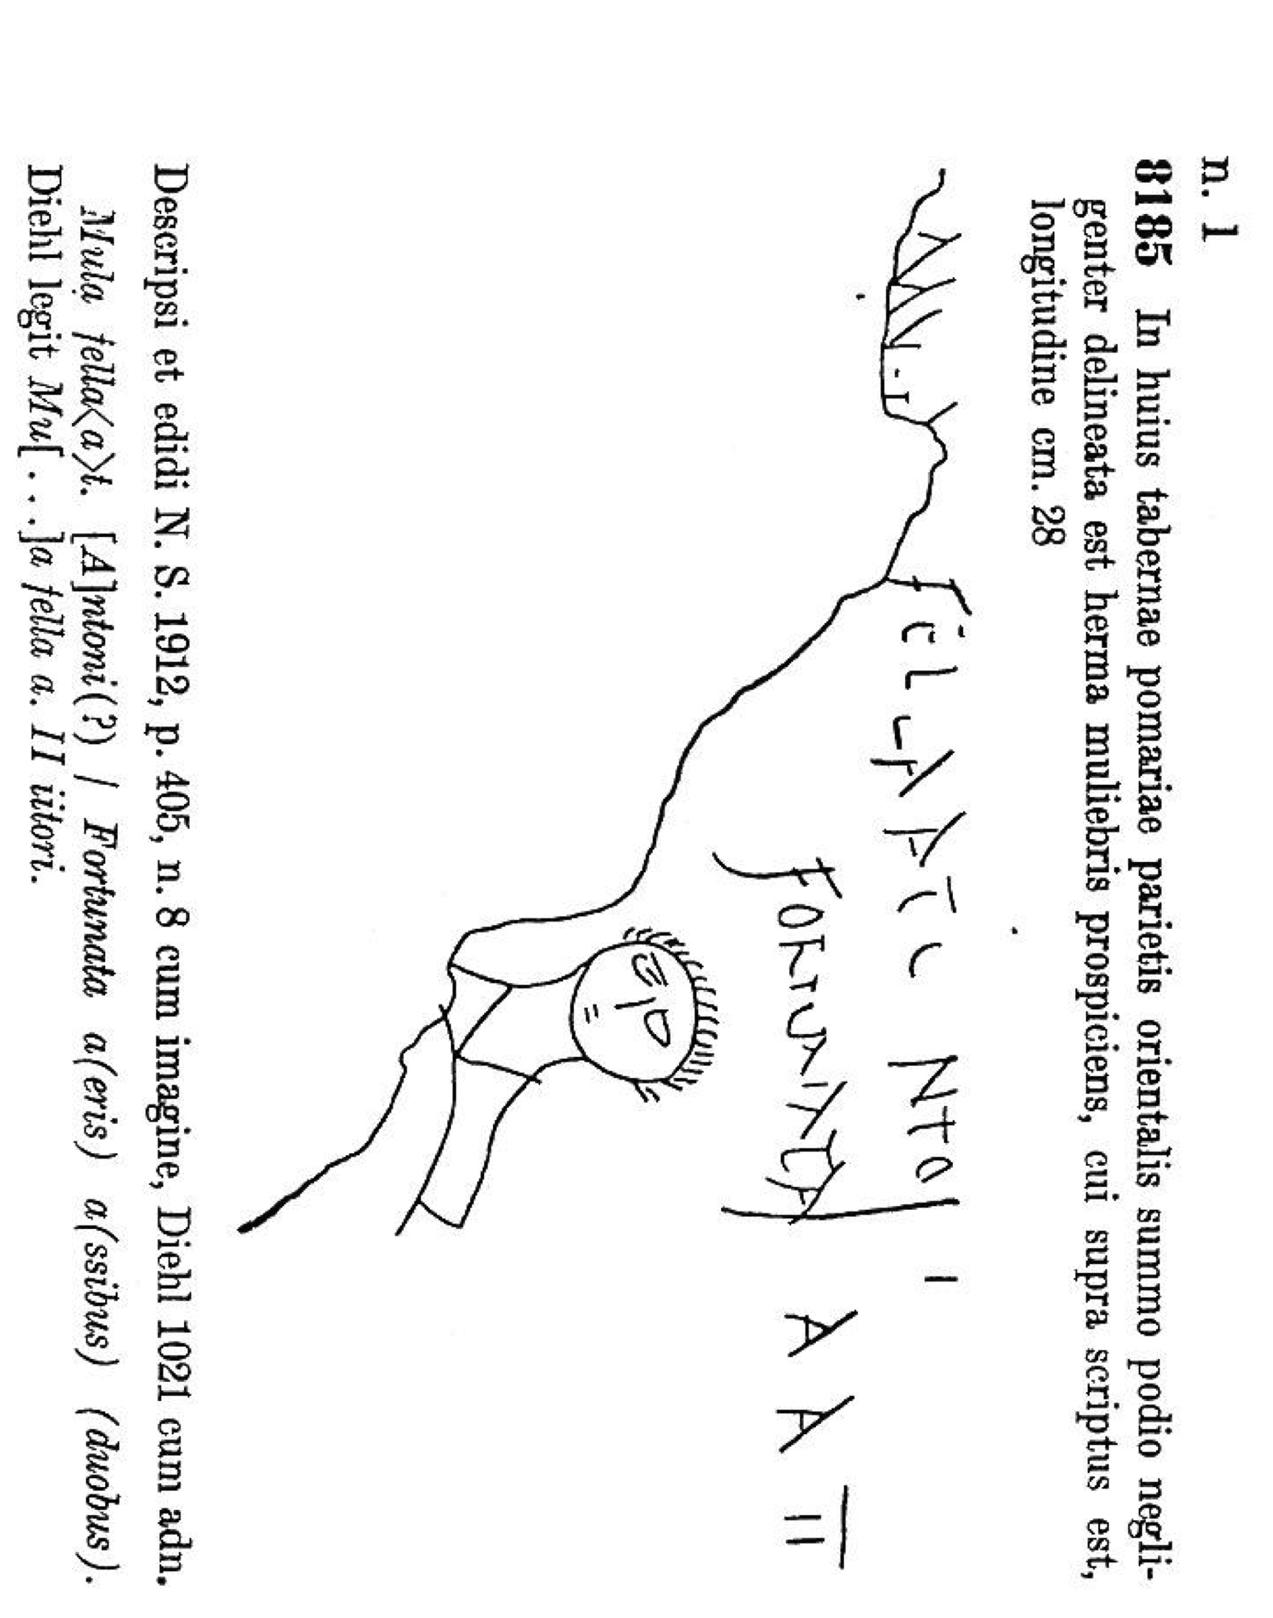As one might imagine, issues of interpretation can arise even with simple descriptions of images. In truth, we have encountered more difficulties with interpretation in the case of drawings that have been described by *CIL*. The first example comes from a shop in Pompeii and represents text and a drawing [*CIL* 4, 8185]. The plaster has clearly broken off, so we do not know if this was part of a larger scene. What remains are two lines of text and just one figure, which would seem to be a drawing of a person facing forward and rendered with head and shoulders. *CIL* describes it thus: *herma muliebris prospiciens* **[Fig. 6]**.

**Fig. 6** *CIL* entry for textual and figural graffiti [*CIL* 4, 8185]

Is this drawing clearly depicting a female? It is difficult to argue from either the hairstyle or the clothing that the figure is female. Here, we can only assume that the editors of *CIL* identified the image as female because the text above mentions the female name Fortunata. But are we sure the image is meant to illustrate the text? Or that the image and text are meant to be read together? Since the figure is clearly not enacting the verb of the text, could this be either Fortunata or Antonius?

The head of a woman, described with a textual graffito from the Suburban Baths in Herculaneum [*CIL* 4, 10676], raises similar problems with verbal descriptions of figural graffiti.In this case, *CIL* does not reproduce an image of the sketch; it only notes that the four-line inscription of *CIL* 4, 10676 appears below a drawing of a female (*infra mulieris imaginem*). In this instance, too, the text nearby includes two names, one female and one male. The drawing has appeared in multiple publications (Della Corte 1960, Deiss 1989, Maulucci 1993) **[Fig. 7]**.

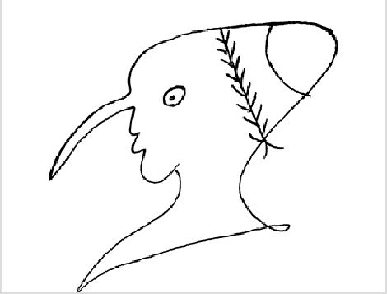

**Fig. 7** Apograph of figural graffito referred to in the note at *CIL* 4, 10676 [Langner 2001, n. 309].

Again, we might question whether this figure should be identified as female. In fact, we not certain that we had located the correct apograph for the drawing. There is considerable discrepancy between the description of the drawing in *CIL* 4, 10676 as female, with no mention of the long nose, and this line-drawing.

Another reason we suspected there might be a mistake was that Martin Langner had catalogued the drawing associated with *CIL* 4, 10676, describing it as a “Phalluskopf.” There was no mention of gender. And he categorized this drawing among several examples of drawings of heads with phallic features. The graffito is in a room that is sealed off, with no access, so we were unable to view it in person. Eventually, however, a photograph published by Antonio Varone in his recent two-volume work providing images of extant ancient graffiti (Varone 2012, 509) allowed us to confirm that this *is* indeed the correct graffito drawing – somewhat above but also drawn partly *through* the text of *CIL* 4, 10676.

Neither description offered by *CIL* or by Langner, however, seems altogether satisfactory. There are no obvious markers of female identity and even the description of *Phalluskopf* is less than transparent. Thus this one drawing has two published descriptions that vary greatly and that each lead to a very different understanding of the graffito. What should we then do in such situations? Do we repeat the identification of *CIL*? Or do we offer a less specific description, merely labeling this a *hominis figura*? In the end, our solution is to offer our own description, which is detailed but less interpretative, with an emphasis on specific features of the image that are readily identifiable. We also document Langner’s description and *CIL*’s earlier identification in our entry for EDR, but we note our hesitation with such identification by labeling the image: *gryllus?* (“caricature?”). We are aware, however, that we also introduce an interpretation with the tentative suggestion this drawing might be a caricature.

The issue of interpretation arises most often in relation to identification. Other examples concern identifying the particular *types* of gladiators or the species of animals, who are assuredly quadrupeds but in some drawings could be any type of animal with four legs (stags, boars, dogs). In such cases, our solution is to describe a drawing with more generic, yet accurate, terms such as “gladiator,” without further specification, or “animal” rather than *cervus, aper*, or *canis*. Similarly, if we cannot determine male or female, we prefer to describe the drawing as “*facies hominis*.” In the AGP search engine we can then indicate possible but not certain identification with a descriptor, or tag, that comes with a question mark: e.g. “stag?”

**4.1 How to search for drawings?**

The third challenge that we face is how to search efficiently for inscriptions that are not just text but either are images or include images. In the AGP search engine, we aim to complement the capabilities of EDR by providing another way to search for these non-textual, figural graffiti. Since we describe the content of the figural graffito in the Textus field of EDR, it is possible for a user to locate a graffito drawing. However, with text-based searching, a user would need to need to know the vocabulary used to describe the drawing. Would someone ever think to search for “*camelus*” without prior knowledge that there is a figural graffito of a camel in Herculaneum? Similarly, if you search for “*gladiator*”, the text field will give you results for all inscriptions that mention gladiators as well as drawings where we have described gladiators. If, however, we’ve described the gladiator more specifically as a “*retiarius*” or we have gladiatorial equipment, such drawings will be omitted from the list of search results.

We are therefore designing AGP with the capacity for locating figural graffiti through a two-prong solution: with both browsing and searching possibilities.

**4.2 Browsing capabilities in AGP**

For browsing, we have defined nine broad general categories, which together cover all the types of figural graffiti we have encountered so far **[Fig. 8]**.



**Fig. 8** Screenshot of AGP search engine showing browsing capabilities.

At this point, one can browse by choosing a category, which will return all examples in that category. So, for example, the category of “Gladiators/equipment” will return sketches of individual gladiators, gladiators fighting in pairs, and gladiator equipment such as helmets. The category of “Animals” will return all figural graffiti that include drawings of animals. As we process greater numbers of figural graffiti, the results of these categories will become larger.

**4.3 Limiting search results in AGP**

It is therefore necessary to design a way to limit results, so that a user could find only gladiatorial equipment, or graffiti depicting only boars but not graffiti depicting other animals. We are developing a method of filters and tags that will allow a user to move beyond browsing. These filters will allow a user 1) to limit an initial return of results, 2) to retrieve more specific results, or 3) to perform a secondary level of search. It will certainly be helpful to refine results of an entire category to include only a subset of that category, for example, only pairs of gladiators instead of all gladiators and their equipment.

To allow for this, we are creating a list of tags that we can apply to figural graffiti to allow for greater specificity of searching. By using tags, we can also assign multiple terms to a single image, e.g. stag and dog. Our goal is ultimately to enable searches by these tags as well, so a user can directly find all drawings with dogs. The search capacity will allow a user to search the tags or the Latin description, so both “*navis*” and “boat” will return hits. Again, standardization is necessary. We are currently developing a list of tags that is comprehensive and flexible enough to cover all graffiti, but that includes a level of standardization so that the list of tags offers extensible terms. We are also creating a system of filters to allow a user to limit the initial results or to move directly to a desired graffito**.** So, a user can search all graffiti drawings and then limit the search results, for example, to find all the drawings in a particular property **[Fig. 9**].

Filter2_screenshot.tiff

**Fig. 9** Screenshot showing filters in AGP.

Or, it will be possible to do a broad search for all drawings of animals, and then filter to limit the results to find what kind of animals are drawn in taverns, for example, but not public buildings or houses.

**5. Conclusion**

This system of tags and filters is in the early stages of the design process. These are our proposed solutions for confronting the challenges of working with text and image, and our ideas for creating a resource to complement the strengths of EDR with search capabilities for characteristics that are specific to these heterogeneous, individualized handwritten inscriptions.

Bibliography

Cooley, Alison E., and Cooley, M.G.L. 2014. *Pompeii and Herculaneum: A Sourcebook,* London-New York: Routledge.

Deiss, Joseph Jay. 1989. *Herculaneum: Italy's Buried Treasure*. Malibu, CA: J. Paul Getty Museum.

Della Corte, Matteo. 1958. "Le iscrizioni di Ercolano." *Rendiconti della Accademia di Archeologia Lettere e Belle Arti (Napoli)* 33:239-308.

Della Corte, Matteo. 1960. *Loves and Lovers in Ancient Pompeii, a Pompeian erotic anthology*. Translated by A. W. Van Buren. (= *Amori e Amanti di Pompei antica*, 1958 ed.) Cava dei Tirreni: di Mauro.

Guadagno, Giuseppe. 1978. "Supplemento epigrafico ercolanese (I)." *Cronache Ercolanesi* 8:132-155.

Guadagno, Giuseppe. 1981. "Supplemento epigrafico ercolanese (II)." *Cronache Ercolanesi* 11:129-164.

Langner, Martin. 2001. *Antike Graffitizeichnungen: Motive, Gestaltung und Bedeutung*, *Palilia, 11*. Wiesbaden: L. Reichert.

Maulucci Vivolo, Francesco Paolo. 1993. *Pompei. I graffiti figurati*. Foggia: Bastogi.

Varone, Antonio. 2012. *Titulorum Graphio Exaratorum qui in C.I.L. Volume IV collecti sunt. Imagines I-II*. Rome: L'Erma di Bretschneider.

Wallace-Hadrill, Andrew. 2011. *Herculaneum: Past and Future*. London: Frances Lincoln.