Abstract

1. Searching inscriptions through the EAGLE Portal

Claudio Prandoni1, Antonella Fresa1, Nicola Alfarano2, Guseppe Amato3, Franco Zoppi3, Andrea Mannocci3, Pietro Liuzzo4, Francesco Mambrini5, Silvia Orlandi6, Raffaella Santucci6

Promoter Srl1, Gogate Srl2, CNR-ISTI3, Heidelberg University4, German Archeological Institute5, Sapienza University of Rome6

Email(s): [prandoni@promoter.it](mailto:prandoni@promoter.it), [fresa@promoter.it](mailto:fresa@promoter.it), [nicola.alfarano@gogate.it](mailto:nicola.alfarano@gogate.it), [giuseppe.amato@isti.cnr.it](mailto:giuseppe.amato@isti.cnr.it), [franco.zoppi@isti.cnr.it](mailto:franco.zoppi@isti.cnr.it), [andrea.mannocci@isti.cnr.it](mailto:andrea.mannocci@isti.cnr.it), [pietro.liuzzo@zaw.uni-heidelberg.de](mailto:pietro.liuzzo@zaw.uni-heidelberg.de), [francesco.mambrini@dainst.de](mailto:francesco.mambrini@dainst.de), [silvia.orlandi@uniroma1.it](mailto:silvia.orlandi@uniroma1.it), [raffaella.santucci@uniroma1.it](mailto:raffaella.santucci@uniroma1.it)

This paper describes the functionalities and the technical infrastructure of the EAGLE Portal, the main gateway into the EAGLE’s massive epigraphic database. The portal can be accessed both by a human through a web browser and by external applications through a set of APIs. It is possible to perform full-text searches using a simple interface, or to launch more advanced queries, including the possibility to upload an image and search for inscriptions that are similar to the provided one. The seven controlled multilingual vocabularies that were created to help aligning the multilingual metadata of the inscriptions from the different content providers, have been also integrated in the search engine as well as all the translations the are available on the EAGLE MediaWiki. All this makes of the EAGLE Portal a very useful tool for the epigraphic community but also for single users and enthusiasts willing to contribute to the research in this field.

Keywords

Search engine, API, image recognition, controlled vocabulary, multilingual translations, advanced search, citizen participation.

1.1. Introduction

The EAGLE Portal is the place where the content provided by the epigraphers’ community is aggregated and stored and where it is made accessible to the users. It is composed by:

* The Metadata Aggregation System (in the following referred also as Aggregator), which is where all the content is stored and indexed.
* A Graphical User Interface (GUI), which is the interface through which users can browse the content and interact with it.

The Aggregator relies on the D-NET software toolkit, developed within the DRIVER project and extended within the OpenAIRE, OpenAIREplus[1], EFG, EFG1914[2] and HOPE[3] projects. D-NET is an open source, general-purpose software conceived to enable the realization and operation of Aggregative Data Infrastructures (ADIs) and to facilitate their evolution and maintenance over time. D-NET implements a service-oriented framework based on standards, namely Web Services with SOAP and REST APIs, where ADIs can be constructed in a LEGO-like approach, by selecting, customizing, and properly combining D-NET services as building blocks. The resulting ADIs are systems, which can be customized, further extended (e.g. by the integration of new services), and scaled (e.g. storage and index replicas can be maintained and deployed on remote nodes to tackle multiple concurrent accesses or very-large data size) at run-time [Amato et al., 2013].

The GUI exposes all the content stored in the Aggregator providing to the users the following functionalities [Prandoni et al., 2014].

* Search and browse the rich set of data made available by EAGLE content providers by using either a free text search or a more advanced interface, including faceted browsing through the integration of the EAGLE controlled vocabularies.
* Similarity search through the image recognition algorithm that have been integrated in the EAGLE Portal.
* Access to all the peer-reviewed translations of the epigraphic texts, in several European languages that have been produced and integrated in the EAGLE MediaWiki.
* Export to the user own PC the EpiDoc document of an object for further analysis and processing.
* Annotate and save relevant information in a user Personal Space (e.g. records of inscriptions, search results, queries), including content saved while using the Flagship Mobile Application.
* Access to the Flagship Storytelling Application to browse the existing epigraphy-related narratives and to create a new story.

The ingestion and curation of data is performed through a separate dedicated interface made available by the Aggregator. This interface includes a series of functionalities to support data ingestion and storage as well as for importing, indexing, enriching and managing the harvested metadata [Amato et al., 2015].

1.2. The EAGLE Collections

Classical Greek and Latin culture is at the very foundation of modern European identity. From philosophy to architecture, geometry to law, a variety of contemporary subjects and disciplines have their roots in the classical world. Only a small fraction of the total production of Greco-Roman texts has survived to the present day, leaving wide gaps in the historiographical record of an epoch that is immensely relevant to our modern day lives.

The collections held by the EAGLE partners have been assembled with the two-fold criterion of historical-cultural significance and strong thematic unity. They feature a great variety of inscriptions written in Greek, Latin and other ancient languages, providing scholars with an authoritative resource by which to verify the reliability of historical reconstructions. Additionally, they equip the broad public with a way to understand and easily appreciate interesting and geographically dispersed inscriptions.

The EAGLE collections come from a wide range of digital repositories of epigraphic content. The following paragraphs illustrate these repositories.

Arachne**[4]** is the central object-database of the German Archaeological Institute (DAI). Since 2001, Arachne has been integrating negative archives of ancient sculpture that went beyond the specialised documentation retained in Cologne itself, such as the negatives of ancient sculpture of the German Archaeological Institute in Rome and the historic glass plate negative collections. Besides this larger project, many additional activities are going on different levels, for example the online preparations for the »Corpus der Antiken Sarkophagreliefs«.

Archaia Kypriaki Grammateia Digital Corpus **(**AKGDC) is a searchable digital library based on the 6 volumes of Archaia Kypriaki Grammateia (Ancient Cypriot Literature), published by the A. G. Leventis Foundation between 1995-2008. The AKGDC/ STARC collection of Cypriot inscriptions are dated from the 5th century BC to the 5th century AD and are mostly funerary or dedicatory epigrams in elegiac couplet or hexameter.

Epigraphic Database Bari (EDB)[5] is a project specialized in epigraphic documents of Christian patronage (third to eighth centuries, AD), including those contained in the *Inscriptiones Christianae Vrbis Romae, nova series*, voll. I-X, in civitate Vaticana 1922-1992 (= ICVR), and those edited in other bibliographical seats and/or not contained in the ICVR. Currently the inscriptions present in the EDB (counting those already online and those awaiting definitive approval) amount to 40,000 items ca, though this number is obviously increasing continually.

The task of the Epigraphic Database Heidelberg (EDH)[6] is the systematic entry of ancient Latin and bilingual (usually Latin and Greek) inscriptions into a complex database. The Epigraphic Text Database is the heart of EDH and contains 65,000 inscriptions at present. Almost all of the records present texts, which have already either been edited in the monumental Inscription corpora or published, revised and discussed in thousands of scholarly articles.

Epigraphic Database Rome (EDR)[7] was launched in 1999 as an experimental project aimed at creating a unified database for ancient epigraphy. EDR is part of the international federation of Epigraphic Databases called Electronic Archive of Greek and Latin Epigraphy. The federation’s purpose is to collect all published Greek and Latin inscriptions up to the 7th century A.D. considering their best existing editions, also enclosing, when possible, a number of additional important data and/or images. As part of the federation, EDR aims at collecting the whole epigraphy of Rome and of the Italian peninsula including Sardinia and Sicily, with the exception of Christian inscriptions (under EDB jurisdiction).

Hispania Epigraphica Online[8] was created in 2002 when an EU grant enabled a joint research project between the Archivo Epigráfico de Hispania and Mag. K. Schaller, who was developing computing applications for archaeological purposes. The focus of the collection is the rich epigraphic patrimony of Portugal and Spain, mainly written in Latin, but with some small pockets of Greek, Semitic and Iberian inscriptions.

Petrae database[9] is a system for the recording of Latin and Greek inscriptions developed at the Institut Ausonius, which collects epigraphic texts from the various regions in which its researchers and collaborators are active. Each record produced has the text of an inscription in both an uppercase and lowercase version, accompanied by metadata on all aspects of the monument, including support, fragments, epigraphic fields and text elements (dating, paleography, critical apparatus, translation, notes).

The Last Statues of Antiquity[10] is a project funded in 2009 by the ‘Arts and Humanities Research Council’ in Oxford. The project collects and analyses all the evidence for new, newly dedicated, or newly re-worked statuary in the period *circa* 284–650. The two main results of the project are a major database, with over 2600 individual entries, and a book, published in late 2012, discussing in print the entire phenomenon of the late-antique statue habit.

The picture databaseVBI ERAT LUPA**[11]** contains stone monuments (sculptures, reliefs, inscriptions, architectural pieces etc.). The project’s scope ranges from prehistoric stone monuments to around the time of Justinian (500 AD). Due to its inception in Vienna, most project data at the moment is from the mid- and south-eastern European region.

Finally, thanks to the great effort in the networking activities, many other partners joined the EAGLE Best Practice Network and made available their collections that are currently being uploaded in the EAGLE Portal[12].

1.3. The EAGLE inscription search engine

The EAGLE Inscriptions Search Engine is accessible through the main horizontal navigation bar of the EAGLE Portal[13]. It represents the core functionality of the portal, through which the entry of keywords and phrases produce matches from EAGLE’s massive epigraphic database.

The EAGLE Portal makes available a “simple search”, an “advanced search” where the user can specify the values of a number of fields in order to make a more accurate search, and an “image search” where the user can upload an image and search for inscriptions that look similar to the provided one [Prandoni et al., 2014].

The objects that a user can search in the EAGLE Portal belong to three different categories, in accordance with the EAGLE conceptual model [Sicila et al., 2015]:

* “Artefacts”, which contain all the information that is somehow related to the physical carrier of the inscription.
* “Texts”, which contain all the information that is textual in nature.
* “Images”, which contain all the information that is visual in nature.

1.3.1. How to search inscriptions

The simple search user interface is very straightforward. The text entered in the query box is used to make a full text search in all the fields of all the EAGLE objects in the category determined when making the query. By default, the search will be done on all the objects in the “Artefact” category. Two more tabs on the result list (labelled “Texts” and “Images”) allow the user to perform the same query choosing a different category.

Using the advanced search interface, a user can specify values for a number of fields, in order to have more accurate results: findspot, bibliography, text of the inscription, type of inscription, decoration, object type, material, type of writing, state of preservation (Fig. 1).

In the fields having a controlled vocabulary, the user is allowed to enter only values coming from the vocabulary. For this purpose, those fields have a “drop-down menu” which displays all the defined values for that field in the “preferred label”, i.e. the text string that has been indicated in the vocabulary as the preferred one for display, regardless of the language in which the string is defined.

Finally, by choosing the Image Search option, a user can exploit the image recognition algorithm that has been integrated in the EAGLE Portal and that allows to search for images that are similar to the one a user has uploaded, ranked in decreasing order of similarity (Fig. 2).

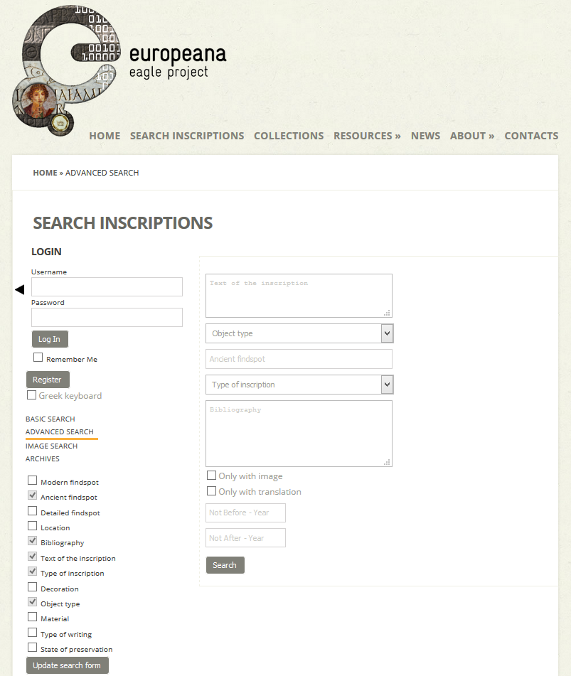

Fig. 1. Search for inscriptions in the EAGLE Portal

Content Based Image Retrieval (CBIR) is becoming an effective way for searching digital libraries, as the amount of available image data is constantly increasing. CBIR applications are increasingly becoming useful in accessing cultural heritage information, as a complement to metadata based search. In fact, in some cases metadata associated with images do not describe the content with sufficient details to satisfy the user queries, or metadata are completely missing. For example, images containing reproductions of works of art contain a lot of implicit information that is not generally captured in manually or automatically generated metadata [Amato et al., 2013].

The EAGLE Image Retrieval System (IRS) receives in input the image of an epigraph and provides effective and efficient image similarity search and image content recognition of epigraphs.

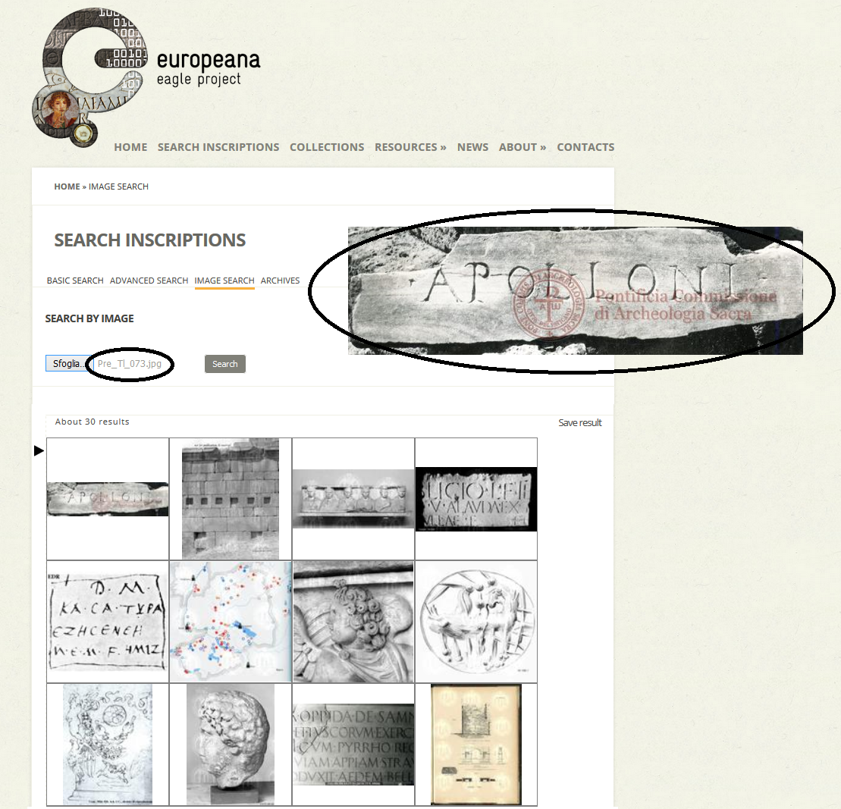

Fig. 2. Image search in EAGLE

The images provided by the EAGLE content providers and collected in the Aggregator have been processed by a set of IRS components (Image Feature Extractor, Image Indexer, CBIR Index) to build the index that allows a fast and efficient similarity search during the query phase.

In addition, for those epigraphs where a set of images is available (training set), each training set has been processed to extract the main features characterizing the epigraph. The training sets and the characterizing features are the base for building another index, to be used by the image recognizer in order to decide if a received image (during the query phase) can be classified as belonging to one of the existing sets or not. In this way, in many cases, the recognizer is able to properly recognize the content of a query image even if the image given in the query was never stored in the database.

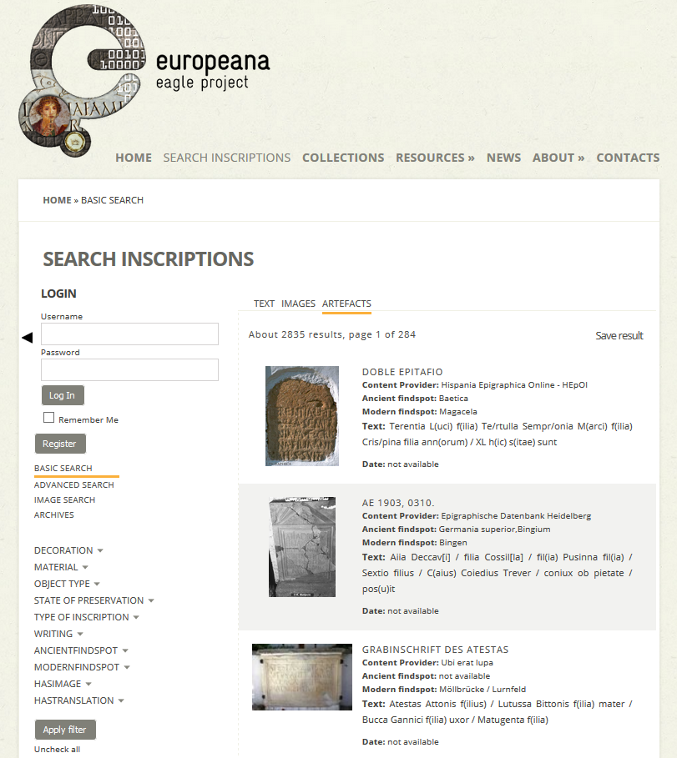

Fig. 3. Results list - Artefacts

1.3.2. Filtering and browsing results

After having submitted a query, the user is presented with a paginated list of results containing some basic information (Fig. 3).

By using the facets displayed on the left side panel, the user has the possibility to refine the query by applying some filters based on the fields that are associated with a controlled vocabulary or based on the fact whether the inscription has an image and/or a translation.

Regardless of the type of query performed by the user and of the category in which the query was done, clicking on one of the items in the result page will display a summary of all the information available for that item, with links to get further details (Fig. 4).

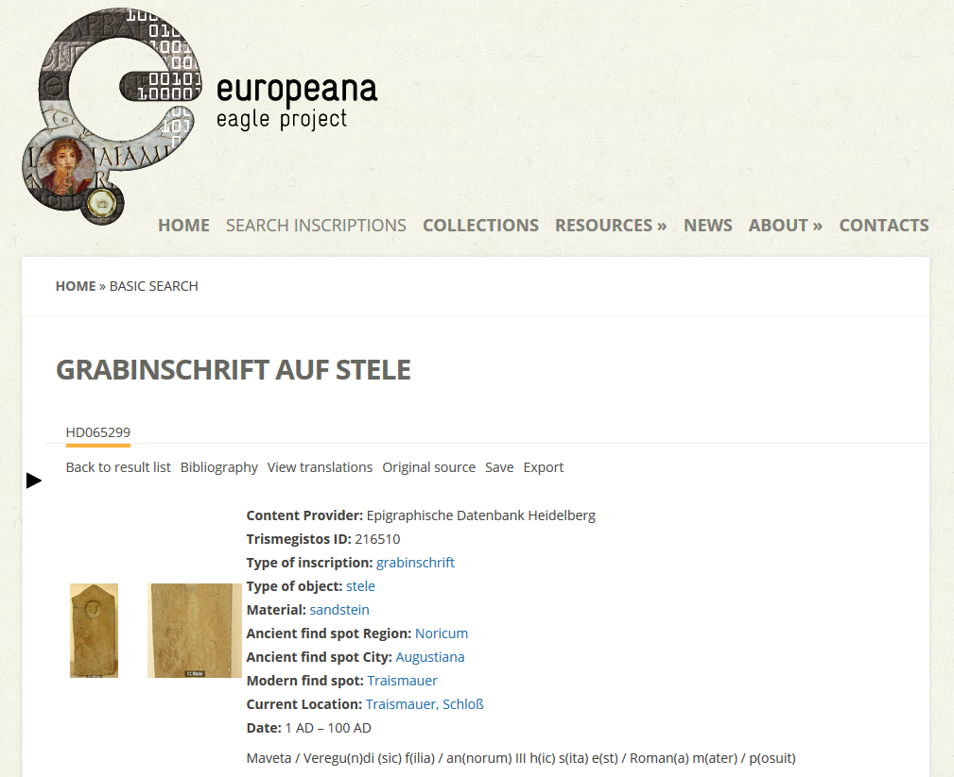

Fig. 4. Object details

The text in big characters on top of the page is the Title of the object. Below the title there is the local ID of the object and after that there is a line collecting all the clickable items of the summary page: Bibliography, which opens a text box with the bibliography associated with the object; Translations, which displays all the translations available for the inscription of the object; Original source, which links the page of the object in the database of the Content Provider who provided it; Save, which allows to save the object in the user’s personal space; Export, which allows to download locally the EpiDoc document describing the object. Finally, all available pictures are displayed, together with the remaining descriptive metadata.

Duplicates identification has been performed through the Trismegistos platform[14]. By standardizing publication references, collection information, material, provenance and date, the overlap of the various databases has been mapped to identify records describing the same inscription. Afterwards a unique numeric identifier, the Trismegistos ID, has been assigned to each document and spread across the partner databases for inclusion in the metadata record to be uploaded in the EAGLE Portal.

If more than one instance of an object is available, the other instances appear on the summary page as clickable “tabs”, each tab being labelled with the local ID of the other instances of the same object.

The seven controlled multilingual vocabularies that have been created (Type of Inscription, Object Type, Material, Execution, Decoration, State of Preservation, Dating Criteria) to help aligning the multilingual metadata of the inscriptions from the different content providers, have been also integrated in the EAGLE search engine. Every time that a term which belongs to one of the vocabularies is displayed, it is automatically linked to the specific page describing the term, where further connections, synonyms and translations can be explored. The EAGLE vocabularies are accessible also as Linked Open Data[15].

Finally, all the peer-reviewed translations in several European languages that are available, have been integrated in the EAGLE Portal too through a RESTful API native of Wikibase, the MediaWiki extension used for this purpose[16]. For each inscription it is possible to view the existing translation, to request a new one and to contribute by connecting to the EAGLE MediaWiki[17].

1.3.3. Annotating and saving objects

A registered user, during a “web” or a “mobile” session, has the capability of annotating and saving (some of) the information that is being provided by the EAGLE system.

Depending on the information the user is looking at, hitting the save button will save two types of data in the personal space:

* A query and its results.
* Detailed information about an inscription.

The data saved by the local user on the EAGLE server is stored internally in a relational database.

A registered user logged in at the EAGLE Portal can access his/her saved data and perform some simple operations on it:

* Display of the saved queries or objects.
* Modify the textual annotations associated with the saved item.
* Delete the saved item from her personal space.
* View the saved item.
* Import the data that he/she saved during a mobile session.

It has to be noted that, when a user views one of the saved items, the object is displayed exactly as he/she saved it. The saved data might be different from the data that can be retrieved by issuing the same query at the time of editing, due to changes in the data stored in the EAGLE database. This allows the user to make comparisons between the information that was available when he/she first saved the object and what has been added afterwards.

1.4. Conclusion

This paper presented the main functionalities of the EAGLE Portal, giving some highlights of the content that is available and of the technical infrastructure that allows to search and browse them.

EAGLE aims to build a multi-lingual online collection of millions of digitised items from European museums, libraries, archives and multi-media collections, which deal with inscriptions from the Greek and Roman World. The aim of the network is to make available the vast majority of the surviving inscriptions of the Greco-Roman world, completed with the essential information about them, enriched through the use of seven multilingual vocabularies, and complemented with a series of peer-reviewed translations in several European languages, which are notoriously unavailable for inscriptions.

All this makes of the EAGLE Portal a very useful tool for the epigraphic community but also for single users and enthusiasts willing to contribute to the research in this field.

The participation of Europe’s citizens in scientific research represents an important opportunity for improving European competitiveness, because of the value that citizens can add in specific areas of research. In particular, the participation of citizens in the research on CH and humanities has the potential to play an important role in the development of the European Research Area, and can take the lead in the discovery of new directions of cross-disciplinary research.

In this framework, the CIVIC EPISTEMOLOGIES[18] project developed a Roadmap for the use of e-Infrastructures to support the participation of European citizens in CH practices and humanities research, where such engagement has a twofold benefit for culture: to be enriched by the citizens’ contributions and to become more widely used and exploited (also, for example, with the participation of creative industries) [Fresa & Justrell, 2015]. The future development of the EAGLE initiative will refer to the CIVIC EPISTEMOLOGIES Roadmap for investigating how to put in place more advanced services supporting citizen science in epigraphic research.

The EAGLE Portal is only an example of application that makes use of the APIs provided by the Aggregator to access the EAGLE collections. Other examples are the Flagship Mobile Application[19], that allows to access the inscriptions’ database through a mobile device and to fully exploit the image recognition features integrated in the EAGLE Portal, and the Flagship Storytelling Application[20], that allows a user to create stories starting from the content available in EAGLE, Europeana and many other data sources.

Other applications may be created based on the APIs provided by the Aggregator, which uses a SOLR-base search engine through which it is possible to search and browse the full set of content[21]. Furthermore, APIs are provided to register a new user, login and perform an image-based search using the EAGLE image recognition algorithm.

Bibliography

Amato, G., Bolettieri P.,Gennaro C., Manghi P., Mannocci A., AIM Infrastructure Specification, Deliverable D4.1, EAGLE Project 2013.

Amato, G., Bolettieri P., Falchi F., Manghi P., Mannocci A., Zoppi F., Second Release of AIM Infrastructure, Deliverable D4.2.1, EAGLE Project 2015.

Fresa A., Justrell B., The Roadmap, CIVIC EPISTEMOLOGIES Project 2015.

Prandoni C., Alfarano N., Casarosa V., EAGLE Portal, Deliverable D5.2, EAGLE Project 2014.

Sicila M., Gomez Pantoja, J., Rubio Fuentes, M., Rivero Ruiz E., Mannocci A., Manghi P., Zoppi F., EAGLE metadata model specification – Second Release, Deliverable D3.1, EAGLE Project 2015.

1. <http://www.openaire.eu/>
2. <http://www.europeanfilmgateway.eu/it>
3. <http://www.peoplesheritage.eu/>
4. <http://arachne.uni-koeln.de>
5. <http://www.edb.uniba.it>
6. <http://edh-www.adw.uni-heidelberg.de>
7. <http://edr-edr.it>
8. <http://eda-bea.es>
9. <http://petrae.tge-adonis.fr>
10. <http://laststatues.classics.ox.ac.uk>
11. <http://www.ubi-erat-lupa.org>
12. For a full list of the EAGLE Associated Partners see <http://www.eagle-network.eu/about/partners/>
13. <http://www.eagle-network.eu/basic-search/>
14. <http://www.trismegistos.org/>
15. <http://www.eagle-network.eu/resources/vocabularies/>
16. <http://www.eagle-network.eu/wiki/api.php>
17. <http://www.eagle-network.eu/wiki>
18. <http://www.civic-epistemologies.eu>
19. <http://www.eagle-network.eu/resources/flagship-mobile-app/>
20. <http://www.eagle-network.eu/stories/>
21. For further information see <http://wiki.apache.org/solr/#Search_and_Indexing>