**Authorization for the reproduction of images for editorial publication**

I the undersigned Yanne Broux, born in the city of Lier, on October 28 1985, resident of Belgium,

Cod. Fisc. (if applicabile) /,

copyright owner of the following images:

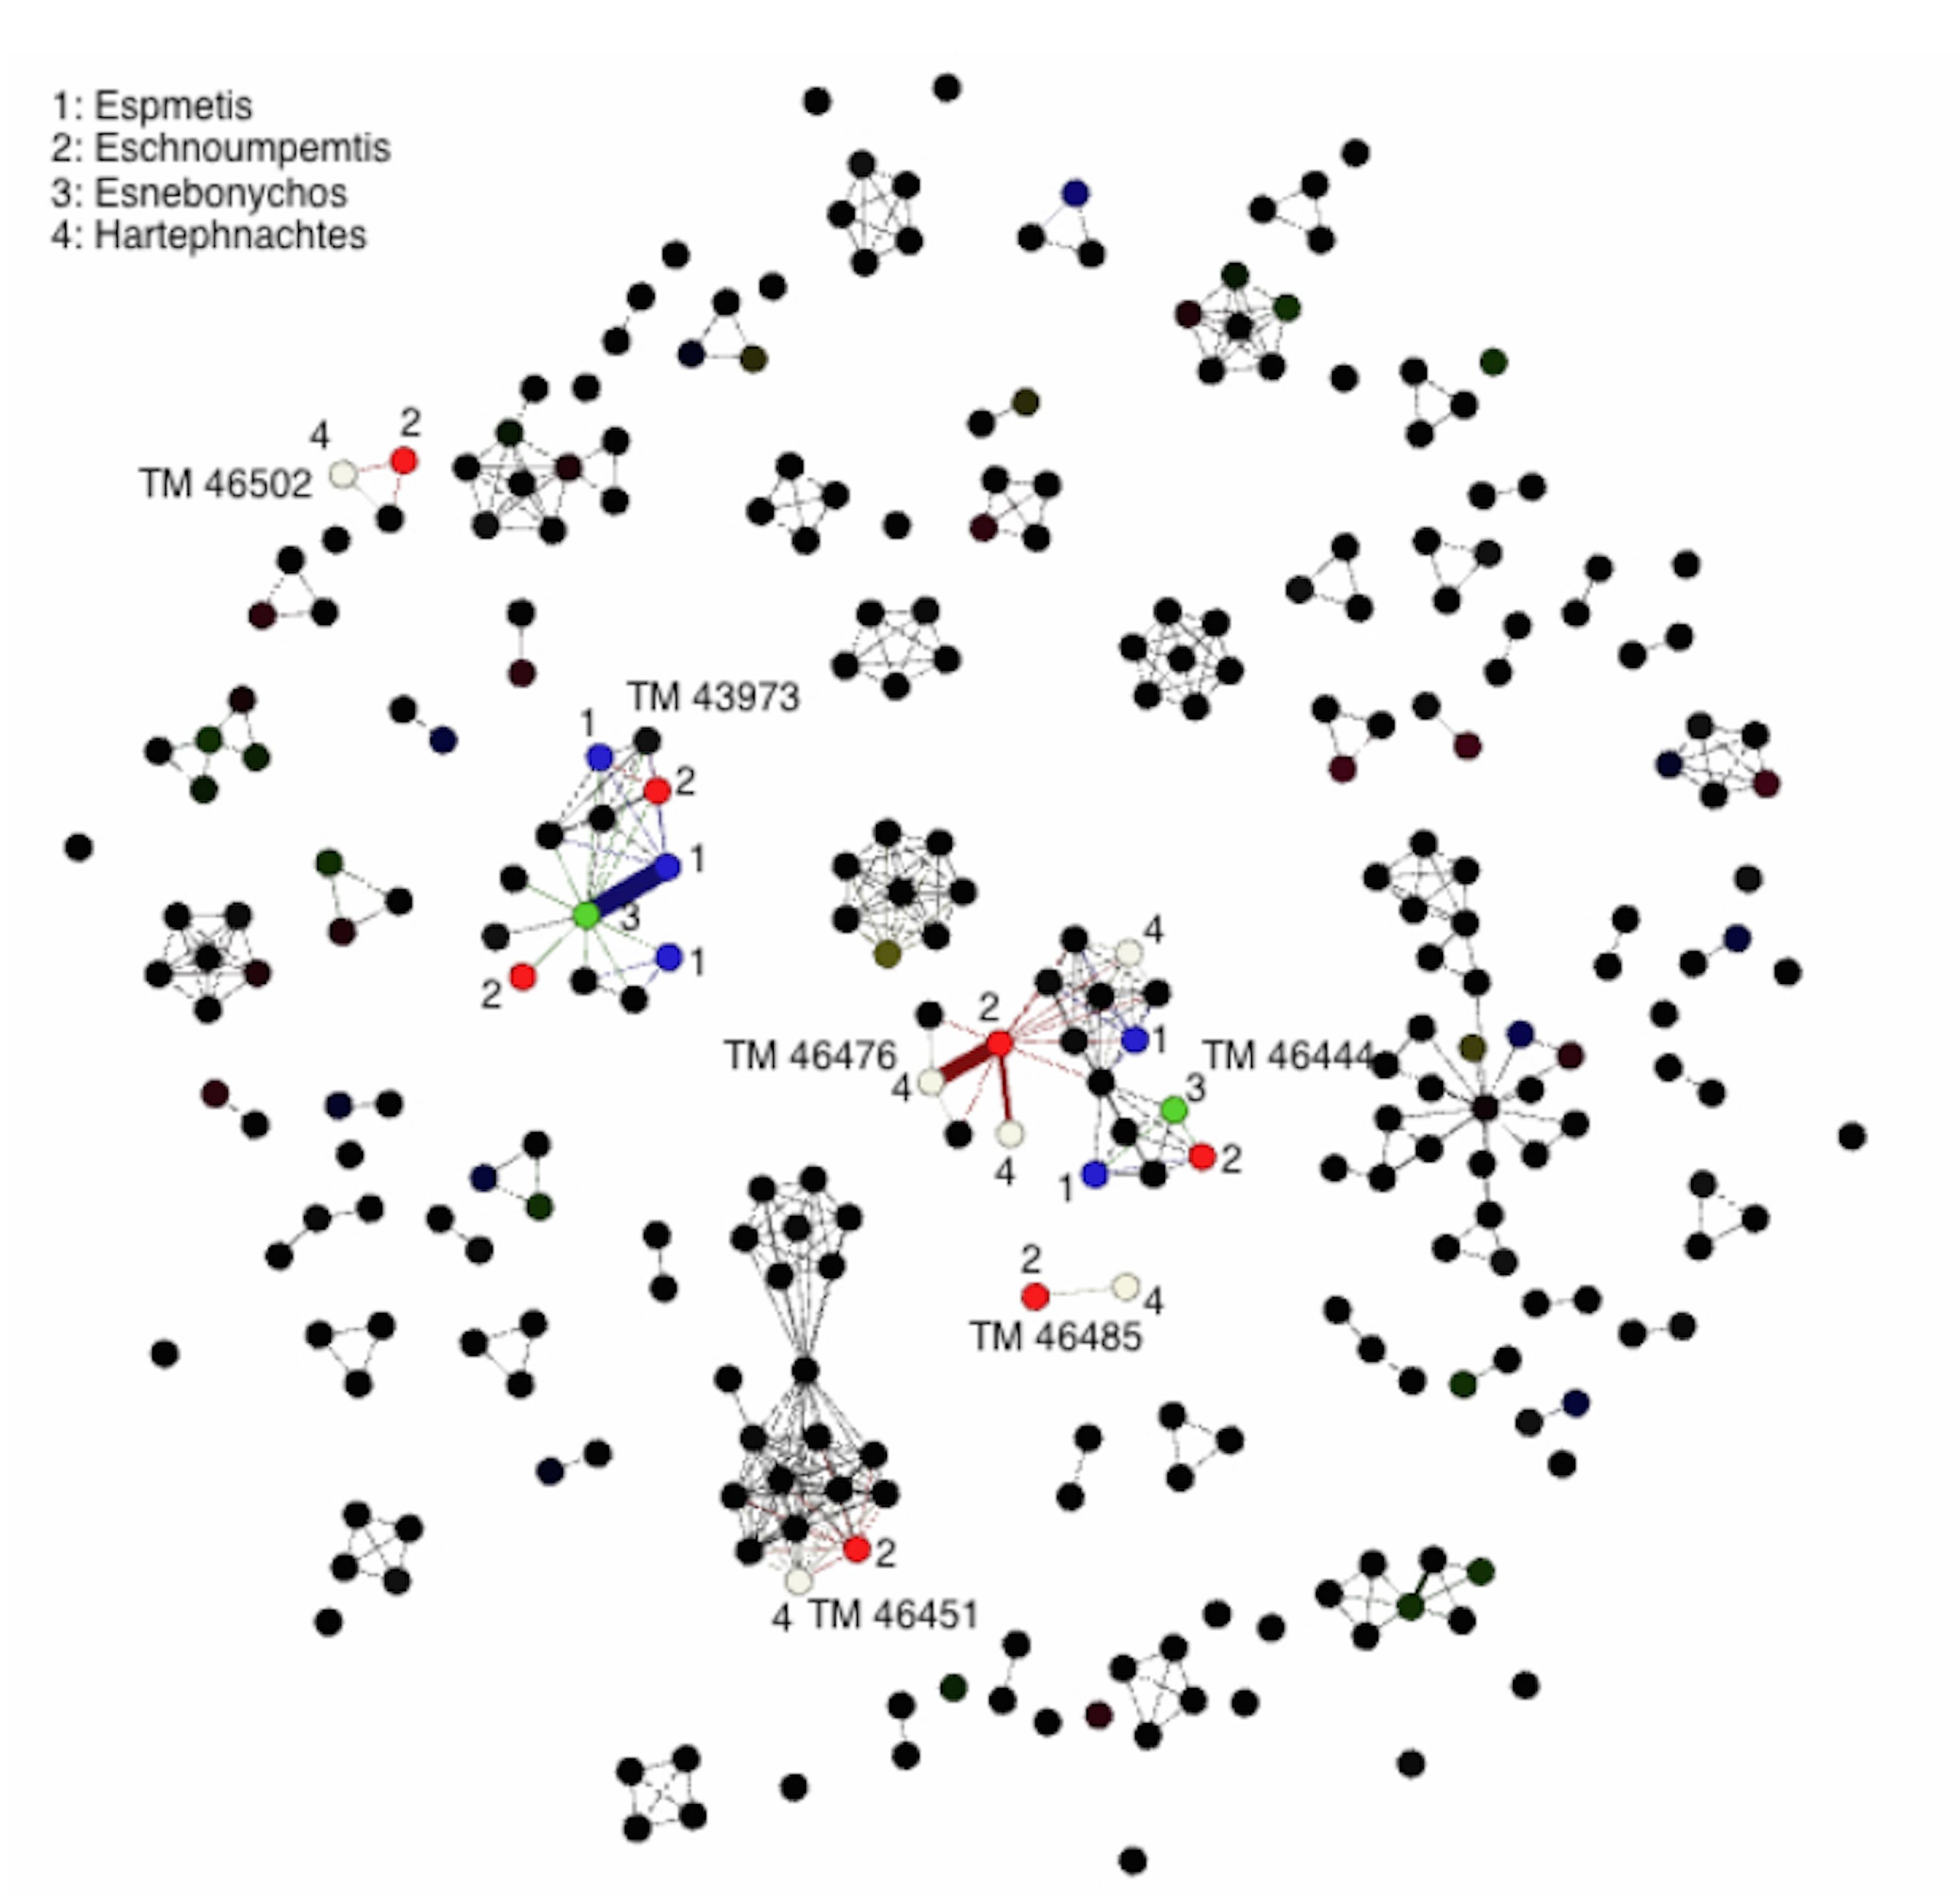

Authorize their publication in the Proceedings of the Eagle2016 International Conference On Digital And Traditional Epigraphy In Context by the Sapienza Università Editrice without financial burden upon the Editor or third parties.

I understand that my material, so long as it is not deformed, may be partially reproduced, blown up, or reduced.

The Editor may also use the iconographic material in question for promotional reasons. The conditions agreed upon in this waiver will be valid for ten years.

Date:

November 14 2014

Signature

