**Introduction.**

Every shop and business in the world require several accounts of many different services for daily need. Email accounts, social media, own system’s passwords are just a few examples of accounts that need to be securely stored in format and accessible at time by each employee.

In addition, security in a company is a regard of high-importance level and must be implemented by any costs necessary. Company’s information, costumer’s important data, services and so forth, are just examples of why it is so important. Otherwise, we give complete permission to third persons to blackmail us or, simply, take us out of the business.

Here is where a password manager takes place to fulfill the need and facilitate the daily activities of the company. A password manager is a computer program that allows users to store and manage their passwords for local applications and online services, as well as help us create stronger passwords and save sometime each time we access an account.

The proposed system is a password manager that is going to be developed and implemented by a “clothes retailer” who needs to help their employees secure their passwords, separate each employee’s own password and make them easily accessible by all of them (eliminating the need of triangulating information among the other employees).

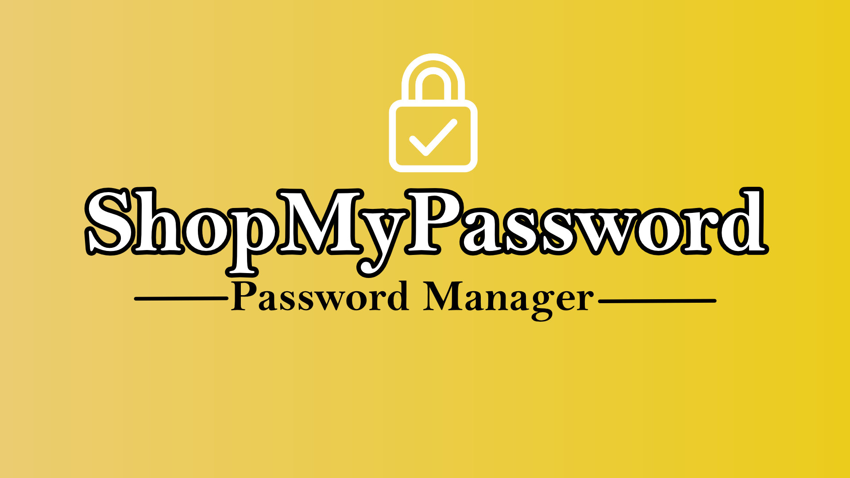

**Functional requirements.**

* The system will only accept 3 types of users: Super-admin, Admin and Regular. Each one will receive specific privileges according to their hierarchy level.
* Each user must have easy access to their information on mostly all devices.
* There will be 3 types of storable passwords: Public global passwords (accessible for everybody), Private global passwords (accessible for only super-admin and admin users) and user’s personal passwords.

**Non-functional requirements.**

* System must be a web application.
* Developed primary to be used on mobile devices.
* Every employee will have their own (not sharable) account.

**Glossary.**

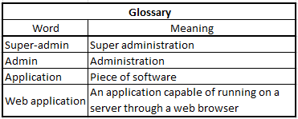

**Resources.** HR, Budget, Time.

