**Introduction.**

Every shop and business in the world require several accounts of many different services for daily need. Email accounts, social media, own system’s passwords are just a few examples of accounts that need to be securely stored in format and accessible at time by each employee.

In addition, security in a company is a regard of high-importance level and must be implemented by any costs necessary. Company’s information, costumer’s important data, services and so forth, are just examples of why it is so important. Otherwise, we give complete permission to third persons to blackmail us or, simply, take us out of the business.

Here is where a password manager takes place to fulfill the need and facilitate the daily activities of the company. A password manager is a computer program that allows users to store and manage their passwords for local applications and online services, as well as help us create stronger passwords and save sometime each time we access an account.

The proposed system is a password manager that is going to be developed and implemented by a “clothes retailer” who needs to help their employees secure their passwords, separate each employee’s own password and make them easily accessible by all of them (eliminating the need of triangulating information among the other employees).

Our development team is yet to be defined.

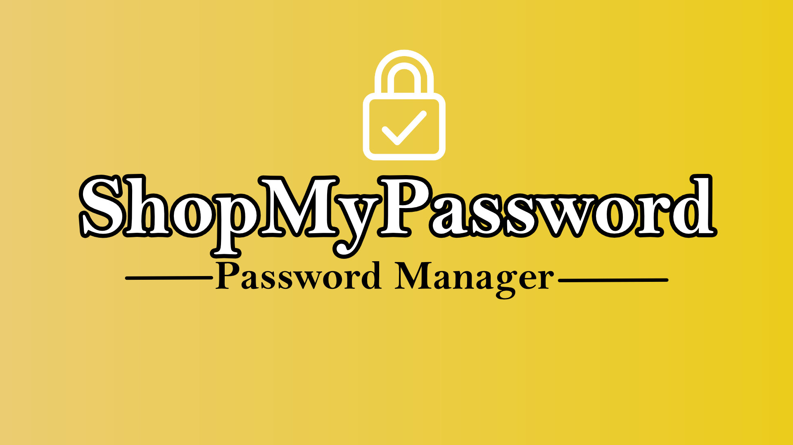

**Functional requirements.**

* The system will have a Super-admin account with privileges for accessing all passwords, add and delete any kind of password, and add and eliminate other users. Creation of new users (admins and regular) is possible. This account(s) are for owners only.
* Different corporation departments have to be created and managed by one admin user.
* Super/admin users are universal across all information stored in the web app.
* An Admin user is necessary, they’re for managers and high hierarchy employees. Addition, elimination, and modification privileges are given as long as they have not been created by a Super-admin user. Creation of new regular users is possible.
* Each Admin can only manage their department.
* Regular accounts for the rest of employees. Only addition, elimination, and modification of personal information, and only access of public universal passwords.
* Universal passwords are needed, and they will be visible all across employees with no restriction.
* Private universal passwords. Passwords visible across admin accounts only.
* Department passwords. For information shared within the same department.
* Personal passwords. Visible only for the user who created them.
* All information must be displayed in order on the web app.
* The information can be queried and downloaded as “.XLSX”.

**Non-functional requirements.**

* System must be a web application.
* Developed primary to be used on mobile devices.
* Every employee will have their own (not sharable) account.
* Programming languages: HTML, CSS, JavaScript and the implementation of React Framework.
* Web app accessible on PC and Mobile devices.

**Glossary.**

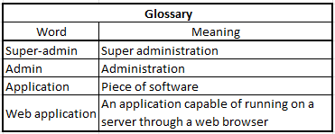

**Resources.**

*Time Management*:

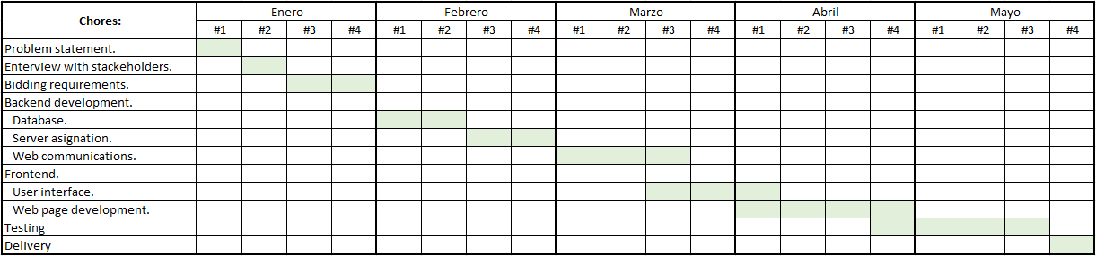

*Budget management:*

The development of this project is estimated to cost $8,000 USD. The cost will be divided into three aspects:

* Salary for developers.
* Costs of the production.
* Maintenance.