**ManageMyBusiness**

**Introduction.**

Introducing our state-of-the-art business management software! This software is designed to streamline your business operations, increase efficiency, and improve productivity. Whether you're a small startup or a large corporation, our software has the tools you need to take your business to the next level.

Our business management software offers a wide range of features to help you manage every aspect of your business, from accounting and inventory management to project management and customer relationship management. With real-time data analytics, you can easily track your progress, identify trends, and make data-driven decisions that drive your business forward.

Our user-friendly interface and intuitive design make it easy to get up and running quickly, so you can focus on what you do best - growing your business. Our software is also scalable, so as your business grows, our software grows with you, providing the tools you need to succeed every step of the way.

In addition, security in a company is a regard of high-importance level and must be implemented by any costs necessary. Company’s information, costumer’s important data, services and so forth, are just examples of why it is so important. Otherwise, we give complete permission to third persons to blackmail us or, simply, take us out of the business.

In summary, our business management software is the ultimate tool for businesses of all sizes looking to improve their operations, increase efficiency, and drive growth. The proposed system is going to be developed and implemented by a “clothes retailer”.

ManageMyBusiness is a web app for compatibility convenience that will also include a python based *.exe*. This program takes management of the following areas of your business:

* Employes schedule: time-cheking, weekly schedule, late report, direct communication...
* Pasives and actives: financial reporting, account management and payment automation.
* Management of merch purchase.
* Adverticement management.
* Billing.
* Purchase interface for sellers to develop a purchase.
* Password manager.

**Functional requirements.**

* The system will have a Super-admin account with privileges for access, managing and settings.
* Different corporation departments have to be created and managed by one admin user.
* Super/admin users are universal across all information stored in the web app.
* An Admin user is necessary, they’re for managers and high hierarchy employees. Addition, elimination, and modification privileges are given as long as they have not been created by a Super-admin user. Creation of new regular users is possible.
* Each Admin can only manage their department.
* Regular accounts for the rest of employees. Only addition, elimination, and modification of personal information, and only access of public universal passwords.
* Universal passwords are needed, and they will be visible all across employees with no restriction.
* Private universal passwords. Passwords visible across admin accounts only.
* Department passwords. For information shared within the same department.
* Personal passwords. Visible only for the user who created them.
* All information must be displayed in order on the web app.
* The information can be queried and downloaded as “.XLSX”.

**Non-functional requirements.**

* System must be a web application.
* Developed primary to be used on mobile devices.
* Front-end on browser and Python-based *.exe*.
* Every employee will have their own (not sharable) account.
* Programming languages: HTML, CSS, JavaScript and the implementation of React Framework and Python.
* Web app accessible on PC and Mobile devices.

**Glossary.**

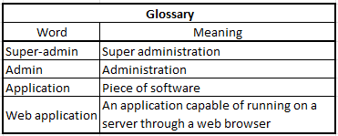

**Resources.**

*Chores Management:*

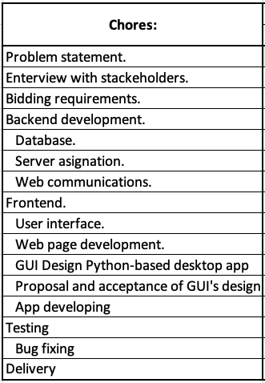

*Time Management*:

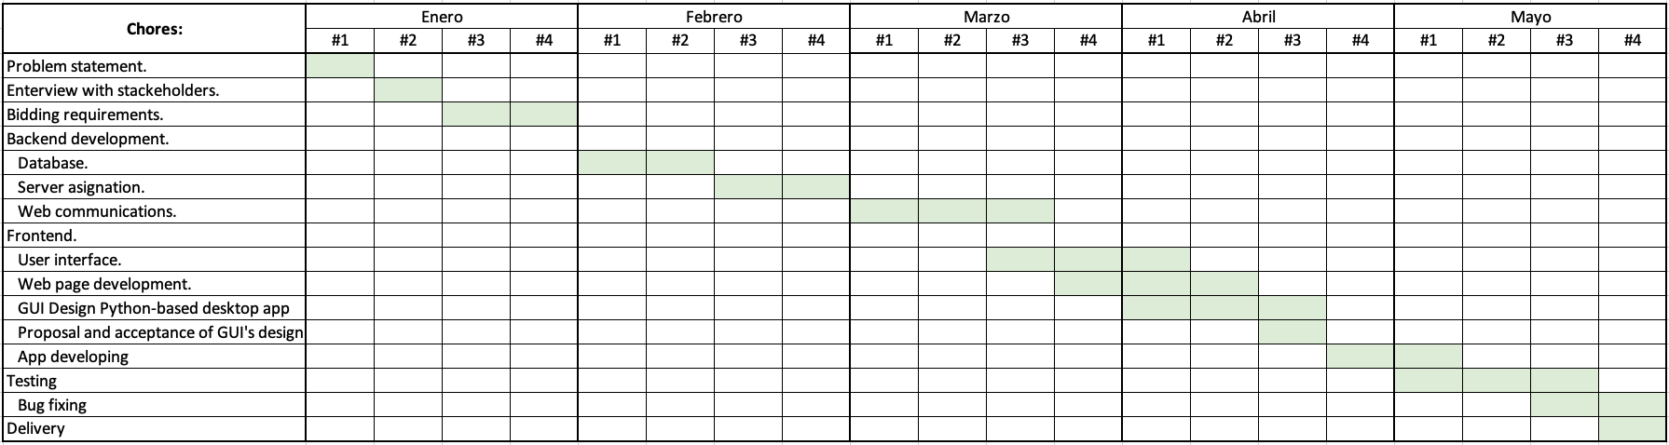

*Budget management:*

The development of this project is estimated to cost $8,000 USD. The cost will be divided into three aspects:

* Salary for developers.
* Costs of the production.
* Maintenance.