**Communi-KT**

The Next-Generation of Social Media in the Metaverse

**Change requests analysis**

**Introduction**

In the intricate nature of humans to develop a hierarchical structure for decision making. In a world where decisions bear consequences that ripple through business and organizations, committee boards stand as the unseen architects of order and strategy. These groups of individuals wield and immense influence, their collective wisdom and expertise as engine for finding the bests strategies for problem solving and auto-improvement.

**Goal of the “Committee board”**

*What do we expect with the creation of a Committee board in this project?* Well, the primary goal we have in this business is to provide us and effective leading and overview of the whole company. It is established to collectively make decisions, set policies, and guide the strategic direction of the entity they serve.

In this project our committee board plays a mayor role in various sectors, its importance cannot be underestimated. Just as an example of the granted roles:

* Strategic Direction.
* Accountability.
* Expertise and guidance.
* Decision-making.
* Risk management

**Structure of committee board**

As researched, each cb (committee board) can vary depending on the organization’s size, type, and purpose. However, there are common elements that are typically found in the structure of most committee boards.

The one that we selected follows the order:

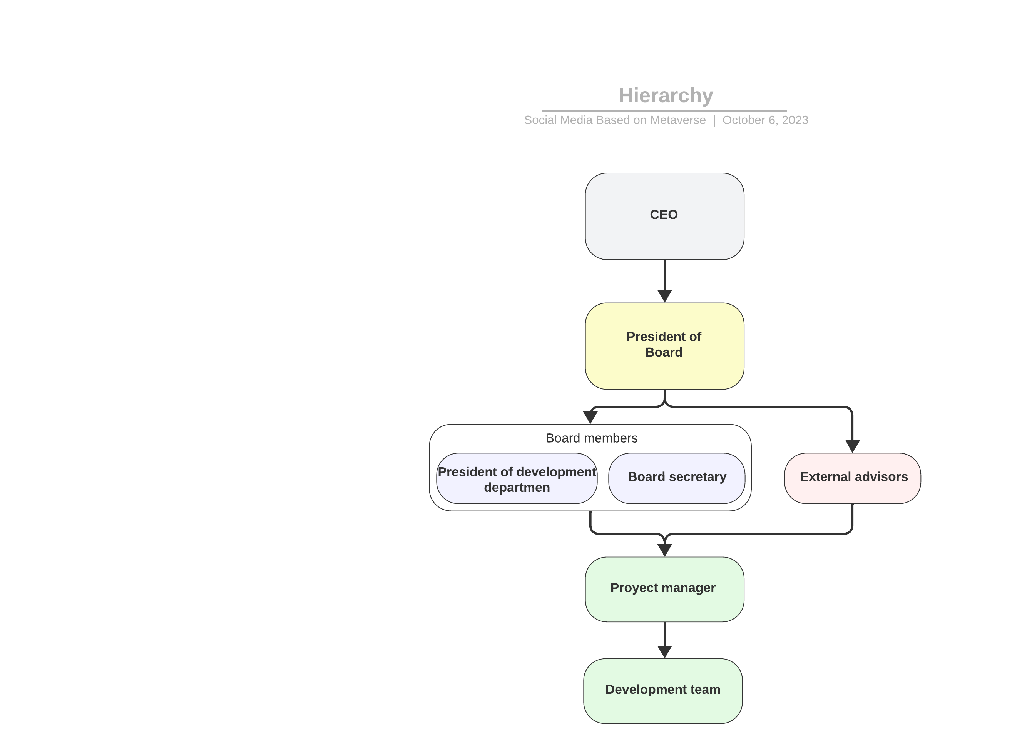

**How the decisions will be taken.**

Decisions in a committee board are typically taken through a structured and democratic process that ensures that all board members have the opportunity to express their views and vote on matters requiring a decision.

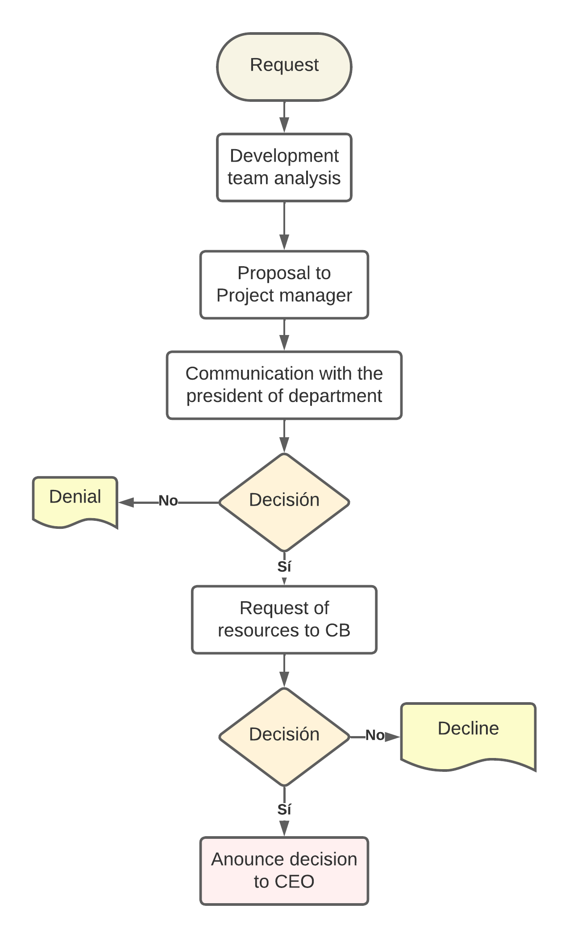

**Criteria for acceptance or decline**

When considering whether to accept or decline a project in a business, it’s essential to evaluate various factors to make an informed decision.

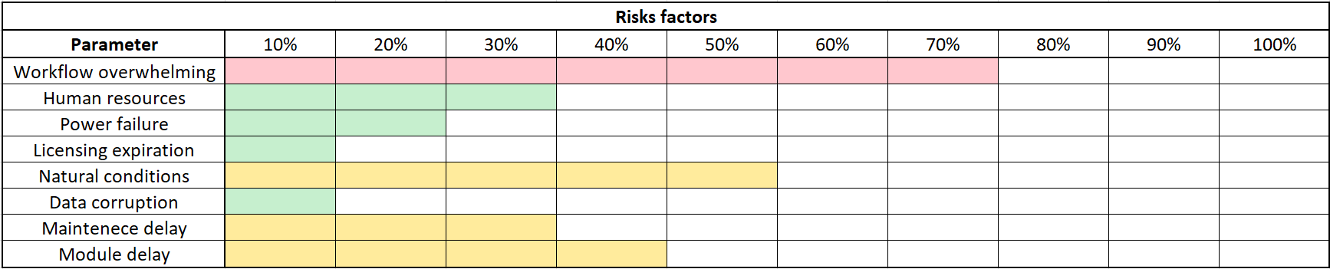

Just to give a risk scale to measure and determine whether accept or decline the Change Request in this project’s development.

