Reliable Office Suppliers
Door No.9, Shop No.2, Hazari Street
(OPP. Hotel Taj Mount) Woods Road, Chennai-600 002.
Cell No: - 7200057450 / 9884317372 / 9344593336
Office Land-Line: - 044-28602330 / 31 / 044-28603454 / 55
Email:-reliableofficesuppliers@yahoo.com

QUOTATION

For Stationary/Computer Consumables & House Keeping Materials

Kind Attn: Respected Sir / Madam,
We Take pride in introducing ourselves as one of the leading Suppliers of Stationery & Printing Products for the past twelve years(12yrs). We have been regularly supplying to Public Pvt. Ltd. companies, Educational Institutions, Banks, Hotels, Hospital, and leading BPO’s and Consult ate & Peripheral areas. We would be much be obliged if you could give us an opportunity. We would live up to our name RELIABLE service to you doors steps. Note: [We also have deliveries to our customers round the clock- we work to the satisfaction of our customers]
We also undertake Printing Jobs like Visiting Cards, envelopes, Brochures, Letterheads, having facilities for Embossing, Numbering, Invisible Ink, Multi-co lour offset printing, B/W Xerox, Multi-co lour Xerox, Ink Cartridge, Toner Cartridge, Data Cartridges, Computer Hardware items and Electrical items for office need and House Keeping , cleaning items., , ,  , , , ,, , , , , , , , , , , , , , , , , , 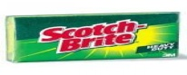, 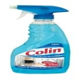, , , , ,  , , 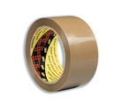 , Etc.

This being a Family Organization, the bearer of this introductory communication will be seeing you and could discuss the matter in details. We feel that confident that given time, trust and opportunity, our association should prove to mutually beneficial and we assure you of our best competitive rates, best qualitative services and prompt attention to your entire satisfaction.
We look forward to win a place amongst your most favored suppliers by our consistently superior quality of products supported by an unmatched service. Waiting for your response and trial order.
Respected Sir / Madam

With Respect to the Above Subject, Please find mentioned below our best rates.

Sub: Quotation for Office Stationery, Computer Consumables & House Keeping Items
Files & Folder 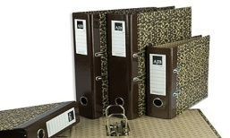
S.No | Description | Rate | Unit
1 | Spring File | 13.00 | Each
2 | Box File Lamination Color1001k | 80.00 | Each
3 | Box File Kangaroo Clip | 60.00 | Each
4 | Box File Blue Color 565 | 95.00 | Each
5 | Plastic L Type Folder F/S | 10.00 | Each
6 | Stick File A/4 | 10.00 | Each
7 | Solo folder A/4 Transparent | 10.00 | Each
Business Card Holders & display book 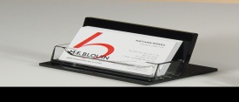
8 | Visiting Card Holder 120 Card | 75.00 | Each
9 | Visiting Card Holder 240 Card | 160.00 | Each
10 | Visiting Card Holder 500 Card | 550.00 | Each
Document Book & CD Album 
11 | Display Book 10 Levees A/4 Size | 45.00 | Each
12 | Display Book 20 Levees A/4 Size | 85.00 | Each
13 | Display Book 30 Levees A/4 Size | 135.00 | Each
14 | Display Book 40 Levees A/4 Size | 155.00 | Each
15 | Display Book 60 Levees A/4 Size | 185.00 | Each
16 | CD Album 40 CDS With Zip | 110.00 | Each
17 | CD Album 80 CDS With Zip | 145.00 | Each
18 | CD Cover Round Plastic | 5.00 | Each
19 | CD Mailer Pouch | 10.00 | Each
Binder Clip & Gem Clip 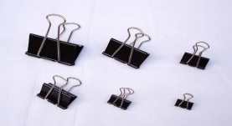
20 | Binder Clip 15 mm | 18.00 | Box
21 | Binder Clip 19 mm | 22.00 | Box
22 | Binder Clip 25 mm | 29.00 | Box
23 | Binder Clip 32 mm | 55.00 | Box
24 | Binder Clip 41 mm | 85.00 | Box
25 | Gem Clip 26 mm | 10.00 | Pkt
26 | Gem Clip 35 mm | 25.00 | Pkt
27 | Plastic Gem Clip 28 mm | 20.00 | Pkt
28 | Paper Pin | 35.00 | Box
29 | Plastic paper Clip | 5.00 | Each
Printer Paper 
30 | A/4 Size J.K Copier Paper 75gsm | 225.00 | Ream
31 | F/C Size J.K Copier Paper | 445.00 | Ream
32 | A/3 Size J.K Copier Paper 75 gsm | 575.00 | Ream
33 | A/4 size Sparkle Paper 75gsm | 225.00 | Ream
34 | TNPL Paper 80 gsm | 285.00 | Ream
35 | A/4 TNPL Copier 75 gsm | 265.00 | Ream
36 | A/4 Size TNPL Copier Paper 70 gsm | 260.00 | Ream
37 | A/4 Size JK Easy Copier Paper 70gsm | 225.00 | Ream
38 | A/3 Size JK Easy copier Paper 70gsm | 560.00 | Ream
39 | JK Eco Rise A4 Paper 75 gsm | 230.00 | Ream
40. | JK Eco Rise A4 Paper 70 gsm | 225.00 | Ream
Spiral Pad & Scribbling Pad 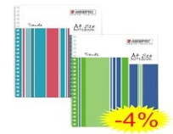
41 | Scribbling Pad A/4 Size | 25.00 | Each
42 | Scribbling Pad 1/6 Size | 20.00 | Each
43 | Scribbling Pad 1/8 Size | 15.00 | Each
44 | Spiral Pad A/4 Size | 55.00 | Each
45 | Spiral Pad 1/6 Size | 45.00 | Each
46 | Spiral Pad 1/8 Size | 35.00 | Each

Note Book & Register & Respite Voucher Book 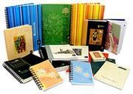

47 | Note Book Deluxe 192 Page | 20.00 | Each
48 | Long Note Book 192 Page | 45.00 | Each
49 | Ruled Register 2Q Abi | 75.00 | Each
50 | Ruled Register 3Q Abi | 85.00 | Each
51 | Ruled Register 4Q Abi | 110.00 | Each
52 | Attendance Register 40pg | 95.00 | Each
53 | Attendance Register 2Q | 195.00 | Each
Gum Tapes, Gum Bottle & Glue Sticks 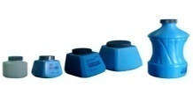, 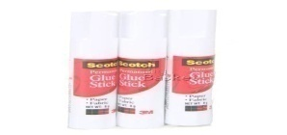

54 | Cello Tape 1” | 10.00 | Each
55 | Cello Tape 2” | 20.00 | Each
56 | Brown Tape 1” | 10.00 | Each
57 | Brown Tape 2” | 20.00 | Each
58 | Brown Tape 3” | 30.00 | Each
59 | Scotch Tape | 85.00 | Each
60 | Double Side Tape 1” | 75.00 | Each
61 | Gum Bottle 700 ml | 85.00 | Bottle
62 | Gum Bottle 300 ml | 40.00 | Bottle
63 | Gum Bottle 150 ml | 25.00 | Each
64 | Gum Tube | 5.00 | Each
65 | Fevi Stick Big/Small | 35/23.00 | Each
66 | Glue Stick Big | 35.00 | Each
Carbon Paper 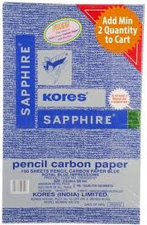
67 | Pencil Carbon Blue | 140.00 | Box
Staplers, Stapler Pins & Punch Machine 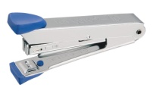, 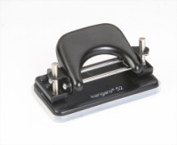

68 | Stapler Machine No-10 | 45.00 | Each
69 | Stapler Machine HD 10 D | 105.00 | Each
70 | Stapler Machine HP 10 | 245.00 | Each
71 | Stapler Machine HD 45 | 110.00 | Each
72 | Stapler Machine HP45 -Big | 235.00 | Each
73 | Stapler HD 1217 Heavy Duty | 1850.00 | Each
74 | Stapler Pin small | 9.00 | Pkt
75 | Stapler Pin big No 24/6 | 18.00 | Pkt
76 | Stapler Pin jumbo No 23/17 | 80.00 | Pkt
77 | Punch Machine No 480 DP | 110.00 | Each
78 | Punch Machine No 600 DP | 165.00 | Each
79 | Punch Machine Heavy Duty 800 | 1340.00 | Each
80 | Single Hole Punch Machine | 105.00 | Each

Pens, Pencil & Markers
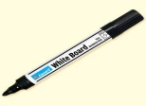, 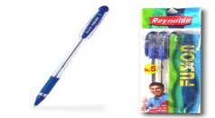, 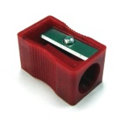, 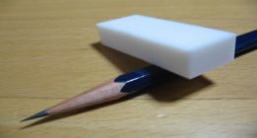

81 | Reynolds Brite | 5.00 | Each
82 | Reynolds Gel Pen | 13.00 | Each
83 | Cello Fine Gripe Pen | 5.00 | Each
84 | Cello Gel Pen | 9.00 | Each
85 | Add Gel Pen Achiever | 55.00 | Each
86 | Pencil Natraj /Apsara Platinum | 45/50.00 | Box
87 | Push Pencil 0.5 mm | 10.00 | Each
88 | Push Pencil 0.7 mm | 10.00 | Each
89 | Sketch Pen Signal | 10.00 | Each
90 | Sketch Pen Set | 20.00 | Set
91 | Highlighter | 18.00 | Each
92 | Permanent Marker | 15.00 | Each
93 | White Board Marker | 18.00 | Each
94 | OHP Marker | 12.00 | Each
95 | Correction Pen | 20.00 | Each
97 | Eraser | 1.00 | Each
98 | Sharpener | 3.00 | Each
Stamp Pad & Ink 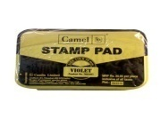
99 | Stamp Pad Big Camlin large | 45.00 | Each
100 | Stamp Pad small | 25.00 | Each
101 | Stamp Pad Faber Castel | 45.00 | Each
102 | Stamp Pad Ink | 25.00 | Bottle
Calculate 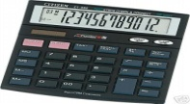
103 | Calculate CT512 Citizen | 225.00 | Each
104 | Calculate MJ 12D Casio | 410.00 | Each
105 | Calculate MJ 120D Casio | 485.00 | Each
106 | Calculate casio DJ 240D | 745.00 | Each
Post It Pad 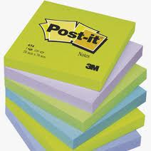
107 | Post It Pad 2x3 | 30.00 | Pkt
108 | Post It Pad 3x3 | 40.00 | Pkt
109 | Post It Pad Prompt 3 color | 55.00 | Pkt
110 | Post It Pad Prompt 5 color | 65.00 | Pkt
Rubber Band 
111 | Rubber Band | 35.00 | Box
Scissor 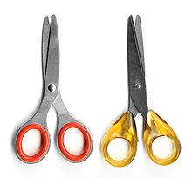
112 | Scissor Big | 75.00 | Each
113 | Scissor Medium | 45.00 | Each
114 | Scissor Small | 35.00 | Each
Paper Cutter 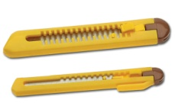
115 | Paper Cutter Big | 25.00 | Each
116 | Paper Cutter | 15.00 | Each

Paper Weight 
117 | Paper Wight Glass | 45.00 | Each
118 | Paper Wight Rubber | 35.00 | Each
Scale 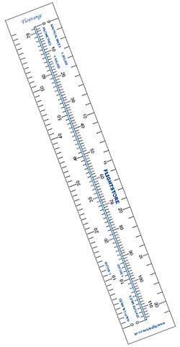
119 | Plastic Scale 12” | 9.00 | Each
120 | Steel Scale 12” | 28.00 | Each
Board Pin 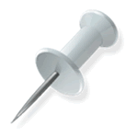
121 | Plastic Board Pin | 35.00 | Pkt
Pen Stand 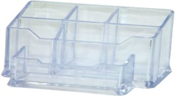
122 | Pen Stand | 45.00 | Each
123 | Pen tray | 95.00 | Each
Paper Tray 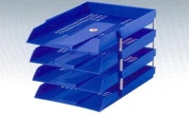
124 | Office Tray Set Of 4 Pic | 490.00 | Set
125 | Omega Tray Set of 2 Pic | 375.00 | Set
Duster 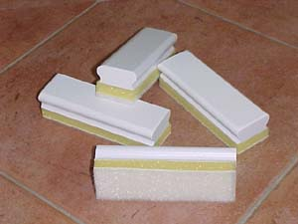
126 | White Board Duster | 25.00 | Each

Telephone Index 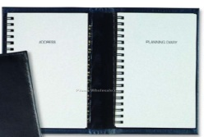
127 | Telephone Index 384 Page | 265.00 | Each
128 | Telephone Index 192 Page | 125.00 | Each

Key chain 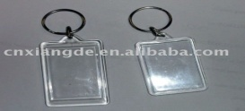
129 | Key Chain Plastic | 5.00 | Each

Office Envelops
130 | A/4 Brown Envelop | 4.00 | Pcs
131 | F/S Brown Envelop | 5.00 | Pcs
132 | A3Brown Envelop | 6.00 | Pcs
133 | A/4 Size White Envelop | 4.00 | Pcs
133. | 11x5 White Envelop | 2.00 | pcs
134 | A/4 Cloth Envelop | 6.00 | Pcs
135 | F/s Cloth Envelop | 7.00 | Pcs
136 | A3 Cloth Envelop | 8.00 | Pcs
137 | 16x18 Cloth Envelop | 25.00 | Pcs

House Keeping:-
, , , , 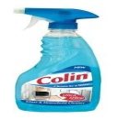, ,, , , , .

138 | Colin Spray | 90.00 | Bottle
139 | Air Freshener with hook | 35.00 | Each
140 | Cleaning Acid | 35.00 | Bottle
141 | Coconut Broom | 35.00 | Each
142 | Dettol 100 ml Bottle | 65.00 | Bottle
143 | Dettol Liquid Hand Wash | 85.00 | Bottle
144 | Harpic 500 ml | 80.00 | Bottle
145 | Hit Spray- | 110.00 | Each
146 | Mop Cloth | 25.00 | Each
147 | Mop Stick Aluminums | 110.00 | Each
148 | Naphthalene Balls | 90.00 | Pkt
149 | Room Fresheners | 75.00 | Each
150 | Scotch Brite | 9.00 | Each
151 | Soap Oil 5 Liters Can | 225.00 | Can
152 | Soft Broom | 75.00 | Each
153 | Steel Scrubber | 15.00 | Each
154 | Table Cloth | 8.00 | Each
155 | Toilet Brush (Plastic) | 75.00 | Each
156 | Urinal Cubes | 35.00 | Pkt
157 | Tide Powder -500gm | 45.00 | Pkt
158 | Vim Soap | 9.00 | Each
159 | Yellow Cloth | 8.00 | Each
160 | Tissue Paper [Fresh] | 30.00 | Pkt
161 | Soap Oil (1 Liter) | 45.00 | Bottle
162 | Mop Refill small/Big | 40/65 | Each
163 | Pril Liquid | 105.00 | Bottle
164 | Rin Soap | 8.50 | Each
165 | Dettol Soap | 30.00 | Each
166 | Fem Liquid 1 Ltr | 160.00 | Bottle
167 | Fem Liquid 250 Ml | 75.00 | Bottle
168 | Lizol Liquid | 95.00 | Bottle
169 | Garbage Bag Extra Large | 75.00 | Box
170 | Garbage Bag Large | 65.00 | Box
171 | Garbage Bag Medium | 50.00 | Box
172 | Garbage Bag Small | 35.00 | Box
173 | Checked Cloth | 8.00 | Each
174 | Dettol 500 Ml | 170.00 | Bottle
175 | Dettol Liquid Soap 1 Liter | 240.00 | Bottle
176 | Domex 500 ML [Toilet /Floor Cleaner] | 88.00 | Bottle
177 | Flush Matic | 45.00 | Pkt
178 | Glass Cloth | 15.00 | Each
179 | Toilet Roll | 25.00 | Roll
180 | C Fold Tissue Napkin | 55.00 | Pkt
181 | Paper Cup 110 ML | 0.55 | Nos
182 | Paper Cup 210 Ml | 0.85 | Nos
183 | Plastic Cup 150 ML | 0.65 | Nos
184 | Plastic Cup 250 ML | 1.00 | Nos
185 | Premier Tissue Box | 69.00 | Box
186 | White Phenyl | 35.00 | Bottle
187 | Vim Liquid | 45.00 | No
188. | Spark Phenyl | 85.00 | Bottle
189. | Mop Stick wood | 85.00 | No
190. | Compound Phenyl | 165.00 | Ltr

ALL PRINTER CARTRIDGE AVAILABLE

NOTE:

Hp/Panasonic/Canon/Lexmark/Xerox/Sam Sung/Brothers New Cartridges & Rifling/We also undertake the making of conference board, Sign Boards, White Boards and other Requested Materials etc.

Thanking you

Terms & Conditions:

- Payments within 30 Days.
- As per TN Govt Implementation for GST
- Delivery Free In Chennai
- Replacement, Repair for Manufacturing or Defected Items Will Be Done, As Per The Terms Of Respective Companies.

Yours Faithfully
Mr. Tikam Kumawat
Cell No-7200057450 / 9884317372
Phone: - 044-28602330 / 31 / 044-28603454 / 55
For: - Reliable Office Suppliers

