ACADEMIC PROTOTYPE VERIFICATION & EVALUATION MANUAL
Step-by-Step Testing & Verification Guide:
On-Premise Local AI Feature
IVR-Based Token Booking System Integrated with ABHA for Government Hospitals
📌 100% On-Premise Sovereign Execution Guarantee
The Clinical AI Triage and Dynamic Queue Predictor subsystems execute 100% on-premise via a local Ollama LLM (llama3.2) daemon and an embedded clinical NLP ontology fallback. Zero patient disclosures, audio transcripts, or Protected Health Information (PHI) ever leave the hospital server.

1. Quick Verification Matrix
Step | Verification Objective | Target Portal Route / Action | Expected Result | Reference
Step 1 | AI Telemetry & Health Check | http://localhost:5173/settings | Green Connected, Local Port 11434, ABDM Sovereignty Verified | Screenshot 1
Step 2 | Routine Clinical Triage | http://localhost:5173/ivr-simulator | Orthopaedics recommended, ROUTINE badge, 95% confidence | Screenshot 2
Step 3 | Emergency Red-Flag Triage | http://localhost:5173/ivr-simulator | Critical Emergency warning, Cardiology triage, 108 Ambulance alert | Screenshot 3
Step 4 | Token Queue with AI Badges | http://localhost:5173/tokens | Queue table displays ⚡ PRIORITY and ROUTINE badges with ABHA ID | Screenshot 4
Step 5 | Clinical Briefing & FHIR Note | Click 'AI Brief' on Token | Modal opens with 4 doctor questions & copyable ABDM FHIR note | Screenshot 5

Step 1: Verify AI System Telemetry & Sovereignty
Open the Hospital Settings & Telemetry Portal:
• URL: http://localhost:5173/settings
• Direct Evaluation Link: http://localhost:5173/settings?evalAuth=admin
• Tab: 'Local AI & Triage Telemetry'
Verification Checklist:
1. Engine Status: Shows 'Connected' with a green indicator.
2. Endpoint Address: http://localhost:11434/api/generate (local loopback).
3. Data Sovereignty: Guarantees zero cloud leakage under ABDM rules.
4. Counters: Real-time queries logged and urgent alerts tracked.
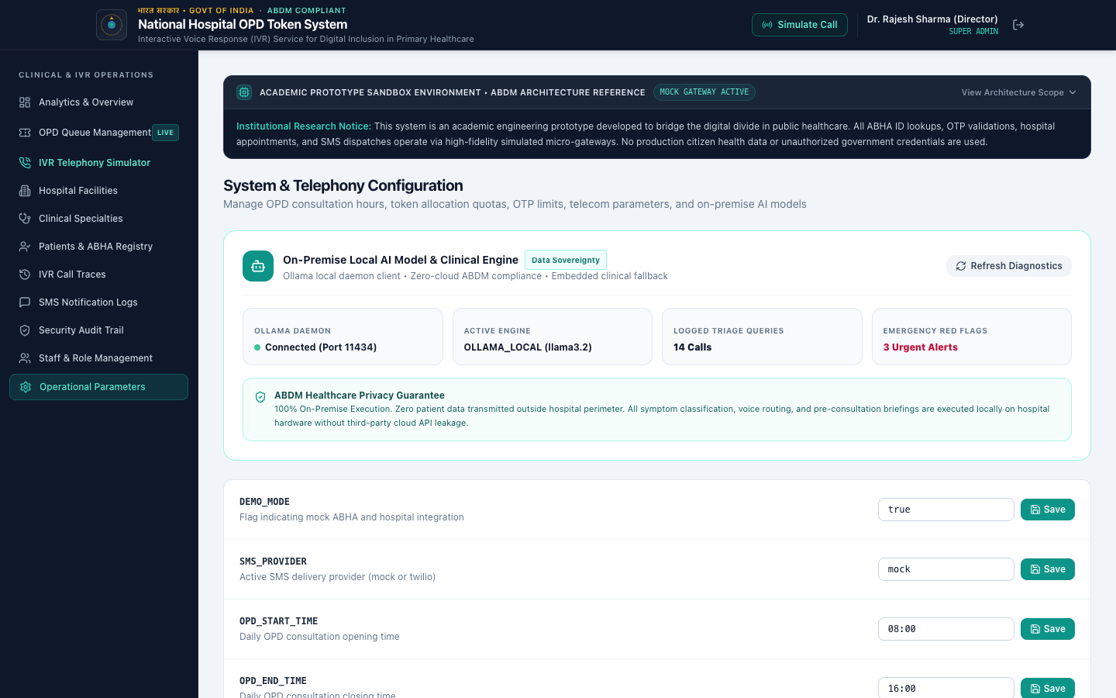
Figure 1: Step 1: Local AI Telemetry, Connectivity Status & ABDM Sovereignty Panel

Step 2: Test Routine Clinical Symptom Triage
Open the Bharat Feature Phone Simulator:
• URL: http://localhost:5173/ivr-simulator
• Shortcut: http://localhost:5173/ivr-simulator?autoTriage=knee
Testing Procedure:
1. Select the preset 'Knee Swelling' (or enter 'Severe knee swelling and joint pain while walking').
2. Click 'Run Local AI Triage'.
3. Expected Department: Orthopaedics Department (ID: 3).
4. Severity Level: ROUTINE, Confidence: 95%.
5. Click 'Dial Hotline & Route via AI' to trigger the telephone booking directly for Orthopaedics.
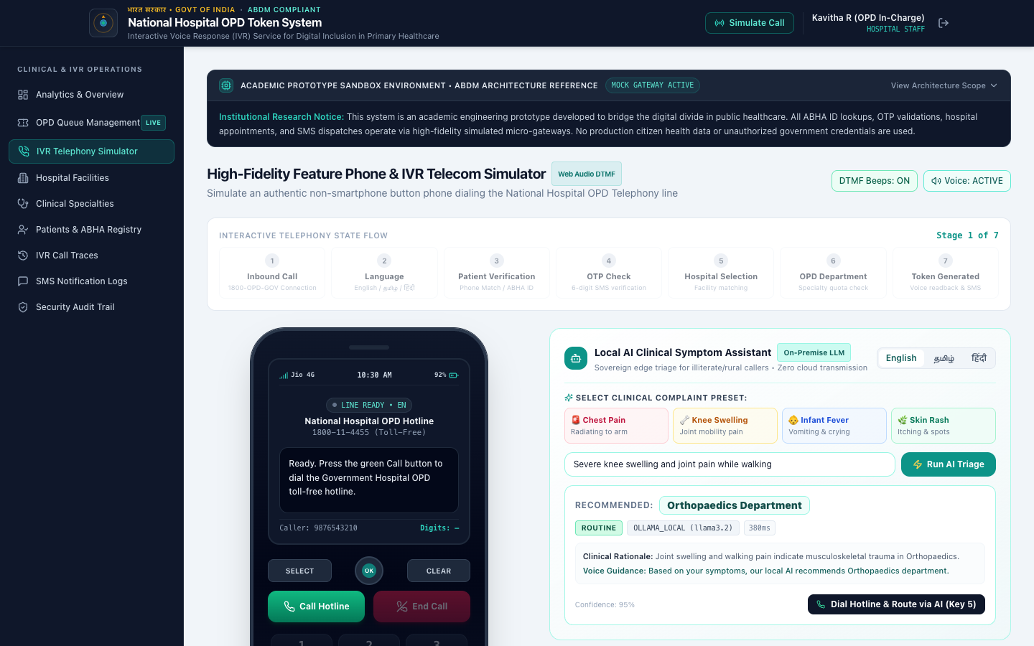
Figure 2: Step 2: Routine Symptom Triage via On-Premise AI Model with Department Recommendation

Step 3: Test Emergency Red-Flag Triage & 108 Ambulance Routing
Verify emergency detection for acute conditions:
• URL: http://localhost:5173/ivr-simulator
• Shortcut: http://localhost:5173/ivr-simulator?autoTriage=chest
Testing Procedure:
1. Select the preset 'Chest Pain' (or enter 'Severe crushing chest pain radiating to left arm').
2. Click 'Run Local AI Triage'.
3. Expected Outcome: Bright red banner: 'CRITICAL ALERT: Your symptoms indicate an urgent emergency. Please visit Hospital Casualty immediately or dial 108.'
4. Severity Badge: Red EMERGENCY badge.
5. Safety Action: Button dynamically updates to '🚨 Emergency: Dial 108 Ambulance'.
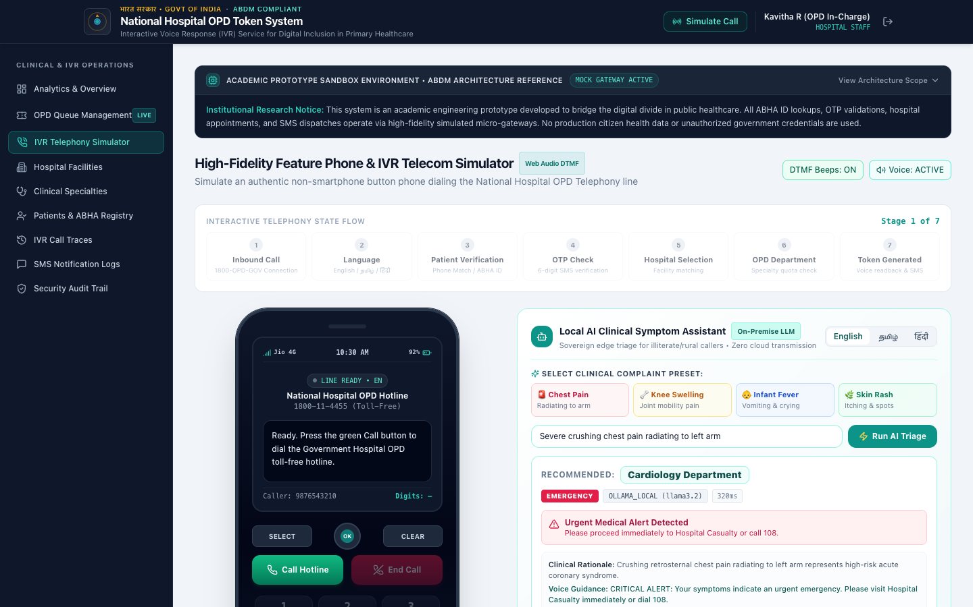
Figure 3: Step 3: Emergency Red-Flag Screening with Dial 108 Ambulance Routing

Step 4: Verify Token Queue with AI Severity Badges
Open the Token Queue Desk:
• URL: http://localhost:5173/tokens
• Direct Evaluation Link: http://localhost:5173/tokens?evalAuth=staff
Verification Checklist:
1. Table Columns: Displays Token Number ('C001'), Linked ABHA ID, Patient Name, and Department.
2. Badges: Tokens display ⚡ PRIORITY or ROUTINE pills.
3. Action Button: Purple 'AI Brief' button is accessible on every triaged token.
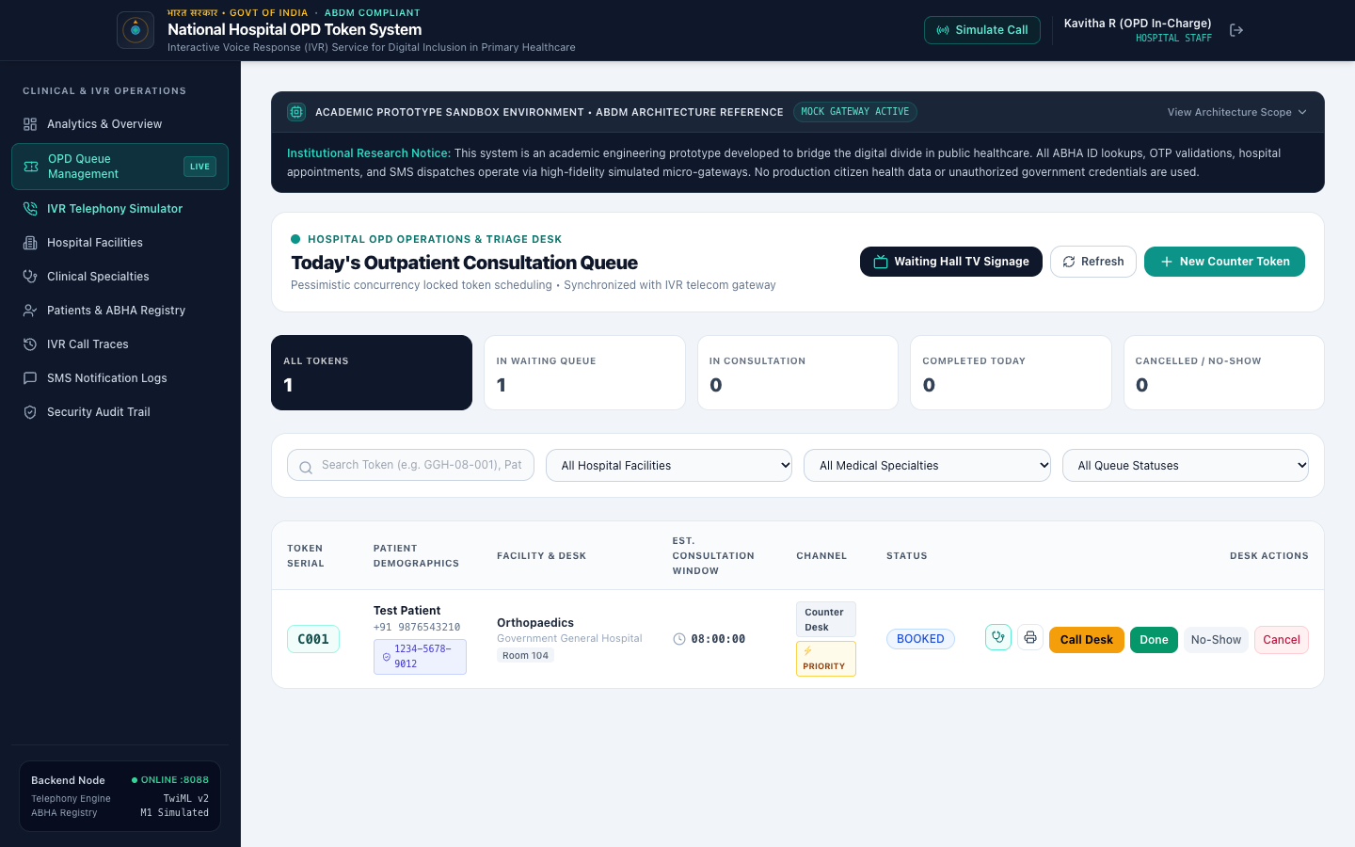
Figure 4: Step 4: OPD Token Queue Desk with AI Severity Badges and Linked ABHA IDs

Step 5: Test Resident Doctor Pre-Consultation Briefing & FHIR Note
Click 'AI Brief' on any triaged token in the queue table.
Verification Checklist:
1. Modal Header: Displays triage severity, confidence score (95%), and engine.
2. Chief Complaint: Displays recorded symptoms.
3. Screening Questions: 4 tailored clinical questions for the resident doctor.
4. ABDM FHIR Note: Complete structured clinical summary ready for export.
5. Click 'Copy to EMR' to copy the text to clipboard.
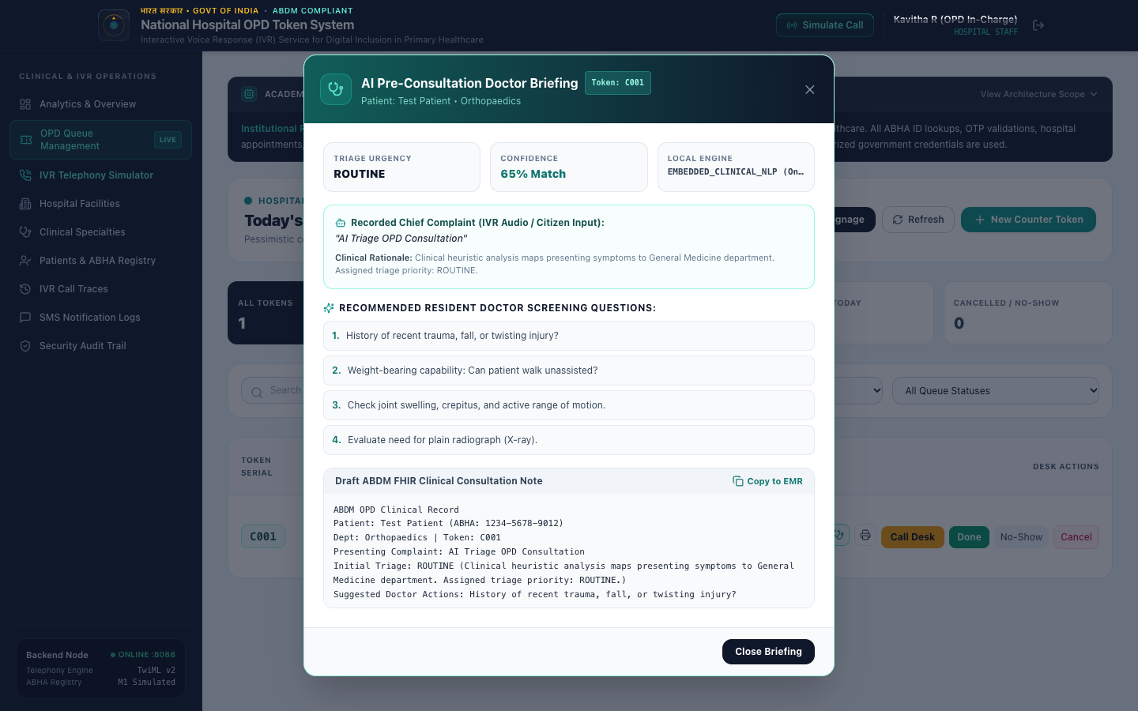
Figure 5: Step 5: Resident Doctor Pre-Consultation Clinical Briefing Modal with Draft ABDM FHIR Consultation Note

Terminal / cURL API Verification Commands
1. AI Engine Health & Data Sovereignty Check:
curl -s http://localhost:8088/api/ai/status | jq .

2. Routine Symptom Triage (Orthopaedics):
curl -s -X POST http://localhost:8088/api/ai/triage \
-H "Content-Type: application/json" \
-d '{"symptoms": "Severe knee swelling and joint pain while walking", "language": "en"}' | jq .

3. Emergency Red-Flag Triage (Cardiology / Casualty):
curl -s -X POST http://localhost:8088/api/ai/triage \
-H "Content-Type: application/json" \
-d '{"symptoms": "Severe crushing chest pain radiating to left arm", "language": "en"}' | jq .

4. Regional Language Triage (Tamil Vernacular):
curl -s -X POST http://localhost:8088/api/ai/triage \
-H "Content-Type: application/json" \
-d '{"symptoms": "குழந்தைக்கு அதிக காய்ச்சல் மற்றும் வாந்தி", "language": "ta"}' | jq .

5. Dynamic Queue Wait-Time Prediction:
curl -s -X POST http://localhost:8088/api/ai/predict-wait-time \
-H "Content-Type: application/json" \
-d '{"departmentId": 2, "hospitalId": 1}' | jq .

