Safety Meta Analysis - Case Control Studies

Chris Robertson

29/04/2021

## Analysis methods

A generic inverse variance method for meta-analysis is used. Statistical heterogeneity of our pooled vaccine safety estimates will be evaluated using the standard x2 and the I2 statistic. Effect estimates from fixed-effect models will only be considered since the same study designs will be carried out in each UK nation. Individual nation’s Risk Ratios (RRs) or Odd Ratios (ORs) and their 95% CIs will be used to estimate the pooled vaccine safety estimates.

The meta-analysis will be based upon the log (RR) and its SE, or the log (OR) and its SE for the SCCS and case control respectively. If, necessary, the SE will be derived from the 95% confidence intervals

Forest plots will be used to visualise any statistical heterogeneity in our pooled estimates across all UK nations.

All statistical tests are two sided and with a 5% significance level. All analyses will be carried out using R/RStudio. The meta package has been used for the analysis and the metagen function.

## Results

## Thrombosis inc CVT SVT

### AstraZeneca

AstraZeneca - Numbers (N) and Number of Events (R)

England

Scotland

Wales

All

Time

N

R

N

R

N

R

N

R

v1_0:27

4683

439

4110

423

2398

214

11191

1076

v1_28+

4455

447

3616

381

1806

178

9877

1006

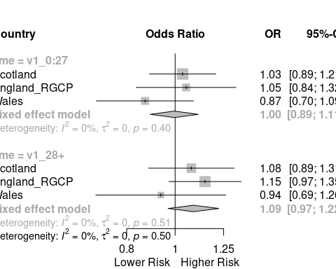

AstraZeneca Dose 1 - Numbers (N) and Number of Events (R)

England

Scotland

Wales

All

Time

N

R

N

R

N

R

N

R

v1_0:6

1154

82

952

92

674

55

2780

229

v1_7:13

1260

112

1074

101

656

66

2990

279

v1_14:20

1207

122

1131

130

575

59

2913

311

v1_21:27

1062

123

953

100

493

34

2508

257

v1_28+

4455

447

3616

381

1806

178

9877

1006

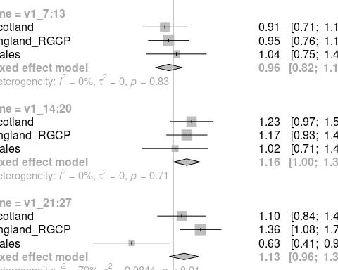 ### Pfizer Biontech

Pfizer-Biontech - Numbers (N) and Number of Events (R)

England

Scotland

Wales

All

Time

N

R

N

R

N

R

N

R

v1_0:27

3537

308

2044

137

1148

93

6729

538

v1_28+

6383

548

2299

203

599

67

9281

818

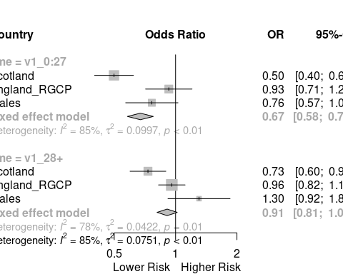

Pfizer-Biontech Dose 1 - Numbers (N) and Number of Events (R)

England

Scotland

Wales

All

Time

N

R

N

R

N

R

N

R

v1_0:6

823

71

460

26

326

19

1609

116

v1_7:13

880

64

589

38

278

30

1747

132

v1_14:20

859

87

547

37

283

26

1689

150

v1_21:27

975

86

448

36

261

18

1684

140

v1_28+

6383

548

2299

203

599

67

9281

818

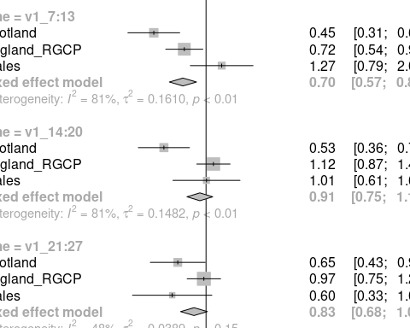

## Thrombosis inc CVT SVT

### AstraZeneca

AstraZeneca - Numbers (N) and Number of Events (R)

England

Scotland

Wales

All

Time

N

R

N

R

N

R

N

R

v1_0:27

4683

439

4110

423

2398

214

11191

1076

v1_28+

4455

447

3616

381

1806

178

9877

1006



AstraZeneca Dose 1 - Numbers (N) and Number of Events (R)

England

Scotland

Wales

All

Time

N

R

N

R

N

R

N

R

v1_0:6

1154

82

952

92

674

55

2780

229

v1_7:13

1260

112

1074

101

656

66

2990

279

v1_14:20

1207

122

1131

130

575

59

2913

311

v1_21:27

1062

123

953

100

493

34

2508

257

v1_28+

4455

447

3616

381

1806

178

9877

1006

 ### Pfizer Biontech

Pfizer-Biontech - Numbers (N) and Number of Events (R)

England

Scotland

Wales

All

Time

N

R

N

R

N

R

N

R

v1_0:27

3537

308

2044

137

1148

93

6729

538

v1_28+

6383

548

2299

203

599

67

9281

818



Pfizer-Biontech Dose 1 - Numbers (N) and Number of Events (R)

England

Scotland

Wales

All

Time

N

R

N

R

N

R

N

R

v1_0:6

823

71

460

26

326

19

1609

116

v1_7:13

880

64

589

38

278

30

1747

132

v1_14:20

859

87

547

37

283

26

1689

150

v1_21:27

975

86

448

36

261

18

1684

140

v1_28+

6383

548

2299

203

599

67

9281

818



## Thrombosis inc CVT SVT

### AstraZeneca

AstraZeneca - Numbers (N) and Number of Events (R)

England

Scotland

Wales

All

Time

N

R

N

R

N

R

N

R

v1_0:27

4683

439

4110

423

2398

214

11191

1076

v1_28+

4455

447

3616

381

1806

178

9877

1006



AstraZeneca Dose 1 - Numbers (N) and Number of Events (R)

England

Scotland

Wales

All

Time

N

R

N

R

N

R

N

R

v1_0:6

1154

82

952

92

674

55

2780

229

v1_7:13

1260

112

1074

101

656

66

2990

279

v1_14:20

1207

122

1131

130

575

59

2913

311

v1_21:27

1062

123

953

100

493

34

2508

257

v1_28+

4455

447

3616

381

1806

178

9877

1006

 ### Pfizer Biontech

Pfizer-Biontech - Numbers (N) and Number of Events (R)

England

Scotland

Wales

All

Time

N

R

N

R

N

R

N

R

v1_0:27

3537

308

2044

137

1148

93

6729

538

v1_28+

6383

548

2299

203

599

67

9281

818



Pfizer-Biontech Dose 1 - Numbers (N) and Number of Events (R)

England

Scotland

Wales

All

Time

N

R

N

R

N

R

N

R

v1_0:6

823

71

460

26

326

19

1609

116

v1_7:13

880

64

589

38

278

30

1747

132

v1_14:20

859

87

547

37

283

26

1689

150

v1_21:27

975

86

448

36

261

18

1684

140

v1_28+

6383

548

2299

203

599

67

9281

818



## Thrombosis inc CVT SVT

### AstraZeneca

AstraZeneca - Numbers (N) and Number of Events (R)

England

Scotland

Wales

All

Time

N

R

N

R

N

R

N

R

v1_0:27

4683

439

4110

423

2398

214

11191

1076

v1_28+

4455

447

3616

381

1806

178

9877

1006



AstraZeneca Dose 1 - Numbers (N) and Number of Events (R)

England

Scotland

Wales

All

Time

N

R

N

R

N

R

N

R

v1_0:6

1154

82

952

92

674

55

2780

229

v1_7:13

1260

112

1074

101

656

66

2990

279

v1_14:20

1207

122

1131

130

575

59

2913

311

v1_21:27

1062

123

953

100

493

34

2508

257

v1_28+

4455

447

3616

381

1806

178

9877

1006

 ### Pfizer Biontech

Pfizer-Biontech - Numbers (N) and Number of Events (R)

England

Scotland

Wales

All

Time

N

R

N

R

N

R

N

R

v1_0:27

3537

308

2044

137

1148

93

6729

538

v1_28+

6383

548

2299

203

599

67

9281

818



Pfizer-Biontech Dose 1 - Numbers (N) and Number of Events (R)

England

Scotland

Wales

All

Time

N

R

N

R

N

R

N

R

v1_0:6

823

71

460

26

326

19

1609

116

v1_7:13

880

64

589

38

278

30

1747

132

v1_14:20

859

87

547

37

283

26

1689

150

v1_21:27

975

86

448

36

261

18

1684

140

v1_28+

6383

548

2299

203

599

67

9281

818



## Thrombosis inc CVT SVT

### AstraZeneca

AstraZeneca - Numbers (N) and Number of Events (R)

England

Scotland

Wales

All

Time

N

R

N

R

N

R

N

R

v1_0:27

4683

439

4110

423

2398

214

11191

1076

v1_28+

4455

447

3616

381

1806

178

9877

1006



AstraZeneca Dose 1 - Numbers (N) and Number of Events (R)

England

Scotland

Wales

All

Time

N

R

N

R

N

R

N

R

v1_0:6

1154

82

952

92

674

55

2780

229

v1_7:13

1260

112

1074

101

656

66

2990

279

v1_14:20

1207

122

1131

130

575

59

2913

311

v1_21:27

1062

123

953

100

493

34

2508

257

v1_28+

4455

447

3616

381

1806

178

9877

1006

 ### Pfizer Biontech

Pfizer-Biontech - Numbers (N) and Number of Events (R)

England

Scotland

Wales

All

Time

N

R

N

R

N

R

N

R

v1_0:27

3537

308

2044

137

1148

93

6729

538

v1_28+

6383

548

2299

203

599

67

9281

818



Pfizer-Biontech Dose 1 - Numbers (N) and Number of Events (R)

England

Scotland

Wales

All

Time

N

R

N

R

N

R

N

R

v1_0:6

823

71

460

26

326

19

1609

116

v1_7:13

880

64

589

38

278

30

1747

132

v1_14:20

859

87

547

37

283

26

1689

150

v1_21:27

975

86

448

36

261

18

1684

140

v1_28+

6383

548

2299

203

599

67

9281

818

