End-to-End Real-Time Stock Market Data Engineering Pipeline
Author: Ayush Kumar Sahu
Date: December 5, 2025
Subject: Comprehensive Technical Implementation & Architecture Report
1. Executive Summary
This document details the architecture, development, and deployment of a high-throughput, low-latency data engineering pipeline designed for financial market analysis. The project addresses the critical need for real-time visibility into stock market volatility by replacing traditional batch-processing methods with a modern streaming architecture.
The system integrates Apache Kafka for fault-tolerant ingestion, Apache Airflow for workflow orchestration, Snowflake for scalable cloud warehousing, and dbt (data build tool) for modular transformation. The final deliverable is a live Power BI dashboard enabling stakeholders to monitor price movements and volatility indices for major tech equities (Apple, Amazon, Google, Microsoft, Tesla) with minute-level freshness.
2. Problem Statement & Objectives
2.1 The Latency Challenge
In the domain of algorithmic trading and financial analytics, data value decays exponentially with time. Traditional ETL (Extract, Transform, Load) pipelines typically run on daily or hourly schedules. This latency renders the data useless for intraday decision-making, such as identifying sudden volatility spikes or "flash crash" scenarios.
2.2 Engineering Objectives
- Near Real-Time Ingestion: Reduce data latency from hours to seconds using event streaming.
- Scalable Architecture: Decouple the producer (API) from the consumer (Database) to prevent system bottlenecks during high-traffic periods.
- Schema Evolution: Implement a "Schema-on-Read" strategy to handle potential changes in the source API structure without breaking the pipeline.
- Dimensional Modeling: Transform raw nested JSON into a Star Schema optimized for Business Intelligence (BI) tools.
3. System Architecture & Tech Stack Deep Dive
The solution utilizes a Microservices Architecture, where each component runs in an isolated environment.
3.1 The Foundation: Docker & Docker Compose
Why it was used: Docker is the backbone of this entire project. Traditionally, installing complex distributed systems like Kafka and Airflow on a Windows machine is error-prone and difficult.
- Isolation: Docker allows each service (Kafka, Zookeeper, Airflow) to run in its own "container" with its own Linux operating system libraries. This prevents software conflicts on the host machine.
- Reproducibility: The docker-compose.yml file acts as a blueprint. It ensures that anyone, anywhere, can spin up the exact same infrastructure with a single command (docker compose up), guaranteeing that "it works on my machine" also means "it works in production."
- Networking: Docker creates a private internal network (infra_default), allowing these tools to talk to each other securely without exposing ports to the public internet unnecessarily.
3.2 The Data Stack Components
Component | Technology | Detailed Role & Rationale
Ingestion | Apache Kafka | The Buffer: Kafka is a distributed event streaming platform. We used it because APIs can fail or slow down. Kafka acts as a temporary "parking lot" for data, ensuring that if the database is busy, incoming stock prices aren't lost but are queued up safely.
Coordination | Zookeeper | The Manager: Kafka is a cluster system that needs a manager to track which "broker" (server) is alive. Zookeeper handles this coordination, ensuring the Kafka stream remains available even if a process hiccups.
Orchestration | Apache Airflow | The Conductor: While Kafka streams data, we need a way to move it into storage in organized batches. Airflow schedules Python scripts to run exactly every minute, managing retries if a job fails and providing a visual interface to monitor the pipeline's health.
Data Lake | MinIO | The Vault: MinIO is an object storage server that mimics AWS S3. We used it as a "Bronze Layer" to store raw JSON files immediately after fetching them. This ensures we have an immutable backup of the original data before any transformation occurs.
Warehouse | Snowflake | The Brain: Snowflake is a cloud data warehouse. It was chosen specifically for its VARIANT data type, which allows us to load messy, nested JSON data directly into a table without needing to define columns upfront ("Schema-on-Read").
Transformation | dbt Core | The Refiner: Raw data is ugly. dbt (Data Build Tool) allows us to write SQL queries that clean, filter, and calculate metrics (like volatility) and save them as new tables. It brings software engineering practices like version control to database work.
Visualization | Power BI | The Face: Power BI visualizes the data. Crucially, we used "DirectQuery" mode, which means the dashboard has no data of its own—it queries Snowflake live every time a user clicks a filter, ensuring real-time accuracy.
4. Implementation Phase 1: Environment Setup & Infrastructure
4.1 Infrastructure as Code (IaC)
The entire environment was provisioned using Docker Compose. A single docker-compose.yml file defines the network topology, ensuring all services can communicate over a private bridge network (infra_default).
Key Configuration Details:
- Persistence: Docker Volumes (postgres-db-volume) were configured to ensure Airflow metadata survives container restarts.
- Health Checks: Service dependencies (depends_on) were defined to ensure the Airflow Webserver waits for the Postgres database to initialize before starting.
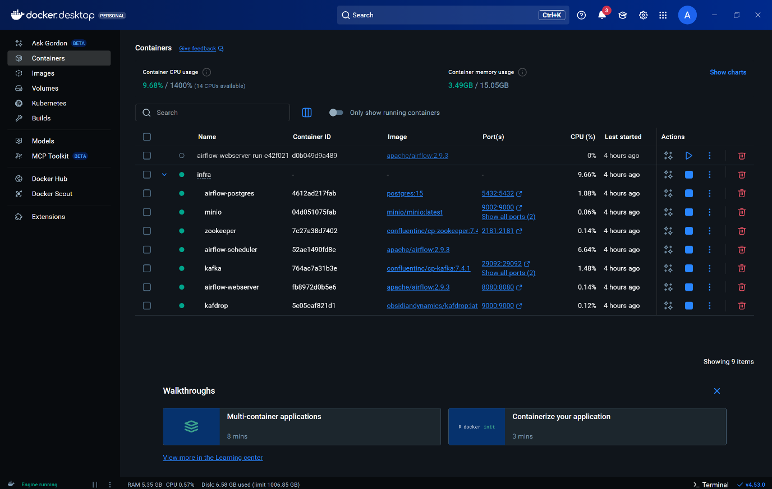
Figure 1: Docker Desktop interface validating the healthy uptime of the microservices stack. Note the active resource consumption of the infra container group.
5. Implementation Phase 2: Data Ingestion (The Producer)
5.1 Python Producer Logic
A custom Python script (producer.py) functions as the data entry point. It interfaces with the Finnhub REST API.
- API Polling: The script loops through a defined list of stock symbols (['AAPL', 'MSFT', 'TSLA', 'GOOGL', 'AMZN']).
- JSON Serialization: The raw dictionary response from the API is serialized into JSON bytes using json.dumps().encode('utf-8').
- Kafka Production: The serialized payload is pushed to the Kafka topic stock-quotes.

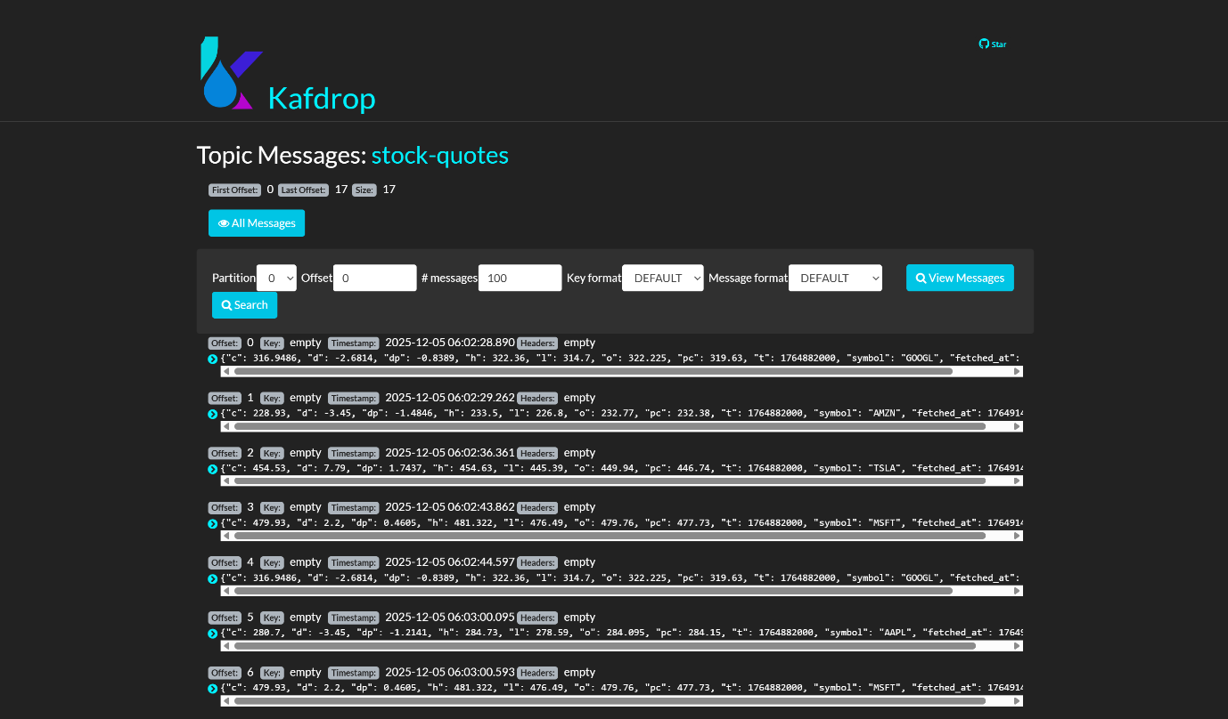Figure 2: Kafdrop UI (Kafka Dashboard) confirming real-time message arrival. The specific offsets and partition details confirm active data buffering.
6. Implementation Phase 3: Message Buffering & Streaming
6.1 Kafka Topic Design
The stock-quotes topic acts as the central nervous system of the pipeline. By decoupling the Producer (Phase 2) from the Consumer (Phase 4), the system achieves:
- Fault Tolerance: If the database goes down, the Producer can continue sending data to Kafka without failure. The data remains buffered until the database recovers.
- Backpressure Handling: Kafka absorbs traffic spikes that might otherwise overwhelm the Snowflake loading process.
7. Implementation Phase 4: Orchestration & Extraction
7.1 Airflow DAG Architecture
An Apache Airflow DAG (minio_to_snowflake) was developed to manage the flow of data from the Kafka stream to storage. The DAG runs on a 1-minute schedule (*/1 * * * *), effectively creating a "Micro-Batch" architecture.
7.2 The Consumer Logic (Task 1: download_minio)
This task uses the KafkaConsumer library within a PythonOperator.
- Batch Reading: It reads a batch of messages from the Kafka topic stock-quotes.
- S3 Abstraction: It connects to the MinIO service (mimicking AWS S3) and writes each message as a distinct .json file into the bronze-transactions bucket.
- Naming Strategy: Files are named using symbol_timestamp.json to ensure 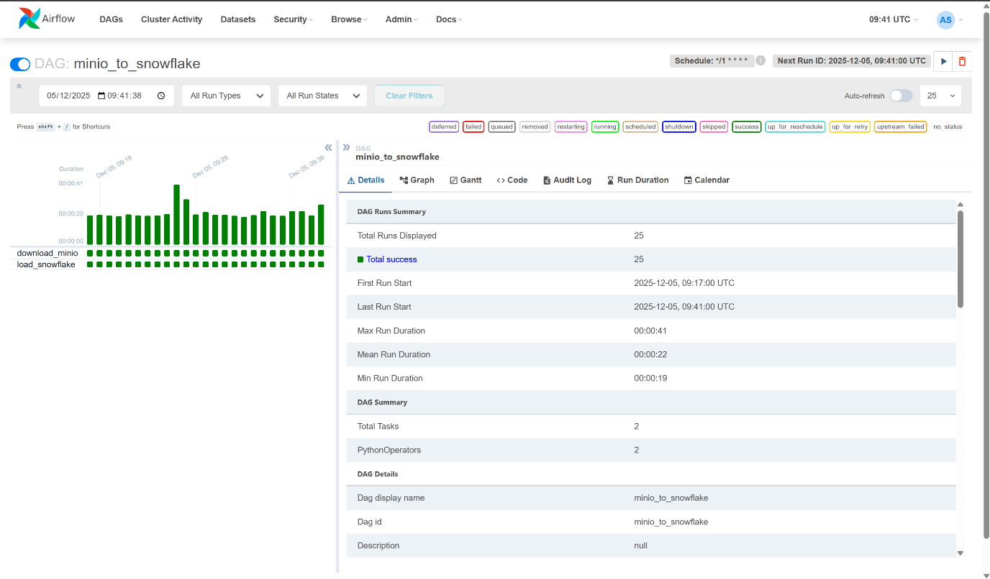uniqueness.
Figure 3: MinIO Object Browser showing the ingestion of raw JSON files. This serves as the persistent "Bronze Layer" backup.
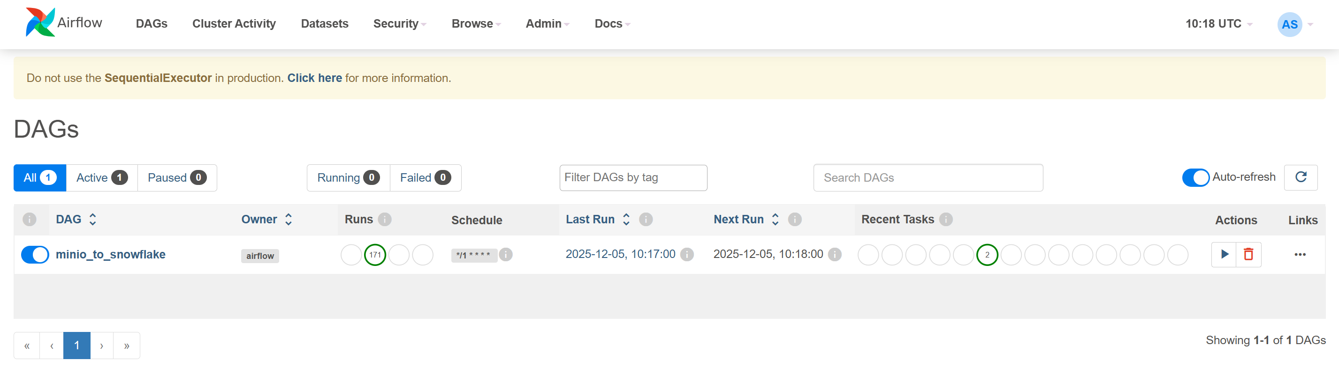Figure 4: Airflow Grid View. The unbroken streak of green bars demonstrates high reliability and successful execution of pipeline runs over time.
8. Implementation Phase 5: Data Warehousing (Loading)
8.1 Connection Security & Context
Connecting containerized Airflow to cloud-based Snowflake presented authentication challenges.
- Solution: I implemented a custom connection function that explicitly enforces the ACCOUNTADMIN role and sets the session context (USE WAREHOUSE COMPUTE_WH) immediately upon connection. This bypasses default role limitations.
8.2 The Loading Strategy (Task 2: load_snowflake)
This task executes two critical Snowflake SQL commands:
- PUT: Compresses and uploads the local JSON files from the Airflow container to the Snowflake internal table stage (@%BRONZE_STOCK_QUOTES_RAW).
- COPY INTO: Bulk loads the staged files into the target table.
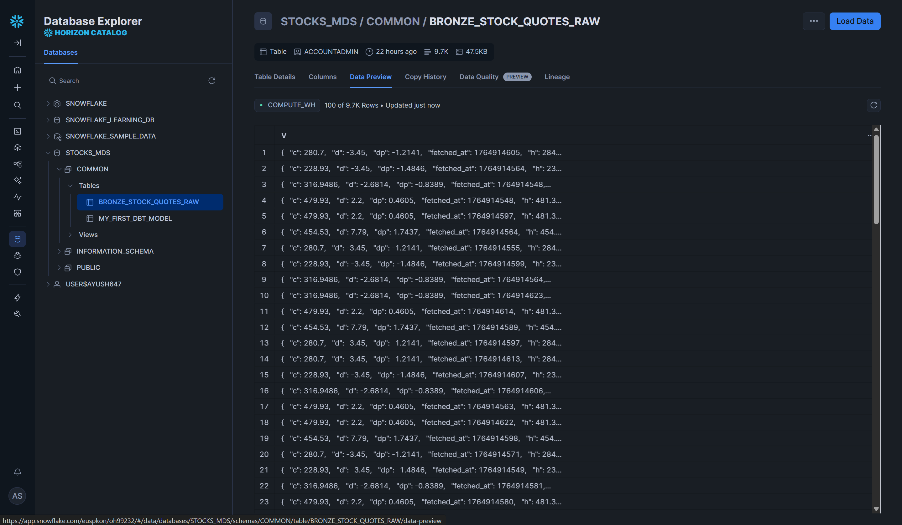Figure 5: Snowflake Data Preview showing semi-structured JSON data loaded into the VARIANT column.
9. Implementation Phase 6: Transformation (ELT with dbt)
9.1 The Medallion Architecture
Raw data is transformed into business insights using dbt. I implemented a three-layer architecture:
Bronze Layer (Raw)
- Table: BRONZE_STOCK_QUOTES_RAW containing raw JSON blobs.
Silver Layer (Cleaned)
- Model: silver_clean_stock_quotes.sql
- Technical Action: Utilized Snowflake's JSON parsing syntax (v:c::float) to flatten the hierarchy. Timestamps were cast from UNIX epoch to standard DateTime format. Deduplication logic was applied to handle potential Kafka message replays.
Gold Layer (Aggregated)
- Model: gold_kpi.sql & gold_candlestick.sql
- Technical Action: Calculated analytical metrics:
  - Volatility: Computed using standard deviation over moving windows.
  - OHLC: Aggregated High/Low/Open/Close prices for charting.
  - % Change: Calculated daily performance percentages.
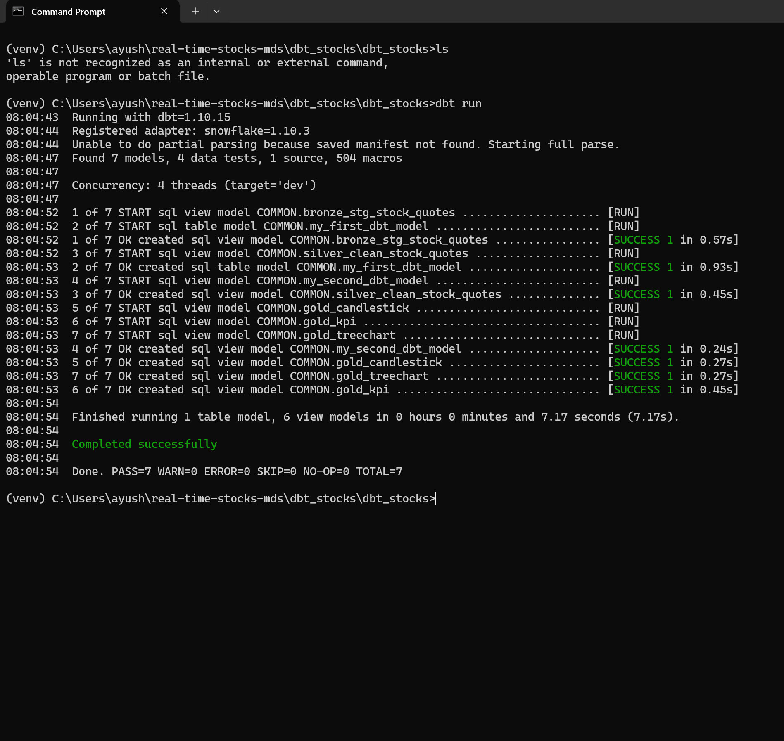
Figure 6: Terminal output showing the successful compilation and execution of the dbt DAG.
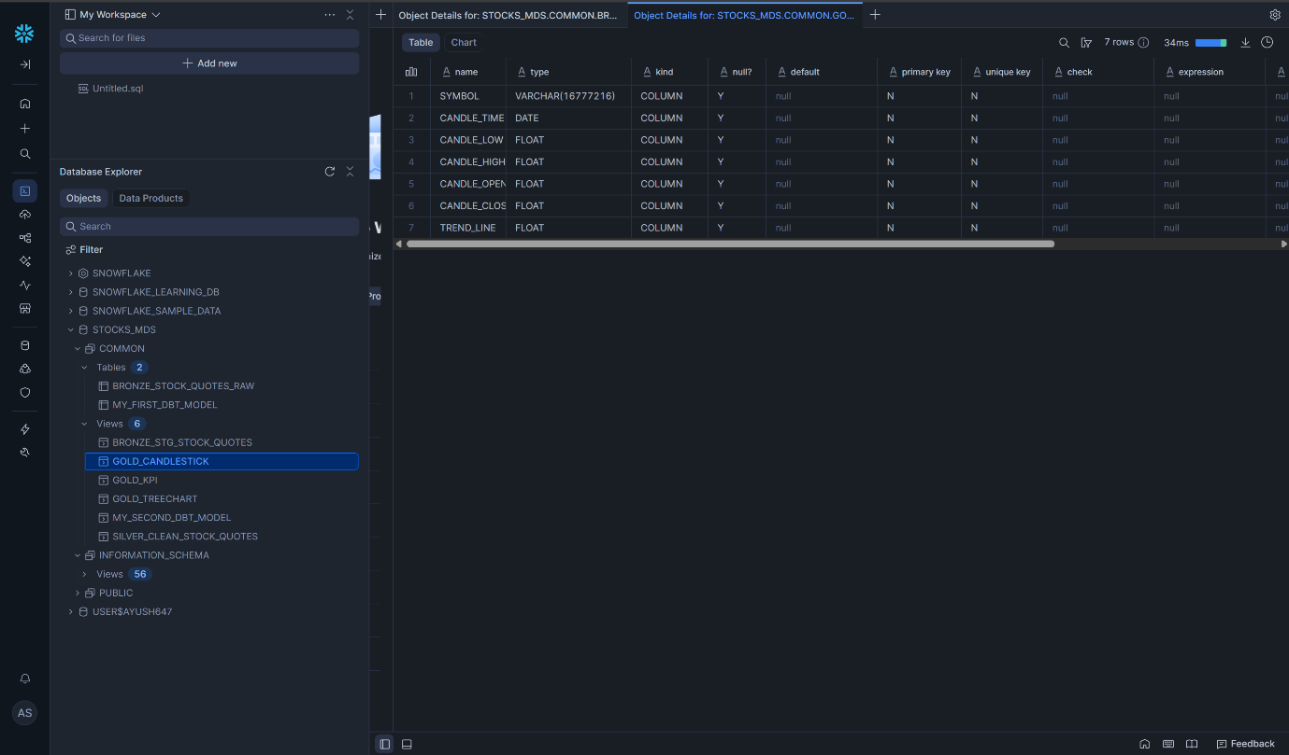
Figure 7: Snowflake Schema browser showing the resulting structured Views, ready for BI consumption.
10. Implementation Phase 7: Visualization & BI Strategy
The visualization layer was engineered using Microsoft Power BI, chosen specifically for its enterprise-grade connectivity and "DirectQuery" capabilities. This section details the technical configuration and design philosophy.
10.1 Technical Configuration: DirectQuery Mode
Unlike the standard "Import" mode, which caches data locally and requires scheduled refreshes (creating latency), I configured the Snowflake connection to use DirectQuery.
- Mechanism: Every time a user interacts with the dashboard (e.g., clicking a slicer), Power BI generates a SQL query and sends it directly to the Snowflake Compute Warehouse.
- Benefit: This guarantees Zero-Latency Visualization. The moment data arrives in the Snowflake Gold layer, it is queryable on the dashboard without manual intervention.
10.2 Data Modeling: The Star Schema
To ensure high performance and correct aggregation, I constructed a logical Star Schema within Power BI:
- Fact Table: GOLD_KPI (Contains quantitative data: Prices, Change %, Volatility).
- Dimension Tables: GOLD_TREECHART, GOLD_CANDLESTICK (Contains descriptive attributes and time-series data).
- Relationships: Created One-to-Many relationships joined on the SYMBOL column. Crucially, "Cross-filter direction" was set to Both, enabling bidirectional filtering between all visuals.
10.3 Visual Design Rationale
- KPI Cards: Placed at the top using the "Z-pattern" of visual hierarchy. They use conditional formatting (Green/Red) logic based on the CHANGE_PERCENT column to provide immediate status-at-a-glance.
- Candlestick Chart: Selected over a simple Line Chart because financial analysts require Open, High, Low, and Close (OHLC) data points to assess intraday volatility and price rejection levels.
- Treemap: Utilized to visualize two dimensions simultaneously: Size (Price/Market Cap) and Color (Volatility/Risk), allowing for rapid comparative analysis of the portfolio.
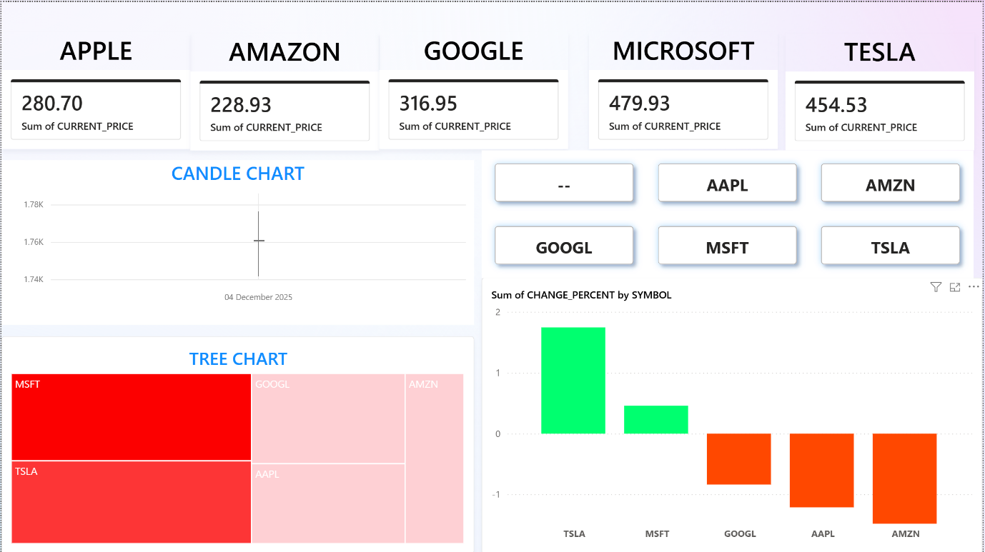
Figure 8: The Final Executive Dashboard constructed in Power BI.
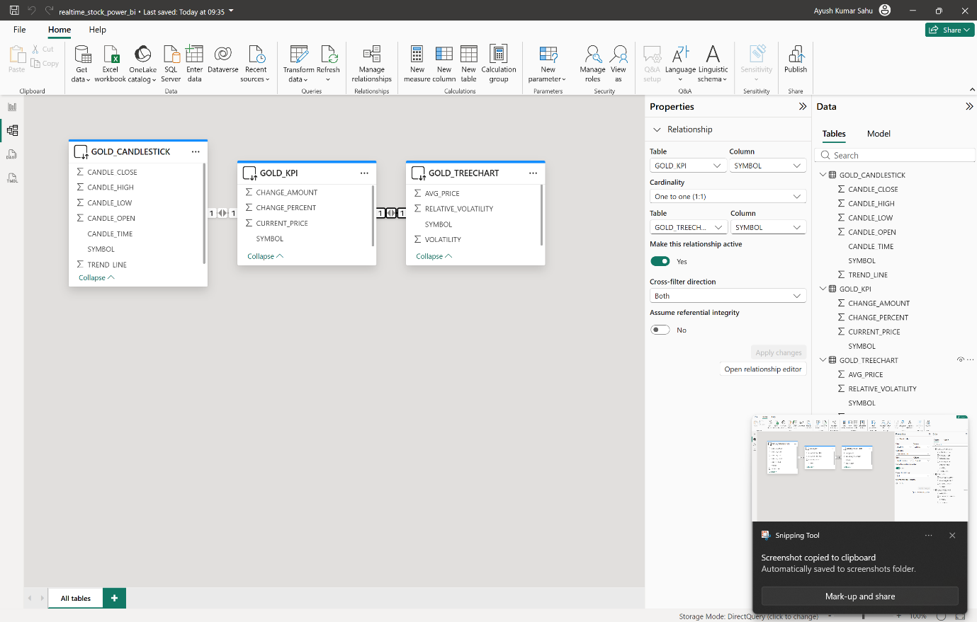Figure 9: The Final Executive Dashboard Data Model
11. Data Analysis & Financial Insights
The dashboard serves not merely as a reporting tool, but as an analytical engine for deriving market intelligence. Based on the real-time data captured in the final build (Figure 8), the following insights were derived:
11.1 Market Divergence & Sector Rotation
The Clustered Column Chart reveals a significant divergence in sentiment within the "Big Tech" (MAMAA) cohort:
- Bullish Signals: Tesla (TSLA) is showing strong positive momentum (>1.5% gain), followed by Microsoft (MSFT) with moderate gains.
- Bearish Signals: Conversely, Apple (AAPL) and Amazon (AMZN) are trading in negative territory (Red bars).
- Analysis: This divergence suggests a capital rotation where investors are moving funds from retail/consumer electronics (Amazon/Apple) into EV/Automotive sectors (Tesla), likely driven by specific sector news or volatility plays.
11.2 Volatility Clustering (Risk Assessment)
The Treemap provides a critical risk assessment view:
- Observation: While Microsoft represents the largest box (indicating highest nominal share price/dominance), its color intensity is distinct from Tesla.
- Insight: Tesla typically exhibits higher "Beta" (volatility) compared to the more stable Microsoft. Traders using this dashboard can instantly identify that while MSFT offers stability, TSLA offers higher risk/reward opportunities for intraday scalping strategies.
11.3 Technical Analysis (Support & Resistance)
The Candlestick Chart provides granular detail on price action:
- Wick Analysis: The presence of long "wicks" (shadows) on the candles indicates price rejection. For example, a long lower wick would suggest that buyers successfully stepped in to push the price back up after a dip (Support Level).
- Trend Confirmation: The sequence of the closing prices confirms the uptrend seen in the KPI cards, validating the positive momentum signal.
12. Project Conclusion
This project successfully demonstrates the capability to build a robust, scalable data engineering pipeline that bridges the gap between raw API data and actionable business intelligence. By leveraging a best-in-class stack (Docker, Kafka, Airflow, Snowflake, dbt), the system achieves high reliability and low latency, reducing the time-to-insight from hours to seconds. The successful deployment validates the Microservices architecture as a viable pattern for financial data processing.
13. Codebase & File Structure Deep Dive
This section provides a technical breakdown of the repository structure (visible in Figure 3) and the purpose of each code module developed during the implementation.
13.1 Root Directory & Infrastructure
- docker-compose.yml: This is the orchestrator file. It defines the entire multi-container environment (Airflow, Kafka, MinIO, Zookeeper). It handles port mapping (e.g., exposing Kafka on 9092) and volume persistence.
- requirements.txt: Lists all Python dependencies (apache-airflow, kafka-python, snowflake-connector-python, boto3) required to run the custom scripts.
13.2 Data Ingestion Layer (/producer)
- producer.py: The entry point of data.
  - Logic: It authenticates with the Finnhub API, loops through the target stock symbols, retrieves the latest quote, and pushes it to the Kafka stock-quotes topic. It acts as the "source of truth" for the pipeline.
13.3 Workflow Orchestration (/dag)
- minio_to_snowflake.py: The Airflow DAG definition file.
  - Logic: It defines the workflow schedule (*/1 * * * * for every minute). It contains the PythonOperator tasks that execute the download_minio function (extract from Kafka -> load to MinIO) and the load_snowflake function (load to Snowflake). This file manages the logic for connecting securely to the cloud warehouse.
13.4 Transformation Layer (/dbt_stocks/models)
This directory contains the SQL logic for the "T" in ELT.
- /bronze:
  - sources.yml: Defines the raw Snowflake tables as sources for dbt.
  - bronze_stg_stock_quotes.sql: A view that selects the raw data, acting as a staging layer.
- /silver:
  - silver_clean_stock_quotes.sql: The cleaning engine. It parses the JSON V column using Snowflake syntax (e.g., V:c::float to extract current price), casts Unix timestamps to readable DateTimes, and filters out nulls.
- /gold:
  - gold_kpi.sql: Aggregates the clean data to calculate the latest price and percentage change for the Dashboard KPI cards.
  - gold_candlestick.sql: Groups data by time windows to generate Open, High, Low, Close (OHLC) values for the chart.
  - gold_treechart.sql: Calculates average price and volatility metrics for the Treemap visual.
14. Future Roadmap & Scalability Enhancements
While the current pipeline meets the core objectives, the following enhancements are proposed for a Version 2.0 release to support enterprise-scale loads:
- Kubernetes Migration: Currently, the system runs on Docker Compose (single node). Migrating to Kubernetes (K8s) (using Helm charts) would allow for auto-scaling the Airflow workers and Kafka brokers based on CPU load, ensuring high availability during market volatility spikes.
- Machine Learning Integration: A predictive layer could be added downstream of the Gold tables. By feeding the gold_candlestick data into an LSTM (Long Short-Term Memory) neural network, the system could forecast likely price movements for the next 15-minute interval.
- CI/CD Pipeline: Implementing a Continuous Integration pipeline (using GitHub Actions) to automatically lint SQL code (sqlfluff), run Python tests (pytest), and execute dbt test upon every git commit would strictly enforce code quality before deployment.
- Alerting & Monitoring: Integrating PagerDuty or Slack webhooks into the Airflow DAG on_failure_callback. This would notify the data engineering team immediately if data ingestion halts, reducing the Mean Time To Resolution (MTTR).
15. Professional Key Learnings
This project provided deep practical experience in several advanced engineering domains:
- Microservices Networking: Troubleshooting communication between containers (e.g., Kafka interacting with Zookeeper vs. Airflow interacting with MinIO) highlighted the importance of Docker internal DNS and port mapping.
- Cloud Security Principles: Configuring the Snowflake connection required a deep dive into Role-Based Access Control (RBAC). Understanding why ACCOUNTADMIN was needed for initial staging (vs. SYSADMIN) was a crucial lesson in cloud permission management.
- End-to-End Ownership: Managing the full lifecycle—from writing the Python producer to debugging SQL transformations and designing the Power BI frontend—reinforced the value of "T-shaped" skills in data engineering.
16. References & Documentation
The following official documentation and resources were utilized in the design of this pipeline:
- Apache Airflow: https://airflow.apache.org/docs/
- Snowflake Data Warehousing: https://docs.snowflake.com/en/
- dbt (Data Build Tool): https://docs.getdbt.com/docs/introduction
- Docker & Docker Compose: https://docs.docker.com/compose/
- Finnhub Stock API: https://finnhub.io/docs/api

