Example of Organization with Styles: Heading 1 is the Top Level of a Structured Document

Heading 2: Opens the Sections of this Document
Here is some information about the first heading 2. It gives some details and supports the general information contained within the paragraph.

Heading 2: Illustrated By A List Of Points
- Point one
- Point two
- Point three

Heading 2: A Point That Need A Graph To Support It
The following graph of “Completion Rate for Attempted Tasks” has used patterns, so people who are colorblind can distinguish the different regions (also helps if copied in black and white.) As illustrated in the following graph, North (solid yellow) has had a very steady year, being the most consistent performer completing around 40 percent of attempted tasks. East (diagonally striped) has performed at about half that rate (20%) every quarter except for the third quarter when it showed a peak of 90 percent completion rate. West (red & white dots) has varied between 30 percent and 40 percent throughout the year. Since I did not caption the graph, I have explained the results in my text. I can also use alternative text to offer a textual interpretation of the results. This allows people who are not able to see the graph, to also understand the point I want to make.
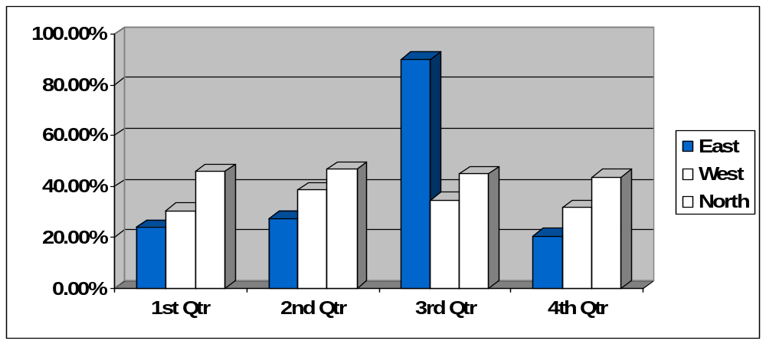

Heading 2: Introduces Tabular Data
Here is some information about another category that actually needs to be subdivided in order to clarify its three points.
Table 1—How Word Styles Transfer to PDF and HTML.
 | Supports Image and alternative text? | Supports Page Headers and Footers? | Supports Heading levels? | Supports embedded URLs? | Supports Navigation? | Supports information from Styles > Preferences? | Supports auto numbering?
Adobe PDF (created  through  “Convert to PDF” | Yes—replicates exactly, alt text becomes “Tooltip” when mouse is over picture. | Yes—replicates exactly. | Yes—will create bookmarks based on heading level, too. | Yes | Yes —headings transfer to Bookmarks. | Yes— will transfer all information and create searchable metadata. | Supported the numbers.
HTML (created through “Save as Filtered HTML” | Yes—may realign orientation. Displays alt as “tooltip”. | No—ignores content. | Yes | Yes | Yes— Headings retained. Also, Table of Contents can create hyperlinks based on headings. | Partial—Title will transfer.  If not “Filtered”, will comment the information in the head section. | Supported Ordered List and numbering.

Heading 3: The First Point about Table 1
Supportive text explains this point. It goes on about why this is true. It also explains why this is important.

Heading 3: The Second Point about Table 1
Supportive text explains this point. It goes on about why this is true. It also explains why.

Heading 4: A subsection of my Second Point
The following image was added to illustrate the importance of alternative text descriptions of images. Alternative text is added to an image to provide a textual alternative to visual information. It is important to remember that some users won’t see your web page, they’ll hear it! Your challenge, then, is to imagine perceiving the content of your document through your audience’s ears.
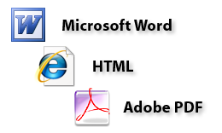

Heading 4: Another subsection of my Second Point
Supportive text explains this point. It goes on about why this is true. It also explains why this is important.

Heading 3: The Third Point about Table 1
Supportive text explains this point. It goes on about why this is true. It also explains why this is important.

Heading 2: Summary
My summary is supportive text explains all of my points. It goes on about why this is true. It also explains why this is important and my conclusions from these findings.

