LuRaCs - Reference Manual
Erik Ewald

Getting Started
Licence, Warranty and Research Use
This software is free and open-source software distributed under the terms of the GNU General Public License, version 3 (GPLv3).
The software is provided “AS IS” and WITHOUT WARRANTY OF ANY KIND, to the maximum extent permitted by applicable law. The warranty disclaimer and limitation of liability contained in Sections 15 and 16 of the GPLv3 apply to the software.
Lund University and its contributors make no representation or warranty that the software is accurate, reliable, error-free, uninterrupted, or suitable for any particular purpose.
Research Use
This software is intended as a research and experimental tool for gamma spectroscopy and mobile radiation measurements. It is not intended to constitute a certified measurement system, and measurement results should not be assumed to be accurate or suitable for regulatory, safety-critical, medical, environmental, or other consequential applications without appropriate independent validation.
Measurement results may be affected by the detector, electronics, calibration, measurement geometry, environmental conditions, acquisition parameters, data processing, and other factors.
Users are responsible for evaluating and validating the software and its results for their particular research application.
To the maximum extent permitted by applicable law, Lund University and its contributors accept no liability for any loss, damage, decision, action, or omission arising from or in connection with the use of the software or reliance on measurements or results obtained using the software.
Nothing in this notice excludes or limits any liability that cannot legally be excluded or limited under applicable law.
The complete GNU General Public License version 3 is provided with the software.

Introduction

LuRaCs-H3
LuRaCs-H3 is a light weight version of the compiled program indented for system with limited storage. It excludes heavy components to reduce file size of the executable. It is approximately 250 MB smaller than the regular version. The following systems are excluded in the H3 version.
- The embedded map, position data can still be recorded.

Installation
LuRaCs distributed as binary does not require any installs before use, with the exception of usb drivers on Windows.
Before installing, ensure that Python version 3.10, 3.11, 3.12 or 3.13 is installed on the system. The Python installation can be verified by opening cmd on windows or a Terminal on MacOS and Linux and entering python –version or python3 –version, if Python is correctly installed the version will be displayed.

With pip
When Python has been correctly set up, make a new folder for the install and open cmd or a terminal in that folder. On Windows enter the following commands in cmd:
powershell # Make a new python environment python -m venv .venv
# Activate the environment .v̇env
# Install pip install luracs
# Run LuRaCs
On Linux and MacOS run the following bash commands:
bash # Make a new python environment python3 -m venv .venv
# Activate the environment source .venv/bin/activate
# Install pip install luracs
# Run LuRaCs
This will install all decencies for the full version of the application and provide the start script LuRaCs.

From source
LuRaCs can be installed from source by cloning the GitHub repository. Installing from source requires a C/C++-compiler for compiling Cython extensions. When installing from source to edit the code, run pip install -e .[dev] to install in editable mode. The will also install development tools like pyinstaller and pytest.
bash # Clone the the GitHub repo git clone –recursive https://github.com/EBELU/LuRaCs.git cd LuRaCs
# Install with pip pip install . # Run LuRaCs

Connecting Detector
Currently implemented devices
Model | Manufacturer | Connections | Note
RadiaCode-1xx | Radiacode | USB, BLE
Raysid | Raysid | BLE
digiBase | Oretec Ametek | USB | Requires Ortec Firmware
digiDart | Oretec Ametek | USB
DetectiveX | Oretec Ametek | NETWORK
In order to use USB connected devices on Linux the udev-rules must be updated by adding the following permissions depending on the device.
bash # Radiacode SUBSYSTEM=="usb", ATTRidVendor=="0483", ATTRidProduct=="f123", TAG+="uaccess", MODE="0660"
# digiBase/digiDart SUBSYSTEM=="usb", ATTRSidVendor=="0a2d", GROUP="users", MODE="0666"
Connecting devices over the network likely requires setup specific to that instrument so no general guide is provided. See example 3.2 for how this can be done for the Ortec Ametec Detective X.
Connecting a digiBase requires the files containing the necessary firmware. These files can be found in the install directories of the Maestro and Gamma Vision software provided by Ortec. LuRaCs does not provide these files and users are responsible for acquiring these files in accordance with applicable licences. Once the files have been identified they can be reached by LuRaCs by saving them in the driver library. Select File -> Import Drivers and select the files. If they appear in File -> Drivers they can now be reached by LuRaCs.

Compatible file formats
LuRaCs is compatible with a selection of file formats, both standard and more niche third party formats. However, LuRaCs is not primarily intended to support general spectrum analysis so if you are looking for a general analysis application consider using InterSpec instead.
Compatible spectrum formats.
Source | Extension | Contained Data
Radiacode | .xml | Counts, background, live time, real time, calibration
Several | .n42 | Counts, background, live time, real time, calibration
Ortec | .spe | Counts, live time, real time, calibration
Canberra | .tka | Counts, live time, real time
Compatible track formats.
Source | Extension
Radiacode | .rctrk

Package dependencies and Resources

Terms & Object Definitions

Spectrum
is a data object that contains count histograms from a radiation detector and associated meta data. A spectrum contains the following information:
- Spectrum name.
- Number of channels, fore- and background must have the same number of channels.
- Optional remark or description.
- Detector identifier.
- Detector model.
- Fore- and Background spectrum.
- ROIs and analysis results from evaluating the ROI on the spectrum like counts and parameters from a curve fit.
- Calibration coefficients for converting channel number to energy.
- Calibrated X-axis expressed in keV.
- Reference to the instrument used for calculations.

Region Of Interest (ROI)
is a spectrum region bounded by energy. They can be applied both in a spectrum and in a spectrogram. When applied to a spectrum a Gaussian function can be fitted to a peak contained inside the ROI.
When applied to spectrograms ROIs do not perform any curve fitting, only the summed counts inside the ROI are calculated. The time series produced from a spectrogram ROI can be viewed separately in the map. Spectrograms can use special ROIs called Calculation ROIs or CalcROIs. These are calculated from data produced by two other ROIs by combining their values with addition, subtraction or division. For example, CAL_0 (a Calculation ROI) can show the results of ROI_0 / ROI_1 where ROI_0 is placed over the K-40 peak and ROI_1 is placed over the Cs-137 peak.

Spectrogram
is the primary method for recording time series data. It allows for measuring the difference in counts in each channel between time points separated by a fixed time. It also interfaces with the GPS function and can store geolocational information for mobile measurements. A spectrogram is a rather complicated object and is discussed further in other parts of this manual, see section [sec:file_spectrogram].
Options when creating a spectrogram are
- Detector to use for data.
- Spectrogram name.
- Save interval, the time between each row.
- If channels should be concatenated, concatenating by a factor 2 means summing two channels to one, halving to total number of channels. Useful for reducing filesize and improving visual analysis.
If spectrum corresponding to the detector used for the spectrogram is energy calibrated this calibration is also used for the spectrogram.

Instrument
s are divided into Generic and Unique instruments. Generic Instrument represent an instrument model. All instruments of the same model share some properties, of which the Generic Instrument stores the following:
- Model name.
- Manufacturer.
- Detector material.
- Sensitive volume size.
- Energy Resolution.
- Intrinsic Energy Efficiency.
A Unique Instrument represents a specific instrument of a certain model. The Generic Instruments serve as a basis for quickly making a new Unique Instrument. A Unique Instrument store the same information as a Generic Instrument in addition to an energy calibration. Unique Instruments can be assigned to a spectrum from which certain tools can pull required data for calculations and they can store the energy calibration for instruments that do not store it themselves.

Detector
denotes an external instrument for detecting radiation that LuRaCs can sample data from. They can be connected through USB, Bluetooth or a network. Each type of detector have their own ’client’. LuRaCs interacts with detectors through clients which contain the code needed to interact with the physical detector but each client can be implemented differently. This structure makes detector implementations in LuRaCs flexible and easily extensible.

Abbreviations
List of abbreviations used in this manual
CLI | Command Line Interface
CPS | Counts Per Second
GUI | Graphical User Interface
ML-EM | Maximum Likelihood - Expectation Maximisation

Interface

Top Tabs

Spectrum
The spectrum view shows spectra as a count histograms, retrieved from a connected device or loaded from a file. It can show several spectra combined in one plot or separately. This can be changed under Options -> Tabbed-/Combined Spectrum View.
Background spectra can be viewed as one the three following methods No background, Background overlay and background subtract. Background overlay shows the background spectrum overlaid on top of the main spectrum. Background subtract does channel wise subtraction of the background from the foreground spectrum, this is a hard background subtraction and will effect ROI calculations on the spectrum. Both Background overlay and background subtract only show values of count rate.
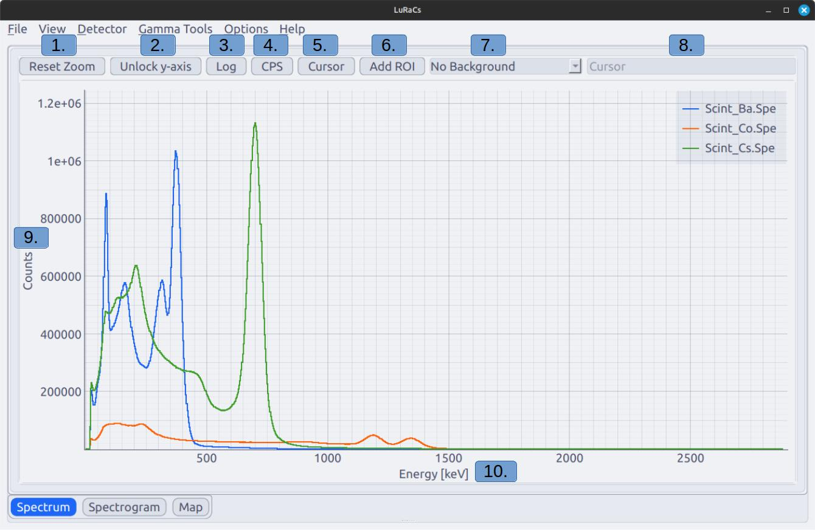
Spectra of Ba-133, C-60 and Cs-137 displayed in Combined Spectrum View.
- Rest Zoom resets the zoom of the spectrum and locks the y-axis if unlocked.
- Unlock y-axis allows the y-axis to be zoomed independently and disables autoscaling.
- Log set the scale of the y-axis to logarithmic.
- CPS normalises the spectrum to the live time, or real time if live time is not available but real time is.
- Cursor toggles the spectrum cursor, see .
- Add ROI adds a customisable region of interest to the spectrum, see .
- Switch the use of background spectrum. Options are No background, Background overlay and background subtract. See the section above.
- Display for info from the cursor, see .
- The y-axis show either total counts or time normalised counts in units of .
- The x-axis always display energy in units of keV.
Regions of interest (ROI) are sub regions of the spectrum bounded in energy and are useful in the analysis of spectrum peaks. Spectrum peaks can in most cases be approximated with a Gaussian function and knowing the function parameters to describe is useful for many analyses. LuRaCs provides a method for fitting Gaussian functions to peaks inside ROIs and do so by default. These fits are required by other tools in the application. However, ROIs can also be configured to not perform fits, in these cases only the total ROIs counts are calculated.
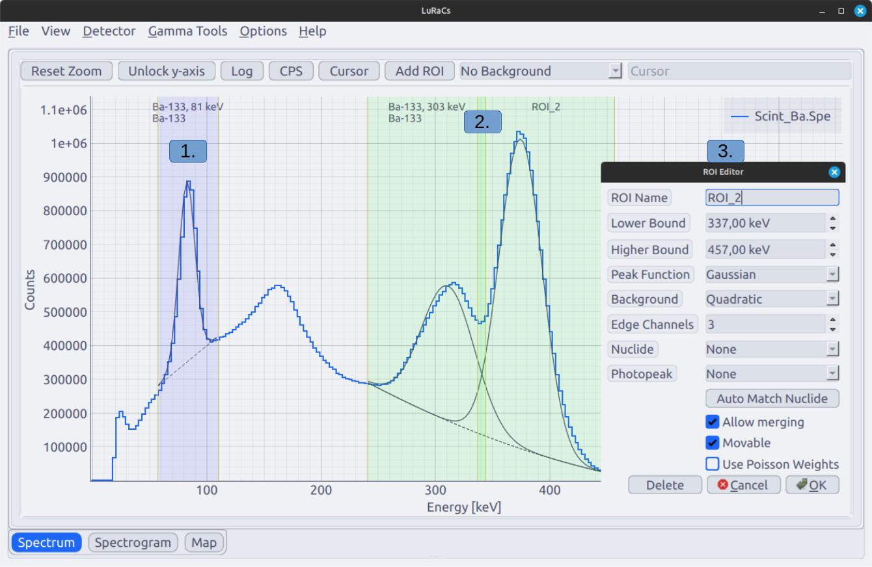
A Ba-133 spectrum with three ROIs, two are merged and fitted to the same background. The ROI editor is open for the right most ROI.
- A ROI with one peak and a fitted Gaussian peak and linear background.
- Two merged ROIs that fit two Gaussian peaks on a shared quadratic background.
- The ROI editor for ’ROI_2’, see .
ROI Editor options
Field | Description
ROI Name | An alias for the ROI used for display purposes and easier identification.
Lower Bound | The lower energy bound of the ROI.
Upper Bound | The upper energy bound of the ROI.
Peak Function | The type function fitted to the peak. Options are: Guassian, None
Background | Type of function used as peak background. Options are: None, Linear, Quadratic
Edge Channels | The number of channels inside of ROI from the upper and lower bounds of the ROI used to fit the background.
Nuclide | Assign a nuclide from the reference library to the ROI. Used for calculations by other tools.
Photopeak | Choose the specific photon emission associated with the peak in the ROI. Options are based on the chosen nuclide.
Auto Match Nuclide | Attempt to automatically find the Nuclide and Emission of the peak. If any nuclides are check and shown in the spectrum the match is limited to these. Blind matches are often unreliable.
Allow Merging | Allow the ROI to merge with other ROIs with merging allowed.
Movable | If the ROI can be moved by using the mouse.
Use Poission Weights | Apply a 1/$σ$ weight to the optimisation to force the peak to emulate a Poission distribution.
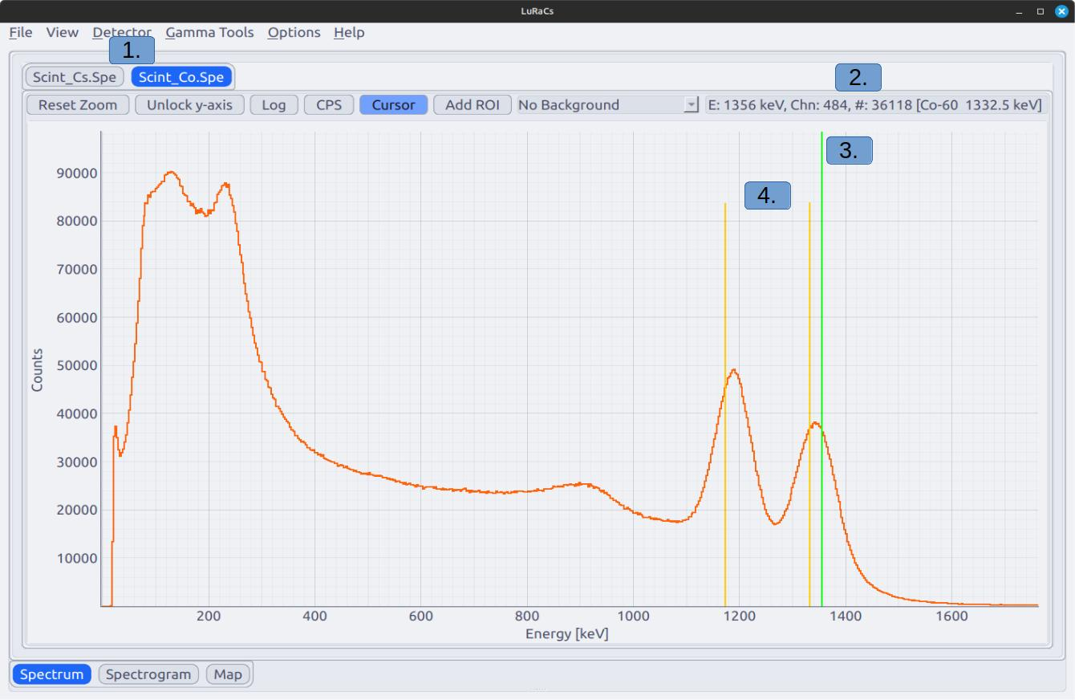
Co-60 spectrum with an active cursor.
- Tabs for selecting spectrum in Tabbed Spectrum View.
- Information about the cursor, it shows position of the cursor in units of energy, corresponding channels number, the number of counts in the channel, closest reference emission line as [nuclide Emission Energy Decay chain if applicable]. Channel and channel counts are only displayed in tabbed spectrum view.
- Cursor in the spectrum.
- Emission lines of the suggested nuclide. These are always to closest to the cursor and does not weigh intensity or anything else. Can be disabled by View -> Spectrum -> Show Cursor Emissions.

Spectrogram
A spectrogram allows time-series measurements to be conducted. A spectrogram stores data at specified time intervals and can be displayed in a waterfall plot. It is also the method LuRaCs uses for mobile measurements. If a GPS is connected the geolocation data provided is automatically stored in the spectrogram. These measurements can visualised on the embedded Map.
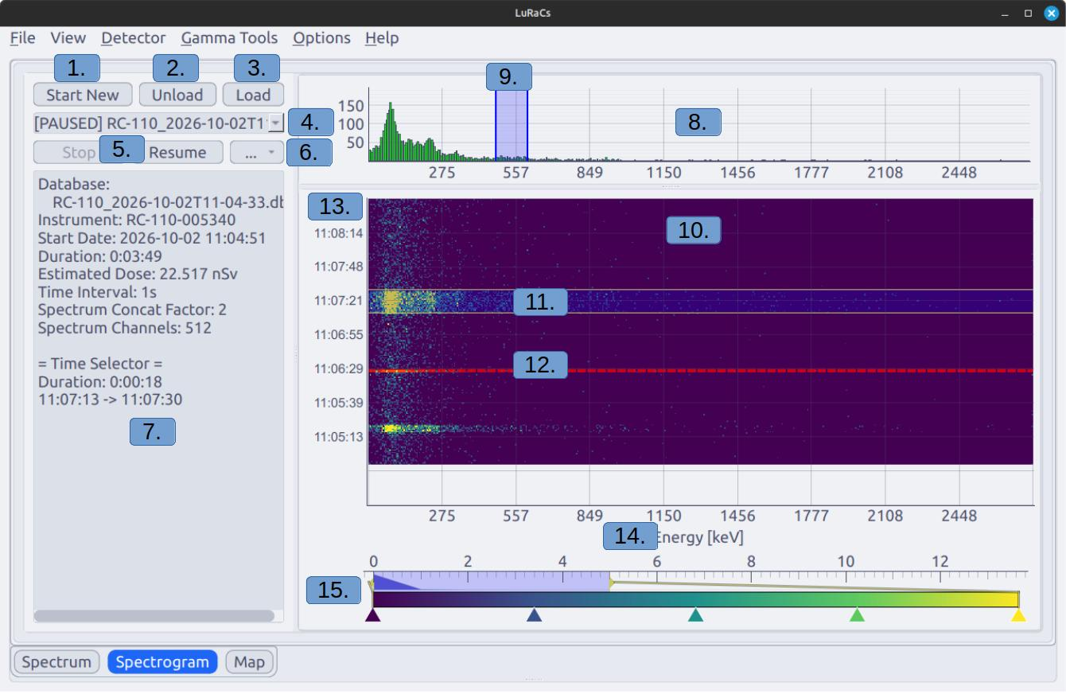
Measured spectrogram with the Time Selector active and one ROI.
- Opens a dialog for starting a new spectrogram.
- Close the viewed spectrogram.
- Shortcut to the Data Store Spectrogram page, see section 2.7.
- Selector for currently loaded spectrograms. Status is shown to the left as [ACTIVE], [LOADED] or [PAUSED].
- Pause or Resume data collections, requires that the same instrument used collect the previous data to be connected.
- Options menu, see
- Current information stored in the spectrogram and information about the Time Selector if active.
- Count histogram. Shows either total accumulated spectrum upon loading a measured spectrogram, summed channel counts inside the Time Selector if active or counts in the latest row.
- ROI illustrated in the histogram, can be deleted with Mouse-2.
- Waterfall diagram of the spectrogram.
- Time Selector to study a specific time interval. Can be toggled in the options menu (6.).
- Break line, illustrates that the time between measured points exceeds the Time Interval. Can indicate a connection and caution should be taken to verify data integrity. Can be toggled in the options menu (6.).
- Y-axis displays the timestamps of when each row was measured.
- X-axis display spectrum energy if calibrated.
- Color slider for the waterfall diagram. Color map can be changed by clicking Mouse-2 on the gradient bar.
The spectrogram format is based around an SQLite database, see section [sec:file_spectrogram] for further details on the format. The following data is stored for each time point in the spectrogram:
- Timestamp.
- Average count rate measured since the last time point.
- Average dose rate measured since the last time point.
- Device temperature at the time the data is written.
- Longitude at the time the data is written, if a GPS is available.
- Latitude at the time the data is written, if a GPS is available.
- Spectrum difference since the last written data point, stored as compressed binary.
- Meta data, stored as a utf-8 encoded and zlib compressed json-string. Examples of stored metadata include extended GPS data.

Exporting a spectrogram
is done trough the data store, quickly accessed via the Load-button (2.).
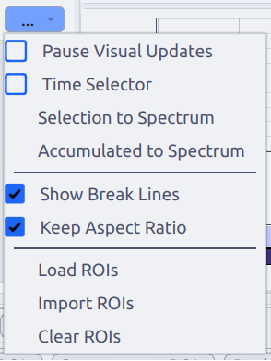
Dropdown options menu in spectrogram pane, see .
Description of fields in the spectrogram options menu
Field | Description
Pause Visual Updates | Stop the view spectrogram from updating while the measurement is still going on in the background. This does not stop the recording of the spectrogram.
Time Selector | Show a selection ROI in the spectrogram (11.) that can select specific time interval and show the sum of the channels in the top count histogram (8.).
Selection to Spectrum | Export the selected interval to the datastore as a spectrum.
Accumulated to Spectrum | Export all accumulated counts to the datastore as a spectrum.
Show Break Lines | If the red lines (12.) indicating if the interval between two rows exceed the specified save interval should be shown.
Keep Aspect Ratio | If the pixels in the spectrogram should always be square. For detectors with many channels it can be useful to turn this off. If this is off the pixels in the spectrogram may not align with the corresponding bar in the count histogram.
Load ROIs | Shortcut the to ROI tab of the Data Store.
Import ROIs | Load ROIs from a file.
Clear ROIs | Remove all spectrogram ROIs

Map
Loading a map enables viewing of geographic measurements made with a spectrogram and a GPS. Maps can be loaded from online API requiring an internet connection or loaded from a .pmtiles-file for offline use. Compatible APIs and files are offered by several vendors, the software QGis offers support for exporting .pmtiles from other formats using plugins.

Disclaimer
LuRaCs does not provide or distribute map data. Users are responsible for ensuring that any map data or tile services they use with LuRaCs are obtained and used in accordance with the applicable licenses, terms, and usage restrictions.
The map is rendered using Qt’s web engine making it a powerful but heavy tool. Using offline maps can use a lot of system memory since the server needs to cache tiles for a smooth view. Use a system with enough memory for this method. However, both the map and datapoints are rendered using GPU acceleration with WebGL allowing for 10 000s of points to be displayed without excessive stress on the system. For reference, a Raspberry Pi 5 with 8 GB of RAM can render a 1.4 GB map file without any stutter, total memory usage was approximately 2 GB.
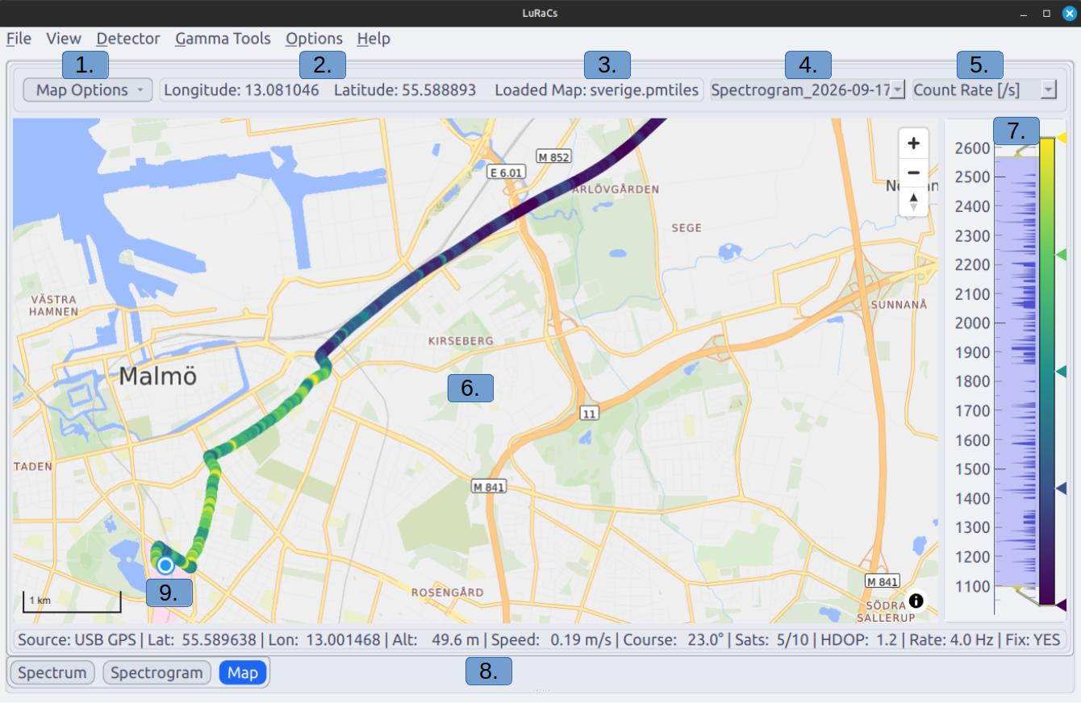
Map with a loaded track and connected GPS.
- Options menu for loading maps and importing and exporting simple tracks.
- Longitude and Latitude of the cursor.
- Name of the loaded map.
- List of loaded spectrograms, if the selected contains no geolocation data no points are displayed.
- Selector for what data is shown. total Count Rate, Dose Rate or count rate inside a loaded ROI.
- Main map view.
- Color gradient selector for the track points and a histogram over measured values. Color map can be changed by clicking Mouse-2 on the gradient bar.
- Live data from the GPS.
- Current GPS position, always displayed as a white and blue circle.

Load a map
is done from Map Options -> Load Online/Offline Map. An offline map takes the form of a .pmltiles files and choosing this options prompts the selection of such a file. Choosing to load an online map prompts the entering of a URL to a tile serving API, possibly including an API key. The checkbox allows for saving the last used URL. If a personal API key is used be aware that URLs are saved unencrypted.

Bottom Tabs

Spectrum Info
Displays information about loaded spectra, both from files and detectors.
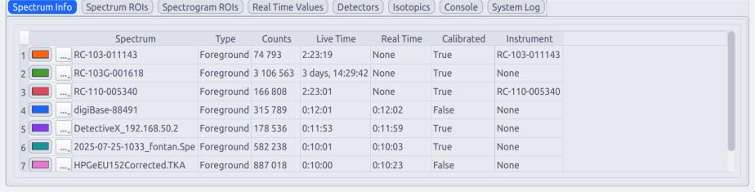
Spectrum Info Tab. For imported spectra with other formats than XML or N42 file extensions are kept in the name.
Description of the columns in the Spectrum Info tab
Column | Description
Column 0 | Color button allowing for changing the color of a spectrum. Options button marked with ’...’, see .
Spectrum | The name of the spectrum.
Type | Foreground or Background, these share the same name in the ’Spectrum’-column for the same spectrum.
Live Time | The live time of the measurement, accounting for dead time.
Real Time | The real time of the measurement.
Calibrated | True or False, if an energy calibration is detected and applied.
Instrument | Which instrument is assigned to the spectrum, see section 1.6
Description of the options menu opened by the button marked ’...’ on each row. Backgrounds are limited to only the ’Remove’ option.
Field | Description
Save | Save the spectrum to the Data Store.
Export | Export the spectrum to a stand alone file of the following formats: XML, CSV, xlsx.
Hide/Show | Toggle visibility of the spectrum in the spectrum view. ROIs are not applied to hidden spectra.
Edit | Edit properties of the spectrum, see .
Remove Spectrum | Remove the spectrum and disconnect the detector connected to the spectrum.

Spectrum ROIs
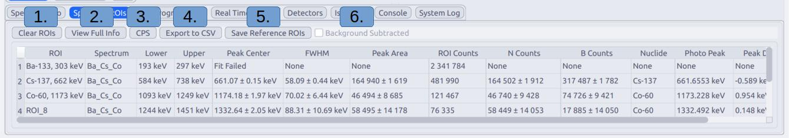
Spectrum ROIs tab
- Clear all loaded ROIs from all spectra.
- Debug view of all data contained in the loaded ROIs.
- Apply time normalisation to the calculated ROI data.
- Export the calculated data and the live of each ROI to a CSV-file.
- Save ROI references to the Data Store, see section 2.7, for later access. These save the settings of the ROI but not the data.
- Icon to display if the spectrum is background subtracted since this effects the results of ROI calculations.

Spectrogram ROIs
Spectrogram ROIs differ from Spectrum ROIs in that do no curve fitting. When applied to a spectrogram they sum the counts from all the channels within their bounds and do so for every row in the spectrogram. The results are displayed in count rate, the number of counts are normalised to the save interval, for easier comparison if the recorded spectrograms use different save intervals.
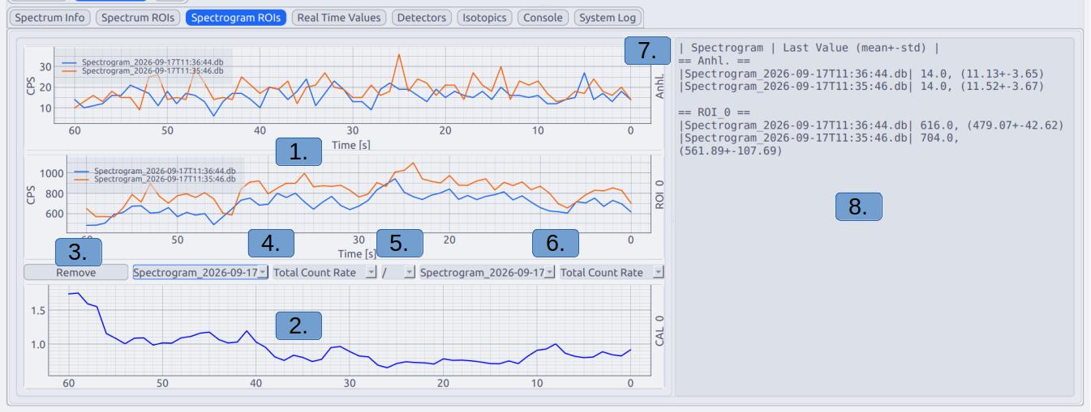
Spectrogram ROI tab with two loaded spectrograms and with two loaded ROIs. Additionally one Calculation ROI is added.
- Plots over two spectrogram ROIs evaluated on two spectrograms.
- Calculation ROI
- Button for removing the calculation ROI
- Settings for the first spectrogram in the calculation ROI. The first combobox lists loaded spectrograms and the second selects the data, total count rate or count rate from a ROI.
- Mathematical operation used to compare the values, +, - or /.
- Settings for the second spectrogram in the calculation ROI. Setting identical to the first (4.).
- ROI names. Calculation ROIs currently only have a tag.
- ROI data in text form. Shown is the latest value and (mean+-std) calculated from the data shown in the plot.
For use in mobile measurements where several ROIs is monitored at the same time a ’Compact View’ can be used. This is enabled under View -> Spectrogram ROis -> Compact View. This strips everything except the y-ticks and the plot itself.
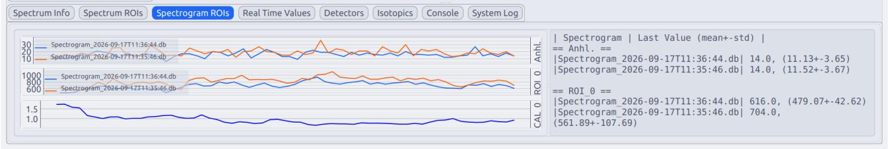
Same spectrograms and ROIs as in but in compact view.
Calculation ROIs are plots calculated from the results of other ROIs. These perform element wise operations and do not account for differences in measurement parameters. Element 0 from ROI 0 is combined with Element 0 of ROI 1, regardless of measurement date or spectrogram save interval.

Real Time Values
Plots the values sampled for a detector in real time. Not all detectors provide both Count Rate and Dose Rate, in these cases the detector is still registered to the plot but noting is shown. Y-axes can be made logarithmic by right clicking the axis Plot Options -> Transforms -> Log Y.
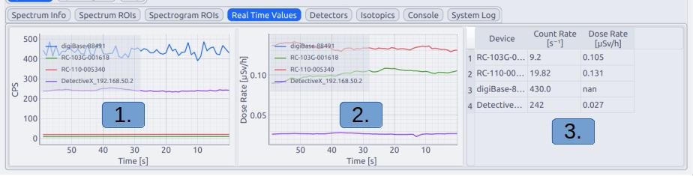
Real Time Values with four different detectors connected.
- Count Rate plot.
- Dose Rate plot, y-axis is always .
- Latest values sampled from the corresponding detector.

Detectors
Information and status of connected detectors are displayed in this tab.
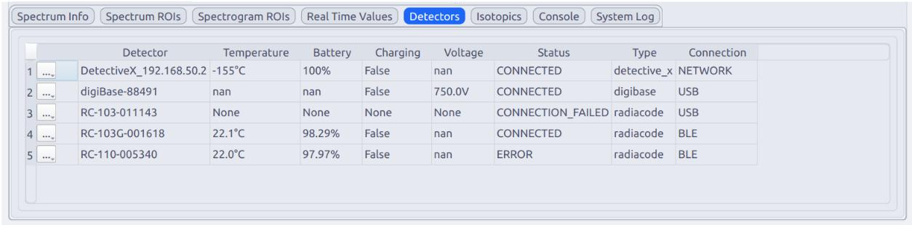
List of connected detectors. An entry can not be removed, if a detector is disconnected it is listed as STOPPED.
Description of the columns in the Detectors tab
Column | Description
Column 0 | Options button marked with ’...’, see .
Detector | The name of the detector.
Temperature | The temperature reading reported by the detector in $​^{∘}$C.
Battery | Reported battery charge in %.
Charging | If the detector reports that it is charging.
Voltage | The actual voltage reported by the detector in V.
Status | Detector state machine reporting the current status of the detector.  - UNINITIALIZED - Detector client created but not started.  - CONNECTING - The detector is starting.  - CONNECTED - The detector is connected and running. Default for normal detector function.  - CONNECTION_FAILED - Detector start failed. Check System Log.  - CONNECTION_LOST - Connection was lost after a successful start. Not universally implemented.  - STOPPING - The detector has received and acknowledged the command to stop.  - STOPPED - The detector has successfully stopped.  - ERROR - An error occurred while connected and the detector is no longer functioning as expected.
Type | Type of detector by the name defined in the detector client.
Connection | How the detector is connected. Can be BLE, USB or NETWORK.
Description of the options menu in the detector tab, opened with the button marked ’...’ in the table.
Field | Description
Disconnect | Sends a stop signal to the detector.
Reset Spectrum | Signals to the selected detector to clear its spectrum.
Start Acquisition | Signals to the selected detector to start spectrum acquisition.
Stop Acquisition | Signals to the selected detector to stop spectrum acquisition.
Make Instrument | Shortcut for creating a Unique Instrument for the detector based on a Generic Instrument and save the current calibration of the connected spectrum. Useful for detectors that do not store their own energy calibration.
Settings | Opens the detector settings dialog, see and .
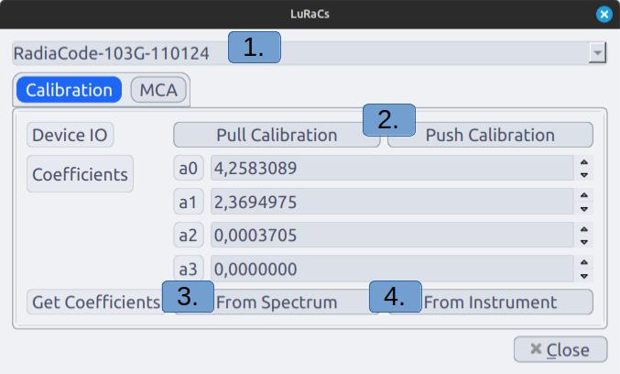
Detector settings dialog showing the options for setting device calibration.
- Unique Instrument from the library to pull settings from.
- Interact with the detector. Pull Calibration will request a calibration from the detector set in the coefficients buffer, not possible for all detectors. Push Calibration will call the setter function for calibration, not possible for all detectors.
- Pull the calibration coefficients from the spectrum connected to the detector and set in the coefficients buffer.
- Pull the calibration coefficients from the instrument set in (1.) and set in the coefficients buffer
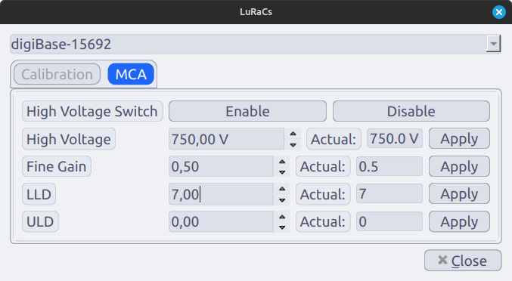
Detector settings dialog showing the options for MCA settings. The first column of spinboxes show the requested setting and the second row shows the actual value reported by the instrument. Apply signals the entered value to the detector’s setter function.
LLD | Lower Level Discriminator
ULD | Upper Lever Discriminator

Isotopics
LuRaCs provides a library of data for a selection of common radionuclides and can be viewed in this tab. These can be used to draw reference lines for emissions in the spectrum plot. Most of the nuclide data is sourced from Laboratoire National Henri Becquerel, a few nuclides not provided by LNHB had be sourced from elsewhere. A citation is provided for each nuclide and full references can be found under Help -> Bibliography.
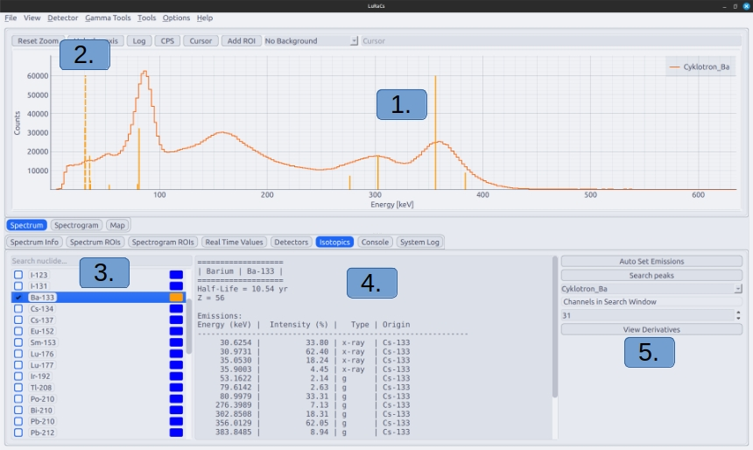
Ba-133 spectrum with Ba-133 selected in the Isotopics Tab.
- Spectrum and gamma emission lines, drawn as solid lines. Line height corresponds to emission intensity,
- X-ray emission lines, drawn as dashed lines. Line height corresponds to emission intensity.
- Nuclide list, select nuclide with the checkbox to the left and change colour of the lines with the right coloured button.
- Information of the current clicked nuclide.
- Peak automation, see bellow.
Auto matching nuclides to ROIs is accomplished by using the centroid of a fitted peak and finding emission close in energy. The matching is weighted by the emission intensity so a strong emission will be chosen over a weak of they are the same distance from the peak centroid. By selecting nuclides the auto matching of nuclides to ROIs, including from using the button inside the ROI Editor, are limited emission from the selected nuclides. Using auto match nuclides against all possible candidates are often unreliable, especially if the energy calibration is imperfect.
The peak search is based on Savitzky-Golay Smoothing and the filter derivatives to compute peak candidates. These candidates are then filtered and the accepted peaks are added as ROIs. The length of the window in the Savitzky-Golay filter can be set in units of channels.

Console
The console allows for entering text commands to control the application and running scripts for basic automation. See for information on available commands and their usage.
The Console can be used for light automation by using the exec command and providing a file path. The file is executed line by line and can used to quickly start set up a measurement session.

System Log
The System Log displays messages from the application and detector clients. If something crashes the error and traceback will be displayed here.

Gamma Tools

Calibration
Calibration is the operation of determining the energy each channel corresponds to.
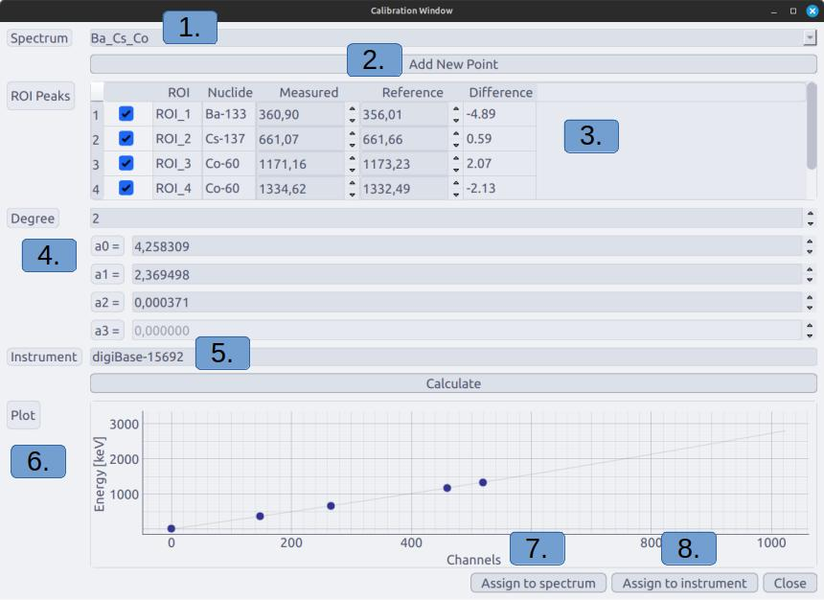
Calibration window of a spectrum with 4 ROIs and assigned nuclides.
- Which spectrum should be calibration. Only data from one spectrum can be used for one calibration.
- Add a calibration point not associated with a ROI. Measured and Reference energies must be set manually.
- Current calibration points detected and information about them. By unchecking a row it will be ignored in the calculation.
- Polynomial degree of the calibration function and the current coefficients. Coefficients can be changed manually but will be overwritten by pressing Calculate.
- The spectrum instrument. Can not be changed here, instead edit the spectrum before starting the calibration.
- Plot showing the energy as a function of channels based on the latest calculated coefficients.
- Assign the coefficients to the Unique Instrument set in (5.).
- Assign the coefficients and recalculate the x-axis for the spectrum selected in (1.), updating the view in the Spectrum-tab. This will not change the calibration of an already started spectrogram.

Deconvolution
This tool does more than simply reducing the effect of energy resolution but will still be referred to as a deconvolution operation. Deconvolution in this sense is more similar to reconstruction as, like image reconstruction in nuclear medicine, it employs the ML-EM algorithm. By using a detector response matrix, most simply acquired using Mone Carlo-simulations, the effects of the detector resolution, scattering in the detector and other effects can be reduced. The response matrix represents the expected detector response to a photon emitted at a certain energy, see and section [sec:]
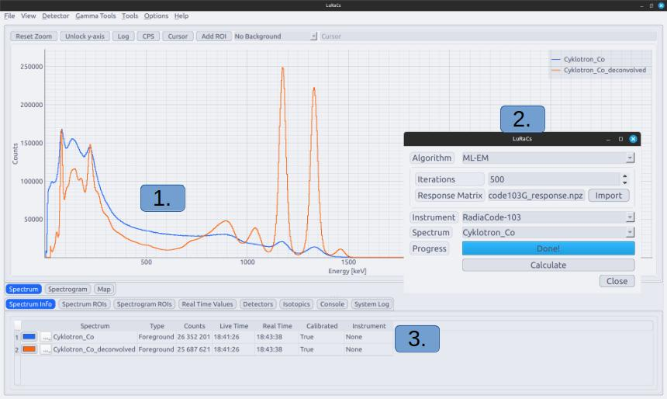
A Co-60 spectrum deconvolved using ML-EM and a response matrix for a Radiacode-103G detecting a parallel beam of monoenergetic photons.
- The original Co-60 spectrum in blue and the deconvolved spectrum in orange.
- Control window for the deconvolution operation, see .
- The deconvolved spectrum is added as new spectrum, copying information from the original.
Description of the deconvolution window.
Field | Description
Algorithm | Which algorithm should be used. Options are ML-EM (use this) and Generalized Richardson-Lucy.
Iterations | The number of iterations the algorithm should run.
(ML-EM) Response Matrix | The path to a .npz file containing the detector response matrix to be used.
Instrument | Instrument providing information the algorithm. For instance, Generalized Richardson-Lucy is based on the resolution saved in the instrument.
Spectrum | Which spectrum should be the operation be executed on.

Efficiency
The intrinsic efficiency is an important detector property and describes the fraction of photons hitting the detector that is actually detected.

Resolution
The energy resolution describes how well the detector can resolve detected photons of different energies. A low resolution results in broad peaks which can cover smaller peaks, making them harder to detect.
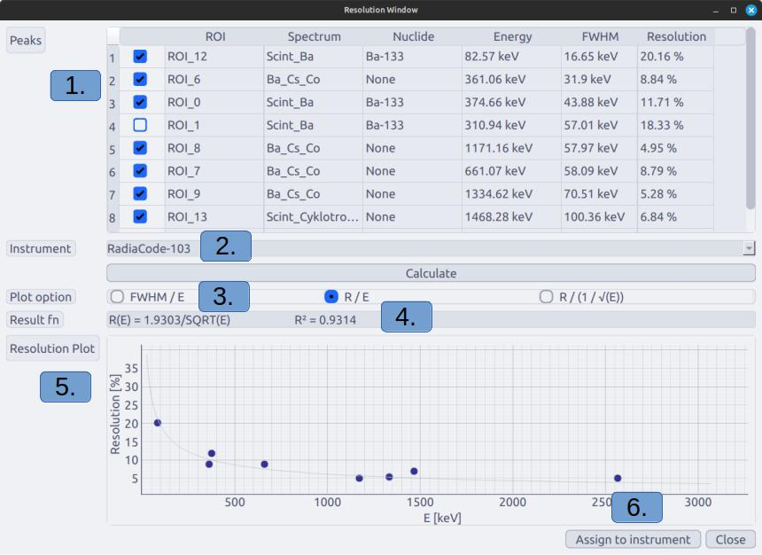
Resolution window with several different spectra measured with a 3"x3" NaI(Tl) scintillator loaded. Using Tabbed Spectrum View so the ROIs are only evaluating one spectrum each.
- Fitted peaks from all loaded spectra and ROIs. A ROI without a fit can not be included. Unchecked entries will be ignored in the calculation.
- Instrument to be given the calculation result. Can be Unique or Generic.
- How the calculation results should be plotted. These do not affect the results, only the view.
- The resolution function, coefficients are in arbitrary units and not % (% = au * 100). The $R^{2}$ value of the fitted function compared with the data points.
- Assign the calculation results to the instrument set in (2.).

Command Line Arguments
Command Line Arguments can be provided when starting the application from a terminal.
Command-line options available when starting LuRaCs.
Option | Description
Table – continued from previous page
Option | Description
–debug | Launch the application in debug mode. A mock device is added automatically for testing and development.
–headless | Run the application without the graphical user interface, using terminal mode instead.
–clear_local_cache | Remove all locally stored files and exit the application.
–import_spectrum <file> [file ...] | Load one or more spectrum files when starting the application. Each specified file must exist and be supported by the application’s file importer.
–import_rois <file> | Load regions of interest from the specified XML file.
-roi <lower> <upper> | Add a region of interest with the specified lower and upper energy bounds in keV. The option can be specified multiple times to add several ROIs.
–nuclides <nuclide> [nuclide ...] | Preset one or more nuclides in the isotopics interface. This option is applied when the graphical user interface is available.
-ble <device> [device ...] | Attempt to establish Bluetooth Low Energy connections using the specified device names.
–bluetooth <device> [device ...] | Long-form alias for -ble. Attempts Bluetooth Low Energy connections using the specified device names.
-usb <device> [device ...] | Attempt to establish USB connections using the specified device names. Matching is performed against detected USB device product names.
-nw <ip> [ip ...] | Attempt to connect to network devices using their IP addresses.
–network <ip> [ip ...] | Long-form alias for -nw. Connects to network devices using their IP addresses.
–serial_gps <interface> | Connect a GPS receiver using a USB serial interface. The specified value identifies the serial interface used by the GPS receiver.
–map_url <URL> | Load an online map from the specified URL at application startup.
–map_file <path> | Load a local offline map from the specified .pmtiles file at application startup.
–map_url and –map_file | Only one map source may be specified at startup. If both options are provided, no map is loaded and a warning is written to the application log.

Command Line Interface (CLI)
Interaction with LuRaCs is done primarily through the GUI but it also provides a terminal based command line interface, allowing for detector control without a GUI. This can be useful for remote measurements or measurements run on a Raspberry Pi attached to a drone. This mode shares most of the same commands as the GUI Console with the exception of visualisation tools.
This mode is started by running LuRaCs in a terminal with the –headless flag.
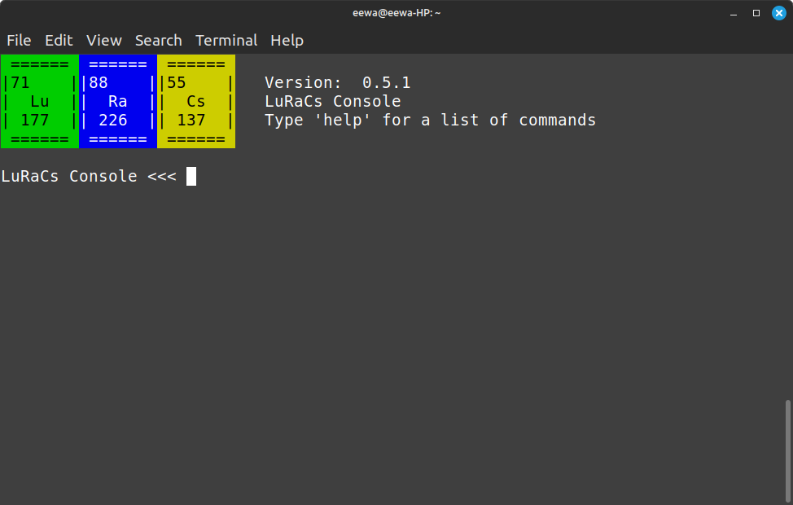
LuRaCs command line interface.
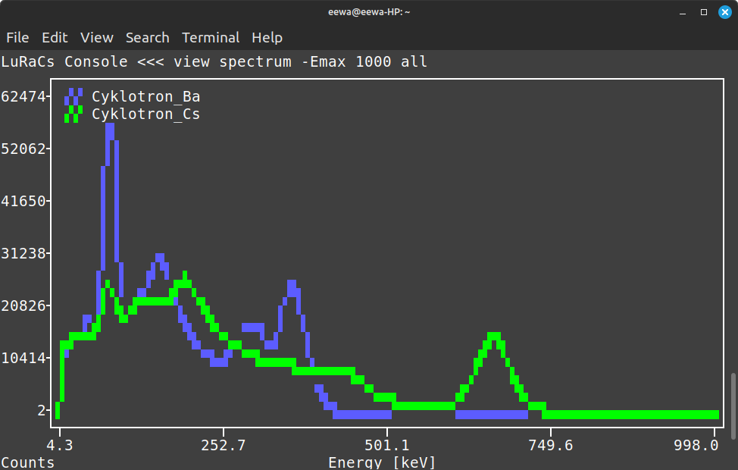
Two spectra viewed through the command line using the command view spectrum -Emax 1000 all. The -Emax 1000 flag limits the x-axis to $<1000$ keV.
Command-line interface command reference.
Command | Description
Table – continued from previous page
Command | Description
help | Display the available commands and their descriptions.
clear | Clear the console and display the application logo.
exit, quit, shutdown | Exit the application.
device scan usb | Scan for connected USB devices.
device scan ble | Scan for nearby Bluetooth Low Energy devices.
device connect usb <device> | Connect to a USB device matching the specified name.
device connect ble <device1> [device2 ...] | Connect to one or more Bluetooth Low Energy devices.
device disconnect <device> | Disconnect the specified device.
device disconnect all | Disconnect all connected devices.
list devices | Display all connected devices.
list spectra | Display all loaded spectra.
list spectrogram | Display all loaded spectrograms.
list rois | Display all loaded regions of interest.
index spectrum | Display indexed spectrum files.
index spectrogram | Display indexed spectrogram files.
index roi | Display indexed ROI files.
view spectrum <name> | Display the specified spectrum. The spectrum can be selected by name or by its index in the loaded spectrum list.
view spectrum -n <name> | Specify the spectrum to display by name.
view spectrum all | Display all loaded spectra on the same plot.
view spectrum -A | Display all loaded spectra on the same plot.
view spectrum -Emin <energy> | Set the lower energy limit of the displayed spectrum, in keV.
view spectrum -Emax <energy> | Set the upper energy limit of the displayed spectrum, in keV.
view spectrum -cps | Display the spectrum as counts per second (CPS) instead of total counts.
view spectrum -log | Display the spectrum using the logarithmic representation.
view spectrum -bkgSub | Display the background-subtracted spectrum.
view rois | Display the currently loaded regions of interest.
view log | Display recent application log entries.
roi <lower> <upper> | Add a region of interest between the specified lower and upper bounds.
roi -c | Clear all regions of interest.
spectrogram start <device> | Start a spectrogram for the specified device.
spectrogram start all | Start spectrograms for all connected devices.
spectrogram pause <name> | Pause the specified spectrogram.
spectrogram pause all | Pause all running spectrograms.
spectrogram unpause <name> | Resume the specified spectrogram.
spectrogram unpause all | Resume all paused spectrograms.
spectrogram load <path> | Load a spectrogram from the specified file.
spectrogram unload <name> | Unload the specified spectrogram.
spectrogram unload all | Unload all loaded spectrograms.
-n <name> | Specify a custom name when starting a spectrogram.
-i <seconds> | Set the spectrogram save interval. Default: $1$ second.
-c <count> | Set the number of spectra to concatenate before saving. Default: $1$.
map url <https-URL> | Load an online map from the specified HTTPS URL.
map file <path> | Load a local offline map from a PMTiles file.
watch | Continuously display live information from connected devices. Press Ctrl+C to stop.
exec <script-file> | Execute commands from a script file. Empty lines and lines beginning with # are ignored.

Detector Connection & Control
Connecting detectors using the GUI is facilitated through a dialog for each type of connection, the are found under Detector -> Connect Bluetooth/USB/Network. Connecting to bluetooth and USB requires the application the scan for available devices, the serial number of the found devices are then displayed for selection.
Connecting the a network devices requires knowing the device IP and type beforehand. Connecting to network detectors have the unique option to use the detector as a GPS. This is primarily intended for the Ortec Detective X which has a built in GPS.
When connecting to serial GPS devices the application scans serial ports and lists suggestions but the port can also be entered manually. The baud rate is typically 4800 but a selection of other common rates are also presented.

Data Store
The Data Store allows for saving data objects in the application it self for easy access. It also allows for limited editing of previously saved objects. It contains the following object types Spectra, Spectrograms, ROIs, Unique Instruments and Generic Instruments.
All data items saved in the Data Store can be exported to a single zip-file with File -> Export Data Store. Such a file can be imported with File -> Import Data Store.

Spectrum Library
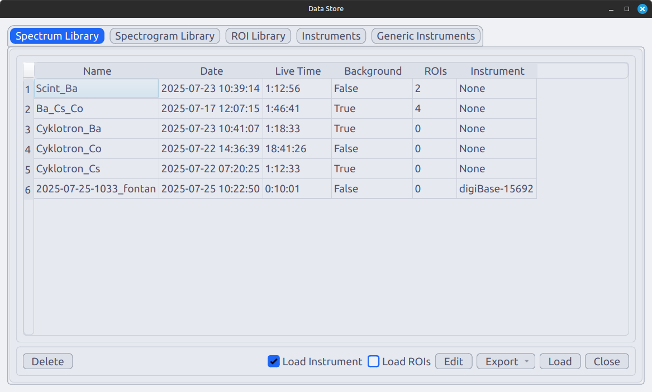
Description of fields in toolbar at the bottom of the Spectrum Library-tab
Field | Description
Delete | Remove selected items.
Load Instrument | Load the instrument contained in the specific spectrum file. If not selected LuRaCs will attempt to match the instrument name to an existing Unique Instrument save in the Data Store.
Load ROIs | Should the ROIs contained in the spectrum be loaded with the spectrum.
Edit | Edit the spectrum name or remark.
Export | Export the spectrum. Available formats: XML, CSV and xlsx.
Load | Load the spectrum into view.
Close | Close the data store.
Description of columns in the Spectrum Library-tab
Column | Description
Name | Spectrum name
Date | Date when the measurement of the foreground started
Live Time | Live time of the foreground
ROIs | How many ROIs are saved with the spectrum, if any.
Instrument | Which instrument is saved with the spectrum if any. If an instrument with the same name exists the in the Data Store, it will be used instead of the instrument saved with the spectrum. This can be changed in setting.

Spectrogram Library
All created spectrograms are placed in the Spectrogram Library. From here they can be loaded back for analysis or continued measurement.
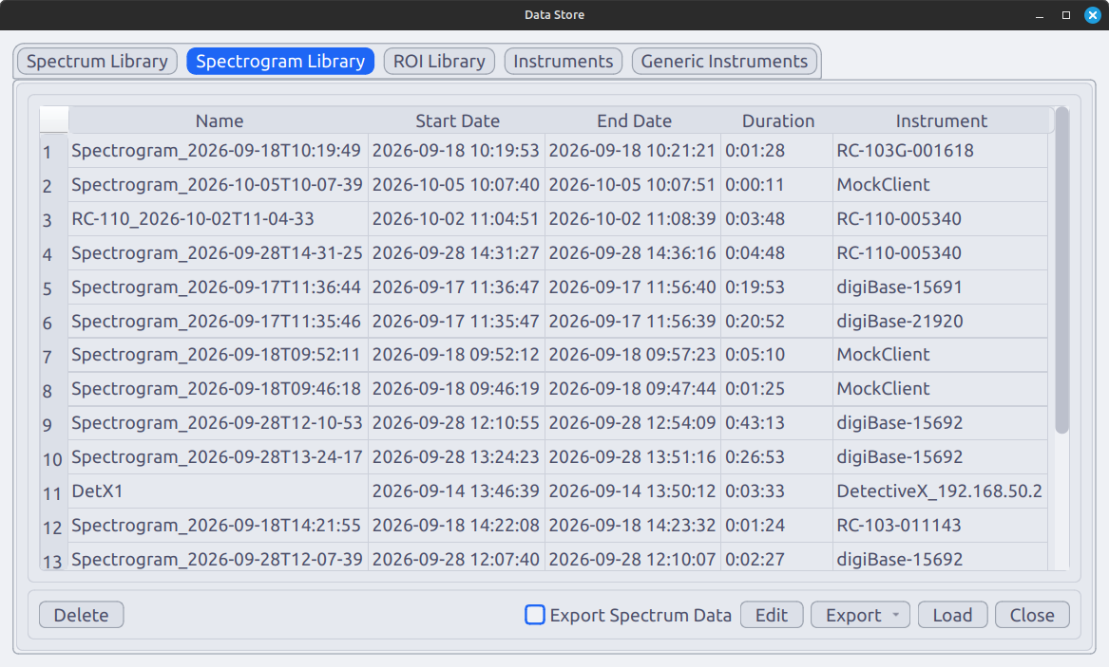
Description of fields in toolbar at the bottom of the Spectrogram Library-tab
Field | Description
Delete | Remove selected items.
Export Spectrum Data | If checked the data for individual channels are included when exporting, everything else is exported the same.
Edit | Edit the spectrogram name.
Export | Export the spectrogram to another file. Available formats: .db (SQLite3) and xlsx.
Load | Load the spectrum into view.
Close | Close the data store.
Description of columns in the Spectrogram Library-tab
Column | Description
Name | Spectrogram name
Start Date | Date when the measurement started.
End Date | Date when the measurement was last stopped.
Duration | Total measurement duration.
Instrument | Identifier for the detector used the measure the spectrogram.

ROI Library
The ROI Library allows for saving references to ROIs to then be loaded to a spectrum or spectrogram. This means the roi options like the energy bounds, fitting options and assigned nuclide are saved but data like fitting parameters or peak counts are not.
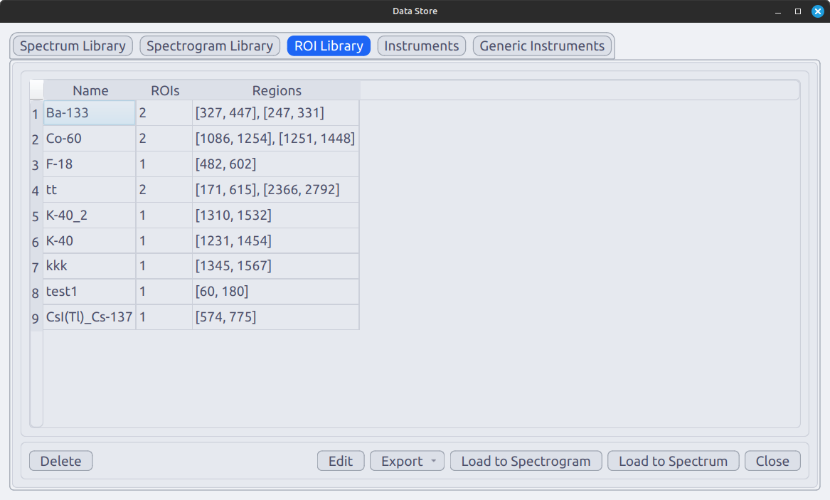
Description of fields in toolbar at the bottom of the ROI Library-tab
Field | Description
Delete | Remove selected items.
Edit | Edit the ROI collection name and the ROIs contained within, see .
Export | Export the ROIs to another file. Available formats: .xml.
Load to Spectrogram | Load the ROIs as spectrogram ROIs.
Load to Spectrum | Load the ROIs as spectrum ROIs.
Close | Close the data store.
Description of columns in the ROI Library-tab
Column | Description
Name | Spectrogram name
Start Date | Date when the measurement started.
End Date | Date when the measurement was last stopped.
Duration | Total measurement duration.
Instrument | Identifier for the detector used the measure the spectrogram.
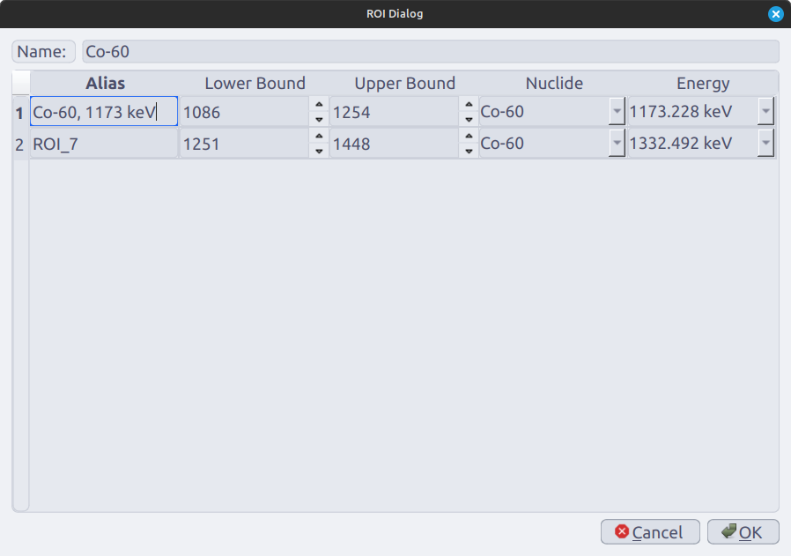
ROI editor inside the Data Store. ROI alias/name can be changed, upper and lower bounds and nuclide and emission can be selected from the nuclide library.

Unique-/Generic Instruments
The tabs for the Unique and Generic Instruments are very similar and treated in the same section.
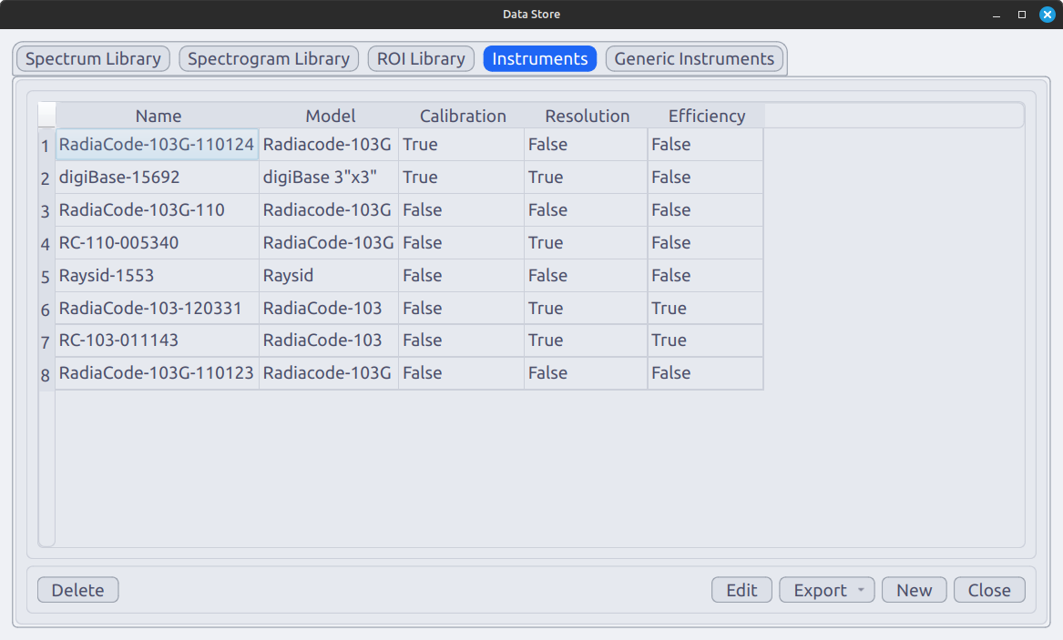
Instruments-tab in the Data Store containing Unique Instruments.
Description of fields in toolbar at the bottom of the Instruments-tab
Field | Description
Delete | Remove selected items.
Edit | Edit an existing instrument, see .
Export | Export the instrument data to another file. Available formats: .xml.
New | Create a new instrument. Unique Instruments can inherit data from Generic Instruments.
Close | Close the data store.
Description of columns in the Instruments-tab
Column | Description
Name | Instrument name (Only for Unique Instrument)
Model | Name of the instrument model.
Calibration | If the instrument stores an energy calibration. (Only for Unique Instrument)
Resolution | If the instrument stores an energy resolution.
Efficiency | If the instrument stores an intrinsic efficiency.
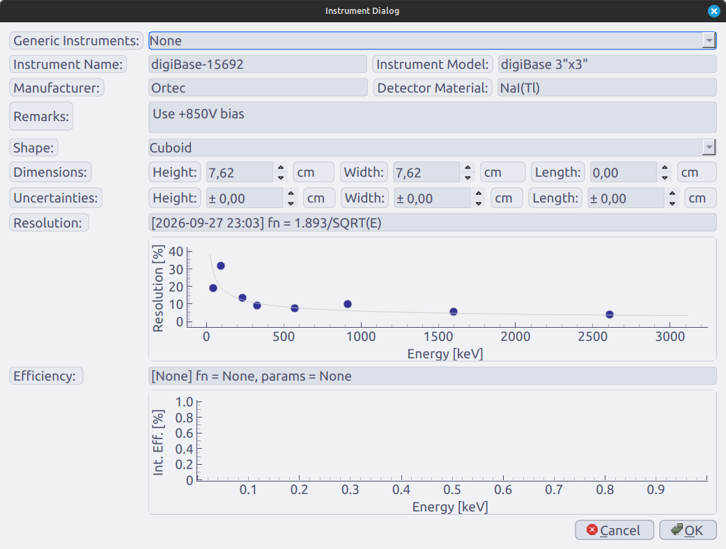
The dialog for creating a new instrument or editing an existing one. ’Instrument Name’ can not be set for a generic instrument.

Settings
The settings are devided into Settings which contain basic and cosmetic settings, and Advanced Settings containing settings that users rarely need to interact with.
Application settings.
Setting | Description
Table – continued from previous page
Setting | Description
Theme | Select the visual theme used by the application interface and plots.
Plot Colour Scheme | Select the colour scheme used when automatically assigning colours to plotted spectra.
Spectrum Draw Style | Select how spectra are rendered. Available options are Pen, Brush, and Pen + Brush.
Font Size | Set the application font size in points.
Spectrum Plot xMax | Set the maximum energy displayed on spectrum plots, in keV.
Verbose Calculation Logging | Enable additional logging during calculations. This can be useful when diagnosing calculation or processing problems.
Load ROIs on import | Automatically load regions of interest when importing a spectrum from a file.
Load instrument on import | Automatically load instrument information when importing a spectrum from a file.
Load calibration from instrument | Load the energy calibration associated with the instrument when importing data from the Data Store or from a file.
Advanced application settings.
Setting | Description
Table – continued from previous page
Setting | Description
Update Loop Delay | Set the delay between iterations of the device monitoring and update loop, in seconds.
Spectrum Update Delay | Set the delay between spectrum updates during live acquisition, in seconds.
GUI Scan Length | Set the duration of Bluetooth Low Energy scans initiated through the graphical user interface, in seconds.
Headless Scan Length | Set the duration of Bluetooth Low Energy scans when no the scan is not tracked in the GUI, in seconds.
Optimizer Max Iter | Set the maximum number of iterations allowed by the optimizer.
Optimizer Tolerance | Set the convergence tolerance used by the optimizer.
Use Chi$​^{2}$ Weight | Enable $χ^{2}$ weighting during optimization.
Log Exceptions | Enable logging of unhandled exceptions.
Write logs to file | Enable writing log messages to the application log file.
Write logs to console | Enable writing log messages to the terminal or console.
Headless Log Buffer Length | Set the maximum number of log entries retained in the in-memory log buffer. Changes to this setting require an application restart.
Spectrogram View Buffer | Set the number of recent spectrogram data points retained for display.
Save extra GPS data | Enable saving additional GPS information with map-related data.

Examples

Quick Starting Several Radiacode Detectors for mobile measurements
This examples demonstrates how the terminal can be used to effectively control several detectors at once, without having to repeat the connection and start measurement procedure for each one. In this example three Radiacode detectors are used but the principle is the same for all other types of detector. The code bellow illustrates the commands start an offline map, connect the GPS and instruments and start spectrograms for all detectors.
bash # Start the map first, cacheing a large map with require all available resources and will cause the application the freeze momentarily. This can disturb the sampling of the detectors. map file /Downloads/sverige.pmtiles
# Once the map is loaded connect the GPS # This assumes only one GPS device is connected to the PC, if several are connected the first serial port is chosen gps connect
# This command will scan all bluetooth devices and match the given name to the serial number of the found devices device connect ble Radia # This will connect all detectors with ’radia’ in the name, matching is case insensitive # Check if all detectors connected, if not repeat the above command list devices
# Start recording spectrograms for all devices spectrogram start all
# When the measurements are concluded stop the recordings spectrogram pause all

Connecting Detective X using direct ethernet
LuRaCs communicates with a Detective X detector using the Mobile Field Kit API described in the Detective X manual. Using this interface requires a network connection between the instrument and a host computer. A simple and stable way to establish such a connection is a direct ethernet cable from the instrument to the PC with no router in between. This method requires some setup before LuRaCs can connect to a Detective X and is described in this example.
The first step is to configure the ethernet interface on the Detective X. Go to Settings \rightarrow Communications \rightarrow Ethernet. Ensure ethernet is enabled and disable DHCP. Manually enter the IP-address and network mask. A good choice of IP is 192.168.50.2, as long as does not interfere with another connected device, and set the network mask to 255.255.255.0.
The second step is to configure the PC to have a static IP address on the ethernet connection. The used IP will be 192.168.50.1 and the network mask 255.255.255.0, leave gateway empty. Examples are shown for Windows 11 () and Linux Mint () but the principle is the same for most systems.
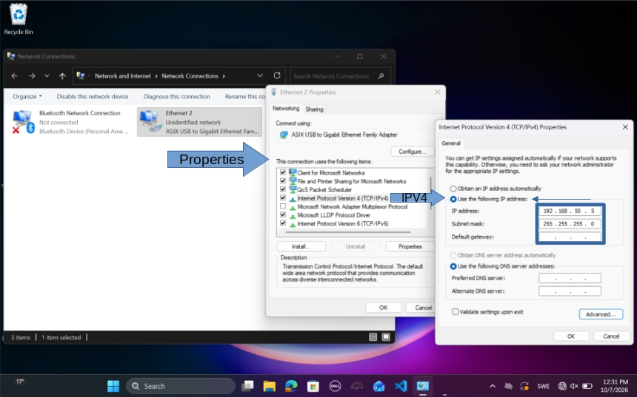
Steps for settings a static IPV4 address on Windows 11.
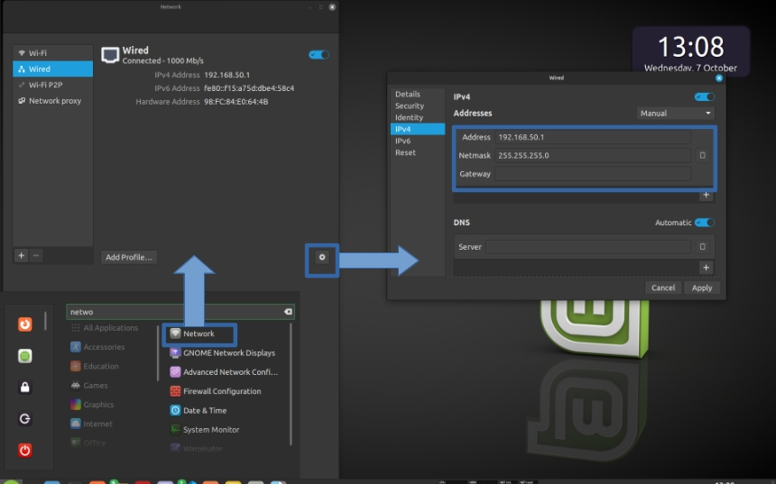
Steps for settings a static IPV4 address on Linux Mint 21.3 (Cinnamon).
Once the network is configured check the connection by pinging Detective X. On most Linux systems, if the ping fails try restarting the network manager with the following command sudo systemctl restart NetworkManager. If that does not work, try rebooting the PC.
If the ping succeeds everything is ready. In LuRaCs go to Devices \rightarrow Connect Network and enter the instrument IP, 192.168.50.2 in this example.

Preparing and Running the LU mobile detector setup
This setup consists of two NaI(Tl) scintillators with digiBase MCAs and one HPGe detector with a digiDart system mounted in a car, equipped with an external usb GPS device.
- Ensure that the digiBase firmware is imported. File -> Drivers. If not se section 1.3
- Connect the detectors, neither the digiBase nor the digiDart save their calibration when used with LuRaCs so only channel numbers will be shown on the energy axis.I connecting from a Linux system serial numbers and detector type will be displayed for easy identification, on Windows they must be identified through the Windows Device Manager. Detector -> Connect USB
- Enable the correct voltage on each detector, this might be remembered by the detector. Otherwise check the serial numbers of the detectors to find which is which. Detector-tab -> ’A detector Row’ -> ’...’-button -> Settings -> MCA-tab -> HV: Enable
- (Optional) Calibrate the detectors with the K-40 and Tl-208 peaks and the 0 channel using the Calibration tool. Apply to the spectrum. Gamma Tools -> Calibration
- With the calibration a new instrument can now be created from the Detectors-tab to save the calibration. It will automatically be fetched next time the detector is connected. Detectors-tab -> ’A detector Row’ -> ’...’-button -> Make Instrument -> ’Save Calibration’ is checked
- Start the map. If an offline map is used start it before any spectrogram, loading a large only map might interfere with sampling of the instruments, messing up the even save intervals. Map-tab -> Map Options -> Load Offline Map
- Connect the GPS. Detector -> Connect Serial GPS, determine the correct port if required and connect. LuRaCs will display all available serial ports and if only one device is connected it is trivial to identify it. 4800 is likely the correct Baud Rate.
- Check that the GPS has a signal. Map-tab -> Line Bellow the map -> ’Fix’ should be ’Yes’ It might take some time for the GPS to warm up.
- Ensure all detectors are running by clearing all spectra. Detector -> Clear All Spectra
- Start the spectrograms individually, Spectrum-tab -> Start New or use the console, Console -> ’spectrogram start all’.

.

