**APPENDIX**

1. **Figures**

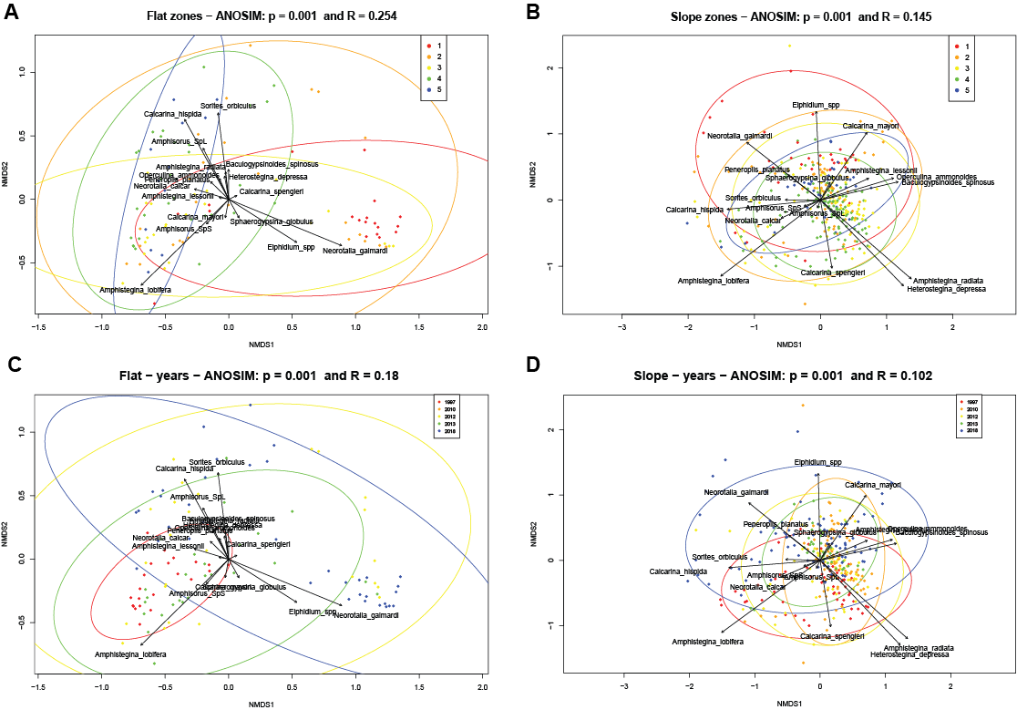

*Figure A.1. Non-metric multidimensional scaling (NMDS) and Analysis of Similarity (ANOSIM) of LBF assemblages between the zones (A, B) and between years (C, D).*

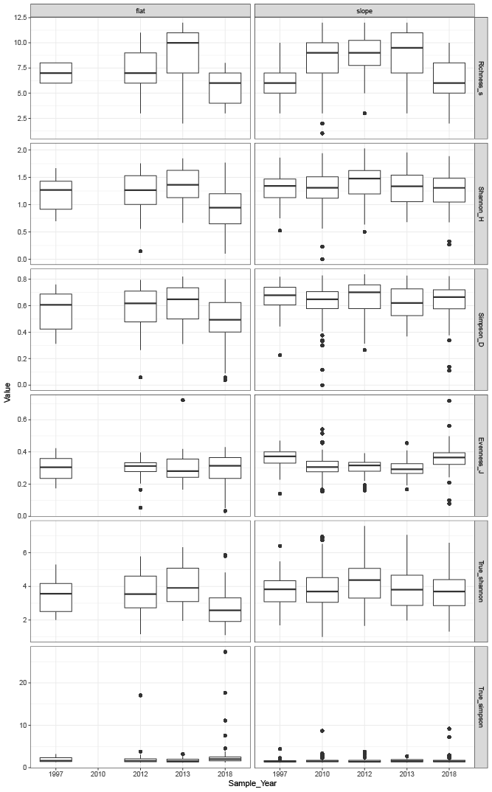

*Figure A.2. Diversity indices calculated for each year and per habitat.*

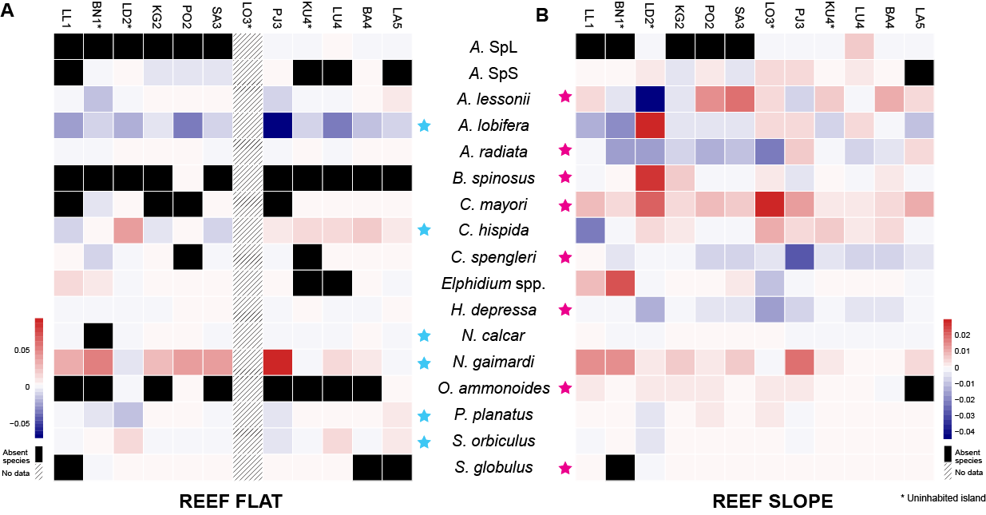

*Figure A.3. Simple linear regression applied on each species at each sampling island for the reef flat (A) and reef slope (B). Species with a positive linear regression slope are marked in red (increasing in abundance over time) and with a negative slope in blue (decreasing in abundance over time). Black: absent species at the location (mean relative abundance = 0); hatched: no data available. Blue stars: indicator species on the reef flat; magenta stars: indicator species on the reef slope.*

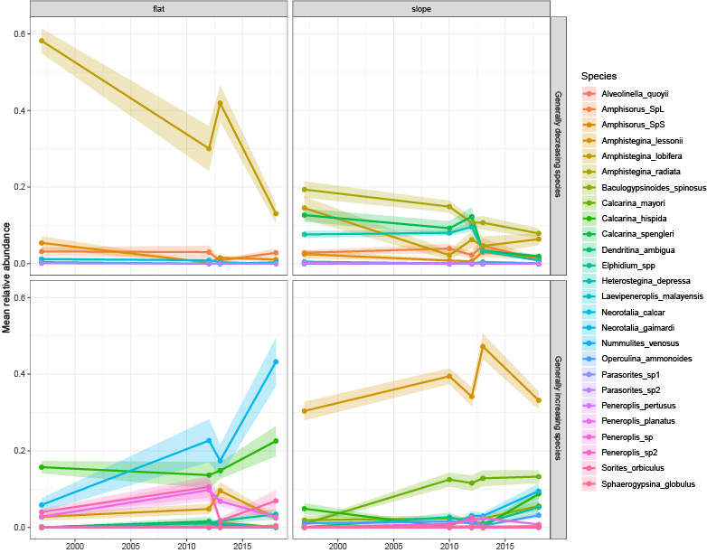

*Figure A.4. Time series of assemblages of LBF (including rare species) on the reef flat and the reef slope. The shaded area indicates the standard error of the mean relative abundance.*

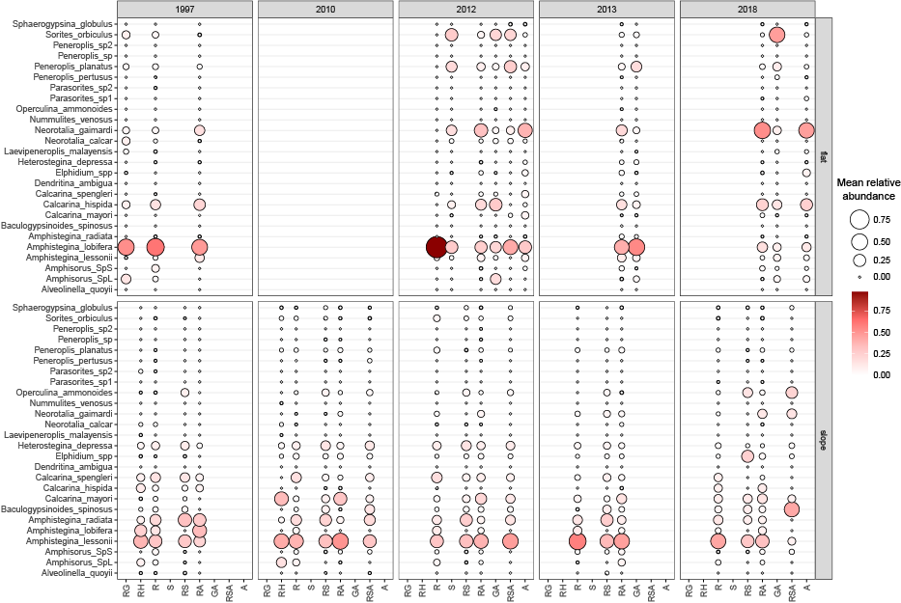

*Figure A.5. Temporal change of foraminiferal relative abundances (of all taxa, including rare species) to different substrate types on A) the reef flat and B) the reef slope. Color and size of the circles are related to the mean relative abundance of a species in a sample. Substrate types: sand (S), coral rubble (R), coral rubble with sand (RS), coral rubble with seagrass (RG), coral rubble with Halimeda (RH), coral rubble with sand and algae (RSA), coral rubble with algae (RA), seagrass with algae (GA) and algae (A).*

1. **Tables**

*Table A.1. Number of samples collected per year and per habitat.*

*Table A.2. Results of the Analysis of Similarity (ANOSIM) for each habitat and each zone between the years.*

*Table A.3. Results of the Indicator species analysis for each species and per habitat.*

*Table A.4. Results of the Analysis of Variance (One-way ANOVA) for each species and per habitat.*