**Supplementary material**

**Coastal eutrophication transforms shallow micro-benthic reef communities**

Elsa B. Girarda,b, Andi M. A. Pratamac, Laura del Rio-Hortegaa, Sophie Volkenandta, Jan-Niklas Machera,d, Willem Renemaa,b

a Naturalis Biodiversity Center, Darwinweg 2, 2333 CR Leiden, the Netherlands

b IBED, University of Amsterdam, Sciencepark 904, 1098 XH Amsterdam, the Netherlands

c Marine Science Department, Faculty of Marine Science and Fisheries, Hasanuddin University, Jl. Perintis Kemerdekaan Km. 10 Tamalenrea, Makassar 90245, Indonesia

d Institute of Environmental Sciences (CML), Leiden University, P.O.Box 9518, 2300RA Leiden, The Netherlands

**Running title:** Effect of eutrophication on reef benthos

**Corresponding author:** Elsa B. Girard

**Email:** elsa.girard@naturalis.nl

**Supplementary tables**

Supplementary Table S1. Metadata for sample collection and other sample characteristics (including substrate type).

Supplementary Table S3. Protocol modifications for DNA extraction of seawater (A) and substrate (B) samples.

Supplementary Table S3. Indicator species analysis results. Only ESVs with a p-value < 0.01 were considered. For foraminifera, the classification followed the morphological morphospecies. If the species was unknown, the family was used for classification (ID > 96 %), and if the family was unknown too, the phylum foraminifera was used. For diatoms and prokaryotes, the lowest taxonomic classification reached was used.

**Supplementary figures**

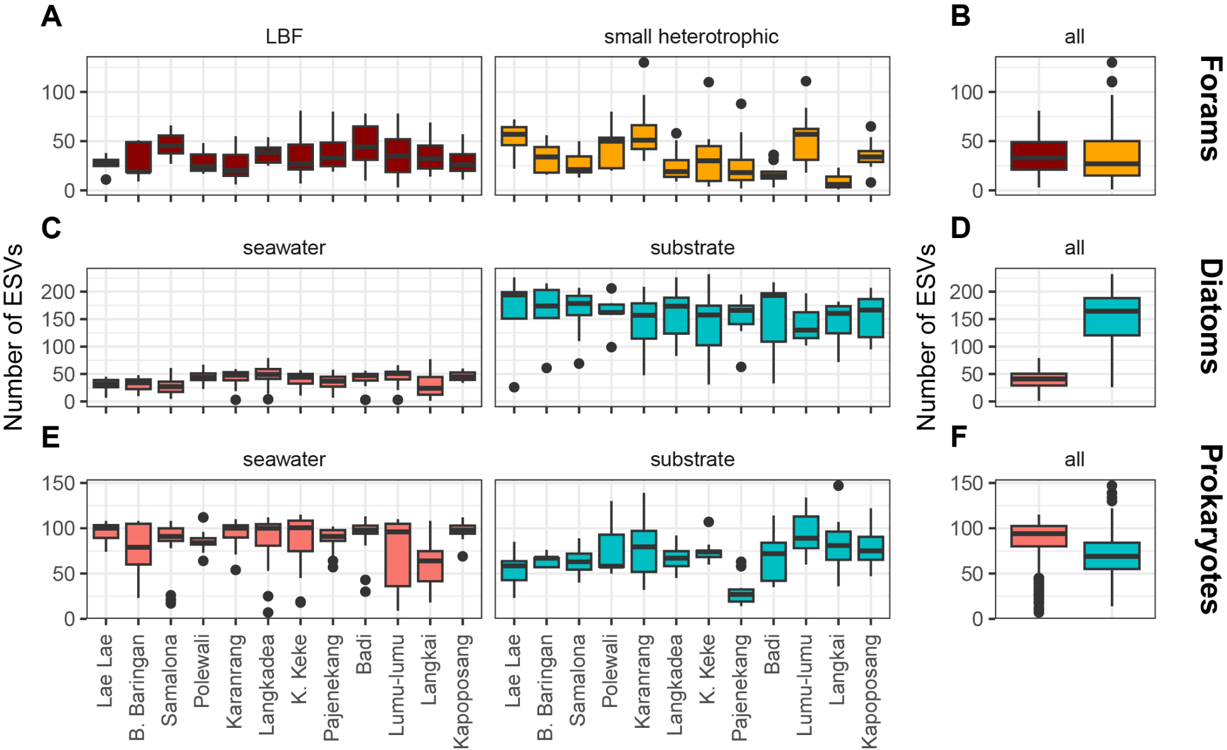

Supplementary Figure S1. Number of ESVs (alpha diversity) found in every sample for each taxonomic group, before taxonomic discrimination. The foraminifera (A,B) samples are divided into LBF (dark red; the studied fraction) and the small heterotrophic (orange) ones. The diatoms (C,D) and prokaryotes (E,F), excluding the chloroplasts, are divided into seawater (pink) and substrate samples (blue). On average, there are more ESVs diatoms in the substrate samples than in the water. This is the opposite for prokaryotes.

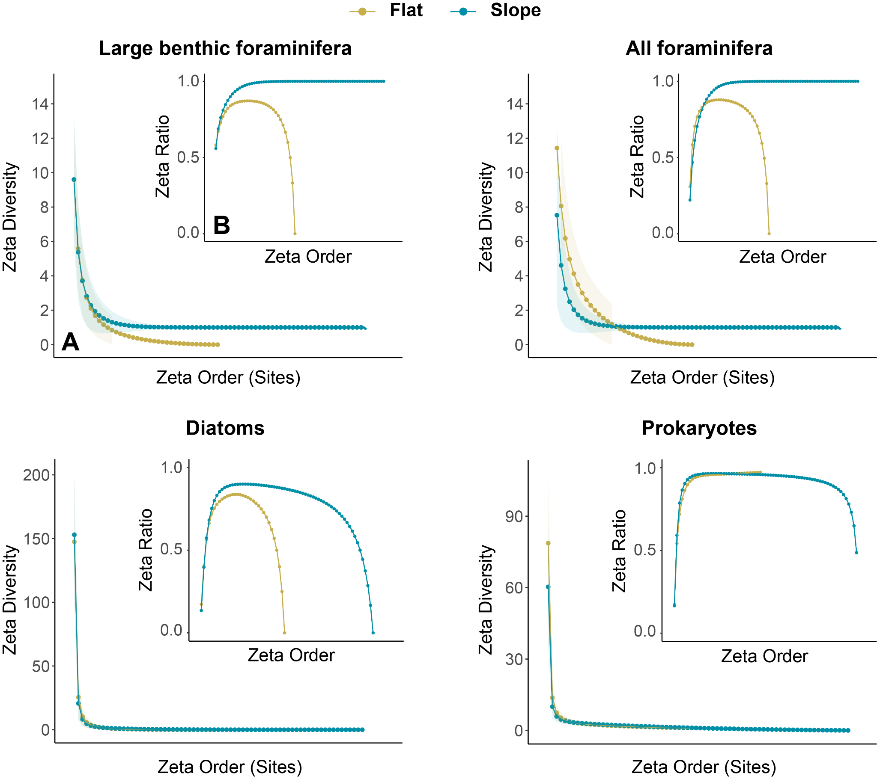

Supplementary Figure S2. Zeta diversity analysis performed on the presence-absence data of the substrate samples for the following groups: large benthic foraminifera (ID > 99.4%), all foraminifera, diatoms and prokaryotes. A) Zeta diversity decay curves. B) Zeta diversity retention curve). The reef flat is represented in yellow and the reef slope in blue.

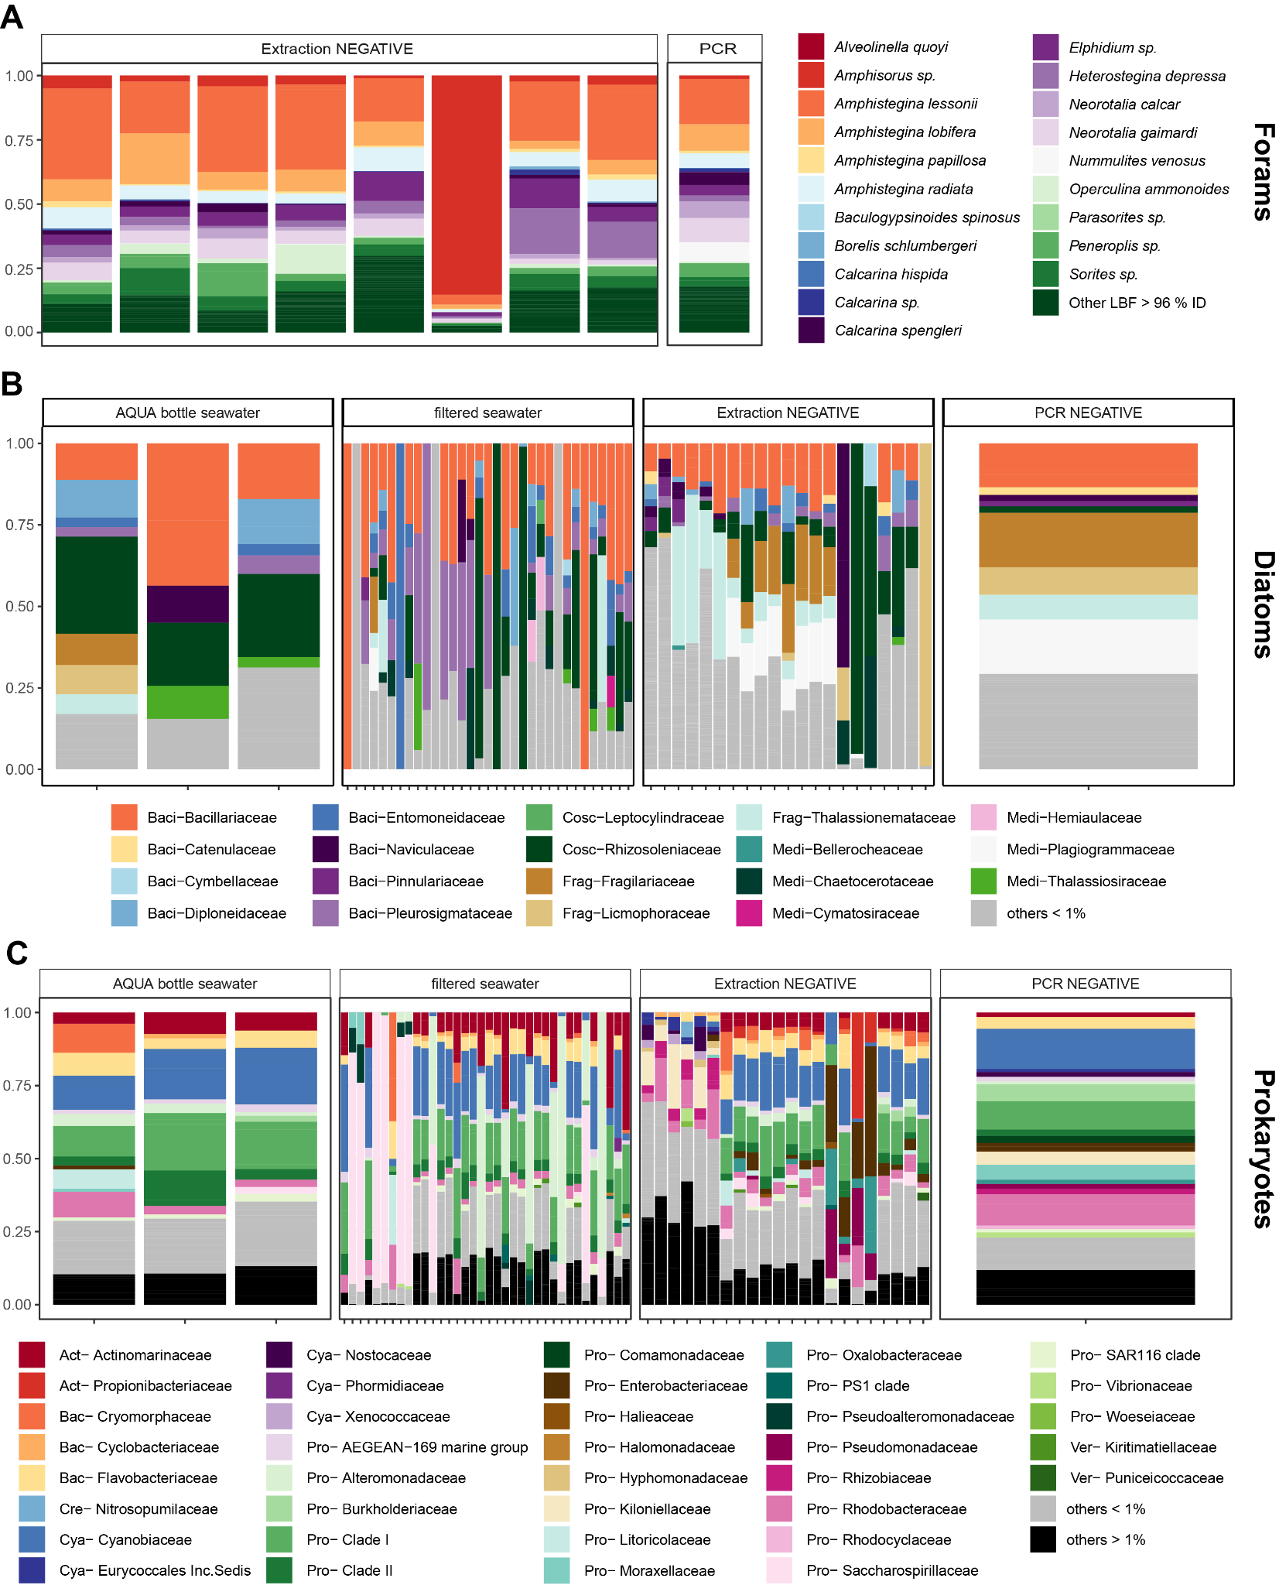

Supplementary Figure S3. Community compositions of the negative controls, which had on average the lowest number of reads compared to true samples, and against which the true samples were decontaminated (see the method section “Quality control of the datasets”). (A) LBF at the morpho-species level. (B) Diatoms at the family level. (C) Prokaryotes at the family level. AQUA bottled water and filtered seawater samples are the controls from fieldwork. Extraction and PCR negatives from the laboratory work.