TECHNICAL COMPANION DOCUMENT
HR Recruitment & Workforce Platform
Full-Feature Architecture · Workflows · Requirements Coverage & Gap Analysis
Prepared by | Date | Version | Status
Bhavani | June 1, 2025 | v1.0 | For technical review

1. Purpose & Scope
This document is the engineering companion to the business proposal. It answers three questions: (a) how the full feature set — recruitment/ATS, HRMS, payroll, accounts & finance, the AI engine and analytics — is architected; (b) how data and work flow through the system end to end; and (c) whether the requirements are fully covered by the proposed build plan, with an honest gap analysis where they are not.
Headline finding (detailed in Sections 9–11): the feature catalogue is comprehensive and internally consistent — the “what” is well defined. The build plan in the proposal (3–4 developers over ~34 weeks) does not fully cover that scope — the “how, who and when” is under-scoped, chiefly for payroll statutory compliance and the full accounting suite. This document sets out what is covered, what is not, and a realistic path to close the gap.

2. System Architecture Overview
The platform is a multi-tenant system built as a set of domain services behind a single API gateway, sharing one data layer and one cross-cutting AI engine. The diagram below shows the six logical layers.
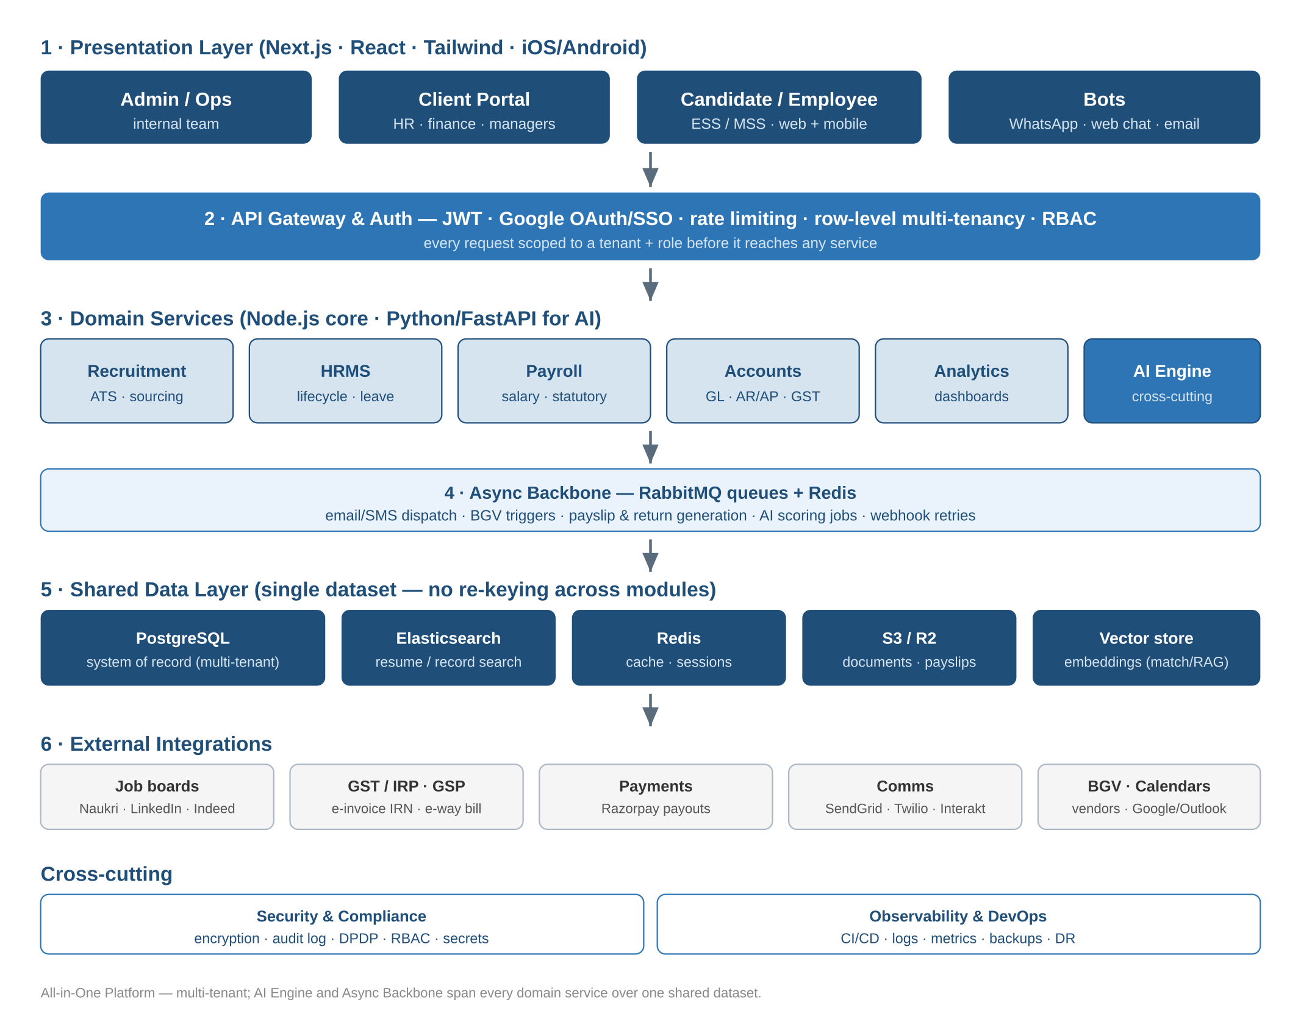
Figure 1 — Layered system architecture of the all-in-one platform
The defining architectural choice is the shared data layer (Layer 5). Because recruitment, HRMS, payroll and accounts read and write the same tenant-scoped dataset, a candidate hired in the ATS becomes an employee, then a payslip, then a ledger entry without any module re-keying data. This is the source of the automation advantage — and also the reason tenant isolation, validation and audit must be first-class.

2.1 Technology by Layer
Layer | Technology | Responsibility
Presentation | Next.js 14 / React / Tailwind; native iOS & Android | Admin, Client, Candidate/Employee portals + chat bots; role-based routing on one codebase.
Gateway & Auth | API gateway; JWT + Google OAuth/SSO | Authn/authz, tenant + role scoping, rate limiting, request validation before any service.
Domain services | Node.js (core) + Python/FastAPI (AI) | Recruitment, HRMS, Payroll, Accounts, Analytics, AI — independently deployable.
Async backbone | RabbitMQ + Redis | Queues for email/SMS, BGV, payslip & return generation, AI scoring, webhook retries.
Data layer | PostgreSQL, Elasticsearch, Redis, S3/R2, vector store | System of record, search, cache, document storage, embeddings for AI match/RAG.
Integrations | Job boards, GST/IRP-GSP, Razorpay, SendGrid/Twilio/Interakt, BGV, calendars | Outbound connectors to regulated and third-party systems.
Note on “microservices”: at MVP scale a modular monolith (one deployable, clear module boundaries, one database with row-level security) is faster and cheaper to build and operate than true microservices, and can be split out later. The proposal’s microservices language is an aspiration, not a day-1 requirement — flagged again in Section 9.

3. The Single-Dataset Backbone
The same record is enriched at each stage of the lifecycle rather than copied between systems. This is what removes manual hand-offs.
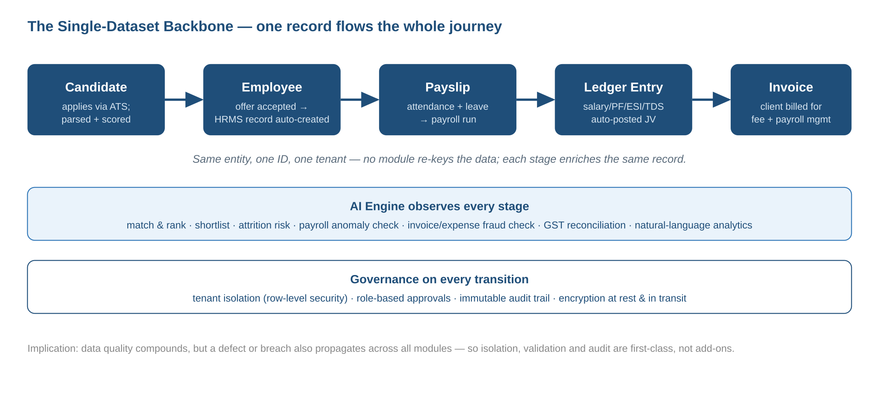
Figure 2 — One record flows from candidate to invoice; AI and governance act on every transition

3.1 Core Entities
Entity | Owned by | Key relationships
Tenant (Client) | Client onboarding | Root of isolation; owns users, jobs, employees, invoices.
Candidate / Application | Recruitment | Linked to Job; converts to Employee on offer acceptance.
Employee | HRMS | Created from Candidate; owns attendance, leave, payroll inputs, assets.
Payroll Run / Payslip | Payroll | Derives from Employee + attendance + leave; emits statutory liabilities.
Journal Voucher | Accounts | Auto-posted from payroll, billing and expenses to the General Ledger.
Invoice / Receipt | Accounts (AR) | Billing for placement & payroll-management fees; ties to Tenant.
Document | Cross-platform | Resume, offer, payslip, invoice — stored in S3/R2, referenced by entity.

4. Component Architecture by Module
Each domain service is described by its main components, the key data it owns, and its external dependencies.

4.1 Recruitment / ATS
Component | Function | Depends on
JD Builder | AI-generated, ATS-optimised job descriptions from a brief. | AI engine (LLM)
Sourcing connectors | Post to and pull from job boards; passive outreach sequences. | Naukri/LinkedIn/Indeed APIs
Resume parser & matcher | Parse, score and semantically rank candidates. | OCR, embeddings, Elasticsearch
Interview orchestration | Calendar sync, slot generation, video links, scorecards. | Google/Outlook, Zoom/Meet
Assessment & BGV | Dispatch tests; trigger background verification. | BGV vendors, async queue
Offer & comms | Branded offers, e-sign, rejection/waitlist mail. | AI engine, e-sign, SendGrid

4.2 HRMS
Component | Function | Depends on
Employee master & ESS/MSS | Records, self-service, org chart, document vault. | PostgreSQL, S3
Attendance & time | Biometric/geo/web punch, shifts, regularisation. | Mobile app, device webhooks
Leave engine | Policy config, accruals, approvals, calendars. | Workflow engine
Performance & LMS | Goals/OKR, appraisals, courses, skill matrix. | AI engine
Expense, travel, assets, engagement | Claims, surveys, recognition, asset register. | OCR, AI sentiment, Accounts
Workflow engine | No-code approvals & forms used by all modules. | Async backbone

4.3 Payroll
Component | Function | Depends on
Salary structure & run | CTC builder, multi-pay-group processing, arrears. | Attendance, leave
Statutory engine | PF, ESI, PT, TDS, LWF, gratuity calculation. | Compliance rule library
Returns & challans | ECR, Form 24Q, Form 16 generation. | Govt portals / GSP
Disbursement | Bank advice / NEFT / payout files. | Razorpay payouts
Accounting hand-off | Auto journal vouchers to the ledger. | Accounts (GL)

4.4 Accounts & Finance
Component | Function | Depends on
General Ledger | Double-entry, chart of accounts, multi-entity. | PostgreSQL
AR / AP | Client invoicing & receipts; vendor bills & payments. | Payroll, billing events
Tax engine | GST (GSTR-1/3B/2B), TDS/TCS, e-invoice IRN, e-way bill. | IRP / GSP, govt portals
Banking | Statement import, auto-reconciliation, vouchers. | Bank feeds
Reporting | P&L, Balance Sheet, Cash Flow, Trial Balance. | GL
External sync | Tally / Zoho Books / QuickBooks import-export. | Those product APIs

4.5 AI & Automation Engine
Component | Function | Depends on
LLM service | JD/offer/email/policy generation, summaries. | GPT-4o + embeddings
Matching & ranking | Resume–JD semantic match, shortlisting. | Vector store, Elasticsearch
Predictive models | Attrition risk, payroll/expense anomaly, fraud. | Historical platform data
Conversational AI | 24/7 candidate & employee chatbot. | WhatsApp/web, RAG
Document AI | OCR & extraction for resumes, BGV, invoices, receipts. | OCR, LLM
NL analytics | “Ask your data” queries + narrative reports. | Data layer, LLM
Reality note: the LLM, matching, document-AI and chatbot components are buildable from day one (they rely on third-party models). The predictive models (attrition, fraud, anomaly) face a cold-start problem — they need months of the platform’s own historical data before they are accurate, so they are realistically post-launch, not MVP.

5. Integration Architecture
Several integrations are regulated or business-critical and carry real delivery risk. They are isolated behind the async backbone with retries, so a third-party outage degrades gracefully rather than blocking a workflow.
Integration | Used for | Risk / note
GST IRP via GSP | e-invoice IRN, e-way bill | Regulated; requires a licensed GSP and certification — lead time.
Statutory portals | PF/ESI/TDS returns & challans | High liability; formats change with budgets/rules.
Razorpay payouts | Salary & vendor disbursement | Money movement — needs KYC, reconciliation, audit, error handling.
Job boards | Posting & sourcing | Each has its own API, quotas and contracts.
BGV vendors | Background verification | Async, slow, vendor-dependent SLAs.
Comms (SendGrid/Twilio/Interakt) | Email/SMS/WhatsApp | WhatsApp Business API needs template approval.
Calendars / video | Scheduling & interviews | OAuth scopes per provider.

6. Key End-to-End Workflows
Five workflows carry most of the operational value. Each is shown as the sequence of automated and human steps.

6.1 Requisition → Hire → Onboard
# | Step | Auto / Human
1 | Client raises requisition in portal; AI drafts JD; HR reviews & publishes. | Auto + human review
2 | Multi-channel sourcing; resumes parsed, scored, shortlisted. | Auto
3 | Assessments dispatched; interviews auto-scheduled with video links. | Auto
4 | Panel scores; AI aggregates; client confirms selection. | Human decision
5 | Offer generated + e-signed; rejections sent; employee record created. | Auto
6 | Onboarding kit, document checklist, IT/asset request dispatched. | Auto

6.2 Attendance → Payroll → Payslip
# | Step | Auto / Human
1 | Attendance & leave captured continuously through the month. | Auto
2 | Payroll run pulls attendance, leave, reimbursements, loans. | Auto
3 | Statutory engine computes PF/ESI/PT/TDS; AI flags anomalies. | Auto + review on flags
4 | Payroll approved; payslips generated; bank/NEFT file produced. | Human approval
5 | Disbursement via Razorpay; payslips published to ESS. | Auto

6.3 Payroll → Accounting (auto-JV)
# | Step | Auto / Human
1 | Approved payroll emits salary, PF, ESI, TDS liability lines. | Auto
2 | Journal vouchers posted to GL by cost centre / department. | Auto
3 | Statutory liabilities scheduled in the compliance calendar. | Auto
4 | Finance reviews trial balance; period close. | Human

6.4 Client Billing → Invoice → Cash (AR)
# | Step | Auto / Human
1 | Billable event (placement fee / monthly payroll fee) detected. | Auto
2 | GST invoice raised; IRN + e-way bill obtained via GSP. | Auto
3 | Invoice sent; payment reminders (dunning) scheduled. | Auto
4 | Receipt recorded; bank line auto-reconciled; AR ageing updated. | Auto + review

6.5 Continuous AI Automation Loop
# | Step | Auto / Human
1 | Every transition emits an event to the AI engine. | Auto
2 | Models score: match, attrition risk, anomaly, fraud, sentiment. | Auto
3 | Below-threshold items proceed; flagged items routed to a human. | Auto routing
4 | Human decisions feed back as labels to improve the models. | Human + retrain

7. Non-Functional Requirements & Coverage
Functional features are only half the requirement. For a platform that disburses salaries, files statutory returns and stores personal data, the non-functional requirements below are mandatory. Coverage is rated against the proposal as written.
Requirement | Why it matters here | Covered?
Multi-tenancy isolation | One breach must not cross tenants. | Partial — row-level security named; needs hard testing
Data protection (DPDP Act) | Personal & salary data; Indian DPDP obligations. | Gap — not addressed in proposal
Encryption at rest & in transit | Sensitive PII and payments. | Partial — implied, not specified
Audit trail & immutability | Payroll/accounts need tamper-proof logs. | Partial — stated for accounts only
Payments compliance | Money movement, KYC, reconciliation. | Gap — relies on Razorpay; controls undefined
Statutory accuracy & liability | Wrong PF/TDS = penalties for clients. | Gap — no QA/compliance workstream
Availability / DR / backups | Payroll has hard monthly deadlines. | Partial — infra named, no SLA/DR plan
Scalability | Multi-tenant growth. | Adequate — stack supports it
Observability | Detect failures before payroll day. | Partial — CI/CD named, monitoring not
Security certification | Enterprise clients ask for SOC2/ISO 27001. | Gap — not planned

8. Functional Requirements Coverage Matrix
Each pillar is rated for how completely the proposal’s plan covers it. “Defined” = features are specified; “Build plan” = whether team & timeline realistically deliver it.
Pillar | Features defined | Build plan covers it?
Recruitment / ATS | Yes — 8 modules, detailed | Yes — realistic for MVP (Phases 1–4)
HRMS | Yes — 14 modules | Partial — light HRMS feasible; full suite is not in 34 weeks
Payroll + statutory | Yes — detailed | No — 8 weeks (Ph.5) is far too little to build & certify
Accounts & Finance | Yes — 12 modules | No — not allocated build time; an ERP-scale effort
AI engine | Yes — 18 capabilities | Partial — LLM/match/chat yes; predictive models post-launch
Analytics | Yes | Yes — feasible (Phase 6)
Non-functional / compliance | Partly | No — security, DPDP, DR, audit not planned

9. Gap Analysis & Reality Check
Direct answer to “is it fully covered or not?” — the requirements are fully defined, but the build plan does not fully cover them. The feature list quietly grew from a recruitment platform into three products: an ATS, a full HRMS+payroll suite, and an accounting/ERP system, all with an AI layer. The original 3–4 developer / ~34-week plan was scoped for the first of those only.

9.1 The biggest gaps
- Payroll statutory compliance is a regulated, high-liability domain. Established players spent years getting PF/ESI/PT/TDS, Form 24Q and Form 16 correct across states. Eight weeks cannot build and certify this safely.
- The full accounting suite (double-entry GL, GST returns, e-invoicing IRN via a licensed GSP, TDS returns, financial statements) is an ERP-scale product on its own and has no dedicated build time in the roadmap.
- Predictive AI (attrition, fraud, anomaly) needs the platform’s own historical data to be accurate — a cold-start problem. These are realistically 6–12 months after launch, not in the MVP.
- Non-functional & compliance work — DPDP Act, encryption specifics, payments/KYC controls, audit immutability, DR, and SOC2/ISO 27001 for enterprise deals — is largely absent and is mandatory for a payroll/finance system.
- Team & timeline: 3–4 developers cannot deliver ATS + HRMS + payroll + accounts + AI in under a year. Realistic for the full all-in-one build is roughly 18–36 months with multiple squads (15–30+ people), or a build-vs-buy strategy.

9.2 What IS solidly covered
- The recruitment/ATS MVP — sourcing, parsing, scoring, scheduling, offers — is well specified and realistically deliverable in the stated window.
- LLM-based features (JD/offer/email generation, summaries), semantic matching and the chatbot rely on mature third-party models and are buildable now.
- The architecture itself is sound: multi-tenant, shared dataset, async backbone, AI as a cross-cutting layer. The shape is right even if the schedule is not.

10. Recommendations & Revised Plan
The fastest, safest route to the all-in-one vision is to build the differentiated core and integrate the commodity, high-liability parts rather than build them from scratch.
Area | Recommendation | Rationale
Recruitment / ATS | Build in-house — this is the differentiator. | Where the AI advantage lives; manageable scope.
Light HRMS | Build core (employee, leave, attendance, ESS). | Needed for the single-dataset story; feasible.
Payroll + statutory | Integrate / white-label (e.g. GreytHR/Keka APIs). | Avoid years of compliance liability; proposal already hints at this.
Accounts & Finance | Integrate Zoho Books / Tally; sync, don’t rebuild. | ERP-scale; reuse a certified engine.
Predictive AI | Phase after launch once data exists. | Cold-start; ship LLM/chat features first.
Compliance & security | Add a dedicated workstream from day one. | DPDP, audit, DR, payments controls are mandatory.
Team & timeline | Re-scope MVP; resize team to the chosen build-vs-buy mix. | Aligns delivery with reality.

10.1 Suggested realistic phasing
Phase | Window | Scope
1 — ATS MVP | Months 1–4 | Recruitment + LLM features + light HRMS + analytics.
2 — Integrate payroll | Months 4–7 | Payroll via partner API; statutory handled by partner.
3 — Integrate accounting | Months 6–9 | Zoho/Tally sync for billing & ledger.
4 — Compliance hardening | Months 7–10 | DPDP, audit, DR, security review / certification path.
5 — Predictive AI | Months 10–16 | Attrition, anomaly, fraud once data has accumulated.
6 — Own payroll (optional) | Months 16–30+ | Replace partner with in-house engine only if volume justifies it.

11. Verdict
Is it fully covered? The requirements and architecture are — yes, comprehensively defined and coherent. The build plan is not: as written it materially under-scopes payroll compliance, the accounting suite, predictive AI, and the entire non-functional/compliance dimension, and the team and timeline are sized for roughly one third of the actual scope.
This is fixable and does not require cutting the vision. Build the recruitment/ATS core and light HRMS in-house, integrate certified payroll and accounting engines instead of rebuilding them, phase predictive AI until data exists, and add a compliance/security workstream. With that build-vs-buy mix the all-in-one platform is realistic; as a from-scratch build by a small team in eight months, it is not.

— End of technical companion —

