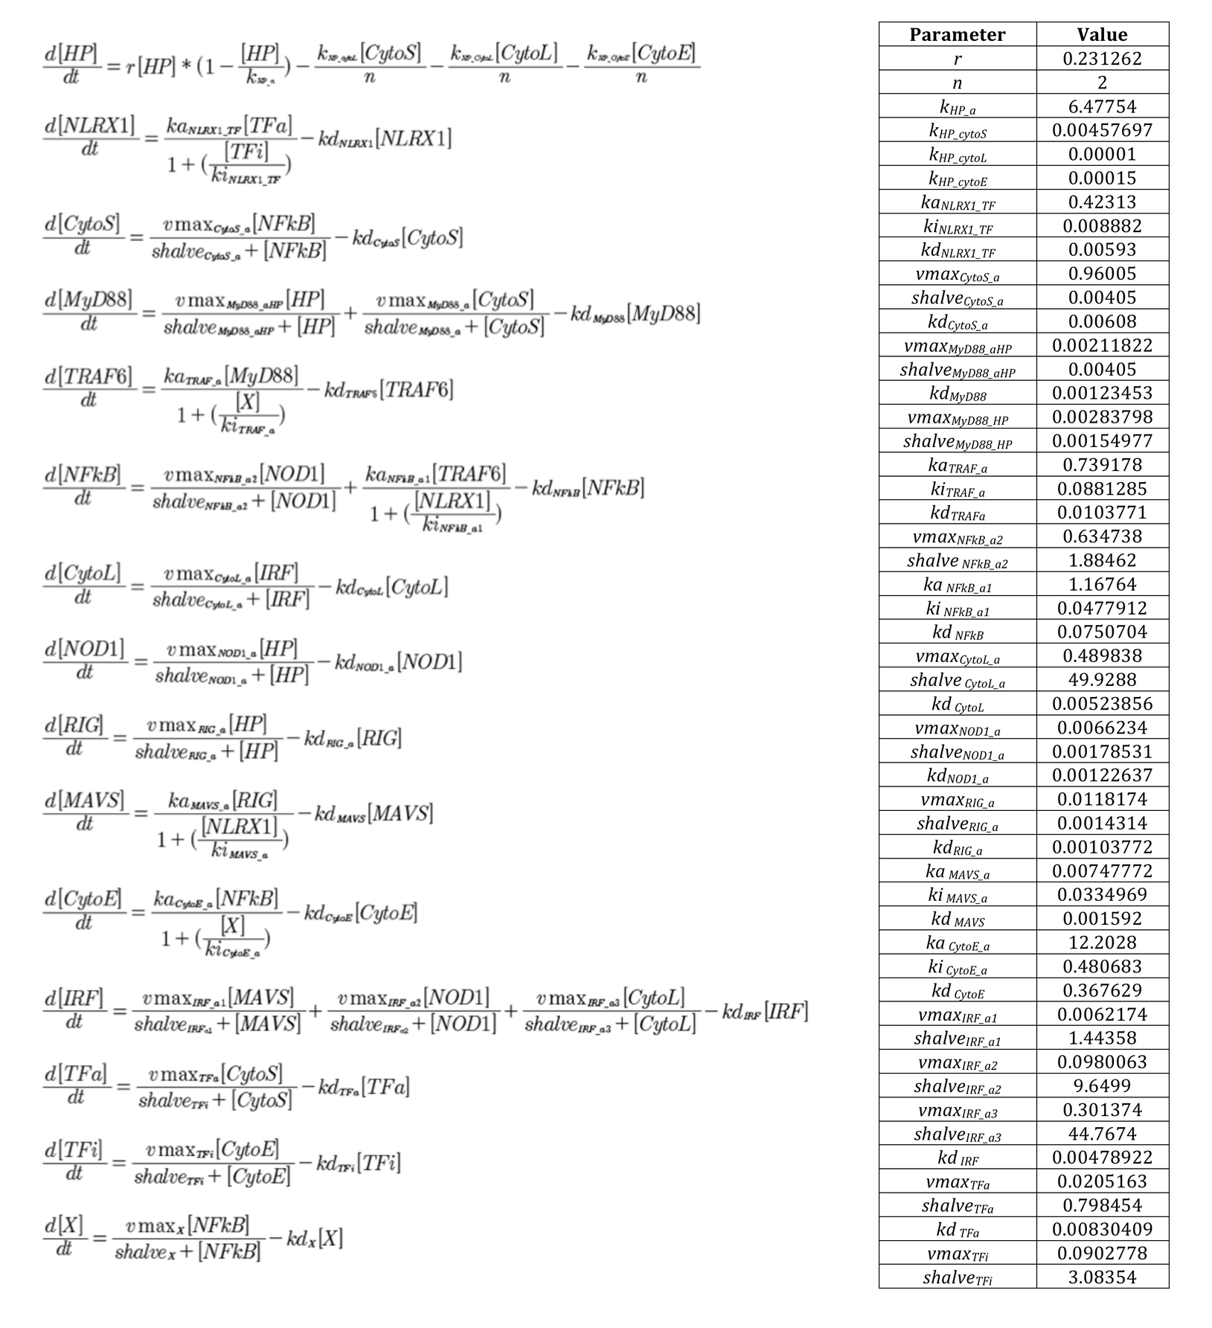

**S1 Fig. Ordinary differential equation based math model and respective parameter values for NLRX1-mediated macrophage immunity.** Dynamic behavior for each species in the biological system of NLRX1-mediated immunity in macrophages (Figure 3B) was obtained using ordinary differential equations. Parameter values were estimated in COPASI.