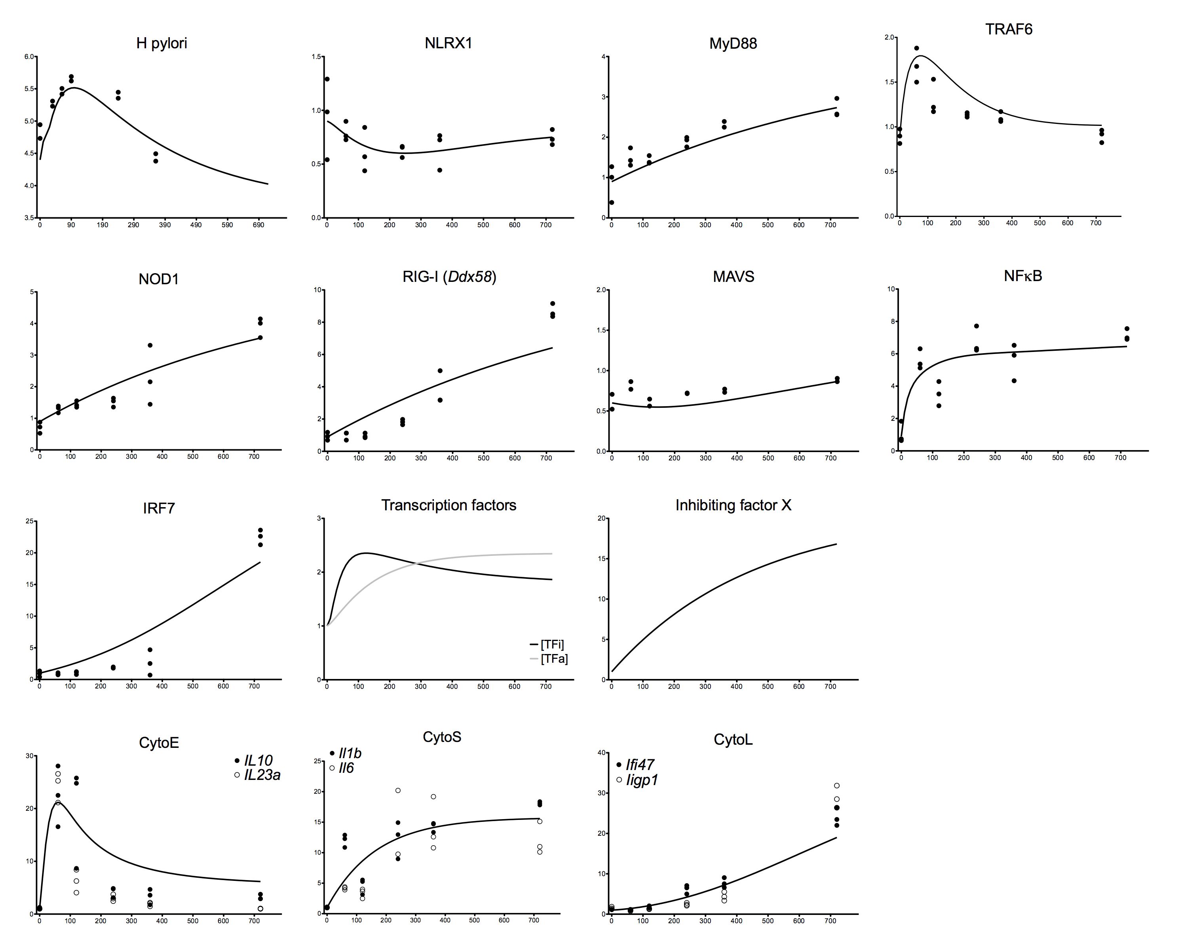

**S2 Fig. Model fitting to experimental training dataset.** Simulations for each model species (solid black line) compared to respective training data (dots). All training data, except for *Helicoabcter pylori,* was extracted from our time course RNAseq dataset for wild type bone marrow derived macrophages co-cultured with *H. pylori*. Training data for *H. pylori* represent two separate projects and each dot represents the average of three replicates. A Genetic Algorithm in COPASI was used to fit data and calculate parameter values.