**Supplemental material**

**for**

**Target-mediated Drug Disposition Model for Bispecific Antibodies: Properties, Approximation and Optimal Dosing Strategy**

**Content:**

1. **QE approximation in free drug concentration and free receptors**
2. **QE and constant total receptor approximation**
3. **Equivalence of the EB model representations**
4. **Derivation of Eq. (35)**
5. **Derivation of Eq. (38)**
6. **Comparison of the free BsAb concentration and the ternary complex from the full model with the QE approximation**
7. **Effects of varying binding parameters and total receptor concentration on the ternary complex**
8. **Effect of varying linear elimination and internalization rates on the free BsAb concentration profile**
9. **General source codes for the implementation of the QE approximation and the full model and remarks regarding IV infusion and datasets**
10. **Applied source codes and additional material for the simulation-estimation study**
11. **QE approximation in free drug concentration and free receptors**

The full BsAb model in total drug concentration and total receptor variables reads with Eqs. (1)-(8),(11)-(13):

|  |  |
| --- | --- |
| $$\frac{d}{dt}AD=In_{SC}(f,t)-k_{a}AD$$ | (A10) |
| $$\frac{d}{dt}C_{tot}=\frac{In_{IV}\left(t\right)}{V}+\frac{k_{a}AD}{V}-k_{el}C-k_{intA}RC_{A}-k_{intB}RC_{B}-k_{intAB}RC_{AB}-k_{12}C+k_{21}\frac{AP}{V}$$ | (A11) |
| $$\frac{d}{dt}R_{totA}=k_{synA}-k_{degA}R_{A}-k_{intA}RC_{A}-k_{intAB}RC_{AB}$$ | (A12) |
| $$\frac{d}{dt}R_{totB}=k_{synB}-k_{degB}R_{B}-k_{intB}RC_{B}-k_{intAB}RC_{AB}$$ | (A13) |
| $$\frac{d}{dt}{RC}_{A}=k_{on1}C⋅R_{A}-\left(k_{off1}+k_{intA}\right)RC_{A}-k_{on3}RC_{A}⋅R_{B}+k_{off3}RC_{AB}$$ | (A14) |
| $$\frac{d}{dt}{RC}_{B}=k_{on2}C⋅R_{B}-\left(k_{off2}+k_{intB}\right)RC_{B}-k_{on4}RC_{B}⋅R_{A}+k_{off4}RC_{AB}$$ | (A15) |
| $$\frac{d}{dt}{RC}_{AB}=k_{on4}RC_{B}⋅R_{A}+k_{on3}RC_{A}⋅R_{B}-\left(k_{off3}+k_{off4}+k_{intAB}\right)RC_{AB}$$ | (A16) |
| $$\frac{d}{dt}AP=k_{12}V⋅C-k_{21}AP$$ | (A18) |

We assume that all four binding occasions shown in Figure 1a are rapid and that the principle of microscopic reversibility (18) holds. This leads to the algebraic equations

|  |  |
| --- | --- |
| $$k_{on1}C⋅R_{A}-k_{off1}RC_{A}=0$$ | (A19) |
| $$k_{on2}C⋅R_{B}-k_{off2}RC_{B}=0$$ | (A20) |
| $$k_{on3}RC_{A}⋅R_{B}-k_{off3}RC_{AB}=0$$ | (A21) |
| $$k_{on4}RC_{B}⋅R_{A}-k_{off4}RC_{AB}=0$$ | (A22) |

Eqs. (A19)-(A20) directly lead to Eqs. (20)-(21). The remaining Eqs. (A21)-(A22) yield

|  |  |
| --- | --- |
| $$RC_{AB}=\frac{RC_{A}R_{B}}{KD_{3}}=\frac{RC_{B}R_{A}}{KD_{4}}$$ | (A23) |

Using $KD_{3}=αKD_{2}$, $KD_{4}=αKD_{1}$, Eqs. (20)-(21), then both realizations of Eq. (A23) are equivalent and we obtain

|  |  |
| --- | --- |
| $$RC_{AB}=\frac{CR_{A}R_{B}}{αKD_{1}KD_{2}}$$ | (A24) |

The derivatives of the binary complex Eqs. (20)-(21) and ternary complex Eq. (A24) are

|  |  |
| --- | --- |
| $$\frac{d}{dt}RC_{A}=\frac{R_{A}}{K_{D1}}⋅\frac{d}{dt}C+\frac{C}{K_{D1}}⋅\frac{d}{dt}R_{A}$$ | (A25) |
| $$\frac{d}{dt}RC_{B}=\frac{R_{B}}{K_{D2}}\frac{d}{dt}C+\frac{C}{K_{D2}}\frac{d}{dt}R_{B}$$ | (A26) |
| $$\frac{d}{dt}RC_{AB}=\frac{R_{B}C}{{αK_{D1}K}_{D2}}⋅\frac{d}{dt}R_{A}+\frac{R_{A}C}{{αK_{D1}K}_{D2}}⋅\frac{d}{dt}R_{B}+\frac{R_{A}R_{B}}{{αK_{D1}K}_{D2}}⋅\frac{d}{dt}C$$ | (A27) |

Inserting Eqs. (A25)-(A27) into the total variables Eqs. (11)-(13) provides

|  |  |
| --- | --- |
| $$\frac{d}{dt}C_{tot}=\left(1+\frac{R_{A}}{K_{D1}}+\frac{R_{B}}{K_{D2}}+\frac{R_{A}R_{B}}{αK_{D1}K_{D2}}\right)\frac{d}{dt}C+\left(\frac{C}{K_{D1}}+\frac{R_{B}C}{αK_{D1}K_{D2}}\right)\frac{d}{dt}R_{A}$$ $$+\left(\frac{C}{K_{D2}}+\frac{R_{A}C}{αK_{D1}K_{D2}}\right)\frac{d}{dt}R_{B}$$ | (A28) |
| $$\frac{d}{dt}R_{totA}=\left(\frac{R_{A}}{K_{D1}}+\frac{R_{A}R_{B}}{αK_{D1}K_{D2}}\right)\frac{d}{dt}C+\left(1+\frac{C}{K_{D1}}+\frac{R_{B}C}{αK_{D1}K_{D2}}\right)\frac{d}{dt}R_{A}$$ $$+\left(\frac{R_{A}C}{αK_{D1}K_{D2}}\right)\frac{d}{dt}R_{B}$$ | (A29) |
| $$\frac{d}{dt}R_{totB}=\left(\frac{R_{B}}{K_{D2}}+\frac{R_{A}R_{B}}{αK_{D1}K_{D2}}\right)\frac{d}{dt}C+\left(\frac{R_{B}C}{αK_{D1}K_{D2}}\right)\frac{d}{dt}R_{A}$$ $$+\left(1+\frac{C}{K_{D2}}+\frac{R_{A}C}{αK_{D1}K_{D2}}\right)\frac{d}{dt}R_{B}$$ | (A30) |

Combining Eqs. (A28)-(A30) with Eqs. (A11)-(A13) results in

|  |  |
| --- | --- |
| $$P\left(C,R_{A},R_{B}\right)\left(\begin{matrix}\frac{d}{dt}C \\ \frac{d}{dt}R_{A} \\ \frac{d}{dt}R_{B}\end{matrix}\right)=g_{BsAb}\left(AD,C,R_{A},R_{B},AP\right)$$ |  |

with

$$P\left(C,R_{A},R_{B}\right)=\left(\begin{matrix}1+\frac{R_{A}}{K_{D1}}+\frac{R_{B}}{K_{D2}}+\frac{R_{A}R_{B}}{αK_{D1}K_{D2}} & \frac{C}{K_{D1}}+\frac{R_{B}C}{αK_{D1}K_{D2}} & \frac{C}{K_{D2}}+\frac{R_{A}C}{αK_{D1}K_{D2}} \\ \frac{R_{A}}{K_{D1}}+\frac{R_{A}R_{B}}{αK_{D1}K_{D2}} & 1+\frac{C}{K_{D1}}+\frac{R_{B}C}{αK_{D1}K_{D2}} & \frac{R_{A}C}{αK_{D1}K_{D2}} \\ \frac{R_{B}}{K_{D2}}+\frac{R_{A}R_{B}}{αK_{D1}K_{D2}} & \frac{R_{B}C}{αK_{D1}K_{D2}} & 1+\frac{C}{K_{D2}}+\frac{R_{A}C}{αK_{D1}K_{D2}}\end{matrix}\right)$$

and Eq. (19). Inverting the matrix $P$ gives matrix $M_{BsAb}$ from Eq. (18) and we obtain the QE approximation Eqs. (15)-(19).

1. **QE and constant total receptor approximation**

Let relationship Eq. (23) hold. Using Eqs. (A12)-(A13) we obtain

|  |  |
| --- | --- |
| $$k_{synX}=k_{degX}\left(R_{X}+RC_{X}+RC_{AB}\right)$$ | (A31) |

for $X∈\left\{A,B\right\}.$ Substituting the complexes Eqs. (20)-(22) in Eq. (A31) provides

|  |  |
| --- | --- |
| $$k_{synA}=k_{degA}\left(R_{A}+\frac{R_{A}C}{K_{D1}}+\frac{R_{A}R_{B}C}{αK_{D1}K_{D2}}\right)$$ | (A32) |
| $$k_{synB}=k_{degB}\left(R_{B}+\frac{R_{B}C}{K_{D2}}+\frac{R_{A}R_{B}C}{αK_{D1}K_{D2}}\right)$$ | (A33) |

In the following we solve the coupled equation system Eqs. (A32)-(A33) with respect to $R_{A}$ and $R_{B}$. Rearranging Eq. (A32) regarding $R_{A}$ and using Eq. (23)-(24) yields Eq. (26). Substituting Eq. (26) in Eq. (A33) provides the quadratic equation

|  |  |
| --- | --- |
| $$a\left(C\right)R_{B}^{2}+b\left(C\right)R_{B}+d\left(C\right)=0$$ | (A34) |

for $R_{B}$ with $a,b,c$ according to Eqs. (28)-(30). Eq. (A34) possesses a unique positive solution for $C>0$ and $R_{B}=R_{totB}^{0}$ for $C=0$. This shows see Eqs. (27)-(30).

Finally, the reduced system for the QE approximation with both constant total receptors reads

|  |  |
| --- | --- |
| $$\frac{d}{dt}C=M_{BsAb}^{QECTR}\left(C\right)⋅g_{BsAb}^{QECTR}\left(AD,C,AP\right)$$ | (A35) |

with

|  |  |
| --- | --- |
| $$M_{BsAb}^{QECTR}\left(C\right)=\frac{m_{11}}{det}$$ | (A36) |

and

|  |  |
| --- | --- |
| $$g_{BsAb}^{QECTR}\left(AD,C,AP\right)=\frac{In_{IV}(t)}{V}+\frac{k_{a}AD}{V}-k_{el}C-k_{int}\frac{R_{A}C}{K_{D1}}-k_{int}\frac{R_{B}C}{K_{D2}}-k_{int}\frac{R_{A}R_{B}C}{αK_{D1}K_{D2}} -k_{12}C+k_{21}\frac{AP}{V}.$$ | (A37) |

and $R_{A},R_{B}$ according to Eqs. (26)-(30).

1. **Equivalence of the EB model representations**

We show here the equivalence of the two representations Eqs. (16), (18)-(22) with (31) and Eqs. (20)-(22), (26)-(31) of the EB model. Rewriting the EB model representation Eqs. (16), (18)-(22) with (31) in total concentrations, i.e. for an IV bolus with $dose=C_{tot}^{0}V$ at $t=0$ yields

|  |  |  |
| --- | --- | --- |
| $$\frac{d}{dt}C_{tot}=0$$ | $$C_{tot}\left(0\right)=C_{tot}^{0}$$ | (A38) |
| $$\frac{d}{dt}R_{totA}=0$$ | $$R_{totA}\left(0\right)=R_{totA}^{0}$$ | (A39) |
| $$\frac{d}{dt}R_{totB}=0$$ | $$R_{totB}\left(0\right)=R_{totB}^{0}$$ | (A40) |

and the equations (20)-(22) for the BCs and the TC. The solution of Eqs. (A38)-(A40) is $C_{tot}(t) =C_{tot}^{0}$, $R_{totA}(t) = R_{totA}^{0}$, $R_{totB}(t) =R_{totB}^{0}.$ Moreover, since Eq. (31) implies Eq. (23) we can apply the results of section 2, supplemental material and obtain the representations Eqs. (26)-(30) for the receptors $R_{A}$ and $R_{B}$.

1. **Derivation of Eq. (35)**

Our proof works in two steps. We first show that the binary complexes $RC_{A}(C)$ and $RC_{B}(C)$ saturate at $R_{totA}^{0}$, $R_{totB}^{0}$ respectively, and second, that these saturations enforce the ternary complex $RC_{AB}$ to vanish, if the concentration of the free BsAb tends to infinity.

By construction, the free receptor $R_{B}(C)$ satisfies Eq. (A34). Using $RC_{B}\left(C\right)=C⋅R_{B}(C)/KD_{2}$, one simply derives

|  |  |
| --- | --- |
| $$\tilde{a}\left(C\right)RC_{B}^{2}+\tilde{b}\left(C\right)RC_{B}+\tilde{d}\left(C\right)=0$$ | (A41) |

with

|  |  |
| --- | --- |
| $$\tilde{a}\left(C\right)=\frac{KD_{2}+C}{\left(KD_{1}+C\right)αC}$$ |  |
| $$\tilde{b}\left(C\right)=\frac{R_{totA}^{0}-R_{totB}^{0}}{α\left(KD_{1}+C\right)}+\frac{KD_{2}}{C}+1$$ |  |
| $$\tilde{d}\left(C\right)=-R_{totB}^{0}$$ |  |

for the binary complex $RC_{B}$. Moreover, $\lim_{C→∞}{\tilde{a}\left(C\right)=0}$ and $\lim_{C→∞}{\tilde{b}\left(C\right)=1}$ hold. Hence, $RB_{∞}≔\lim_{C→∞}{RC_{B}\left(C\right)}$ satisfies the limit equation

|  |  |
| --- | --- |
| $$0⋅RB_{∞}^{2}+1⋅RB_{∞}-R_{totB}^{0}=RB_{∞}-R_{totB}^{0}=0$$ |  |

which proves

|  |  |
| --- | --- |
| $$\lim_{C→∞}{RC_{B}\left(C\right)}=R_{totB}^{0}$$ | (A42) |

Then using Eqs. (26), (A42) we obtain

|  |  |
| --- | --- |
| $$\lim_{C→∞}{RC_{A}\left(C\right)}=\frac{R_{totA}^{0}\frac{C}{KD_{1}}}{1+\frac{C}{KD_{1}}+\frac{RC_{B}(C)}{αKD_{1}}}=R_{totA}^{0}$$ |  |

and, finally,

|  |  |
| --- | --- |
| $$\lim_{C→∞}{RC_{AB}\left(C\right)}=\lim_{C→∞}{\frac{1}{αC}RC_{A}(C)RC_{B}\left(C\right)}=0$$ |  |

follows.

1. **Derivation of Eq. (38)**

In the total constant receptor situation without a peripheral compartment and $k_{el}=k_{int}$ we obtain from Eq. (A11)

|  |  |
| --- | --- |
| $$\frac{d}{dt}C_{tot}=-k_{int}C-k_{int}RC_{A}-k_{int}RC_{B}-k_{int}RC_{AB}=-k_{int}C_{tot}$$ |  |

with $C_{tot}\left(0\right)=C^{0}=\frac{dose_{init}}{V}$ and the solution representation Eq. (38) follows.

1. **Comparison of the free BsAb concentration from the full model with the QE approximation**

Comparison of the free BsAb concentration (panel A) and the ternary complex (panel B) from the full model with the QE approximation without a peripheral compartment and an IV bolus dose of 50 and 250 mg is shown in Figure S1 (black curve is the full BsAb model and red curve is the QE approximation). All model parameter values are taken from Table 2.

**A B**

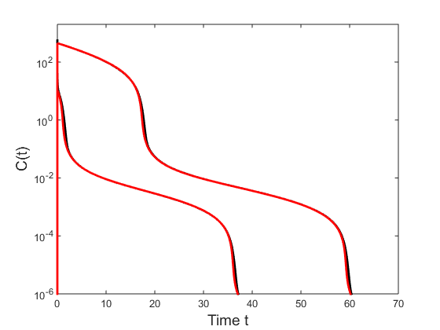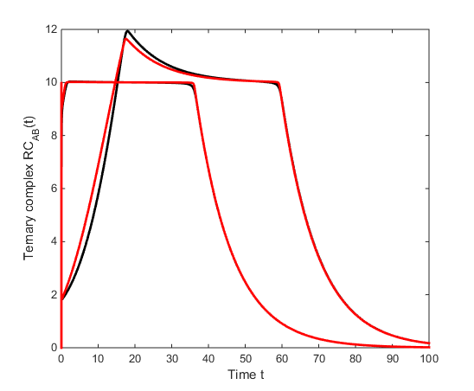

*Figure S1*

In Figure S2 the comparison is shown, if rapid binding is violated by $k_{on2}$ = 0.0001 1/(nM day). Hence, we see that rapid binding is essential to guarantee a good approximation in free BsAb concentration as well as in the other model components as the ternary complex

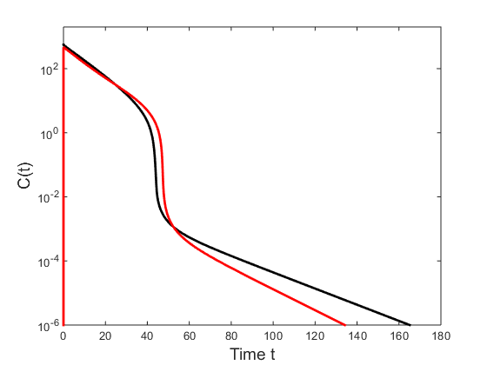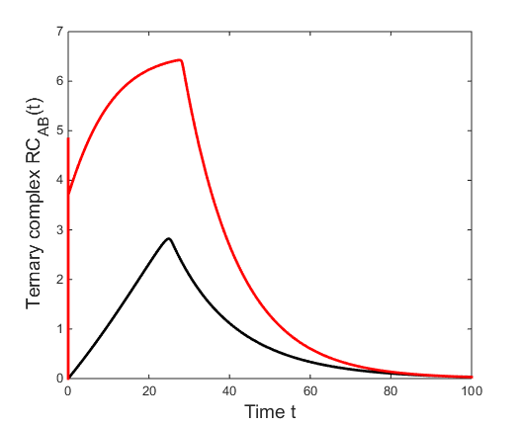

*Figure S2*

In the last comparison, a peripheral compartment is used. Figure S3, panel A shows the situation with the approximation for lower free BsAb concentrations. In fact, the full model (black) behaves quite differently than the approximation, suggesting that the rapid binding is partially violated. In panel B, the kon’s and koff’s are multiplied by the factor 100; please note that the dissociation constants stay the same. The full model is now closer to the approximation. In panel C, the rates between the central and peripheral compartment are multiplied by the factor 100, and full model and approximation behave equally. Panels D-F show the ternary complex for each situation.

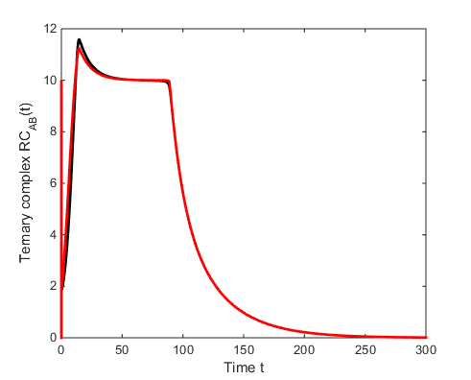**A D**

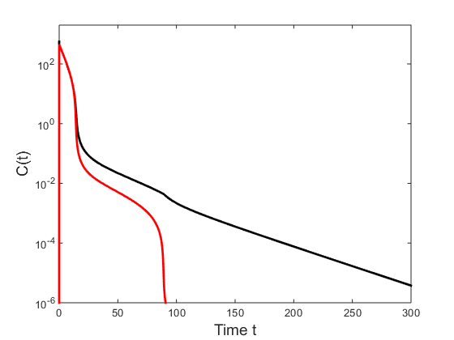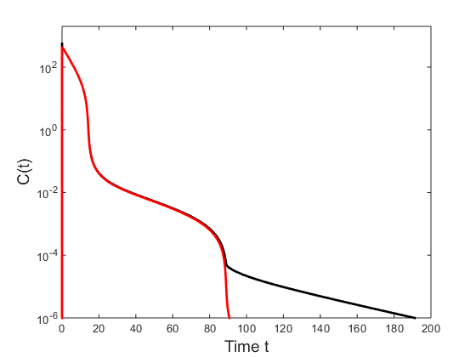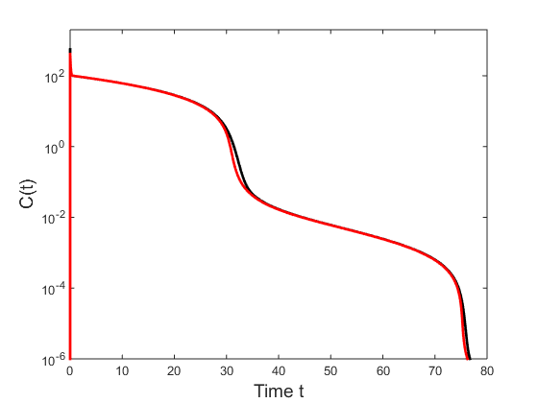

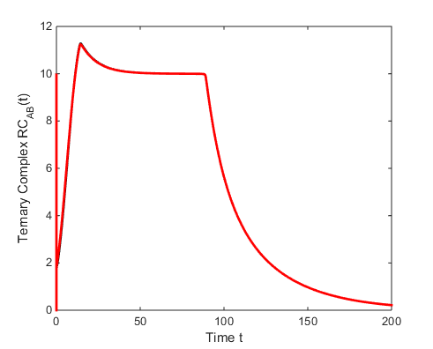**B E**

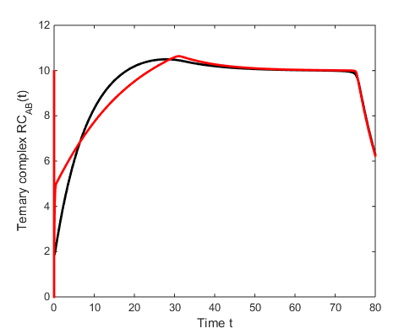 **C** **F**

*Figure S3*

1. **Effects of varying binding parameters and total receptor concentration on the ternary complex**

To visualize the effect of varying binding parameters and total receptor concentration on the bell-shaped curve describing the relationship between $C_{tot}(C)$ and ${RC}_{AB}(C)$, we provide the Matlab implementation of the model Eqs. (20)-(22),(26)-(30):

🡺 Please see file Supp_Code_0.docx

1. **Effect of varying linear elimination and internalization rates on the free BsAb concentration profile**

The effect of varying linear elimination rate $k_{el}$ is shown in Figure S4. For an increasing rate the free BsAb concentration profile shifts to the left.

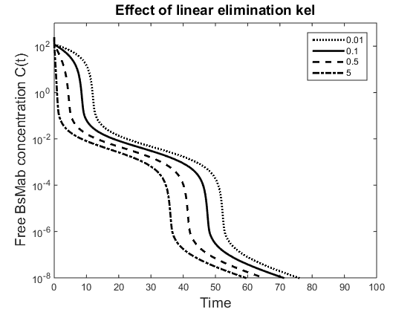

*Figure S4*

For $R_{A}^{0}<R_{B}^{0}$ the effect of the three different internalization rates is shown. Only the relevant states with changes in their profile are visualized. For varying $k_{intA}∈$ [0.0005, 0.05, 5] (blue, red, black) 1/day and fixed $k_{intB}$ = 0.05 and $k_{intAB}$ = 0.1, nearly no effect on the free BsAb concentration profile could be seen, whereas the binary $RC_{A}$ and ternary $RC_{AB}$ complex showed changes in their profile, see Figure S5 panel A. For varying $k_{intB}∈$ [0.0005, 0.05, 5] (blue, red, black) and fixed $k_{intA}$ = 0.05 and $k_{intAB}$ = 0.1, the free BsAb concentration profile in the first non-linear phase results in changing behaviour of the free receptors $R_{A}$ and additionally on all three complexes, see Figure S5 panel B. Finally, for $k_{intAB}∈$ [0.001, 0.1, 10] (blue, red, black) and fixed $k_{intA}$ = 0.05 and $k_{intB}$ = 0.01, an effect on the free BsAb concentration in the second non-linear phase is observed. Also the ternary complex showed strong $k_{intAB}$ dependency, see Figure S5 panel C.

**A B**

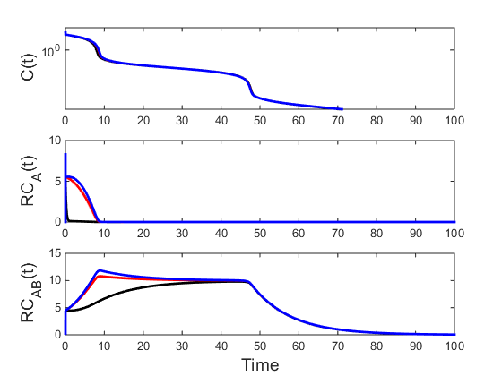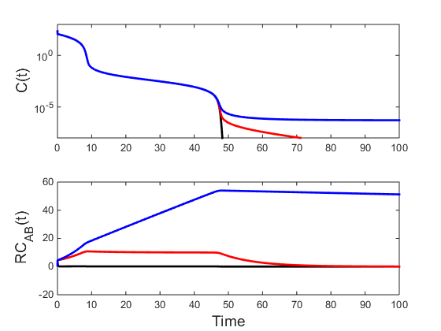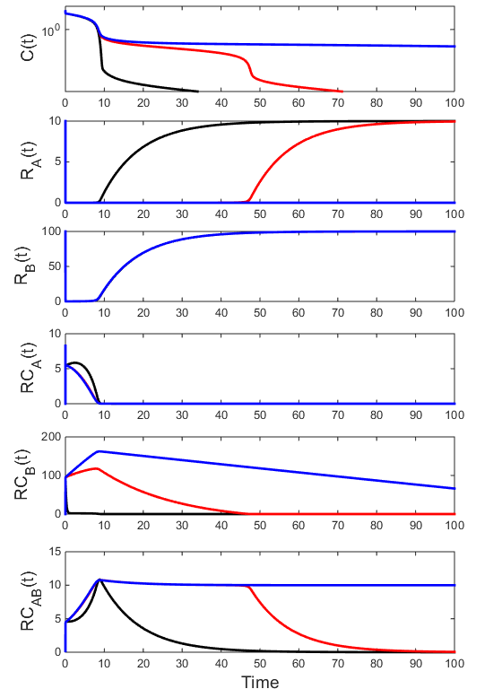

**C**

*Figure S5:* Effects of varying internalization rates are shown (panel A $k_{intA}$, panel B $k_{intB}$, and panel C $k_{intAB}$). Blue curves represent a very small value and black curves a very high value.

1. **General source codes for the implementation of the QE approximation and the full model and remarks regarding IV infusion and dataset**

As described in the Method Section, internal dosing mechanisms from Monolix and Nonmem cannot be used to handle IV infusion for the QE approximation. Therefore, we present a solution for Monolix and Nonmem to implement an IV infusion for the QE approximation. In both cases let tdur be the duration of infusion.

**Monolix**

As described in the Method Section, an additional dummy compartment Eq. (42)

$$\frac{d}{dt}In_{IVDum}\left(t\right)=0 , In_{IVDum}\left(0\right)=0$$

can be used, which is simply added to the other model equations. The dummy compartment is then controlled via the tlag and “bioavailability” functionality. More precisely, with the depot command the dummy state $In_{IVdum}$ is increased to a certain value $x$ for $t_{1}≤t≤t_{1}+t_{dur}$ where $t_{1}$ is the dosing time point. The first depot command

depot(adm = 1,target = In,p = 1/tdur)

sets

$$In_{IVDum}=p⋅dose$$

for $t_{1}≤t≤t_{1}+t_{dur}$ by using the “bioavailability” option p = 1/tdur and therefore starts the infusion. The second depot command

depot(adm = 1,target = In,p = -1/tdur, Tlag = tdur)

sets

$$In_{IVDum}=0$$

for $t>t_{1}+t_{dur}$. Hence, after time tdur, the tlag option together with the “bioavailability” option is used to stop the infusion.

The drug amount is taken from the data file

|  |  |  |  |  |  |  |
| --- | --- | --- | --- | --- | --- | --- |
| #ID | TIME | DV | AMT | EVID | MDV | ADM |
| 1 | 0 | . | 670 | 1 | 1 | 1 |

With a tdur small, e.g. 1e-4, an IV bolus can be mimicked by an IV short infusion.

Example code of the QE approximation with non-constant total receptors

🡺 Please see file Supp_Code_1.docx

Example code of the full model:

🡺 Please see file Supp_Code_2.docx

**Nonmem**

In Nonmem it is not clear how a negative “bioavailability” can be used. Consequently application of an additional dummy compartment to describe the input function seems not to be applicable. Therefore, we “hard-code” the infusion mechanism as presented in the Method Section. To be as general as possible, both routes of administration, SC and IV, are included in the Nonmem code. In case of an SC administration everything is as usual and the dose is provided by the AMT column. For the IV administration, we have to set up a very low dummy dose, such as 1e-16, in the AMT column. The real dose is provided in the Nonmem code.

Example code of the QE approximation with non-constant total receptors

🡺 Please see file Supp_Code_3.docx

Example code of the full model:

🡺 Please see file Supp_Code_4.docx

1. **Applied source codes and additional material for the simulation-estimation study**

**Applied Monolix source code for Eqs. (15)-(23)**

🡺 Please see file Supp_Code_5.docx

Visual predictive checks:

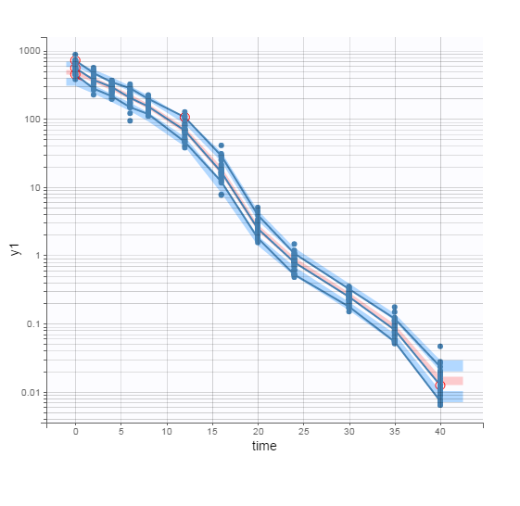BsAb concentration $C:$

Free receptor concentrations $R_{A}$ and $R_{B}$:

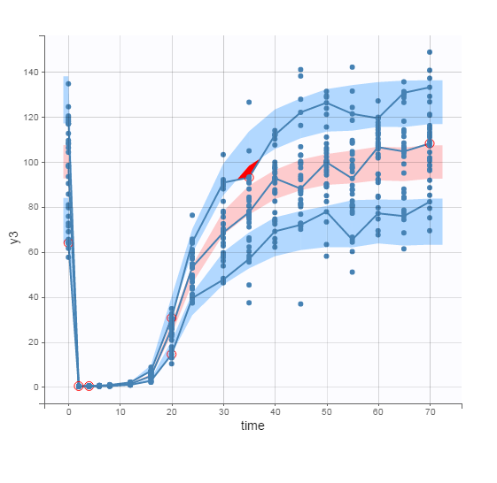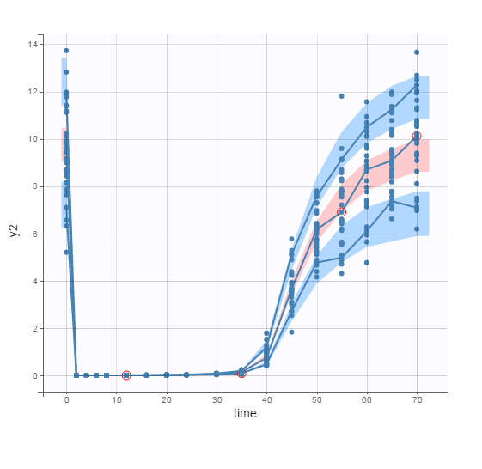

**Alternative Monolix source code for Eqs. (15),(17),(25)-(30)**

In this formulation the setting odeType = stiff causes convergence problems and is therefore not recommended. Without a stiff solver, results were comparable to values obtained from the above source code and presented in Table 3.

🡺 Please see file Supp_Code_6.docx

**Applied Nonmem source code for Eqs. (15)-(23)**

🡺 Please see file Supp_Code_7.docx

**Alternative Nonmem source code for Eqs. (15),(17),(25)-(30)**

🡺 Please see file Supp_Code_8.docx