**Supplementary material – Sensitivity analysis**

The sensitivity analysis was performed to determine the influence of various parameters. A parameter P was varied at a time and the change in steady state C3bBb values was recorded. The sensitivity index S was calculated using the formula

$$S=\frac{abs(C3bBb\left(Pj+∆Pj\right)-C3bBb\left(Pj\right))}{∆Pj}*\frac{Pj}{C3bBb(Pj)}$$

Where $Pj$ denotes the $jth$ parameter, $∆Pj$ denotes the change in the $jth$ parameter and $C3bBb(Pj)$ and $C3bBb(Pj+ ∆Pj)$ denote the steady state values of C3bBb at the original and new parameter value respectively. The sensitivity index $S$ is normalized with parameter size as well as the original C3bBb steady state for comparability. Figures A and B show the relative sensitivity indices *S* for minimal and properdin models, respectively.

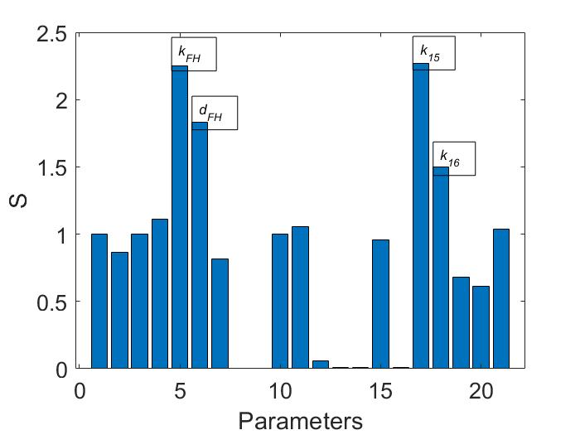

Figure A: Results of sensitivity analysis of the minimal model.

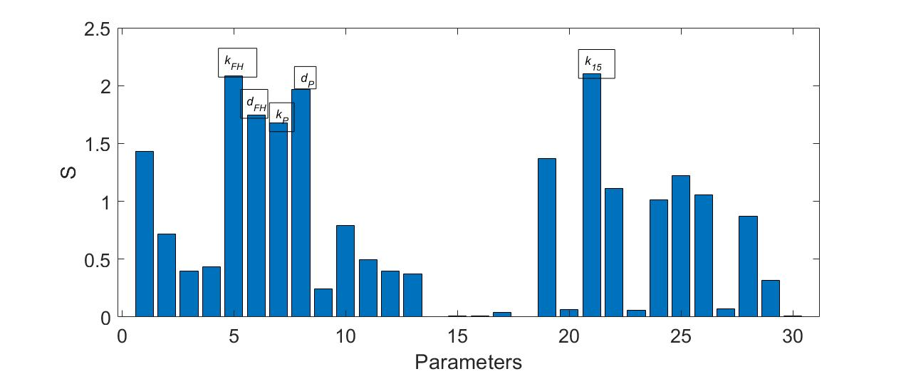

Figure B: Results of sensitivity analysis of the properdin model.