**Supplement to:**

**Extending the minimal model of metabolic oscillations in   
*Bacillus subtilis* biofilms**

Ravindra Garde 1,2,4 , Bashar Ibrahim 1,3,4*, Stefan Schuster 1*

1Department of Bioinformatics, Matthias Schleiden Institute, Friedrich Schiller University Jena, Ernst-Abbe-Platz 2, 07743, Jena, Germany. 2

2Max Planck Institute for Chemical Ecology Hans-Knöll Str. 8, 07745, Jena, Germany. 3

3Centre for Applied Mathematics and Bioinformatics, and Department of Mathematics and Natural Sciences Gulf University for Science and Technology, Hawally, 32093, Kuwait. 4

4These authors contributed equally: Ravindra Garde and Bashar Ibrahim.   
*email: [bashar.ibrahim@uni-jena.de](mailto:bashar.ibrahim@uni-jena.de); [stefan.schu@uni-jena.de](mailto:stefan.schu@uni-jena.de)

***Quasi-steady-state approximation non trivial steady state***

The Jacobian matrix for the NTSS reads:

$M=\left(\begin{matrix}\left(k_{1}G_{E}-k_{4}\right)-\frac{k_{2}k_{5}}{k_{3}+k_{-5}}G_{i} & -\frac{k_{2}k_{5}}{k_{3}+k_{-5}}G_{p}+\frac{{k_{-2}k}_{5}}{k_{3}+k_{-5}}+k_{-4} \\ k_{4} & \frac{{k_{-5}k}_{5}}{k_{3}+k_{-5}}- k_{5}- k_{-4}\end{matrix}\right)$

The eigenvalues are $λ_{1,2} =\frac{-b±\sqrt{b^{2}-4ac}}{2}$, where

for the NTSS:

$\begin{matrix}a=1 \\ b=-a_{11}-a_{22}= {-[k}_{1}G_{E}-k_{4 }-{GG}_{i}+\frac{{k_{-5}k}_{5}}{k_{3}+k_{-5}}- k_{5}- k_{-4}] \\ c=a_{11}a_{22}-a_{12}a_{21}={(k}_{1}G_{E}-k_{4 }-{GG}_{i})(\frac{{k_{-5}k}_{5}}{k_{3}+k_{-5}}- k_{5}- k_{-4})- k_{4}(\frac{{k_{-2}k}_{5}}{k_{3}+k_{-5}}+k_{-4})\end{matrix}$

$and {GG}_{i}=\frac{k_{2}k_{5}}{k_{3}+k_{-5}}G_{iSS}$ (always positive , and $k_{3}+k_{-5}≠0$)

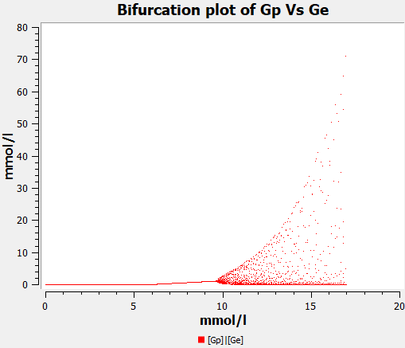

**Figure S1:** Bifurcation plot of *Gp* versus *GE* (model s6ODE): The Hopf bifurcation occurs at about *GE* = 9.6 mmol/l, as opposed to 24.4 mmol/l for model BM or c6ODE.

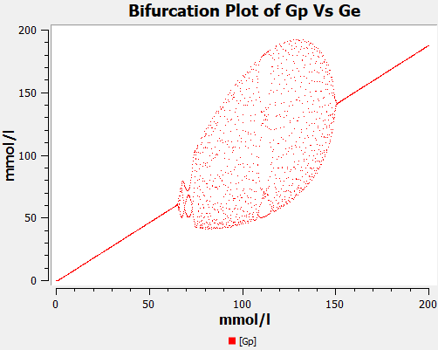

**Figure S2:** Bifurcation plot of *Gp* versus *GE* (model R): Parameters: *k1* = 0.74 (mM* h)-1, *k-1* = 0.074 (mM* h)-1, *k2* = *k-2* = *k5* = *k-5* = *k2* = 2.3 h-1, *k3* = *k-3* = 4 h-1, *k2* = *k2* = 3 h-1. Only for this set of parameters, and when *k-1* is non zero, the bubble-like Hopf bifurcation can be observed, indicating that reversibility of reaction 1 is crucial for this kind of a bifurcation.