Request by Alexander Braun from 18-Feb-2026
  - Interrupted Time Series - Segmented linear regression // Nonparametric regression
Claus P. Nowak
13 April 2026

Preliminary/Which data do I use?
Update 13-Apr-2026. Based on the manuscript from Alexander Braun (received by e-mail on 8-Apr-2026 at 18:17), I have added some additional computations.
Update 03-Apr-2026. Alexander Braun sent me an email at 09:08 with the request to add three robustness checks.
- Eine Variation des Interruptionpoints +/- 1 Monat und einen mit 1.1.2025
- Evtl. einer anderen Autokorrelationsannahme (Ar(2))?
- Einer parametrischen Schätzung mit den Monatswerten? (Vermutlich geht da die Influenzaadjustierung nicht)
Update 24-Mar-2026. Alexander Braun sent me an email at 10:47 with a link to the complete data set, which I downloaded from https://donauuni.sharepoint.com/:x:/s/EbVF/IQAin0Q910FBTJlyLZaEDy60AXy2zfBWdV3r7PPKEvXKc8U?e=D2RyRy on 25-Mar-2026 at 09:05. In his email he explained/requested
- In Patient Age sind 16 unplausible Werte (Geburtsdatum nach Aufnahme), ich habe die Werte aus Patient_Age herausgenommen.
- Es gibt einige doppelte Fälle, die komplett identisch sind. Kannst Du die identifizieren und nur einmal zählen?
- PVE_Open ist nun angepasst. Nur WAHRE Fälle sind bezeichnet mit WAHR (dort wo es das Zentrum nicht gab oder keine Öffnungszeit war, ist die Zelle leer)
- Für die ITSA wären drei Tabellen vorgesehen + die Grafiken (einmal parametric und einmal non-parametric und evtl. in der X-Achse die Jahreszahlen anstatt die laufenden Tage).
Update 11-Mar-2026. Veronika Boskova gave me an article by
- Kovacevic et al. (2025). The impact of primary care networks on emergency hospitalisations in the English NHS: An interrupted time series analysis. Health policy. https://doi.org/10.1016/j.healthpol.2025.105524.
I have some doubts as to whether this approach is preferable because of overfitting issues. It is my understanding that they have essentially 26 data points (quarters) in total and model two interruptions and seasonality as binary dummy variables on top.
Update 04-Mar-2026. Further to today’s meeting with Alexander Braun, I incorporate the possibility of a different intercept during influenza season in the ITS equation.
17-Feb-2026. I received an email from Alexander Braun with a request to perform an Interrupted Time Series Analysis. I used the data as downloaded from MS Teams https://donauuni.sharepoint.com/:x:/s/EbVF/IQCYSk6ZYf8eQoPEiYvG5FNEAc0cXjS0hHeHlnqnSbAXgM4?e=pjcRSb on 18-Feb-2026 at 08:52 (CET).
This was part of his email:
- Uns geht es darum herauszufinden, ob das neugegründete Primärversorgungszentrum (Öffnung am 1.1.2024) Auswirkungen auf die Notfallbehandlungen im Spital Wiener Neustadt hatten (Jede Zeile ist eine gesonderte Aufnahme).
- Unsere Überlegung dazu war eine ITSA zu berechnen. Wir denken, dass folgende Prädiktoren Auswirkung haben könnten:
  - Ist das PVZ offen (also vorher-nachher und wenn es eröffnet hat, ob Wochenende/Öffnungszeiten ist („Spalte H: PVE_Open“)
    - Based on previous emails the interruption in the time series (PVE-Eröffnung occurred on 01-Jan-2024).
  - das Alter (Spalte I Patient_Birth_year)
  - das Geschlecht („Spalte L (M/W“)
  - Schweregrad entlang des Manchester-Triage-Systems (vermutlich eher Prio 3 und 4, da diese vermutlich auch in PVE behandelt werden können (z.B. Schnittwunden,…)
  - Ob gerade Grippesaison ist oder nicht (Spalte N: Influenza)
- Ich würde weiters die These aufstellen, dass die Tage von Weihnachten bis Neujahr ebenfalls einen Einfluss hat (Christmas Shock oder wie auch immer man das nennen möchte, zumindest gibt es dazu Literatur).
- Kannst Du damit was anfangen? Ich glaube zu komplex ist das gar nicht, aber ich habe dir ja gezeigt, dass diese Zeit um die Eröffnung halt sehr fuzzy ist, das wir mit Influenza allein nicht erklären konnten. Vielleicht hast Du dazu eine Idee? Ich würde mich freuen, wenn Du mir dabei hilfst.

General Comments from Claus
Interrupted Time Series. For the interrupted time series analysis I used the model by Korevaar et al. (see https://tinyurl.com/its-meta-analysis-workshop).
$$y_{t}=β_{0}+β_{1}t+β_{2}I_{t}+β_{3}\left(t−T\right)I_{t}+ε_{t},$$
where
- $y_{t}$ is the number of hospital admissions at day $t=1,..,n$;
- $T$ is the interruption day, in our case $T=731$,
- $I_{t}$ is an indicator variable which takes 0 before the interruption, i.e., if $t<T$, and 1 otherwise,
- $ε_{t}$ are modelled as autocorrelated errors of order 1.
Note that this approach might not be ideal because $y_{t}$ are count data so arguably a GLMM with a negative binomial distribution might be more appropriate. However, treating $y_{t}$ as continuous simplifies interpretation and fluctuations (at least when considering all data) do not seem to substantially deviate from normality.
If we already consider Influenza, I would expect this covariate to be correlated with “Christmas” season, so I am not really sure whether it makes sense to include both in a model.
The outliers seem less pronounced after removing duplicate rows.
Update 04-Mar-2026:
I include an indicator variable $F_{t}$ which takes 1 if the day $t$ is during the influenza season and 0 otherwise. The coefficient $β_{4}$ allows for a different intercept during the influenza season,
$$y_{t}=β_{0}+β_{1}t+β_{2}I_{t}+β_{3}\left(t−T\right)I_{t}+β_{4}F_{t}+ε_{t},$$
with the other variables remaining as before. A graphical inspection of the influenza admissions per day seems to support this approach.
Update 31-Mar-2026: As a sensitivity analysis, I also modelled the error terms, i.e., $ε_{t}$ as an ARMA(1,1) process for the full data accounting for influenza.
Update 03-Apr-2026: I also modelled the errors as AR(2) process as requested by Alexander Braun.
Nonparametric trend estimation. In addition to the Interrupted Time Series analysis, I would recommend a semiparametric model defined by
$$y_{t}=m\left(x_{t}\right)+ε_{t},$$
where
- $y_{t}$ is the number of hospital admissions at time point (or day) $t=1,...,n$;
- $x_{t}=t/n$ denotes the rescaled time,
- $m$ is a smooth function representing the trend, which is estimated in a nonparametric manner,
- $ε_{t}$ is a zero mean stationary process.
This method is implemented in the R package smoots which allows for a completely data driven selection of the optimal bandwidth while taking autocorrelation into account. See also
- Feng Y, Gries T, Letmathe S, Schulz D. The smoots Package in R for Semiparametric Modeling of Trend Stationary Time Series. R Journal March 2022;14/1:182-195. https://doi.org/10.32614/rj-2022-017.

Which packages and R version do I use?
library(tidyverse)
── Attaching core tidyverse packages ──────────────────────── tidyverse 2.0.0 ──
✔ dplyr 1.2.0 ✔ readr 2.2.0
✔ forcats 1.0.1 ✔ stringr 1.6.0
✔ ggplot2 4.0.2 ✔ tibble 3.3.1
✔ lubridate 1.9.5 ✔ tidyr 1.3.2
✔ purrr 1.2.1
── Conflicts ────────────────────────────────────────── tidyverse_conflicts() ──
✖ dplyr::filter() masks stats::filter()
✖ dplyr::lag() masks stats::lag()
ℹ Use the conflicted package (<http://conflicted.r-lib.org/>) to force all conflicts to become errors
library(readxl)
library(smoots)
********************************************************************************
Welcome to the package 'smoots'!
********************************************************************************
Please report any possible errors and bugs to dominik.schulz@uni-paderborn.de.
Thank you.
********************************************************************************
library(nlme)
Attaching package: 'nlme'
The following object is masked from 'package:dplyr':
collapse
library(multcomp)
Loading required package: mvtnorm
Loading required package: survival
Loading required package: TH.data
Loading required package: MASS
Attaching package: 'MASS'
The following object is masked from 'package:dplyr':
select
Attaching package: 'TH.data'
The following object is masked from 'package:MASS':
geyser
sessionInfo()
R version 4.5.3 (2026-03-11 ucrt)
Platform: x86_64-w64-mingw32/x64
Running under: Windows 10 x64 (build 19045)
Matrix products: default
LAPACK version 3.12.1
locale:
[1] LC_COLLATE=English_Europe.utf8 LC_CTYPE=English_Europe.utf8
[3] LC_MONETARY=English_Europe.utf8 LC_NUMERIC=C
[5] LC_TIME=English_Europe.utf8
time zone: Europe/Vienna
tzcode source: internal
attached base packages:
[1] stats graphics grDevices utils datasets methods base
other attached packages:
[1] multcomp_1.4-30 TH.data_1.1-5 MASS_7.3-65 survival_3.8-6
[5] mvtnorm_1.3-6 nlme_3.1-168 smoots_1.1.4 readxl_1.4.5
[9] lubridate_1.9.5 forcats_1.0.1 stringr_1.6.0 dplyr_1.2.0
[13] purrr_1.2.1 readr_2.2.0 tidyr_1.3.2 tibble_3.3.1
[17] ggplot2_4.0.2 tidyverse_2.0.0
loaded via a namespace (and not attached):
[1] gtable_0.3.6 xfun_0.56 lattice_0.22-9
[4] tzdb_0.5.0 vctrs_0.7.1 tools_4.5.3
[7] generics_0.1.4 parallel_4.5.3 sandwich_3.1-1
[10] pkgconfig_2.0.3 Matrix_1.7-4 RColorBrewer_1.1-3
[13] S7_0.2.1 lifecycle_1.0.5 compiler_4.5.3
[16] farver_2.1.2 progress_1.2.3 codetools_0.2-20
[19] htmltools_0.5.9 yaml_2.3.12 pillar_1.11.1
[22] crayon_1.5.3 parallelly_1.46.1 tidyselect_1.2.1
[25] digest_0.6.39 stringi_1.8.7 future_1.70.0
[28] listenv_0.10.1 splines_4.5.3 fastmap_1.2.0
[31] grid_4.5.3 cli_3.6.5 magrittr_2.0.4
[34] future.apply_1.20.2 withr_3.0.2 prettyunits_1.2.0
[37] scales_1.4.0 timechange_0.4.0 rmarkdown_2.30
[40] globals_0.19.1 otel_0.2.0 progressr_0.18.0
[43] cellranger_1.1.0 zoo_1.8-15 hms_1.1.4
[46] evaluate_1.0.5 knitr_1.51 rlang_1.1.7
[49] Rcpp_1.1.1 glue_1.8.0 rstudioapi_0.18.0
[52] jsonlite_2.0.0 R6_2.6.1

How do read in the data set and get the dates for the Influenza seasons?
filename <- "C:/Users/CNowak/OneDrive - Universität für Weiterbildung Krems/Beratung/2026/AlexanderBraun_20260217/"
# all_dates <- tibble(Triage_Begin_Date = seq.Date(as.Date("2022-01-01"),
# as.Date("2025-12-31"),
# by = "day"))
addVariables <- function(dat,intday="01Jan2024"){
dat <- alldates |> left_join(dat,by=c("Triage_Begin_Date",
"Day",
"Month",
"Year",
"Week_Day"))
dat <- dat |> mutate(
Triage_Begin_Day=as.integer(Triage_Begin_Date - min(Triage_Begin_Date)) + 1,
Interruption_Day=as.integer(as.Date(x=intday,"%d%b%Y") - min(Triage_Begin_Date)) + 1,
Level_Change=ifelse(Triage_Begin_Day < Interruption_Day,0,1),
Slope_Change=ifelse(Level_Change==0,0,Triage_Begin_Day-Interruption_Day), #01Jan2024 equals Triage_Begin_Day 731
n=ifelse(is.na(n),0,n),
.after=1)
return(dat)
}
addVariables2 <- function(dat,intday="01Jan2024"){
dat <- dat |> mutate(
Triage_Begin_Month=as.integer(interval(min(Triage_Begin_Date),Triage_Begin_Date) %/% months(1)) + 1,
Interruption_Month=as.integer(interval(min(Triage_Begin_Date),as.Date(x=intday,"%d%b%Y")) %/% months(1)) + 1,
Level_Change=ifelse(Triage_Begin_Month < Interruption_Month,0,1),
Slope_Change=ifelse(Level_Change==0,0,Triage_Begin_Month-Interruption_Month),
n=ifelse(is.na(n),0,n),
.after=1)
return(dat)
}
dat00 <- read_xlsx(str_c(filename,"MTS Daten_2022-2025_complete.xlsx"),
range="A1:M84739",
sheet="Daten2022-2025") |>
mutate(Triage_Begin_Date=as_date(Triage_Begin), .after=1) |>
distinct() # removes 3067 duplicated entries
alldates <- dat00 |> group_by(Triage_Begin_Date,Day,Month,Year,
Week_Day) |>
count() |> ungroup() |>
dplyr::select(-n)
influenz <- dat00 |> dplyr::select(Triage_Begin_Date,Influenza) |>
filter(Influenza=="ja") |> count(Triage_Begin_Date)
plot(influenz,las=1,main="Number of Influenza Admissions")
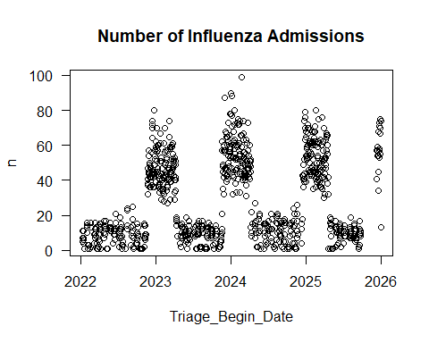
influenz |> filter(n>=30) |>
mutate(next_date = lead(Triage_Begin_Date),
gap = as.integer(next_date - Triage_Begin_Date)) |>
filter(gap >= 2)
# A tibble: 8 × 4
Triage_Begin_Date n next_date gap
<date> <int> <date> <int>
1 2023-01-28 51 2023-01-30 2
2 2023-02-08 32 2023-02-10 2
3 2023-02-24 52 2023-02-26 2
4 2023-03-11 45 2023-03-13 2
5 2023-04-01 33 2023-04-03 2
6 2023-04-09 51 2023-11-20 225
7 2024-04-07 52 2024-12-16 253
8 2025-04-20 32 2025-12-11 235
influenz |> filter(n>=30) |>
summarise(season1_start=min(Triage_Begin_Date),
season4_end=max(Triage_Begin_Date))
# A tibble: 1 × 2
season1_start season4_end
<date> <date>
1 2022-11-21 2025-12-30
alldates <- alldates |>
mutate(season1=as.integer(Triage_Begin_Date >= as.Date("2022-11-21") & Triage_Begin_Date <= as.Date("2023-04-09")),
season2=as.integer(Triage_Begin_Date >= as.Date("2023-11-20") & Triage_Begin_Date <= as.Date("2024-04-07")),
season3=as.integer(Triage_Begin_Date >= as.Date("2024-12-16") & Triage_Begin_Date <= as.Date("2025-04-20")),
season4=as.integer(Triage_Begin_Date >= as.Date("2025-12-11") & Triage_Begin_Date <= as.Date("2025-12-31")),
influenza=season1+season2+season3+season4) |>
dplyr::select(-c(season1,season2,season3,season4))
Based on this data set I extracted the following dates for the influenza season:
Influenza | Start Date | End Date
Season 1 | 2022-11-21 | 2023-04-09
Season 2 | 2023-11-20 | 2024-04-07
Season 3 | 2024-12-16 | 2025-04-20
Season 4 | 2025-12-11 | 2025-12-31

How do I get daily and monthy admissions before and after the opening of the PHC?
daily <- dat00 |>
group_by(Triage_Begin_Date,Day,Month,Year,Week_Day) |>
count() |>
mutate(PreInterruption = ifelse(Triage_Begin_Date < as.Date(x="01Jan2024","%d%b%Y"),0,1))
plot(daily$Triage_Begin_Date,daily$n,
ylim=c(0,120),
las=1,
ylab="Number of Admissions",
#type="l",
xlab="Date",
main="Number of Admissions per Day")
abline(v=as.Date(x="01Jan2024","%d%b%Y"))
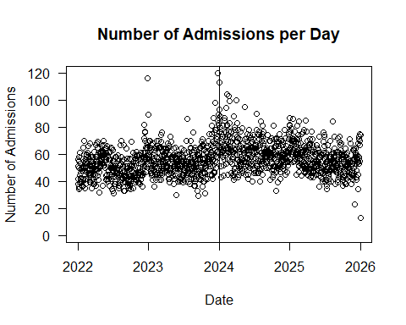
plot(daily$Triage_Begin_Date,daily$n,
ylim=c(0,120),
las=1,
ylab="Number of Admissions",
type="l",
xlab="Date",
main="Number of Admissions per Day")
abline(v=as.Date(x="01Jan2024","%d%b%Y"))
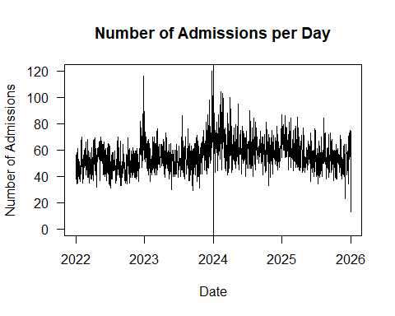
monthly <- dat00 |>
mutate(Triage_Begin_ym=format(Triage_Begin, "%Y-%m"),
Triage_Begin_ymf=floor_date(Triage_Begin_Date,unit="month"),.after=2) |>
group_by(Year,Triage_Begin_ymf) |>
count() |>
mutate(PreInterruption = ifelse(Triage_Begin_ymf < as.Date(x="01Jan2024","%d%b%Y"),0,1))
yearly <- dat00 |>
group_by(Year) |>
count()
plot(monthly$Triage_Begin_ymf,monthly$n,
ylim=c(0,2200),
las=1,
ylab="Number of Admissions",
#type="l",
xlab="Date",
main="Number of Admissions per Month")
abline(v=as.Date(x="01Jan2024","%d%b%Y"))
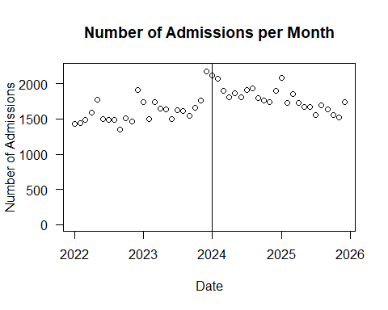
plot(monthly$Triage_Begin_ymf,monthly$n,
ylim=c(0,2200),
las=1,
ylab="Number of Admissions",
type="l",
xlab="Date",
main="Number of Admissions per Month")
abline(v=as.Date(x="01Jan2024","%d%b%Y"))
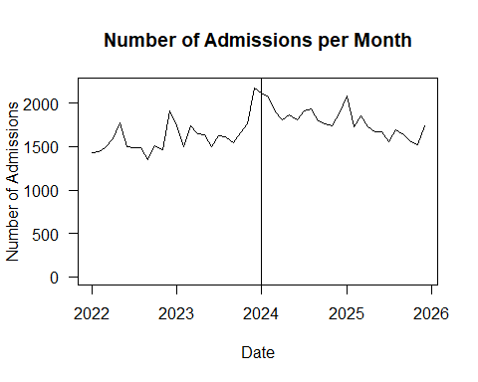
desdaily <- daily |> group_by(PreInterruption) |>
summarise(mean=mean(n),
sd=sd(n),
n=n())
desmonthly <- monthly |> group_by(PreInterruption) |>
summarise(mean=mean(n),
sd=sd(n),
n=n())
desdaily
# A tibble: 2 × 4
PreInterruption mean sd n
<dbl> <dbl> <dbl> <int>
1 0 52.9 10.7 730
2 1 58.9 11.4 731
desmonthly
# A tibble: 2 × 4
PreInterruption mean sd n
<dbl> <dbl> <dbl> <int>
1 0 1608. 180. 24
2 1 1795. 161. 24
yearly
# A tibble: 4 × 2
# Groups: Year [4]
Year n
<dbl> <int>
1 2022 18439
2 2023 20145
3 2024 22632
4 2025 20455
(desdaily$mean[2]-desdaily$mean[1])/desdaily$mean[1]*100 # change in percent
[1] 11.51788
(desmonthly$mean[2]-desmonthly$mean[1])/desmonthly$mean[1]*100 # change in percent
[1] 11.67064

How do I get additional results for the manuscript from 08-Apr-2026?
dat00 |> dplyr::select(Year,Patient_Age) |>
group_by(Year) |>
summarize(mean=mean(Patient_Age,na.rm=T),
sd=sd(Patient_Age,na.rm=T))
# A tibble: 4 × 3
Year mean sd
<dbl> <dbl> <dbl>
1 2022 56.5 25.2
2 2023 57.5 23.2
3 2024 58.8 20.7
4 2025 61.5 19.1
dat00 |> group_by(Year) |>
count(Prio) |>
mutate(Percent=round(n/sum(n)*100,2))
# A tibble: 20 × 4
# Groups: Year [4]
Year Prio n Percent
<dbl> <dbl> <int> <dbl>
1 2022 1 66 0.36
2 2022 2 2086 11.3
3 2022 3 6715 36.4
4 2022 4 8396 45.5
5 2022 5 1176 6.38
6 2023 1 49 0.24
7 2023 2 2120 10.5
8 2023 3 8079 40.1
9 2023 4 8920 44.3
10 2023 5 977 4.85
11 2024 1 46 0.2
12 2024 2 2315 10.2
13 2024 3 8967 39.6
14 2024 4 9834 43.4
15 2024 5 1470 6.5
16 2025 1 43 0.21
17 2025 2 1985 9.7
18 2025 3 8231 40.2
19 2025 4 8988 43.9
20 2025 5 1208 5.91

How do I get the data sets for the analyses?
datall<- dat00 |>
group_by(Triage_Begin_Date,Day,Month,Year,Week_Day) |>
count() |> ungroup() |> addVariables()
datalld<-dat00 |>
group_by(Triage_Begin_Date,Day,Month,Year,Week_Day) |>
count() |> ungroup() |> addVariables(intday="01Dec2023")
datallf<-dat00 |>
group_by(Triage_Begin_Date,Day,Month,Year,Week_Day) |>
count() |> ungroup() |> addVariables(intday="01Feb2024")
datall5<-dat00 |>
group_by(Triage_Begin_Date,Day,Month,Year,Week_Day) |>
count() |> ungroup() |> addVariables(intday="01Jan2025")
datallm<-dat00 |>
mutate(Triage_Begin_Date = floor_date(Triage_Begin_Date,"month")) |>
dplyr::select(Triage_Begin_Date,Month,Year) |>
group_by(Triage_Begin_Date,Month,Year) |>
count() |> ungroup() |> addVariables2(intday="01Jan2024")
####### Subgroup analyses ######
datsem<- dat00 |> filter(Patient_Sex=="M") |>
group_by(Triage_Begin_Date,Day,Month,Year,Week_Day) |>
count() |> ungroup() |> addVariables()
datsef<- dat00 |> filter(Patient_Sex=="W") |>
group_by(Triage_Begin_Date,Day,Month,Year,Week_Day) |>
count() |> ungroup() |> addVariables()
datag12<-dat00 |> filter(Patient_Age_Category %in% c("1","2")) |>
group_by(Triage_Begin_Date,Day,Month,Year,Week_Day) |>
count() |> ungroup() |> addVariables()
datag3<- dat00 |> filter(Patient_Age_Category=="3") |>
group_by(Triage_Begin_Date,Day,Month,Year,Week_Day) |>
count() |> ungroup() |> addVariables()
datag4<- dat00 |> filter(Patient_Age_Category=="4") |>
group_by(Triage_Begin_Date,Day,Month,Year,Week_Day) |>
count() |> ungroup() |> addVariables()
datag5<- dat00 |> filter(Patient_Age_Category=="5") |>
group_by(Triage_Begin_Date,Day,Month,Year,Week_Day) |>
count() |> ungroup() |> addVariables()
datpr12<-dat00 |> filter(Prio %in% c("1","2")) |>
group_by(Triage_Begin_Date,Day,Month,Year,Week_Day) |>
count() |> ungroup() |> addVariables()
datpr3<- dat00 |> filter(Prio=="3") |>
group_by(Triage_Begin_Date,Day,Month,Year,Week_Day) |>
count() |> ungroup() |> addVariables()
datpr45<-dat00 |> filter(Prio %in% c("4","5")) |>
group_by(Triage_Begin_Date,Day,Month,Year,Week_Day) |>
count() |> ungroup() |> addVariables()

Which function do I write to perform the segmented regression analysis as suggested by Korevaar et al.?
getITSresults <- function(dat0,outcome,ptitle,intday="01Jan2024"){
form <- formula(paste0(outcome, " ~ Triage_Begin_Day + Level_Change + Slope_Change",sep=""))
print(form)
REML_model <- gls(model=form,
method="REML",
corr=corAR1(form=~Triage_Begin_Day),
data=dat0
)
# print the results of the analysis to the console
print(summary(REML_model)) # display the parameter estimates
# to save the parameter estimates:
# predicted values
model_estimates <- REML_model$fitted
# save the parameter estimates for display in graphs etc.
model_intercept <- REML_model$coefficients[1]
model_pre_slope <- REML_model$coefficients[2]
model_level_change <- REML_model$coefficients[3]
model_slope_change <- REML_model$coefficients[4]
# generate the confidence intervals
model_CIs <- confint(REML_model)
# display the confidence intervals in the console
print("Below are the model estimates together with their 95% confidence limits.")
print(cbind(`Point estimates`=c(model_intercept,
model_pre_slope,
model_level_change,
model_slope_change),
model_CIs))
# save the CIs for display in graphs etc.
####
print("Below are the model estimates together with multiplicity adjusted p-values and confidence limits")
set.seed(12345)
REML_modelg <- glht(REML_model)
print(summary(REML_modelg))
print(confint(REML_modelg))
## outputs Alex:
model_n <- REML_model$dims$N
ss <- summary(REML_model)
model_AIC <- ss$AIC
model_BIC <- ss$BIC
print("Below is the output requested by Alexander Braun")
print(round(t(data.frame(model_intercept=model_intercept,
model_pre_slope=model_pre_slope,
model_level_change=model_level_change,
model_slope_change=model_slope_change,
model_AIC=model_AIC,
model_BIC=model_BIC,
model_n=model_n)),5))
#####################
### Create a plot ###
#####################
dat0$prediction <- predict(REML_model)
# create the counterfactual data, recall this is what would have happened had there been no interruption
# and therefore is simple to generate by just using the intercept and pre_slope data
dat0$counterfactual <- model_intercept + model_pre_slope*dat0$Triage_Begin_Day
# for the graph we need the interruption time
int_time <- as.Date(x=intday,"%d%b%Y")
# colourblind colour blue
myblue <- rgb(0,114,178,max=255,alpha=255)
myothe <- rgb(248,118,109,max=255,alpha=255)
# legends can be tricky, I found this useful... https://stackoverflow.com/questions/17148679/construct-a-manual-legend-for-a-complicated-plot
# set the colours to be used
colors <- c("Trend lines"=myblue,"Counterfactual"=myblue,"Data points"=myblue)
# set the line types (the lty values)
line_types <- c("Trend lines"=1,"Counterfactual"=2)
# set up the plot
ITS_plot <- ggplot(data=dat0,aes(x=Triage_Begin_Date,y=!!sym(outcome))) +
# add the actual data points
geom_point(color="black", pch=1, size=1, stroke=1) +
# set the predicted line in the pre-interruption segment
geom_line(data=subset(dat0,Level_Change==0), aes(x=Triage_Begin_Date,y=prediction,color="Trend lines",linetype="Trend lines"), lwd=2) +
# set the predicted line in the post-interruption segment
geom_line(data=subset(dat0,Level_Change==1), aes(x=Triage_Begin_Date,y=prediction,color="Trend lines",linetype="Trend lines"), lwd=2) +
# set the counterfactual line in the post-interruption segment
geom_line(data=subset(dat0,Level_Change==1), aes(x=Triage_Begin_Date,y=counterfactual,color="Counterfactual",linetype="Counterfactual"), lwd=2) +
# add some labels to the axes
labs(x="Date",y="Number of Admissions per Day",title=ptitle) +
scale_y_continuous(limits = c(0, 120)) +
# set the colours to be used using the vector we set up above
scale_color_manual(name="Legend:",values=c(myothe,myblue)) +
# set up the line types using the vector we set up above
scale_linetype_manual(name="Legend:",values=line_types) +
# add a vertical line for the interruption time
geom_vline(xintercept=int_time, color="black", lty="dashed", lwd=2) +
theme(legend.position = "bottom",
#legend.background = element_rect(fill="white",linewidth=1,linetype="solid"),
#legend.title = element_text(size=15),
#legend.text = element_text(size=15),
#legend.key.width = unit(4,"cm"),
#legend.key = element_rect(colour=NA, fill=NA),
#panel.background = element_blank(),
#panel.grid.major = element_line(colour="gray"),
#axis.title.y = element_text(face="bold", size=20),
#axis.title.x = element_text(face="bold", size=20),
#plot.title = element_text(face="bold", size=20),
#axis.text.x=element_text(face="bold", size=15),
#axis.text.y=element_text(face="bold", size=15),
)
# show this plot in the plots window
ITS_plot
}
###
###
###
getITSresultsMonth <- function(dat0,outcome,ptitle,intday="01Jan2024"){
form <- formula(paste0(outcome, " ~ Triage_Begin_Month + Level_Change + Slope_Change",sep=""))
print(form)
REML_model <- gls(model=form,
method="REML",
corr=corAR1(form=~Triage_Begin_Month),
data=dat0
)
# print the results of the analysis to the console
print(summary(REML_model)) # display the parameter estimates
# to save the parameter estimates:
# predicted values
model_estimates <- REML_model$fitted
# save the parameter estimates for display in graphs etc.
model_intercept <- REML_model$coefficients[1]
model_pre_slope <- REML_model$coefficients[2]
model_level_change <- REML_model$coefficients[3]
model_slope_change <- REML_model$coefficients[4]
# generate the confidence intervals
model_CIs <- confint(REML_model)
# display the confidence intervals in the console
print("Below are the model estimates together with their 95% confidence limits.")
print(cbind(`Point estimates`=c(model_intercept,
model_pre_slope,
model_level_change,
model_slope_change),
model_CIs))
# save the CIs for display in graphs etc.
####
print("Below are the model estimates together with multiplicity adjusted p-values and confidence limits")
set.seed(12345)
REML_modelg <- glht(REML_model)
print(summary(REML_modelg))
print(confint(REML_modelg))
## outputs Alex:
model_n <- REML_model$dims$N
ss <- summary(REML_model)
model_AIC <- ss$AIC
model_BIC <- ss$BIC
print("Below is the output requested by Alexander Braun")
print(round(t(data.frame(model_intercept=model_intercept,
model_pre_slope=model_pre_slope,
model_level_change=model_level_change,
model_slope_change=model_slope_change,
model_AIC=model_AIC,
model_BIC=model_BIC,
model_n=model_n)),5))
#####################
### Create a plot ###
#####################
dat0$prediction <- predict(REML_model)
# create the counterfactual data, recall this is what would have happened had there been no interruption
# and therefore is simple to generate by just using the intercept and pre_slope data
dat0$counterfactual <- model_intercept + model_pre_slope*dat0$Triage_Begin_Month
# for the graph we need the interruption time
int_time <- as.Date(x=intday,"%d%b%Y")
# colourblind colour blue
myblue <- rgb(0,114,178,max=255,alpha=255)
myothe <- rgb(248,118,109,max=255,alpha=255)
# legends can be tricky, I found this useful... https://stackoverflow.com/questions/17148679/construct-a-manual-legend-for-a-complicated-plot
# set the colours to be used
colors <- c("Trend lines"=myblue,"Counterfactual"=myblue,"Data points"=myblue)
# set the line types (the lty values)
line_types <- c("Trend lines"=1,"Counterfactual"=2)
# set up the plot
ITS_plot <- ggplot(data=dat0,aes(x=Triage_Begin_Date,y=!!sym(outcome))) +
# add the actual data points
geom_point(color="black", pch=1, size=1, stroke=1) +
# set the predicted line in the pre-interruption segment
geom_line(data=subset(dat0,Level_Change==0), aes(x=Triage_Begin_Date,y=prediction,color="Trend lines",linetype="Trend lines"), lwd=2) +
# set the predicted line in the post-interruption segment
geom_line(data=subset(dat0,Level_Change==1), aes(x=Triage_Begin_Date,y=prediction,color="Trend lines",linetype="Trend lines"), lwd=2) +
# set the counterfactual line in the post-interruption segment
geom_line(data=subset(dat0,Level_Change==1), aes(x=Triage_Begin_Date,y=counterfactual,color="Counterfactual",linetype="Counterfactual"), lwd=2) +
# add some labels to the axes
labs(x="Date",y="Number of Admissions per Month",title=ptitle) +
scale_y_continuous(limits = c(0, 2200)) +
# set the colours to be used using the vector we set up above
scale_color_manual(name="Legend:",values=c(myothe,myblue)) +
# set up the line types using the vector we set up above
scale_linetype_manual(name="Legend:",values=line_types) +
# add a vertical line for the interruption time
geom_vline(xintercept=int_time, color="black", lty="dashed", lwd=2) +
theme(legend.position = "bottom",
#legend.background = element_rect(fill="white",linewidth=1,linetype="solid"),
#legend.title = element_text(size=15),
#legend.text = element_text(size=15),
#legend.key.width = unit(4,"cm"),
#legend.key = element_rect(colour=NA, fill=NA),
#panel.background = element_blank(),
#panel.grid.major = element_line(colour="gray"),
#axis.title.y = element_text(face="bold", size=20),
#axis.title.x = element_text(face="bold", size=20),
#plot.title = element_text(face="bold", size=20),
#axis.text.x=element_text(face="bold", size=15),
#axis.text.y=element_text(face="bold", size=15),
)
# show this plot in the plots window
ITS_plot
}
###
getITSresultsInf <- function(dat0,outcome,ptitle,intday="01Jan2024"){
form <- formula(paste0(outcome, " ~ Triage_Begin_Day + Level_Change + Slope_Change + influenza",sep=""))
print(form)
REML_model <- gls(model=form,
method="REML",
corr=corAR1(form=~Triage_Begin_Day),
#corr=corARMA(form=~Triage_Begin_Day,p=1,q=1),
data=dat0
)
# print the results of the analysis to the console
print(summary(REML_model)) # display the parameter estimates
# to save the parameter estimates:
# predicted values
model_estimates <- REML_model$fitted
# save the parameter estimates for display in graphs etc.
model_intercept <- REML_model$coefficients[1]
model_pre_slope <- REML_model$coefficients[2]
model_level_change <- REML_model$coefficients[3]
model_slope_change <- REML_model$coefficients[4]
model_influenza <- REML_model$coefficients[5]
# generate the confidence intervals
model_CIs <- confint(REML_model)
# display the confidence intervals in the console
print("Below are the model estimates together with their 95% confidence limits.")
print(cbind(`Point estimates`=c(model_intercept,
model_pre_slope,
model_level_change,
model_slope_change,
model_influenza),
model_CIs))
###
print("Below are the model estimates together with multiplicity adjusted p-values and confidence limits")
set.seed(12345)
REML_modelg <- glht(REML_model)
print(summary(REML_modelg))
print(confint(REML_modelg))
## outputs Alex:
model_n <- REML_model$dims$N
ss <- summary(REML_model)
model_AIC <- ss$AIC
model_BIC <- ss$BIC
print("Below is the output requested by Alexander Braun")
print(round(t(data.frame(model_intercept=model_intercept,
model_pre_slope=model_pre_slope,
model_level_change=model_level_change,
model_slope_change=model_slope_change,
model_influenza=model_influenza,
model_AIC=model_AIC,
model_BIC=model_BIC,
model_n=model_n)),5))
#####################
### Create a plot ###
#####################
dat0$prediction <- predict(REML_model)
# create the counterfactual data, recall this is what would have happened had there been no interruption
# and therefore is simple to generate by just using the intercept and pre_slope data
dat0$counterfactual <- model_intercept + model_pre_slope*dat0$Triage_Begin_Day + model_influenza*dat0$influenza
# for the graph we need the interruption time
int_time <- as.Date(x=intday,"%d%b%Y")
# colourblind colour blue
myblue <- rgb(0,114,178,max=255,alpha=255)
myothe <- rgb(248,118,109,max=255,alpha=255)
# legends can be tricky, I found this useful... https://stackoverflow.com/questions/17148679/construct-a-manual-legend-for-a-complicated-plot
# set the colours to be used
colors <- c("Trend lines"=myblue,"Counterfactual"=myblue,"Data points"=myblue)
# set the line types (the lty values)
line_types <- c("Trend lines"=1,"Counterfactual"=2)
# set up the plot
ITS_plot <- ggplot(data=dat0,aes(x=Triage_Begin_Date,y=!!sym(outcome))) +
# add the actual data points
geom_point(color="black", pch=1, size=1, stroke=1) +
# set the predicted line in the pre-interruption segment
geom_line(data=subset(dat0,Level_Change==0), aes(x=Triage_Begin_Date,y=prediction,color="Trend lines",linetype="Trend lines"), lwd=2) +
# set the predicted line in the post-interruption segment
geom_line(data=subset(dat0,Level_Change==1), aes(x=Triage_Begin_Date,y=prediction,color="Trend lines",linetype="Trend lines"), lwd=2) +
# set the counterfactual line in the post-interruption segment
geom_line(data=subset(dat0,Level_Change==1), aes(x=Triage_Begin_Date,y=counterfactual,color="Counterfactual",linetype="Counterfactual"), lwd=2) +
# add some labels to the axes
labs(x="Date",y="Number of Admissions per Day",title=ptitle) +
scale_y_continuous(limits = c(0, 120)) +
# set the colours to be used using the vector we set up above
scale_color_manual(name="Legend:",values=c(myothe,myblue)) +
# set up the line types using the vector we set up above
scale_linetype_manual(name="Legend:",values=line_types) +
# add a vertical line for the interruption time
geom_vline(xintercept=int_time, color="black", lty="dashed", lwd=2) +
theme(legend.position = "bottom",
#legend.background = element_rect(fill="white",linewidth=1,linetype="solid"),
#legend.title = element_text(size=15),
#legend.text = element_text(size=15),
#legend.key.width = unit(4,"cm"),
#legend.key = element_rect(colour=NA, fill=NA),
#panel.background = element_blank(),
#panel.grid.major = element_line(colour="gray"),
#axis.title.y = element_text(face="bold", size=20),
#axis.title.x = element_text(face="bold", size=20),
#plot.title = element_text(face="bold", size=20),
#axis.text.x=element_text(face="bold", size=15),
#axis.text.y=element_text(face="bold", size=15),
)
# show this plot in the plots window
ITS_plot
}
getITSresultsInfARMA11 <- function(dat0,outcome,ptitle){
form <- formula(paste0(outcome, " ~ Triage_Begin_Day + Level_Change + Slope_Change + influenza",sep=""))
print(form)
REML_model <- gls(model=form,
method="REML",
#corr=corAR1(form=~Triage_Begin_Day),
corr=corARMA(form=~Triage_Begin_Day,p=1,q=1),
data=dat0
)
# print the results of the analysis to the console
print(summary(REML_model)) # display the parameter estimates
# to save the parameter estimates:
# predicted values
model_estimates <- REML_model$fitted
# save the parameter estimates for display in graphs etc.
model_intercept <- REML_model$coefficients[1]
model_pre_slope <- REML_model$coefficients[2]
model_level_change <- REML_model$coefficients[3]
model_slope_change <- REML_model$coefficients[4]
model_influenza <- REML_model$coefficients[5]
# generate the confidence intervals
model_CIs <- confint(REML_model)
# display the confidence intervals in the console
print("Below are the model estimates together with their 95% confidence limits.")
print(cbind(`Point estimates`=c(model_intercept,
model_pre_slope,
model_level_change,
model_slope_change,
model_influenza),
model_CIs))
###
print("Below are the model estimates together with multiplicity adjusted p-values and confidence limits")
set.seed(12345)
REML_modelg <- glht(REML_model)
print(summary(REML_modelg))
print(confint(REML_modelg))
## outputs Alex:
model_n <- REML_model$dims$N
ss <- summary(REML_model)
model_AIC <- ss$AIC
model_BIC <- ss$BIC
print("Below is the output requested by Alexander Braun")
print(round(t(data.frame(model_intercept=model_intercept,
model_pre_slope=model_pre_slope,
model_level_change=model_level_change,
model_slope_change=model_slope_change,
model_influenza=model_influenza,
model_AIC=model_AIC,
model_BIC=model_BIC,
model_n=model_n)),5))
#####################
### Create a plot ###
#####################
dat0$prediction <- predict(REML_model)
# create the counterfactual data, recall this is what would have happened had there been no interruption
# and therefore is simple to generate by just using the intercept and pre_slope data
dat0$counterfactual <- model_intercept + model_pre_slope*dat0$Triage_Begin_Day + model_influenza*dat0$influenza
# for the graph we need the interruption time
int_time <- as.Date(x="01Jan2024","%d%b%Y")
# colourblind colour blue
myblue <- rgb(0,114,178,max=255,alpha=255)
myothe <- rgb(248,118,109,max=255,alpha=255)
# legends can be tricky, I found this useful... https://stackoverflow.com/questions/17148679/construct-a-manual-legend-for-a-complicated-plot
# set the colours to be used
colors <- c("Trend lines"=myblue,"Counterfactual"=myblue,"Data points"=myblue)
# set the line types (the lty values)
line_types <- c("Trend lines"=1,"Counterfactual"=2)
# set up the plot
ITS_plot <- ggplot(data=dat0,aes(x=Triage_Begin_Date,y=!!sym(outcome))) +
# add the actual data points
geom_point(color="black", pch=1, size=1, stroke=1) +
# set the predicted line in the pre-interruption segment
geom_line(data=subset(dat0,Level_Change==0), aes(x=Triage_Begin_Date,y=prediction,color="Trend lines",linetype="Trend lines"), lwd=2) +
# set the predicted line in the post-interruption segment
geom_line(data=subset(dat0,Level_Change==1), aes(x=Triage_Begin_Date,y=prediction,color="Trend lines",linetype="Trend lines"), lwd=2) +
# set the counterfactual line in the post-interruption segment
geom_line(data=subset(dat0,Level_Change==1), aes(x=Triage_Begin_Date,y=counterfactual,color="Counterfactual",linetype="Counterfactual"), lwd=2) +
# add some labels to the axes
labs(x="Date",y="Number of Admissions per Day",title=ptitle) +
scale_y_continuous(limits = c(0, 120)) +
# set the colours to be used using the vector we set up above
scale_color_manual(name="Legend:",values=c(myothe,myblue)) +
# set up the line types using the vector we set up above
scale_linetype_manual(name="Legend:",values=line_types) +
# add a vertical line for the interruption time
geom_vline(xintercept=int_time, color="black", lty="dashed", lwd=2) +
theme(legend.position = "bottom",
#legend.background = element_rect(fill="white",linewidth=1,linetype="solid"),
#legend.title = element_text(size=15),
#legend.text = element_text(size=15),
#legend.key.width = unit(4,"cm"),
#legend.key = element_rect(colour=NA, fill=NA),
#panel.background = element_blank(),
#panel.grid.major = element_line(colour="gray"),
#axis.title.y = element_text(face="bold", size=20),
#axis.title.x = element_text(face="bold", size=20),
#plot.title = element_text(face="bold", size=20),
#axis.text.x=element_text(face="bold", size=15),
#axis.text.y=element_text(face="bold", size=15),
)
# show this plot in the plots window
ITS_plot
}
getITSresultsInfAR2 <- function(dat0,outcome,ptitle){
form <- formula(paste0(outcome, " ~ Triage_Begin_Day + Level_Change + Slope_Change + influenza",sep=""))
print(form)
REML_model <- gls(model=form,
method="REML",
#corr=corAR1(form=~Triage_Begin_Day),
corr=corARMA(form=~Triage_Begin_Day,p=2,q=0),
data=dat0
)
# print the results of the analysis to the console
print(summary(REML_model)) # display the parameter estimates
# to save the parameter estimates:
# predicted values
model_estimates <- REML_model$fitted
# save the parameter estimates for display in graphs etc.
model_intercept <- REML_model$coefficients[1]
model_pre_slope <- REML_model$coefficients[2]
model_level_change <- REML_model$coefficients[3]
model_slope_change <- REML_model$coefficients[4]
model_influenza <- REML_model$coefficients[5]
# generate the confidence intervals
model_CIs <- confint(REML_model)
# display the confidence intervals in the console
print("Below are the model estimates together with their 95% confidence limits.")
print(cbind(`Point estimates`=c(model_intercept,
model_pre_slope,
model_level_change,
model_slope_change,
model_influenza),
model_CIs))
###
print("Below are the model estimates together with multiplicity adjusted p-values and confidence limits")
set.seed(12345)
REML_modelg <- glht(REML_model)
print(summary(REML_modelg))
print(confint(REML_modelg))
## outputs Alex:
model_n <- REML_model$dims$N
ss <- summary(REML_model)
model_AIC <- ss$AIC
model_BIC <- ss$BIC
print("Below is the output requested by Alexander Braun")
print(round(t(data.frame(model_intercept=model_intercept,
model_pre_slope=model_pre_slope,
model_level_change=model_level_change,
model_slope_change=model_slope_change,
model_influenza=model_influenza,
model_AIC=model_AIC,
model_BIC=model_BIC,
model_n=model_n)),5))
#####################
### Create a plot ###
#####################
dat0$prediction <- predict(REML_model)
# create the counterfactual data, recall this is what would have happened had there been no interruption
# and therefore is simple to generate by just using the intercept and pre_slope data
dat0$counterfactual <- model_intercept + model_pre_slope*dat0$Triage_Begin_Day + model_influenza*dat0$influenza
# for the graph we need the interruption time
int_time <- as.Date(x="01Jan2024","%d%b%Y")
# colourblind colour blue
myblue <- rgb(0,114,178,max=255,alpha=255)
myothe <- rgb(248,118,109,max=255,alpha=255)
# legends can be tricky, I found this useful... https://stackoverflow.com/questions/17148679/construct-a-manual-legend-for-a-complicated-plot
# set the colours to be used
colors <- c("Trend lines"=myblue,"Counterfactual"=myblue,"Data points"=myblue)
# set the line types (the lty values)
line_types <- c("Trend lines"=1,"Counterfactual"=2)
# set up the plot
ITS_plot <- ggplot(data=dat0,aes(x=Triage_Begin_Date,y=!!sym(outcome))) +
# add the actual data points
geom_point(color="black", pch=1, size=1, stroke=1) +
# set the predicted line in the pre-interruption segment
geom_line(data=subset(dat0,Level_Change==0), aes(x=Triage_Begin_Date,y=prediction,color="Trend lines",linetype="Trend lines"), lwd=2) +
# set the predicted line in the post-interruption segment
geom_line(data=subset(dat0,Level_Change==1), aes(x=Triage_Begin_Date,y=prediction,color="Trend lines",linetype="Trend lines"), lwd=2) +
# set the counterfactual line in the post-interruption segment
geom_line(data=subset(dat0,Level_Change==1), aes(x=Triage_Begin_Date,y=counterfactual,color="Counterfactual",linetype="Counterfactual"), lwd=2) +
# add some labels to the axes
labs(x="Date",y="Number of Admissions per Day",title=ptitle) +
scale_y_continuous(limits = c(0, 120)) +
# set the colours to be used using the vector we set up above
scale_color_manual(name="Legend:",values=c(myothe,myblue)) +
# set up the line types using the vector we set up above
scale_linetype_manual(name="Legend:",values=line_types) +
# add a vertical line for the interruption time
geom_vline(xintercept=int_time, color="black", lty="dashed", lwd=2) +
theme(legend.position = "bottom",
#legend.background = element_rect(fill="white",linewidth=1,linetype="solid"),
#legend.title = element_text(size=15),
#legend.text = element_text(size=15),
#legend.key.width = unit(4,"cm"),
#legend.key = element_rect(colour=NA, fill=NA),
#panel.background = element_blank(),
#panel.grid.major = element_line(colour="gray"),
#axis.title.y = element_text(face="bold", size=20),
#axis.title.x = element_text(face="bold", size=20),
#plot.title = element_text(face="bold", size=20),
#axis.text.x=element_text(face="bold", size=15),
#axis.text.y=element_text(face="bold", size=15),
)
# show this plot in the plots window
ITS_plot
}
###
getnts <- function(dat0,ptitle){
est_n <- msmooth(dat0$n)
plot(dat0$Triage_Begin_Date,est_n$orig,type="l",col="gray",
las=1,lwd=1,
main=str_c("Nonparametric Time Series Trend Estimation\n",ptitle),
ylab="Number of Admissions per Day",
ylim=c(0,120),
xlab="Date")
points(dat0$Triage_Begin_Date,est_n$ye,type="l",col="black",lwd=2)
#points(cbest_n$np.estim$ye.ub,type="l",col="red",lwd=2)
#points(cbest_n$np.estim$upper,type="l",col="red",lwd=1)
#points(cbest_n$np.estim$lower,type="l",col="red",lwd=1)
abline(v=as.Date(x="01Jan2024","%d%b%Y"),lwd=2,lty=2)
}

How do I perform the ITSA as suggested by Korevaar et al.?
getITSresults(dat0=datall,outcome="n",ptitle="All data")
n ~ Triage_Begin_Day + Level_Change + Slope_Change
<environment: 0x0000023dbb023858>
Generalized least squares fit by REML
Model: form
Data: dat0
AIC BIC logLik
10980.94 11012.65 -5484.472
Correlation Structure: AR(1)
Formula: ~Triage_Begin_Day
Parameter estimate(s):
Phi
0.2233564
Coefficients:
Value Std.Error t-value p-value
(Intercept) 48.04890 0.9791666 49.07122 0
Triage_Begin_Day 0.01312 0.0023201 5.65330 0
Level_Change 8.47466 1.3812324 6.13558 0
Slope_Change -0.03278 0.0032803 -9.99245 0
Correlation:
(Intr) Tr_B_D Lvl_Ch
Triage_Begin_Day -0.866
Level_Change 0.354 -0.613
Slope_Change 0.613 -0.708 0.002
Standardized residuals:
Min Q1 Med Q3 Max
-3.67739615 -0.68004487 -0.05619068 0.58098473 6.00039220
Residual standard error: 10.53969
Degrees of freedom: 1461 total; 1457 residual
[1] "Below are the model estimates together with their 95% confidence limits."
Point estimates 2.5 % 97.5 %
(Intercept) 48.04889937 46.129768071 49.96803067
Triage_Begin_Day 0.01311645 0.008569056 0.01766384
Level_Change 8.47465517 5.767489430 11.18182091
Slope_Change -0.03277816 -0.039207418 -0.02634891
[1] "Below are the model estimates together with multiplicity adjusted p-values and confidence limits"
Simultaneous Tests for General Linear Hypotheses
Fit: gls(model = form, data = dat0, correlation = corAR1(form = ~Triage_Begin_Day),
method = "REML")
Linear Hypotheses:
Estimate Std. Error z value Pr(>|z|)
(Intercept) == 0 48.04890 0.97917 49.071 < 1e-09 ***
Triage_Begin_Day == 0 0.01312 0.00232 5.653 3.21e-08 ***
Level_Change == 0 8.47466 1.38123 6.136 2.06e-09 ***
Slope_Change == 0 -0.03278 0.00328 -9.992 < 1e-09 ***
---
Signif. codes: 0 '***' 0.001 '**' 0.01 '*' 0.05 '.' 0.1 ' ' 1
(Adjusted p values reported -- single-step method)
Simultaneous Confidence Intervals
Fit: gls(model = form, data = dat0, correlation = corAR1(form = ~Triage_Begin_Day),
method = "REML")
Quantile = 2.3979
95% family-wise confidence level
Linear Hypotheses:
Estimate lwr upr
(Intercept) == 0 48.048899 45.701000 50.396798
Triage_Begin_Day == 0 0.013116 0.007553 0.018680
Level_Change == 0 8.474655 5.162661 11.786649
Slope_Change == 0 -0.032778 -0.040644 -0.024912
[1] "Below is the output requested by Alexander Braun"
(Intercept)
model_intercept 48.04890
model_pre_slope 0.01312
model_level_change 8.47466
model_slope_change -0.03278
model_AIC 10980.94304
model_BIC 11012.64785
model_n 1461.00000
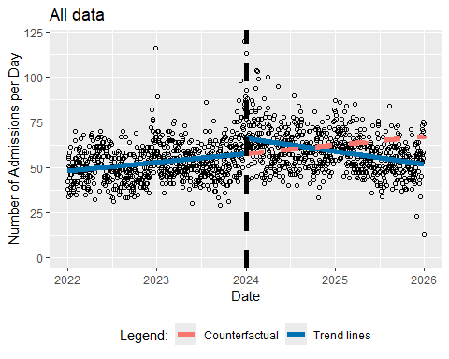

How do I perform the ITSA accounting for influenza?
getITSresultsInf(dat0=datall,outcome="n",ptitle="All data")
n ~ Triage_Begin_Day + Level_Change + Slope_Change + influenza
<environment: 0x0000023db5c96be0>
Generalized least squares fit by REML
Model: form
Data: dat0
AIC BIC logLik
10922.29 10959.27 -5454.144
Correlation Structure: AR(1)
Formula: ~Triage_Begin_Day
Parameter estimate(s):
Phi
0.1726749
Coefficients:
Value Std.Error t-value p-value
(Intercept) 47.81174 0.9015244 53.03432 0
Triage_Begin_Day 0.00979 0.0021751 4.50321 0
Level_Change 8.01940 1.2726598 6.30129 0
Slope_Change -0.02626 0.0031236 -8.40838 0
influenza 5.83470 0.7254561 8.04281 0
Correlation:
(Intr) Tr_B_D Lvl_Ch Slp_Ch
Triage_Begin_Day -0.844
Level_Change 0.355 -0.593
Slope_Change 0.584 -0.721 -0.009
influenza -0.033 -0.191 -0.042 0.258
Standardized residuals:
Min Q1 Med Q3 Max
-4.28553309 -0.70188619 -0.05811215 0.62930950 5.79696780
Residual standard error: 10.22125
Degrees of freedom: 1461 total; 1456 residual
[1] "Below are the model estimates together with their 95% confidence limits."
Point estimates 2.5 % 97.5 %
(Intercept) 47.811738071 46.04478269 49.57869345
Triage_Begin_Day 0.009794937 0.00553182 0.01405805
Level_Change 8.019395078 5.52502763 10.51376253
Slope_Change -0.026264050 -0.03238611 -0.02014199
influenza 5.834704615 4.41283675 7.25657248
[1] "Below are the model estimates together with multiplicity adjusted p-values and confidence limits"
Simultaneous Tests for General Linear Hypotheses
Fit: gls(model = form, data = dat0, correlation = corAR1(form = ~Triage_Begin_Day),
method = "REML")
Linear Hypotheses:
Estimate Std. Error z value Pr(>|z|)
(Intercept) == 0 47.811738 0.901524 53.034 <1e-04 ***
Triage_Begin_Day == 0 0.009795 0.002175 4.503 <1e-04 ***
Level_Change == 0 8.019395 1.272660 6.301 <1e-04 ***
Slope_Change == 0 -0.026264 0.003124 -8.408 <1e-04 ***
influenza == 0 5.834705 0.725456 8.043 <1e-04 ***
---
Signif. codes: 0 '***' 0.001 '**' 0.01 '*' 0.05 '.' 0.1 ' ' 1
(Adjusted p values reported -- single-step method)
Simultaneous Confidence Intervals
Fit: gls(model = form, data = dat0, correlation = corAR1(form = ~Triage_Begin_Day),
method = "REML")
Quantile = 2.5061
95% family-wise confidence level
Linear Hypotheses:
Estimate lwr upr
(Intercept) == 0 47.811738 45.552406 50.071070
Triage_Begin_Day == 0 0.009795 0.004344 0.015246
Level_Change == 0 8.019395 4.829952 11.208838
Slope_Change == 0 -0.026264 -0.034092 -0.018436
influenza == 0 5.834705 4.016622 7.652787
[1] "Below is the output requested by Alexander Braun"
(Intercept)
model_intercept 47.81174
model_pre_slope 0.00979
model_level_change 8.01940
model_slope_change -0.02626
model_influenza 5.83470
model_AIC 10922.28704
model_BIC 10959.27118
model_n 1461.00000
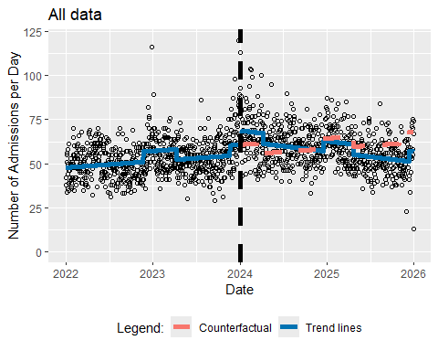
getITSresultsInf(dat0=datsem,outcome="n",ptitle="Men only")
n ~ Triage_Begin_Day + Level_Change + Slope_Change + influenza
<environment: 0x0000023dbd6708b0>
Generalized least squares fit by REML
Model: form
Data: dat0
AIC BIC logLik
9573.872 9610.856 -4779.936
Correlation Structure: AR(1)
Formula: ~Triage_Begin_Day
Parameter estimate(s):
Phi
0.1032389
Coefficients:
Value Std.Error t-value p-value
(Intercept) 22.949168 0.5234891 43.83887 0e+00
Triage_Begin_Day 0.004630 0.0012632 3.66509 3e-04
Level_Change 3.647379 0.7392968 4.93358 0e+00
Slope_Change -0.012658 0.0018138 -6.97885 0e+00
influenza 2.997797 0.4218099 7.10699 0e+00
Correlation:
(Intr) Tr_B_D Lvl_Ch Slp_Ch
Triage_Begin_Day -0.844
Level_Change 0.355 -0.593
Slope_Change 0.584 -0.721 -0.009
influenza -0.033 -0.191 -0.042 0.258
Standardized residuals:
Min Q1 Med Q3 Max
-3.47302619 -0.65573118 -0.08181918 0.57854863 4.51761715
Residual standard error: 6.368527
Degrees of freedom: 1461 total; 1456 residual
[1] "Below are the model estimates together with their 95% confidence limits."
Point estimates 2.5 % 97.5 %
(Intercept) 22.949168199 21.923148496 23.975187902
Triage_Begin_Day 0.004629712 0.002153904 0.007105520
Level_Change 3.647378838 2.198383741 5.096373935
Slope_Change -0.012657934 -0.016212832 -0.009103036
influenza 2.997797287 2.171065157 3.824529417
[1] "Below are the model estimates together with multiplicity adjusted p-values and confidence limits"
Simultaneous Tests for General Linear Hypotheses
Fit: gls(model = form, data = dat0, correlation = corAR1(form = ~Triage_Begin_Day),
method = "REML")
Linear Hypotheses:
Estimate Std. Error z value Pr(>|z|)
(Intercept) == 0 22.949168 0.523489 43.839 < 0.001 ***
Triage_Begin_Day == 0 0.004630 0.001263 3.665 0.00114 **
Level_Change == 0 3.647379 0.739297 4.934 < 0.001 ***
Slope_Change == 0 -0.012658 0.001814 -6.979 < 0.001 ***
influenza == 0 2.997797 0.421810 7.107 < 0.001 ***
---
Signif. codes: 0 '***' 0.001 '**' 0.01 '*' 0.05 '.' 0.1 ' ' 1
(Adjusted p values reported -- single-step method)
Simultaneous Confidence Intervals
Fit: gls(model = form, data = dat0, correlation = corAR1(form = ~Triage_Begin_Day),
method = "REML")
Quantile = 2.5034
95% family-wise confidence level
Linear Hypotheses:
Estimate lwr upr
(Intercept) == 0 22.949168 21.638691 24.259645
Triage_Begin_Day == 0 0.004630 0.001468 0.007792
Level_Change == 0 3.647379 1.796659 5.498099
Slope_Change == 0 -0.012658 -0.017198 -0.008117
influenza == 0 2.997797 1.941859 4.053736
[1] "Below is the output requested by Alexander Braun"
(Intercept)
model_intercept 22.94917
model_pre_slope 0.00463
model_level_change 3.64738
model_slope_change -0.01266
model_influenza 2.99780
model_AIC 9573.87173
model_BIC 9610.85587
model_n 1461.00000
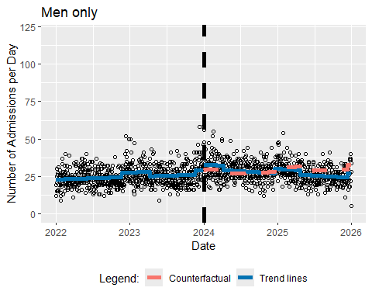
getITSresultsInf(dat0=datsef,outcome="n",ptitle="Women only")
n ~ Triage_Begin_Day + Level_Change + Slope_Change + influenza
<environment: 0x0000023db38a5708>
Generalized least squares fit by REML
Model: form
Data: dat0
AIC BIC logLik
9644.489 9681.474 -4815.245
Correlation Structure: AR(1)
Formula: ~Triage_Begin_Day
Parameter estimate(s):
Phi
0.1280139
Coefficients:
Value Std.Error t-value p-value
(Intercept) 24.861788 0.5515659 45.07492 0e+00
Triage_Begin_Day 0.005166 0.0013309 3.88175 1e-04
Level_Change 4.342654 0.7788484 5.57574 0e+00
Slope_Change -0.013537 0.0019110 -7.08366 0e+00
influenza 2.854636 0.4442439 6.42583 0e+00
Correlation:
(Intr) Tr_B_D Lvl_Ch Slp_Ch
Triage_Begin_Day -0.844
Level_Change 0.355 -0.593
Slope_Change 0.584 -0.721 -0.009
influenza -0.033 -0.191 -0.042 0.258
Standardized residuals:
Min Q1 Med Q3 Max
-3.31956724 -0.67523459 -0.07500497 0.65882262 5.56639047
Residual standard error: 6.544443
Degrees of freedom: 1461 total; 1456 residual
[1] "Below are the model estimates together with their 95% confidence limits."
Point estimates 2.5 % 97.5 %
(Intercept) 24.861788109 23.780738841 25.942837376
Triage_Begin_Day 0.005166154 0.002557672 0.007774637
Level_Change 4.342653903 2.816139047 5.869168759
Slope_Change -0.013537137 -0.017282701 -0.009791573
influenza 2.854636209 1.983934169 3.725338249
[1] "Below are the model estimates together with multiplicity adjusted p-values and confidence limits"
Simultaneous Tests for General Linear Hypotheses
Fit: gls(model = form, data = dat0, correlation = corAR1(form = ~Triage_Begin_Day),
method = "REML")
Linear Hypotheses:
Estimate Std. Error z value Pr(>|z|)
(Intercept) == 0 24.861788 0.551566 45.075 < 1e-04 ***
Triage_Begin_Day == 0 0.005166 0.001331 3.882 0.000442 ***
Level_Change == 0 4.342654 0.778848 5.576 < 1e-04 ***
Slope_Change == 0 -0.013537 0.001911 -7.084 < 1e-04 ***
influenza == 0 2.854636 0.444244 6.426 < 1e-04 ***
---
Signif. codes: 0 '***' 0.001 '**' 0.01 '*' 0.05 '.' 0.1 ' ' 1
(Adjusted p values reported -- single-step method)
Simultaneous Confidence Intervals
Fit: gls(model = form, data = dat0, correlation = corAR1(form = ~Triage_Begin_Day),
method = "REML")
Quantile = 2.5034
95% family-wise confidence level
Linear Hypotheses:
Estimate lwr upr
(Intercept) == 0 24.861788 23.481024 26.242552
Triage_Begin_Day == 0 0.005166 0.001834 0.008498
Level_Change == 0 4.342654 2.392921 6.292387
Slope_Change == 0 -0.013537 -0.018321 -0.008753
influenza == 0 2.854636 1.742537 3.966736
[1] "Below is the output requested by Alexander Braun"
(Intercept)
model_intercept 24.86179
model_pre_slope 0.00517
model_level_change 4.34265
model_slope_change -0.01354
model_influenza 2.85464
model_AIC 9644.48940
model_BIC 9681.47353
model_n 1461.00000
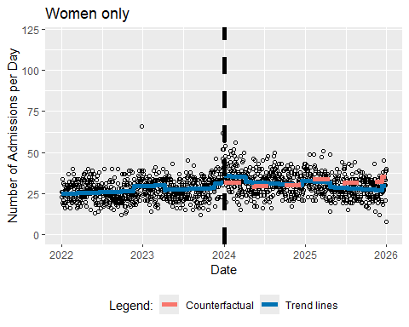
getITSresultsInf(dat0=datag12,outcome="n",ptitle="Age Category 1 and 2")
n ~ Triage_Begin_Day + Level_Change + Slope_Change + influenza
<environment: 0x0000023dba285370>
Generalized least squares fit by REML
Model: form
Data: dat0
AIC BIC logLik
9103.361 9140.345 -4544.68
Correlation Structure: AR(1)
Formula: ~Triage_Begin_Day
Parameter estimate(s):
Phi
0.3490115
Coefficients:
Value Std.Error t-value p-value
(Intercept) 10.995993 0.6131733 17.932930 0.0000
Triage_Begin_Day 0.003620 0.0014784 2.448513 0.0145
Level_Change 3.635928 0.8638114 4.209169 0.0000
Slope_Change -0.018959 0.0021245 -8.924178 0.0000
influenza 2.620889 0.4903746 5.344667 0.0000
Correlation:
(Intr) Tr_B_D Lvl_Ch Slp_Ch
Triage_Begin_Day -0.844
Level_Change 0.354 -0.592
Slope_Change 0.584 -0.721 -0.008
influenza -0.032 -0.190 -0.041 0.255
Standardized residuals:
Min Q1 Med Q3 Max
-2.58310735 -0.66683304 -0.02697302 0.56935990 4.99538837
Residual standard error: 5.757066
Degrees of freedom: 1461 total; 1456 residual
[1] "Below are the model estimates together with their 95% confidence limits."
Point estimates 2.5 % 97.5 %
(Intercept) 10.995993362 9.7941958484 12.197790876
Triage_Begin_Day 0.003619773 0.0007222492 0.006517297
Level_Change 3.635928154 1.9428888345 5.328967474
Slope_Change -0.018959228 -0.0231231304 -0.014795326
influenza 2.620888589 1.6597720890 3.582005089
[1] "Below are the model estimates together with multiplicity adjusted p-values and confidence limits"
Simultaneous Tests for General Linear Hypotheses
Fit: gls(model = form, data = dat0, correlation = corAR1(form = ~Triage_Begin_Day),
method = "REML")
Linear Hypotheses:
Estimate Std. Error z value Pr(>|z|)
(Intercept) == 0 10.995993 0.613173 17.933 <0.001 ***
Triage_Begin_Day == 0 0.003620 0.001478 2.449 0.0578 .
Level_Change == 0 3.635928 0.863811 4.209 <0.001 ***
Slope_Change == 0 -0.018959 0.002124 -8.924 <0.001 ***
influenza == 0 2.620889 0.490375 5.345 <0.001 ***
---
Signif. codes: 0 '***' 0.001 '**' 0.01 '*' 0.05 '.' 0.1 ' ' 1
(Adjusted p values reported -- single-step method)
Simultaneous Confidence Intervals
Fit: gls(model = form, data = dat0, correlation = corAR1(form = ~Triage_Begin_Day),
method = "REML")
Quantile = 2.5024
95% family-wise confidence level
Linear Hypotheses:
Estimate lwr upr
(Intercept) == 0 1.100e+01 9.462e+00 1.253e+01
Triage_Begin_Day == 0 3.620e-03 -7.962e-05 7.319e-03
Level_Change == 0 3.636e+00 1.474e+00 5.798e+00
Slope_Change == 0 -1.896e-02 -2.428e-02 -1.364e-02
influenza == 0 2.621e+00 1.394e+00 3.848e+00
[1] "Below is the output requested by Alexander Braun"
(Intercept)
model_intercept 10.99599
model_pre_slope 0.00362
model_level_change 3.63593
model_slope_change -0.01896
model_influenza 2.62089
model_AIC 9103.36068
model_BIC 9140.34482
model_n 1461.00000
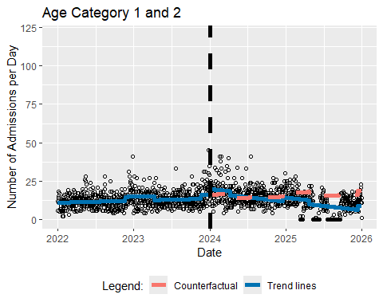
getITSresultsInf(dat0=datag3,outcome="n",ptitle="Age Category 3")
n ~ Triage_Begin_Day + Level_Change + Slope_Change + influenza
<environment: 0x0000023db36b78c8>
Generalized least squares fit by REML
Model: form
Data: dat0
AIC BIC logLik
9003.526 9040.51 -4494.763
Correlation Structure: AR(1)
Formula: ~Triage_Begin_Day
Parameter estimate(s):
Phi
0.2883483
Coefficients:
Value Std.Error t-value p-value
(Intercept) 14.227095 0.5421346 26.242739 0.0000
Triage_Begin_Day 0.002984 0.0013075 2.282034 0.0226
Level_Change 1.951099 0.7644601 2.552258 0.0108
Slope_Change -0.001271 0.0018784 -0.676911 0.4986
influenza 0.904311 0.4347622 2.080012 0.0377
Correlation:
(Intr) Tr_B_D Lvl_Ch Slp_Ch
Triage_Begin_Day -0.844
Level_Change 0.354 -0.593
Slope_Change 0.584 -0.721 -0.008
influenza -0.032 -0.190 -0.041 0.256
Standardized residuals:
Min Q1 Med Q3 Max
-3.58514333 -0.68718827 -0.07010336 0.57594474 5.69046348
Residual standard error: 5.44291
Degrees of freedom: 1461 total; 1456 residual
[1] "Below are the model estimates together with their 95% confidence limits."
Point estimates 2.5 % 97.5 %
(Intercept) 14.227095340 13.1645311460 15.289659534
Triage_Begin_Day 0.002983769 0.0004211082 0.005546431
Level_Change 1.951098953 0.4527847445 3.449413162
Slope_Change -0.001271481 -0.0049529924 0.002410031
influenza 0.904310626 0.0521924341 1.756428818
[1] "Below are the model estimates together with multiplicity adjusted p-values and confidence limits"
Simultaneous Tests for General Linear Hypotheses
Fit: gls(model = form, data = dat0, correlation = corAR1(form = ~Triage_Begin_Day),
method = "REML")
Linear Hypotheses:
Estimate Std. Error z value Pr(>|z|)
(Intercept) == 0 14.227095 0.542135 26.243 <0.001 ***
Triage_Begin_Day == 0 0.002984 0.001308 2.282 0.0878 .
Level_Change == 0 1.951099 0.764460 2.552 0.0442 *
Slope_Change == 0 -0.001271 0.001878 -0.677 0.9232
influenza == 0 0.904311 0.434762 2.080 0.1406
---
Signif. codes: 0 '***' 0.001 '**' 0.01 '*' 0.05 '.' 0.1 ' ' 1
(Adjusted p values reported -- single-step method)
Simultaneous Confidence Intervals
Fit: gls(model = form, data = dat0, correlation = corAR1(form = ~Triage_Begin_Day),
method = "REML")
Quantile = 2.5016
95% family-wise confidence level
Linear Hypotheses:
Estimate lwr upr
(Intercept) == 0 14.2270953 12.8708828 15.5833079
Triage_Begin_Day == 0 0.0029838 -0.0002871 0.0062546
Level_Change == 0 1.9510990 0.0387133 3.8634846
Slope_Change == 0 -0.0012715 -0.0059704 0.0034274
influenza == 0 0.9043106 -0.1832974 1.9919187
[1] "Below is the output requested by Alexander Braun"
(Intercept)
model_intercept 14.22710
model_pre_slope 0.00298
model_level_change 1.95110
model_slope_change -0.00127
model_influenza 0.90431
model_AIC 9003.52554
model_BIC 9040.50968
model_n 1461.00000
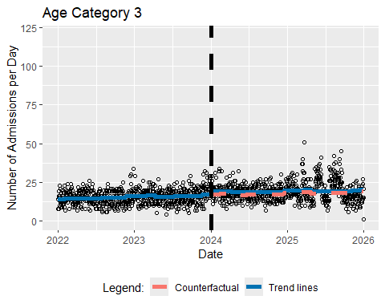
getITSresultsInf(dat0=datag4,outcome="n",ptitle="Age Category 4")
n ~ Triage_Begin_Day + Level_Change + Slope_Change + influenza
<environment: 0x0000023db93687e8>
Generalized least squares fit by REML
Model: form
Data: dat0
AIC BIC logLik
8242.55 8279.534 -4114.275
Correlation Structure: AR(1)
Formula: ~Triage_Begin_Day
Parameter estimate(s):
Phi
0.03429678
Coefficients:
Value Std.Error t-value p-value
(Intercept) 12.017288 0.3077530 39.04848 0.0000
Triage_Begin_Day 0.000840 0.0007427 1.13103 0.2582
Level_Change 1.141565 0.4347456 2.62582 0.0087
Slope_Change -0.001458 0.0010663 -1.36747 0.1717
influenza 1.378943 0.2482173 5.55539 0.0000
Correlation:
(Intr) Tr_B_D Lvl_Ch Slp_Ch
Triage_Begin_Day -0.844
Level_Change 0.356 -0.593
Slope_Change 0.584 -0.721 -0.009
influenza -0.033 -0.191 -0.042 0.259
Standardized residuals:
Min Q1 Med Q3 Max
-2.42461828 -0.67459537 -0.05624045 0.60010279 4.20733371
Residual standard error: 4.011498
Degrees of freedom: 1461 total; 1456 residual
[1] "Below are the model estimates together with their 95% confidence limits."
Point estimates 2.5 % 97.5 %
(Intercept) 12.0172883018 11.4141034267 1.262047e+01
Triage_Begin_Day 0.0008400006 -0.0006156346 2.295636e-03
Level_Change 1.1415648007 0.2894791645 1.993650e+00
Slope_Change -0.0014581063 -0.0035479842 6.317715e-04
influenza 1.3789433150 0.8924463715 1.865440e+00
[1] "Below are the model estimates together with multiplicity adjusted p-values and confidence limits"
Simultaneous Tests for General Linear Hypotheses
Fit: gls(model = form, data = dat0, correlation = corAR1(form = ~Triage_Begin_Day),
method = "REML")
Linear Hypotheses:
Estimate Std. Error z value Pr(>|z|)
(Intercept) == 0 12.0172883 0.3077530 39.048 <0.001 ***
Triage_Begin_Day == 0 0.0008400 0.0007427 1.131 0.6682
Level_Change == 0 1.1415648 0.4347456 2.626 0.0359 *
Slope_Change == 0 -0.0014581 0.0010663 -1.367 0.5042
influenza == 0 1.3789433 0.2482173 5.555 <0.001 ***
---
Signif. codes: 0 '***' 0.001 '**' 0.01 '*' 0.05 '.' 0.1 ' ' 1
(Adjusted p values reported -- single-step method)
Simultaneous Confidence Intervals
Fit: gls(model = form, data = dat0, correlation = corAR1(form = ~Triage_Begin_Day),
method = "REML")
Quantile = 2.5038
95% family-wise confidence level
Linear Hypotheses:
Estimate lwr upr
(Intercept) == 0 12.017288 11.246742 12.787835
Triage_Begin_Day == 0 0.000840 -0.001020 0.002700
Level_Change == 0 1.141565 0.053057 2.230073
Slope_Change == 0 -0.001458 -0.004128 0.001212
influenza == 0 1.378943 0.757462 2.000425
[1] "Below is the output requested by Alexander Braun"
(Intercept)
model_intercept 12.01729
model_pre_slope 0.00084
model_level_change 1.14156
model_slope_change -0.00146
model_influenza 1.37894
model_AIC 8242.55007
model_BIC 8279.53420
model_n 1461.00000
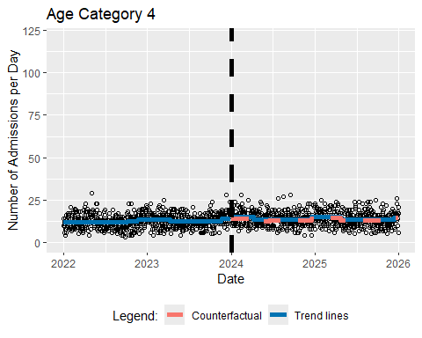
getITSresultsInf(dat0=datag5,outcome="n",ptitle="Age Category 5")
n ~ Triage_Begin_Day + Level_Change + Slope_Change + influenza
<environment: 0x0000023e09176740>
Generalized least squares fit by REML
Model: form
Data: dat0
AIC BIC logLik
8174.376 8211.36 -4080.188
Correlation Structure: AR(1)
Formula: ~Triage_Begin_Day
Parameter estimate(s):
Phi
0.05729748
Coefficients:
Value Std.Error t-value p-value
(Intercept) 10.582233 0.3079646 34.36185 0.0000
Triage_Begin_Day 0.002388 0.0007432 3.21281 0.0013
Level_Change 1.338158 0.4350086 3.07616 0.0021
Slope_Change -0.004744 0.0010670 -4.44620 0.0000
influenza 0.818100 0.2483155 3.29460 0.0010
Correlation:
(Intr) Tr_B_D Lvl_Ch Slp_Ch
Triage_Begin_Day -0.844
Level_Change 0.355 -0.593
Slope_Change 0.584 -0.721 -0.009
influenza -0.033 -0.191 -0.042 0.258
Standardized residuals:
Min Q1 Med Q3 Max
-2.55372398 -0.71796306 -0.05003809 0.62792232 3.52861221
Residual standard error: 3.923133
Degrees of freedom: 1461 total; 1456 residual
[1] "Below are the model estimates together with their 95% confidence limits."
Point estimates 2.5 % 97.5 %
(Intercept) 10.582233360 9.978633899 11.185832820
Triage_Begin_Day 0.002387682 0.000931086 0.003844277
Level_Change 1.338157659 0.485556549 2.190758770
Slope_Change -0.004744172 -0.006835488 -0.002652856
influenza 0.818100053 0.331410589 1.304789516
[1] "Below are the model estimates together with multiplicity adjusted p-values and confidence limits"
Simultaneous Tests for General Linear Hypotheses
Fit: gls(model = form, data = dat0, correlation = corAR1(form = ~Triage_Begin_Day),
method = "REML")
Linear Hypotheses:
Estimate Std. Error z value Pr(>|z|)
(Intercept) == 0 10.5822334 0.3079646 34.362 < 0.001 ***
Triage_Begin_Day == 0 0.0023877 0.0007432 3.213 0.00619 **
Level_Change == 0 1.3381577 0.4350086 3.076 0.00923 **
Slope_Change == 0 -0.0047442 0.0010670 -4.446 < 0.001 ***
influenza == 0 0.8181001 0.2483155 3.295 0.00412 **
---
Signif. codes: 0 '***' 0.001 '**' 0.01 '*' 0.05 '.' 0.1 ' ' 1
(Adjusted p values reported -- single-step method)
Simultaneous Confidence Intervals
Fit: gls(model = form, data = dat0, correlation = corAR1(form = ~Triage_Begin_Day),
method = "REML")
Quantile = 2.5019
95% family-wise confidence level
Linear Hypotheses:
Estimate lwr upr
(Intercept) == 0 10.5822334 9.8117305 11.3527362
Triage_Begin_Day == 0 0.0023877 0.0005283 0.0042470
Level_Change == 0 1.3381577 0.2498009 2.4265145
Slope_Change == 0 -0.0047442 -0.0074138 -0.0020746
influenza == 0 0.8181001 0.1968344 1.4393657
[1] "Below is the output requested by Alexander Braun"
(Intercept)
model_intercept 10.58223
model_pre_slope 0.00239
model_level_change 1.33816
model_slope_change -0.00474
model_influenza 0.81810
model_AIC 8174.37583
model_BIC 8211.35997
model_n 1461.00000
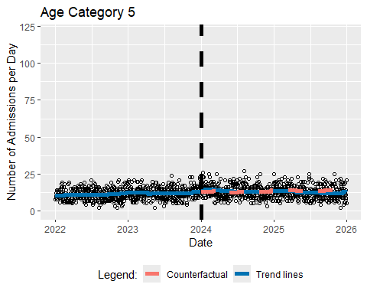
getITSresultsInf(dat0=datpr12,outcome="n",ptitle="Prio 1 and 2")
n ~ Triage_Begin_Day + Level_Change + Slope_Change + influenza
<environment: 0x0000023db378afd0>
Generalized least squares fit by REML
Model: form
Data: dat0
AIC BIC logLik
7129.239 7166.223 -3557.62
Correlation Structure: AR(1)
Formula: ~Triage_Begin_Day
Parameter estimate(s):
Phi
0.09275989
Coefficients:
Value Std.Error t-value p-value
(Intercept) 5.973988 0.22349811 26.729481 0.0000
Triage_Begin_Day -0.000427 0.00053931 -0.791334 0.4289
Level_Change 1.010878 0.31565052 3.202522 0.0014
Slope_Change -0.001780 0.00077436 -2.299135 0.0216
influenza 0.405898 0.18011726 2.253522 0.0244
Correlation:
(Intr) Tr_B_D Lvl_Ch Slp_Ch
Triage_Begin_Day -0.844
Level_Change 0.355 -0.593
Slope_Change 0.584 -0.721 -0.009
influenza -0.033 -0.191 -0.042 0.258
Standardized residuals:
Min Q1 Med Q3 Max
-2.32485654 -0.70084576 -0.06407648 0.65127154 4.65892232
Residual standard error: 2.747769
Degrees of freedom: 1461 total; 1456 residual
[1] "Below are the model estimates together with their 95% confidence limits."
Point estimates 2.5 % 97.5 %
(Intercept) 5.9739884983 5.535940253 6.4120367434
Triage_Begin_Day -0.0004267779 -0.001483816 0.0006302596
Level_Change 1.0108778487 0.392214189 1.6295415088
Slope_Change -0.0017803677 -0.003298093 -0.0002626419
influenza 0.4058982736 0.052874937 0.7589216104
[1] "Below are the model estimates together with multiplicity adjusted p-values and confidence limits"
Simultaneous Tests for General Linear Hypotheses
Fit: gls(model = form, data = dat0, correlation = corAR1(form = ~Triage_Begin_Day),
method = "REML")
Linear Hypotheses:
Estimate Std. Error z value Pr(>|z|)
(Intercept) == 0 5.9739885 0.2234981 26.729 < 0.001 ***
Triage_Begin_Day == 0 -0.0004268 0.0005393 -0.791 0.87408
Level_Change == 0 1.0108778 0.3156505 3.203 0.00545 **
Slope_Change == 0 -0.0017804 0.0007744 -2.299 0.08442 .
influenza == 0 0.4058983 0.1801173 2.254 0.09396 .
---
Signif. codes: 0 '***' 0.001 '**' 0.01 '*' 0.05 '.' 0.1 ' ' 1
(Adjusted p values reported -- single-step method)
Simultaneous Confidence Intervals
Fit: gls(model = form, data = dat0, correlation = corAR1(form = ~Triage_Begin_Day),
method = "REML")
Quantile = 2.5003
95% family-wise confidence level
Linear Hypotheses:
Estimate lwr upr
(Intercept) == 0 5.9739885 5.4151736 6.5328034
Triage_Begin_Day == 0 -0.0004268 -0.0017752 0.0009217
Level_Change == 0 1.0108778 0.2216532 1.8001025
Slope_Change == 0 -0.0017804 -0.0037165 0.0001558
influenza == 0 0.4058983 -0.0444510 0.8562476
[1] "Below is the output requested by Alexander Braun"
(Intercept)
model_intercept 5.97399
model_pre_slope -0.00043
model_level_change 1.01088
model_slope_change -0.00178
model_influenza 0.40590
model_AIC 7129.23925
model_BIC 7166.22339
model_n 1461.00000
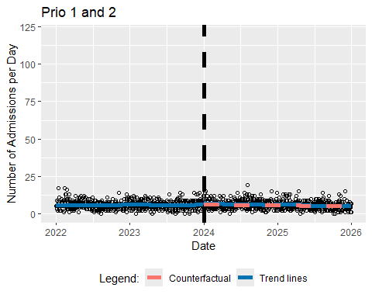
getITSresultsInf(dat0=datpr3,outcome="n",ptitle="Prio 3")
n ~ Triage_Begin_Day + Level_Change + Slope_Change + influenza
<environment: 0x0000023db386fb00>
Generalized least squares fit by REML
Model: form
Data: dat0
AIC BIC logLik
9276.799 9313.783 -4631.4
Correlation Structure: AR(1)
Formula: ~Triage_Begin_Day
Parameter estimate(s):
Phi
0.05089041
Coefficients:
Value Std.Error t-value p-value
(Intercept) 16.740935 0.4466579 37.48044 0e+00
Triage_Begin_Day 0.007981 0.0010779 7.40441 0e+00
Level_Change 2.396005 0.6309319 3.79756 2e-04
Slope_Change -0.014166 0.0015476 -9.15386 0e+00
influenza 2.428350 0.3601759 6.74212 0e+00
Correlation:
(Intr) Tr_B_D Lvl_Ch Slp_Ch
Triage_Begin_Day -0.844
Level_Change 0.356 -0.593
Slope_Change 0.584 -0.721 -0.009
influenza -0.033 -0.191 -0.042 0.258
Standardized residuals:
Min Q1 Med Q3 Max
-3.08177979 -0.67349996 -0.06219026 0.61097619 4.88355214
Residual standard error: 5.726472
Degrees of freedom: 1461 total; 1456 residual
[1] "Below are the model estimates together with their 95% confidence limits."
Point estimates 2.5 % 97.5 %
(Intercept) 16.740935374 15.865501895 17.61636885
Triage_Begin_Day 0.007981035 0.005868437 0.01009363
Level_Change 2.396004702 1.159400827 3.63260858
Slope_Change -0.014166087 -0.017199237 -0.01113294
influenza 2.428349782 1.722417928 3.13428164
[1] "Below are the model estimates together with multiplicity adjusted p-values and confidence limits"
Simultaneous Tests for General Linear Hypotheses
Fit: gls(model = form, data = dat0, correlation = corAR1(form = ~Triage_Begin_Day),
method = "REML")
Linear Hypotheses:
Estimate Std. Error z value Pr(>|z|)
(Intercept) == 0 16.740935 0.446658 37.480 < 1e-04 ***
Triage_Begin_Day == 0 0.007981 0.001078 7.404 < 1e-04 ***
Level_Change == 0 2.396005 0.630932 3.798 0.000605 ***
Slope_Change == 0 -0.014166 0.001548 -9.154 < 1e-04 ***
influenza == 0 2.428350 0.360176 6.742 < 1e-04 ***
---
Signif. codes: 0 '***' 0.001 '**' 0.01 '*' 0.05 '.' 0.1 ' ' 1
(Adjusted p values reported -- single-step method)
Simultaneous Confidence Intervals
Fit: gls(model = form, data = dat0, correlation = corAR1(form = ~Triage_Begin_Day),
method = "REML")
Quantile = 2.5061
95% family-wise confidence level
Linear Hypotheses:
Estimate lwr upr
(Intercept) == 0 16.740935 15.621560 17.860311
Triage_Begin_Day == 0 0.007981 0.005280 0.010682
Level_Change == 0 2.396005 0.814818 3.977191
Slope_Change == 0 -0.014166 -0.018044 -0.010288
influenza == 0 2.428350 1.525708 3.330991
[1] "Below is the output requested by Alexander Braun"
(Intercept)
model_intercept 16.74094
model_pre_slope 0.00798
model_level_change 2.39600
model_slope_change -0.01417
model_influenza 2.42835
model_AIC 9276.79923
model_BIC 9313.78337
model_n 1461.00000
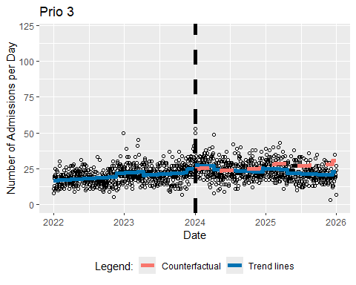
getITSresultsInf(dat0=datpr45,outcome="n",ptitle="Prio 4 and 5")
n ~ Triage_Begin_Day + Level_Change + Slope_Change + influenza
<environment: 0x0000023db1790ca8>
Generalized least squares fit by REML
Model: form
Data: dat0
AIC BIC logLik
9911.556 9948.541 -4948.778
Correlation Structure: AR(1)
Formula: ~Triage_Begin_Day
Parameter estimate(s):
Phi
0.1372317
Coefficients:
Value Std.Error t-value p-value
(Intercept) 25.090692 0.6109968 41.06518 0.0000
Triage_Begin_Day 0.002259 0.0014743 1.53210 0.1257
Level_Change 4.557025 0.8627239 5.28214 0.0000
Slope_Change -0.010228 0.0021170 -4.83154 0.0000
influenza 3.027693 0.4920268 6.15351 0.0000
Correlation:
(Intr) Tr_B_D Lvl_Ch Slp_Ch
Triage_Begin_Day -0.844
Level_Change 0.355 -0.593
Slope_Change 0.584 -0.721 -0.009
influenza -0.033 -0.191 -0.042 0.258
Standardized residuals:
Min Q1 Med Q3 Max
-3.27319930 -0.66000725 -0.07843921 0.58310574 6.02098622
Residual standard error: 7.182221
Degrees of freedom: 1461 total; 1456 residual
[1] "Below are the model estimates together with their 95% confidence limits."
Point estimates 2.5 % 97.5 %
(Intercept) 25.090692118 23.8931604155 26.288223821
Triage_Begin_Day 0.002258705 -0.0006307893 0.005148199
Level_Change 4.557025327 2.8661175122 6.247933142
Slope_Change -0.010228133 -0.0143772800 -0.006078986
influenza 3.027692635 2.0633378268 3.992047443
[1] "Below are the model estimates together with multiplicity adjusted p-values and confidence limits"
Simultaneous Tests for General Linear Hypotheses
Fit: gls(model = form, data = dat0, correlation = corAR1(form = ~Triage_Begin_Day),
method = "REML")
Linear Hypotheses:
Estimate Std. Error z value Pr(>|z|)
(Intercept) == 0 25.090692 0.610997 41.065 <0.001 ***
Triage_Begin_Day == 0 0.002259 0.001474 1.532 0.397
Level_Change == 0 4.557025 0.862724 5.282 <0.001 ***
Slope_Change == 0 -0.010228 0.002117 -4.832 <0.001 ***
influenza == 0 3.027693 0.492027 6.154 <0.001 ***
---
Signif. codes: 0 '***' 0.001 '**' 0.01 '*' 0.05 '.' 0.1 ' ' 1
(Adjusted p values reported -- single-step method)
Simultaneous Confidence Intervals
Fit: gls(model = form, data = dat0, correlation = corAR1(form = ~Triage_Begin_Day),
method = "REML")
Quantile = 2.5034
95% family-wise confidence level
Linear Hypotheses:
Estimate lwr upr
(Intercept) == 0 25.090692 23.561151 26.620233
Triage_Begin_Day == 0 0.002259 -0.001432 0.005949
Level_Change == 0 4.557025 2.397322 6.716729
Slope_Change == 0 -0.010228 -0.015528 -0.004929
influenza == 0 3.027693 1.795975 4.259410
[1] "Below is the output requested by Alexander Braun"
(Intercept)
model_intercept 25.09069
model_pre_slope 0.00226
model_level_change 4.55703
model_slope_change -0.01023
model_influenza 3.02769
model_AIC 9911.55638
model_BIC 9948.54052
model_n 1461.00000
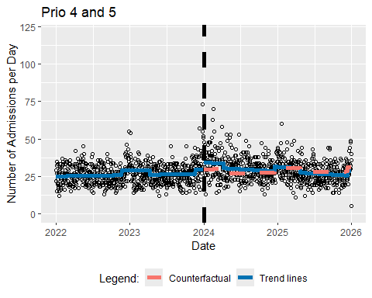

How do I perform the ITSA accounting for influenze with different interruption dates?
getITSresultsInf(dat0=datalld,outcome="n",ptitle="All data",intday="01Dec2023")
n ~ Triage_Begin_Day + Level_Change + Slope_Change + influenza
<environment: 0x0000023dbcf69180>
Generalized least squares fit by REML
Model: form
Data: dat0
AIC BIC logLik
10899.93 10936.92 -5442.967
Correlation Structure: AR(1)
Formula: ~Triage_Begin_Day
Parameter estimate(s):
Phi
0.1533249
Coefficients:
Value Std.Error t-value p-value
(Intercept) 48.77453 0.8953534 54.47518 0.000
Triage_Begin_Day 0.00626 0.0022240 2.81403 0.005
Level_Change 10.85102 1.2504949 8.67738 0.000
Slope_Change -0.02336 0.0030329 -7.70052 0.000
influenza 5.20095 0.7109355 7.31564 0.000
Correlation:
(Intr) Tr_B_D Lvl_Ch Slp_Ch
Triage_Begin_Day -0.850
Level_Change 0.368 -0.596
Slope_Change 0.612 -0.752 0.034
influenza -0.074 -0.113 -0.160 0.242
Standardized residuals:
Min Q1 Med Q3 Max
-4.27285448 -0.70015889 -0.04035678 0.63273820 5.91297248
Residual standard error: 10.10959
Degrees of freedom: 1461 total; 1456 residual
[1] "Below are the model estimates together with their 95% confidence limits."
Point estimates 2.5 % 97.5 %
(Intercept) 48.774534913 47.019674571 50.52939525
Triage_Begin_Day 0.006258451 0.001899456 0.01061745
Level_Change 10.851022296 8.400097327 13.30194727
Slope_Change -0.023355173 -0.029299614 -0.01741073
influenza 5.200945836 3.807537793 6.59435388
[1] "Below are the model estimates together with multiplicity adjusted p-values and confidence limits"
Simultaneous Tests for General Linear Hypotheses
Fit: gls(model = form, data = dat0, correlation = corAR1(form = ~Triage_Begin_Day),
method = "REML")
Linear Hypotheses:
Estimate Std. Error z value Pr(>|z|)
(Intercept) == 0 48.774535 0.895353 54.475 <0.001 ***
Triage_Begin_Day == 0 0.006258 0.002224 2.814 0.0209 *
Level_Change == 0 10.851022 1.250495 8.677 <0.001 ***
Slope_Change == 0 -0.023355 0.003033 -7.701 <0.001 ***
influenza == 0 5.200946 0.710936 7.316 <0.001 ***
---
Signif. codes: 0 '***' 0.001 '**' 0.01 '*' 0.05 '.' 0.1 ' ' 1
(Adjusted p values reported -- single-step method)
Simultaneous Confidence Intervals
Fit: gls(model = form, data = dat0, correlation = corAR1(form = ~Triage_Begin_Day),
method = "REML")
Quantile = 2.4988
95% family-wise confidence level
Linear Hypotheses:
Estimate lwr upr
(Intercept) == 0 48.7745349 46.5372322 51.0118377
Triage_Begin_Day == 0 0.0062585 0.0007011 0.0118158
Level_Change == 0 10.8510223 7.7262943 13.9757502
Slope_Change == 0 -0.0233552 -0.0309338 -0.0157765
influenza == 0 5.2009458 3.4244651 6.9774266
[1] "Below is the output requested by Alexander Braun"
(Intercept)
model_intercept 48.77453
model_pre_slope 0.00626
model_level_change 10.85102
model_slope_change -0.02336
model_influenza 5.20095
model_AIC 10899.93376
model_BIC 10936.91790
model_n 1461.00000
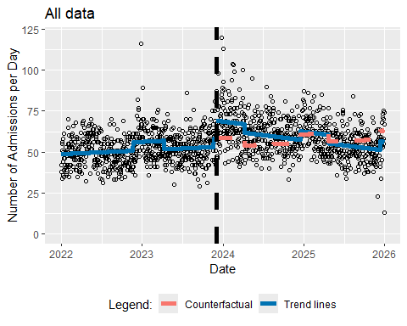
getITSresultsInf(dat0=datallf,outcome="n",ptitle="All data",intday="01Feb2024")
n ~ Triage_Begin_Day + Level_Change + Slope_Change + influenza
<environment: 0x0000023dbf4544d8>
Generalized least squares fit by REML
Model: form
Data: dat0
AIC BIC logLik
10932.96 10969.95 -5459.481
Correlation Structure: AR(1)
Formula: ~Triage_Begin_Day
Parameter estimate(s):
Phi
0.1799252
Coefficients:
Value Std.Error t-value p-value
(Intercept) 47.23603 0.8935582 52.86285 0
Triage_Begin_Day 0.01185 0.0021020 5.63681 0
Level_Change 6.02360 1.2920592 4.66202 0
Slope_Change -0.02811 0.0031739 -8.85768 0
influenza 6.21688 0.7355956 8.45149 0
Correlation:
(Intr) Tr_B_D Lvl_Ch Slp_Ch
Triage_Begin_Day -0.837
Level_Change 0.346 -0.597
Slope_Change 0.555 -0.684 -0.050
influenza 0.000 -0.257 0.075 0.251
Standardized residuals:
Min Q1 Med Q3 Max
-4.2964532 -0.6863088 -0.0462820 0.6160953 5.6746134
Residual standard error: 10.27266
Degrees of freedom: 1461 total; 1456 residual
[1] "Below are the model estimates together with their 95% confidence limits."
Point estimates 2.5 % 97.5 %
(Intercept) 47.23602761 45.484685766 48.98736946
Triage_Begin_Day 0.01184874 0.007728834 0.01596864
Level_Change 6.02360172 3.491212237 8.55599119
Slope_Change -0.02811374 -0.034334538 -0.02189293
influenza 6.21688098 4.775140118 7.65862185
[1] "Below are the model estimates together with multiplicity adjusted p-values and confidence limits"
Simultaneous Tests for General Linear Hypotheses
Fit: gls(model = form, data = dat0, correlation = corAR1(form = ~Triage_Begin_Day),
method = "REML")
Linear Hypotheses:
Estimate Std. Error z value Pr(>|z|)
(Intercept) == 0 47.236028 0.893558 52.863 < 1e-05 ***
Triage_Begin_Day == 0 0.011849 0.002102 5.637 < 1e-05 ***
Level_Change == 0 6.023602 1.292059 4.662 1.32e-05 ***
Slope_Change == 0 -0.028114 0.003174 -8.858 < 1e-05 ***
influenza == 0 6.216881 0.735596 8.451 < 1e-05 ***
---
Signif. codes: 0 '***' 0.001 '**' 0.01 '*' 0.05 '.' 0.1 ' ' 1
(Adjusted p values reported -- single-step method)
Simultaneous Confidence Intervals
Fit: gls(model = form, data = dat0, correlation = corAR1(form = ~Triage_Begin_Day),
method = "REML")
Quantile = 2.509
95% family-wise confidence level
Linear Hypotheses:
Estimate lwr upr
(Intercept) == 0 47.236028 44.994101 49.477954
Triage_Begin_Day == 0 0.011849 0.006575 0.017123
Level_Change == 0 6.023602 2.781841 9.265363
Slope_Change == 0 -0.028114 -0.036077 -0.020150
influenza == 0 6.216881 4.371281 8.062481
[1] "Below is the output requested by Alexander Braun"
(Intercept)
model_intercept 47.23603
model_pre_slope 0.01185
model_level_change 6.02360
model_slope_change -0.02811
model_influenza 6.21688
model_AIC 10932.96281
model_BIC 10969.94695
model_n 1461.00000
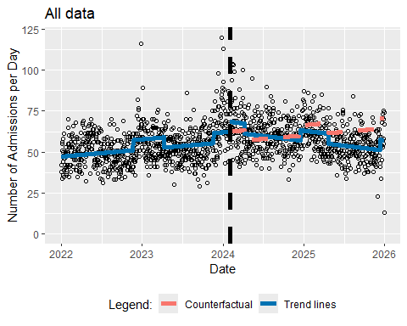
getITSresultsInf(dat0=datall5,outcome="n",ptitle="All data",intday="01Jan2025")
n ~ Triage_Begin_Day + Level_Change + Slope_Change + influenza
<environment: 0x0000023db38a3510>
Generalized least squares fit by REML
Model: form
Data: dat0
AIC BIC logLik
10941.16 10978.14 -5463.579
Correlation Structure: AR(1)
Formula: ~Triage_Begin_Day
Parameter estimate(s):
Phi
0.186204
Coefficients:
Value Std.Error t-value p-value
(Intercept) 47.01586 0.7658113 61.39353 0.000
Triage_Begin_Day 0.01282 0.0011940 10.73478 0.000
Level_Change -4.02960 1.5415505 -2.61399 0.009
Slope_Change -0.03145 0.0066122 -4.75692 0.000
influenza 6.65284 0.7537827 8.82594 0.000
Correlation:
(Intr) Tr_B_D Lvl_Ch Slp_Ch
Triage_Begin_Day -0.830
Level_Change 0.282 -0.398
Slope_Change 0.097 -0.210 -0.675
influenza -0.184 -0.095 -0.230 0.308
Standardized residuals:
Min Q1 Med Q3 Max
-4.2560602 -0.6882021 -0.0608242 0.6138008 5.5949287
Residual standard error: 10.31828
Degrees of freedom: 1461 total; 1456 residual
[1] "Below are the model estimates together with their 95% confidence limits."
Point estimates 2.5 % 97.5 %
(Intercept) 47.01586037 45.51489772 48.51682303
Triage_Begin_Day 0.01281681 0.01047671 0.01515691
Level_Change -4.02959905 -7.05098254 -1.00821555
Slope_Change -0.03145392 -0.04441367 -0.01849416
influenza 6.65284195 5.17545509 8.13022881
[1] "Below are the model estimates together with multiplicity adjusted p-values and confidence limits"
Simultaneous Tests for General Linear Hypotheses
Fit: gls(model = form, data = dat0, correlation = corAR1(form = ~Triage_Begin_Day),
method = "REML")
Linear Hypotheses:
Estimate Std. Error z value Pr(>|z|)
(Intercept) == 0 47.015860 0.765811 61.394 <0.001 ***
Triage_Begin_Day == 0 0.012817 0.001194 10.735 <0.001 ***
Level_Change == 0 -4.029599 1.541551 -2.614 0.0382 *
Slope_Change == 0 -0.031454 0.006612 -4.757 <0.001 ***
influenza == 0 6.652842 0.753783 8.826 <0.001 ***
---
Signif. codes: 0 '***' 0.001 '**' 0.01 '*' 0.05 '.' 0.1 ' ' 1
(Adjusted p values reported -- single-step method)
Simultaneous Confidence Intervals
Fit: gls(model = form, data = dat0, correlation = corAR1(form = ~Triage_Begin_Day),
method = "REML")
Quantile = 2.5101
95% family-wise confidence level
Linear Hypotheses:
Estimate lwr upr
(Intercept) == 0 47.01586 45.09359 48.93813
Triage_Begin_Day == 0 0.01282 0.00982 0.01581
Level_Change == 0 -4.02960 -7.89906 -0.16014
Slope_Change == 0 -0.03145 -0.04805 -0.01486
influenza == 0 6.65284 4.76076 8.54492
[1] "Below is the output requested by Alexander Braun"
(Intercept)
model_intercept 47.01586
model_pre_slope 0.01282
model_level_change -4.02960
model_slope_change -0.03145
model_influenza 6.65284
model_AIC 10941.15804
model_BIC 10978.14218
model_n 1461.00000
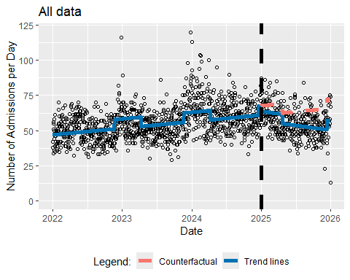

How do I perform the ITSA accounting for influenza using ARMA(1,1) and AR(2) errors?
getITSresultsInfARMA11(dat0=datall,outcome="n",ptitle="All data") # ARMA(1,1) - process
n ~ Triage_Begin_Day + Level_Change + Slope_Change + influenza
<environment: 0x0000023db8472970>
Generalized least squares fit by REML
Model: form
Data: dat0
AIC BIC logLik
10907.1 10949.37 -5445.551
Correlation Structure: ARMA(1,1)
Formula: ~Triage_Begin_Day
Parameter estimate(s):
Phi1 Theta1
0.9140928 -0.8247787
Coefficients:
Value Std.Error t-value p-value
(Intercept) 47.57538 1.4829411 32.08177 0.0000
Triage_Begin_Day 0.01115 0.0035436 3.14540 0.0017
Level_Change 7.25721 2.0327438 3.57015 0.0004
Slope_Change -0.02719 0.0051426 -5.28739 0.0000
influenza 5.13714 1.0949952 4.69148 0.0000
Correlation:
(Intr) Tr_B_D Lvl_Ch Slp_Ch
Triage_Begin_Day -0.844
Level_Change 0.337 -0.580
Slope_Change 0.592 -0.730 -0.004
influenza -0.028 -0.180 -0.029 0.226
Standardized residuals:
Min Q1 Med Q3 Max
-4.2283823 -0.6934942 -0.0554386 0.6210806 5.7754987
Residual standard error: 10.26509
Degrees of freedom: 1461 total; 1456 residual
[1] "Below are the model estimates together with their 95% confidence limits."
Point estimates 2.5 % 97.5 %
(Intercept) 47.57538065 44.66886951 50.48189179
Triage_Begin_Day 0.01114612 0.00420074 0.01809150
Level_Change 7.25720730 3.27310263 11.24131197
Slope_Change -0.02719108 -0.03727045 -0.01711171
influenza 5.13714374 2.99099255 7.28329493
[1] "Below are the model estimates together with multiplicity adjusted p-values and confidence limits"
Simultaneous Tests for General Linear Hypotheses
Fit: gls(model = form, data = dat0, correlation = corARMA(form = ~Triage_Begin_Day,
p = 1, q = 1), method = "REML")
Linear Hypotheses:
Estimate Std. Error z value Pr(>|z|)
(Intercept) == 0 47.575381 1.482941 32.082 < 0.001 ***
Triage_Begin_Day == 0 0.011146 0.003544 3.145 0.00767 **
Level_Change == 0 7.257207 2.032744 3.570 0.00146 **
Slope_Change == 0 -0.027191 0.005143 -5.287 < 0.001 ***
influenza == 0 5.137144 1.094995 4.691 < 0.001 ***
---
Signif. codes: 0 '***' 0.001 '**' 0.01 '*' 0.05 '.' 0.1 ' ' 1
(Adjusted p values reported -- single-step method)
Simultaneous Confidence Intervals
Fit: gls(model = form, data = dat0, correlation = corARMA(form = ~Triage_Begin_Day,
p = 1, q = 1), method = "REML")
Quantile = 2.5038
95% family-wise confidence level
Linear Hypotheses:
Estimate lwr upr
(Intercept) == 0 47.575381 43.862431 51.288331
Triage_Begin_Day == 0 0.011146 0.002274 0.020019
Level_Change == 0 7.257207 2.167675 12.346739
Slope_Change == 0 -0.027191 -0.040067 -0.014315
influenza == 0 5.137144 2.395523 7.878765
[1] "Below is the output requested by Alexander Braun"
(Intercept)
model_intercept 47.57538
model_pre_slope 0.01115
model_level_change 7.25721
model_slope_change -0.02719
model_influenza 5.13714
model_AIC 10907.10117
model_BIC 10949.36876
model_n 1461.00000
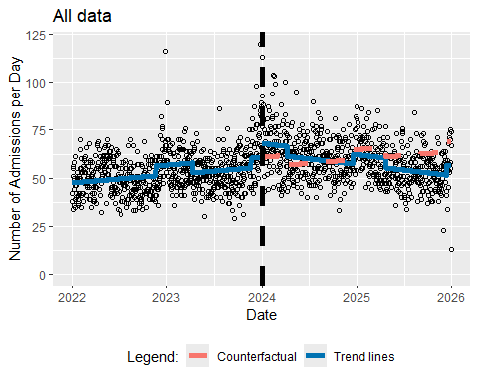
getITSresultsInfAR2(dat0=datall,outcome="n",ptitle="All data") # ARMA(2,0) - process
n ~ Triage_Begin_Day + Level_Change + Slope_Change + influenza
<environment: 0x0000023db43b95d8>
Generalized least squares fit by REML
Model: form
Data: dat0
AIC BIC logLik
10922.89 10965.15 -5453.443
Correlation Structure: ARMA(2,0)
Formula: ~Triage_Begin_Day
Parameter estimate(s):
Phi1 Phi2
0.16738381 0.03131965
Coefficients:
Value Std.Error t-value p-value
(Intercept) 47.81368 0.9301976 51.40164 0
Triage_Begin_Day 0.00979 0.0022440 4.36401 0
Level_Change 8.04053 1.3127294 6.12504 0
Slope_Change -0.02630 0.0032229 -8.16120 0
influenza 5.81696 0.7477546 7.77924 0
Correlation:
(Intr) Tr_B_D Lvl_Ch Slp_Ch
Triage_Begin_Day -0.844
Level_Change 0.355 -0.593
Slope_Change 0.584 -0.721 -0.008
influenza -0.033 -0.190 -0.042 0.257
Standardized residuals:
Min Q1 Med Q3 Max
-4.28242134 -0.70197210 -0.05916388 0.63034730 5.79784314
Residual standard error: 10.22266
Degrees of freedom: 1461 total; 1456 residual
[1] "Below are the model estimates together with their 95% confidence limits."
Point estimates 2.5 % 97.5 %
(Intercept) 47.813682027 45.990528193 49.63683586
Triage_Begin_Day 0.009793042 0.005394796 0.01419129
Level_Change 8.040525380 5.467622979 10.61342778
Slope_Change -0.026302811 -0.032619597 -0.01998603
influenza 5.816963236 4.351391141 7.28253533
[1] "Below are the model estimates together with multiplicity adjusted p-values and confidence limits"
Simultaneous Tests for General Linear Hypotheses
Fit: gls(model = form, data = dat0, correlation = corARMA(form = ~Triage_Begin_Day,
p = 2, q = 0), method = "REML")
Linear Hypotheses:
Estimate Std. Error z value Pr(>|z|)
(Intercept) == 0 47.813682 0.930198 51.402 <0.001 ***
Triage_Begin_Day == 0 0.009793 0.002244 4.364 <0.001 ***
Level_Change == 0 8.040525 1.312729 6.125 <0.001 ***
Slope_Change == 0 -0.026303 0.003223 -8.161 <0.001 ***
influenza == 0 5.816963 0.747755 7.779 <0.001 ***
---
Signif. codes: 0 '***' 0.001 '**' 0.01 '*' 0.05 '.' 0.1 ' ' 1
(Adjusted p values reported -- single-step method)
Simultaneous Confidence Intervals
Fit: gls(model = form, data = dat0, correlation = corARMA(form = ~Triage_Begin_Day,
p = 2, q = 0), method = "REML")
Quantile = 2.5061
95% family-wise confidence level
Linear Hypotheses:
Estimate lwr upr
(Intercept) == 0 47.813682 45.482487 50.144877
Triage_Begin_Day == 0 0.009793 0.004169 0.015417
Level_Change == 0 8.040525 4.750656 11.330395
Slope_Change == 0 -0.026303 -0.034380 -0.018226
influenza == 0 5.816963 3.942994 7.690933
[1] "Below is the output requested by Alexander Braun"
(Intercept)
model_intercept 47.81368
model_pre_slope 0.00979
model_level_change 8.04053
model_slope_change -0.02630
model_influenza 5.81696
model_AIC 10922.88649
model_BIC 10965.15408
model_n 1461.00000
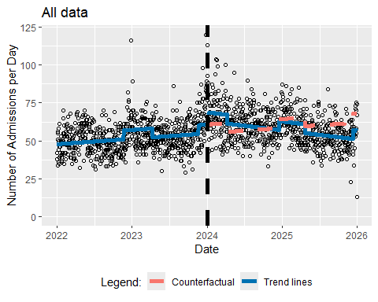

How do I perform the ITSA with Months?
getITSresultsMonth(dat0=datallm,outcome="n",ptitle="All data")
n ~ Triage_Begin_Month + Level_Change + Slope_Change
<environment: 0x0000023dbd08fc68>
Generalized least squares fit by REML
Model: form
Data: dat0
AIC BIC logLik
583.2494 593.9545 -285.6247
Correlation Structure: AR(1)
Formula: ~Triage_Begin_Month
Parameter estimate(s):
Phi
0.3817266
Coefficients:
Value Std.Error t-value p-value
(Intercept) 1422.3023 83.64773 17.003478 0.0000
Triage_Begin_Month 15.5313 5.73413 2.708562 0.0096
Level_Change 148.7655 105.62948 1.408371 0.1660
Slope_Change -30.2976 8.47780 -3.573754 0.0009
Correlation:
(Intr) Tr_B_M Lvl_Ch
Triage_Begin_Month -0.865
Level_Change 0.338 -0.591
Slope_Change 0.619 -0.739 0.040
Standardized residuals:
Min Q1 Med Q3 Max
-1.5014169 -0.5776937 -0.2152613 0.5403930 2.6630722
Residual standard error: 141.9217
Degrees of freedom: 48 total; 44 residual
[1] "Below are the model estimates together with their 95% confidence limits."
Point estimates 2.5 % 97.5 %
(Intercept) 1422.30228 1258.35575 1586.24882
Triage_Begin_Month 15.53125 4.29256 26.76995
Level_Change 148.76551 -58.26447 355.79550
Slope_Change -30.29756 -46.91374 -13.68138
[1] "Below are the model estimates together with multiplicity adjusted p-values and confidence limits"
Simultaneous Tests for General Linear Hypotheses
Fit: gls(model = form, data = dat0, correlation = corAR1(form = ~Triage_Begin_Month),
method = "REML")
Linear Hypotheses:
Estimate Std. Error z value Pr(>|z|)
(Intercept) == 0 1422.302 83.648 17.003 <0.001 ***
Triage_Begin_Month == 0 15.531 5.734 2.709 0.0204 *
Level_Change == 0 148.766 105.629 1.408 0.3810
Slope_Change == 0 -30.298 8.478 -3.574 <0.001 ***
---
Signif. codes: 0 '***' 0.001 '**' 0.01 '*' 0.05 '.' 0.1 ' ' 1
(Adjusted p values reported -- single-step method)
Simultaneous Confidence Intervals
Fit: gls(model = form, data = dat0, correlation = corAR1(form = ~Triage_Begin_Month),
method = "REML")
Quantile = 2.3963
95% family-wise confidence level
Linear Hypotheses:
Estimate lwr upr
(Intercept) == 0 1422.3023 1221.8577 1622.7469
Triage_Begin_Month == 0 15.5313 1.7906 29.2719
Level_Change == 0 148.7655 -104.3538 401.8849
Slope_Change == 0 -30.2976 -50.6129 -9.9823
[1] "Below is the output requested by Alexander Braun"
(Intercept)
model_intercept 1422.30228
model_pre_slope 15.53125
model_level_change 148.76551
model_slope_change -30.29756
model_AIC 583.24937
model_BIC 593.95451
model_n 48.00000
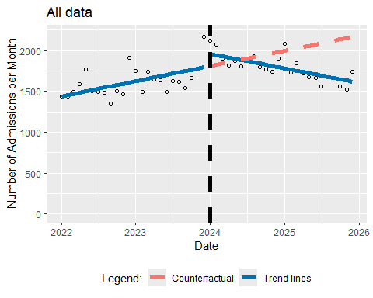

How do I estimate the time series trend using the semiparametric model suggested by Feng et al.?
getnts(dat0=datall,ptitle="All data")
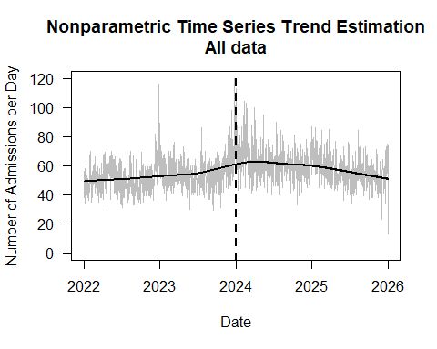
getnts(dat0=datsem,ptitle="Men only")
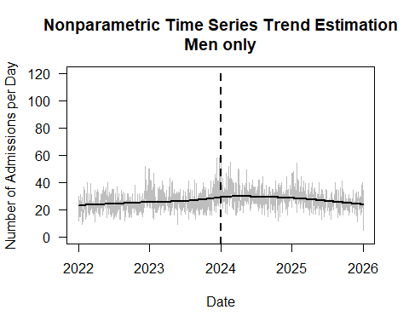
getnts(dat0=datsef,ptitle="Women only")
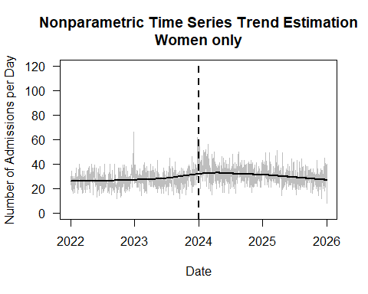
getnts(dat0=datag12,ptitle="Age Categories 1 and 2")
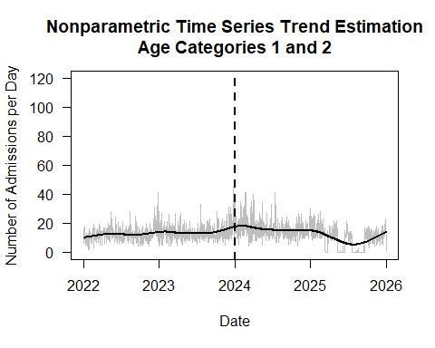
getnts(dat0=datag3,ptitle="Age Category 3")
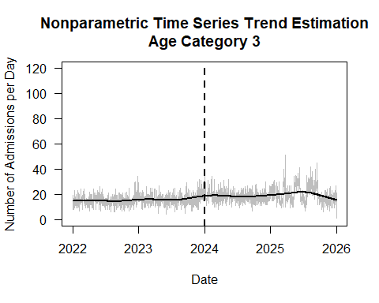
getnts(dat0=datag4,ptitle="Age Category 4")
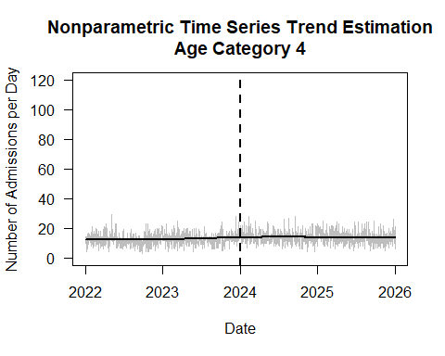
getnts(dat0=datag5,ptitle="Age Category 5")
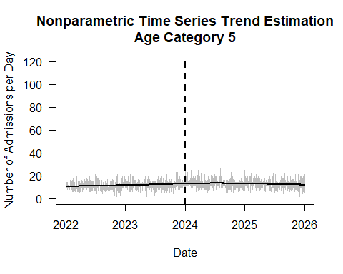
getnts(dat0=datpr12,ptitle="Prio 1 and 2")
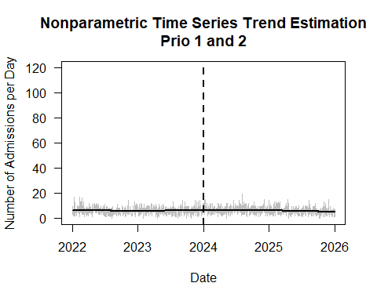
getnts(dat0=datpr3,ptitle="Prio 3")
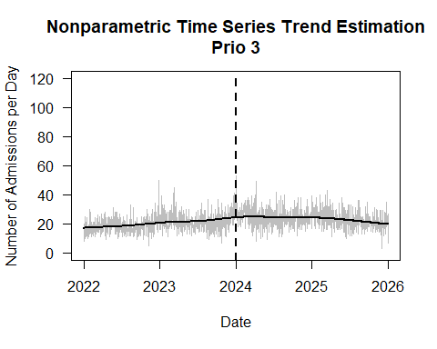
getnts(dat0=datpr45,ptitle="Prio 4 and 5")
