MD.120 Installation Instructions

VENANCIO

Tela Fabricante Divisão x Fornecedores

Author: ALC Consultoria

Creation Date: 07/26/2020

Last Update Date: 07/26/2020

Last Updated by: ALC Consultoria

Version Number: 1.0



## Document Control

### Change Record

| Date | Author | Version Number | Change |
| --- | --- | --- | --- |
| 07/26/2020 | ALC Consultoria | 1.0 | DocumentoInicial |
|  |  |  |  |
|  |  |  |  |
|  |  |  |  |
|  |  |  |  |
|  |  |  |  |
|  |  |  |  |
|  |  |  |  |
|  |  |  |  |
|  |  |  |  |
|  |  |  |  |
|  |  |  |  |

1

## TABLE OF CONTENTS

Document Control ii

Change Record ii

TABLE OF CONTENTS iii

Initial Installation Instructions 1

Pre-Installation 1

Installation 1

Post Installation/ Modification Instructions 3

Open and Closed Issues 4

Open Issues 4

Closed Issues 4

## Initial Installation Instructions

Installation custom Tela Fabricante Divisão x Fornecedores

### Pre-Installation

N/A

### Installation

1. **Table**

Sqlplus APPS/<PASSWORD> @XXVEN_AP_DIVISION_MANUFACT.tab

1. **Grant**

Sqlplus APPS/<PASSWORD> @XXVEN_AP_DIVISION_MANUFACT.grt

1. **Sinonym**

Sqlplus APPS/<PASSWORD> @XXVEN_AP_DIVISION_MANUFACT.syn

1. **Forms**

Abrir uma sessão do sistema operacional (UNIX), enviar o arquivo XXVEN_AP_DIV_MANUFACTURER.fmb para o diretorio $AU_TOP/forms/US e executar o comando de compilacao e copia abaixo.

frmcmp_batch module=XXVEN_AP_DIV_MANUFACTURER.fmb Userid=apps//<PASSWORD> output_file=$XXVEN_TOP/forms/US/XXVEN_AP_DIV_MANUFACTURER.fmx Module_Type=FORM Compile_All=YES

frmcmp_batch module=XXVEN_AP_DIV_MANUFACTURER.fmb Userid=apps//<PASSWORD> output_file=$XXVEN_TOP/forms/PTB/XXVEN_AP_DIV_MANUFACTURER.fmx Module_Type=FORM Compile_All=YES

1. **Menu**

Abrir uma sessão do sistema operacional (UNIX), enviar os arquivos de Seed Datas para qualquer diretório temporário. Esse arquivo irá criar o menu customizado.

$FND_TOP/bin/FNDLOAD apps/<PASSWORD> 0 Y UPLOAD $FND_TOP/patch/115/import/afsload.lct XXVEN_AP_CUSTOMIZACOES_MNU.ldt

Associar menu customizado “XXVEN_AP_CUSTOMIZACOES” ao menu da responsabilidade do AP “XXVEN_AP_NAVIGATE_GUI12” através da responsabilidade Desenvolvedor de aplicações:

Menu> Aplicações > Menu

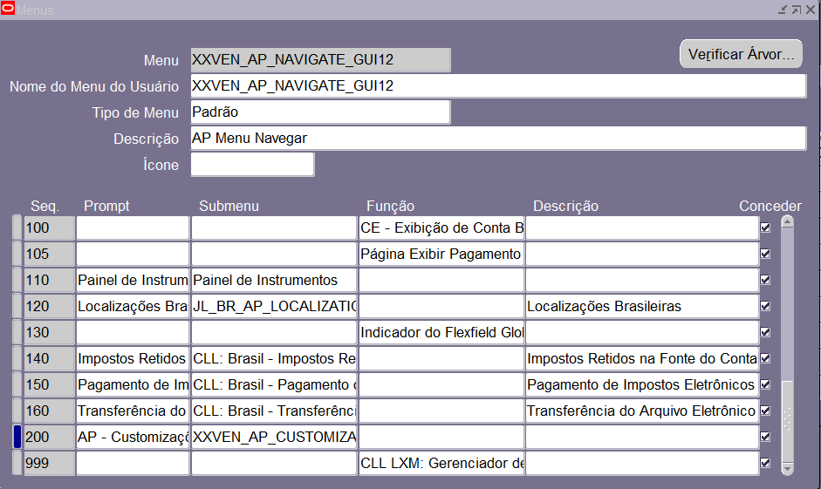

## Post Installation/ Modification Instructions

## Open and Closed Issues

### Open Issues

1. Any unanswered questions regarding this deliverable should be entered here.

| ID | Issue | Resolution | Responsibility | Date Opened |
| --- | --- | --- | --- | --- |
|  |  |  |  |  |
| 1 |  |  |  |  |
| 2 |  |  |  |  |
| 3 |  |  |  |  |
| 4 |  |  |  |  |
| 5 |  |  |  |  |
| 6 |  |  |  |  |
| 7 |  |  |  |  |
| 8 |  |  |  |  |

### Closed Issues

1. When an issue is closed, move it to the closed section and add the resolution. Keep the ID of the issue the same it was when it was still open.

| ID | Issue | Resolution | Responsibility | Date Opened | Date Closed |
| --- | --- | --- | --- | --- | --- |
|  |  |  |  |  |  |
| 1 |  |  |  |  |  |
| 2 |  |  |  |  |  |
| 3 |  |  |  |  |  |
| 4 |  |  |  |  |  |
| 5 |  |  |  |  |  |
| 6 |  |  |  |  |  |
| 7 |  |  |  |  |  |
| 8 |  |  |  |  |  |