FINANCIAL DATA REPORTING
AND ANALYTICS PLAN
Reporting, Dashboards & Analytics Framework for SAP FICO
Prepared for: Meridian Industrial Products Pvt. Ltd. (fictional mid-sized manufacturing company)
Scope: Financial Reports, Dashboards, KPIs, Predictive Analytics, Visualization Design
Week 3 Deliverable — Financial Data Reporting and Analytics
Prepared by: SAP FICO Implementation Consulting Team
Date: August 2026

Table of Contents
1. Executive Summary
2. Introduction and Objectives
3. Reporting Requirements and Stakeholder Needs
4. Core Financial Report Specifications
4.1 Income Statement (Profit & Loss)
4.2 Balance Sheet
4.3 Cash Flow Statement
4.4 Cost Center and Profitability Reports
5. Dashboard Design and Mock-ups
5.1 Executive Financial Dashboard
5.2 Cash Flow Forecast Dashboard
5.3 Monthly KPI Scorecard
6. Financial KPIs and Decision-Making Indicators
7. Analytics Framework
8. Data Visualization Techniques
9. Underlying Data Architecture (SAP BW/4HANA & Reporting Tools)
10. Report Distribution and Access Control
11. Feedback Loop and Continuous Improvement
12. Anticipated Outcomes
13. Conclusion

1. Executive Summary
This document defines the financial data reporting and analytics plan for Meridian Industrial Products Pvt. Ltd.'s SAP FICO implementation, building on the project plan (Week 1) and the configuration/integration design (Week 2). It specifies the core financial reports the business requires, the dashboards and visual analytics that will make those reports actionable, the KPIs that will drive decision-making, and the analytics framework that will move the organization from descriptive reporting toward predictive, decision-support analytics.
Four report/dashboard mock-ups are included: an Executive Financial Dashboard, a standard Income Statement report template, a Cash Flow Forecast dashboard with a rolling 13-week projection, and a Monthly Financial KPI Scorecard. Each mock-up is accompanied by a specification describing its data source, refresh frequency, intended audience, and the SAP tool used to produce it (SAP Fiori analytical apps, embedded analytics in S/4HANA, or SAP Analytics Cloud where licensed).
The plan also defines the underlying data architecture, access control model for sensitive financial data, and a feedback loop process so that reports and dashboards are reviewed and refined quarterly based on actual business usage rather than being built once and left static.

2. Introduction and Objectives
Financial reporting in the legacy environment at Meridian is largely retrospective: monthly spreadsheet consolidations that are often two to three weeks out of date by the time they reach decision-makers. The objective of this reporting and analytics plan is to close that gap by defining a reporting architecture that is timely (near real-time where the business case justifies it), consistent (single source of truth from the SAP FICO system of record), and actionable (built around decisions the business actually needs to make, not just numbers it needs to record).

2.1 Objectives
- Define specifications for the core statutory and management financial reports (P&L, Balance Sheet, Cash Flow, cost center/profitability reports).
- Design dashboards that surface exceptions and trends, not just raw figures, reducing the time finance and plant managers spend hunting for insight.
- Establish a KPI framework that ties financial metrics to operational decisions (pricing, working capital, cost control, capital allocation).
- Introduce a basic predictive analytics layer (cash flow forecasting, cost trend projection) as a foundation for more advanced analytics in later phases.
- Define a governance and feedback process so reporting evolves with business needs rather than becoming stale.

3. Reporting Requirements and Stakeholder Needs
Different stakeholder groups need different views of the same underlying financial data. Reporting requirements were gathered by mapping each stakeholder group to the decisions they make and the frequency at which they need information.
Stakeholder | Primary Decisions Supported | Reporting Frequency | Preferred Format
CFO / Finance Leadership | Capital allocation, cost control, investor/board reporting | Daily snapshot, monthly deep-dive | Executive dashboard + PDF board pack
Plant Controllers | Cost center performance, variance investigation | Weekly / real-time drill-down | Interactive dashboard (Fiori)
Treasury Manager | Cash positioning, funding decisions, payment scheduling | Daily | Cash flow dashboard
Sales & Commercial Leadership | Pricing, customer profitability, credit exposure | Weekly | COPA profitability report
Statutory / Tax Team | Regulatory filings (GST, income tax, MCA) | Monthly / quarterly | Standard formatted report (PDF/Excel)
External Auditors | Financial statement verification | Quarterly / annual | Standard report with drill-to-document audit trail

4. Core Financial Report Specifications

4.1 Income Statement (Profit & Loss)
The Income Statement report presents revenue, cost of goods sold, operating expenses, and profitability metrics, compared against budget and the prior year for the same period. It is generated from SAP FI General Ledger data using the cost-of-sales or period accounting method (configured in Week 2), drawing on functional area and cost center assignments for expense classification.
- Data source: SAP FI General Ledger (table BSEG/ACDOCA in S/4HANA), aggregated by G/L account and functional area.
- Refresh frequency: Real-time (embedded analytics) with a finalized monthly snapshot at period close.
- Comparison dimensions: Actual vs Budget vs Prior Year, with variance % calculated automatically.
- Drill-down: Each line item can be drilled to the underlying cost center, profit center, or individual GL document.
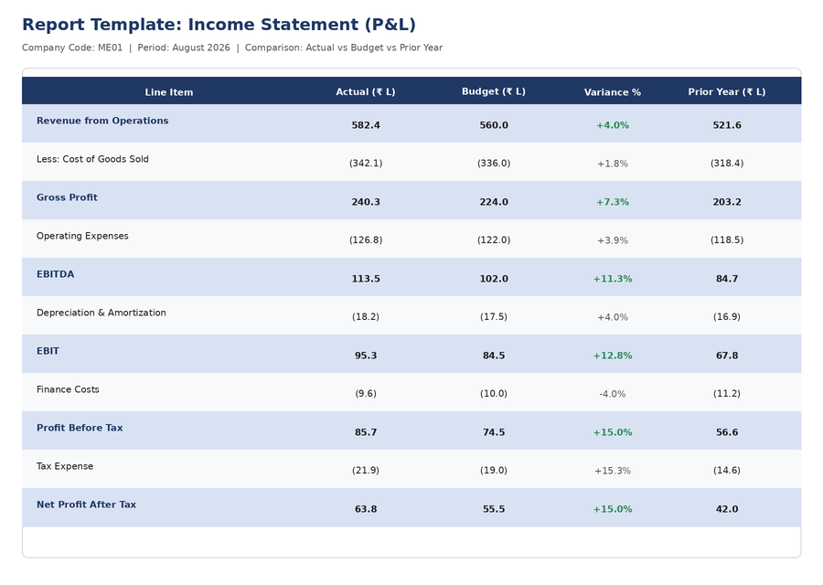
Figure 1: Income Statement report template — Actual vs Budget vs Prior Year with variance highlighting.

4.2 Balance Sheet
The Balance Sheet report presents assets, liabilities, and equity as of period-end, structured per Schedule III of the Companies Act (for statutory alignment) with an internal management view grouped by liquidity.
- Data source: SAP FI General Ledger, balance-carried-forward accounts, Asset Accounting (for fixed asset schedules).
- Refresh frequency: Finalized at month-end close; a preliminary "flash" version available two working days before final close.
- Key supporting schedules: Fixed asset movement schedule, inventory ageing, debtor/creditor ageing (linked to AR/AP sub-ledgers).

4.3 Cash Flow Statement
The Cash Flow Statement is produced using the indirect method, reconciling net profit to operating cash flow, and is supplemented by a forward-looking 13-week rolling cash forecast for treasury decision-making (distinct from the statutory, backward-looking cash flow statement).
- Data source: SAP FI Bank Accounting, AR/AP open items, and a treasury forecasting model layered on top of SAP data.
- Refresh frequency: Statutory cash flow statement monthly; rolling forecast dashboard updated daily.
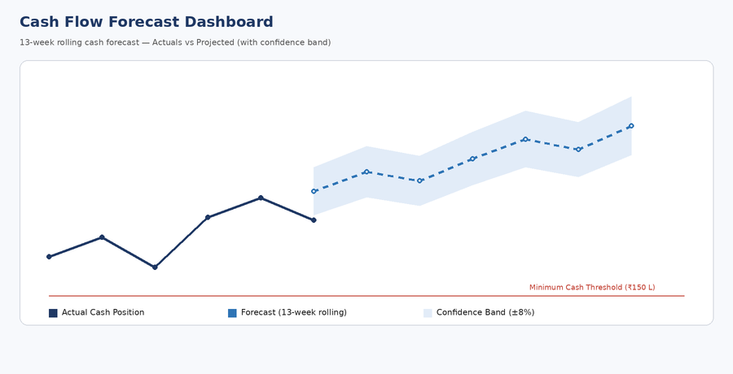
Figure 2: Cash Flow Forecast dashboard — actuals plus a 13-week rolling forecast with a confidence band and minimum cash threshold indicator.

4.4 Cost Center and Profitability Reports
Cost center reports present actual-vs-budget spend by cost center and cost element, supporting plant controllers in managing departmental budgets. Profitability reports (from COPA) present margin by product, customer, and channel, supporting commercial decision-making.
- Cost center variance report: actual vs budget vs prior period, with automatic flagging of variances beyond a configurable threshold (e.g., ±10%).
- Profitability report (COPA): contribution margin by product line and customer segment, refreshed weekly.
- Internal order report: capex and project spend vs budget, with committed (purchase order) vs actual spend shown separately.

5. Dashboard Design and Mock-ups
Dashboards translate the underlying reports into a visual, exception-driven format so that users can identify what needs attention without reading every line of a report. Three dashboards are specified below, each with an illustrative mock-up.

5.1 Executive Financial Dashboard
Audience: CFO and finance leadership. Purpose: a single-screen view of overall financial health, refreshed daily, combining headline KPIs, a revenue trend, cost composition, cost center variance exceptions, and receivables ageing.
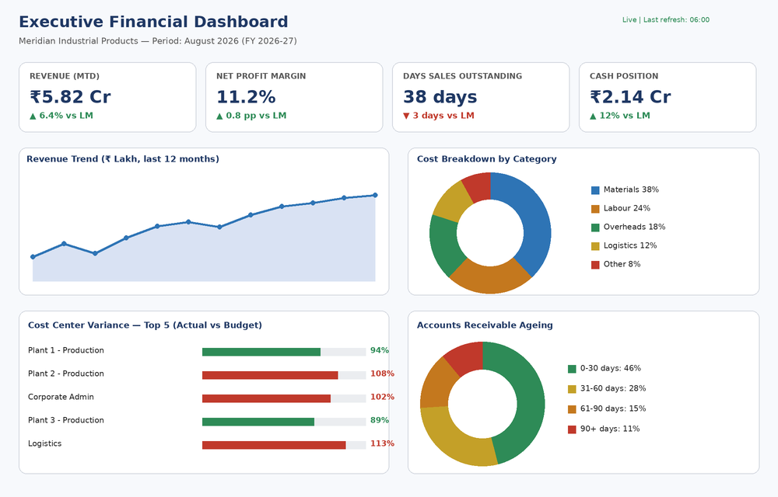
Figure 3: Executive Financial Dashboard mock-up — KPI summary cards, revenue trend, cost breakdown, cost center variance, and AR ageing in a single view.
- Tool: SAP Fiori Overview Page / embedded analytics tile framework on S/4HANA, optionally SAP Analytics Cloud for a richer front end.
- Interactivity: KPI cards and chart segments are clickable, drilling into the underlying report (e.g., clicking a cost center variance bar opens the cost center line-item report).

5.2 Cash Flow Forecast Dashboard
Audience: Treasury manager and CFO. Purpose: visualize actual cash position against a rolling forecast, with a confidence band reflecting forecast uncertainty and a visual minimum-cash-threshold indicator to flag potential funding gaps early.
- Data source: actuals from SAP FI Bank Accounting; forecast generated using a rolling average / trend-based model over historical inflows and outflows (see Section 7).
- Alerting: automatic notification to the treasury manager if the forecast line is projected to cross the minimum cash threshold within the 13-week window.

5.3 Monthly KPI Scorecard
Audience: Plant controllers and finance leadership. Purpose: a compact, gauge-based scorecard showing performance against target for the KPIs that matter most operationally, updated monthly at period close.
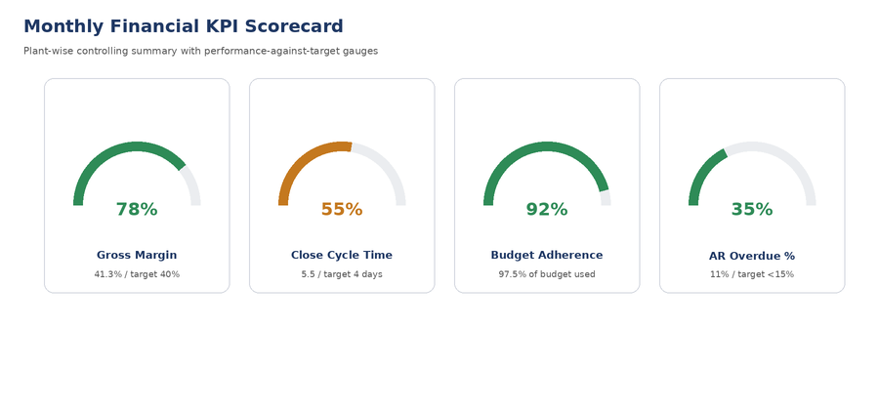
Figure 4: Monthly Financial KPI Scorecard mock-up — gauge visualization of performance against target for four core KPIs.
- Gauge color coding: green (on/above target), amber (within 10% of target), red (more than 10% off target) — consistent across all dashboards for immediate recognition.

6. Financial KPIs and Decision-Making Indicators
KPIs are grouped into four categories aligned to the decisions they support: profitability, liquidity, efficiency, and control. Each KPI has an owner, a target, and a defined calculation to avoid ambiguity or inconsistent reporting across teams.
KPI | Category | Calculation | Target
Gross Margin % | Profitability | (Revenue - COGS) / Revenue | 40%
EBITDA Margin % | Profitability | EBITDA / Revenue | 18%
Days Sales Outstanding (DSO) | Liquidity | (Accounts Receivable / Revenue) x Days in Period | < 35 days
Days Payable Outstanding (DPO) | Liquidity | (Accounts Payable / COGS) x Days in Period | 40-45 days
Cash Conversion Cycle | Liquidity | DSO + Days Inventory Outstanding - DPO | < 45 days
Financial Close Cycle Time | Efficiency | Working days from period-end to finalized close | 4 days
Budget Adherence % | Control | Actual Spend / Budgeted Spend, by cost center | 95-105%
Cost Center Variance % | Control | (Actual - Budget) / Budget, flagged if beyond threshold | Within ±10%
AR Overdue % (90+ days) | Control | Overdue receivables (90+ days) / Total receivables | < 15%
Working Capital Ratio | Liquidity | Current Assets / Current Liabilities | 1.5 - 2.0

7. Analytics Framework
The analytics framework is built in three progressive layers, reflecting a common maturity model (descriptive, diagnostic, predictive) so that the organization can adopt more advanced analytics incrementally rather than requiring a big-bang investment.

7.1 Layer 1 — Descriptive Analytics (Foundation)
- Standard SAP reports and dashboards presenting what happened: actual vs budget vs prior year, as documented in Sections 4-5.
- Delivered via SAP embedded analytics and Fiori apps directly on the S/4HANA system, avoiding a separate data replication layer for this initial phase.

7.2 Layer 2 — Diagnostic Analytics
- Variance drill-down and root-cause views: cost center variance reports that let a controller drill from a variance percentage down to the individual posting causing it.
- Cohort and trend comparisons: e.g., comparing this month's customer payment behavior against the same customer's 6-month trend to identify emerging credit risk.

7.3 Layer 3 — Predictive Analytics (Phase 2 roadmap)
- 13-week rolling cash flow forecasting using a trend/weighted-average model over historical AR collections and AP disbursements (implemented as the initial predictive use case, shown in Figure 2).
- Cost trend projection: extrapolating cost center spend trajectories to flag cost centers likely to breach their annual budget before year-end.
- Future roadmap (beyond this phase): SAP Analytics Cloud predictive scenarios / smart predict for more sophisticated forecasting (e.g., machine-learning-based demand-driven working capital forecasting), contingent on licensing SAP Analytics Cloud.
The predictive layer intentionally starts with transparent, explainable statistical methods (rolling averages, trend lines, confidence bands) rather than opaque machine-learning models, so that finance users can trust and validate forecasts before more advanced techniques are introduced.

8. Data Visualization Techniques
Visualization choices are matched to the type of insight each report needs to convey, rather than defaulting to a single chart type for everything.
Visualization | Best Used For | Example in This Plan
KPI Summary Cards | A small number of headline metrics with trend direction, scanned in seconds | Executive dashboard revenue, margin, DSO, cash position cards
Line / Area Chart | Trends over time, especially with an actual-vs-forecast split | Revenue trend; cash flow forecast with confidence band
Donut / Pie Chart | Composition of a whole (cost breakdown, ageing buckets) — used sparingly, capped at 5-6 segments for readability | Cost breakdown by category; AR ageing buckets
Horizontal Bar (variance) | Comparing actual to a target/budget across several categories at once | Cost center variance (actual vs budget, colour-coded by over/under)
Gauge / Radial Progress | Single-metric performance against a target, ideal for scorecards | Monthly KPI scorecard (gross margin, close cycle time, budget adherence, AR overdue%)
Tabular Report with Conditional Formatting | Detailed, auditable figures where every number matters (statutory reports) | Income statement, balance sheet templates
Waterfall Chart | Explaining the bridge between two totals (e.g., budget to actual profit) | Recommended addition for board-level profit bridge reporting
Design principles applied consistently across all dashboards: a single accent color palette (navy/blue for actuals, green/amber/red for performance status), no more than 5-6 categories per chart, and every chart is drillable to its underlying transactional detail so a visual is never a dead end.

9. Underlying Data Architecture (SAP BW/4HANA & Reporting Tools)
For this implementation phase, reporting is delivered primarily through SAP's embedded analytics capability directly on S/4HANA (using the universal journal / ACDOCA table), avoiding the complexity of a separate data warehouse for the initial go-live. This keeps reports real-time and avoids data latency and reconciliation issues between a warehouse and the source system.
- Reporting layer: SAP Fiori analytical apps and CDS (Core Data Services) views built on top of ACDOCA and CO tables.
- Ad hoc analysis: SAP Analysis for Office (Excel add-in) for finance users who need to build custom pivot-style reports without IT involvement.
- Future scalability: SAP BW/4HANA or SAP Datasphere is recommended once reporting scope expands beyond FI/CO to include MM, SD, and PP data blended together, or when multi-year historical trend analysis volume makes embedded analytics performance-intensive.
- External-facing reports (auditor packs, board packs): scheduled export to PDF/Excel via SAP background jobs, distributed through the report distribution mechanism in Section 10.

10. Report Distribution and Access Control
Access to financial reports and dashboards is governed by the same role-based authorization concept defined in the Week 2 security design, extended here with report-specific considerations.
- Dashboards and reports are assigned to Fiori launchpad groups by role (CFO, plant controller, treasury, sales leadership), so each user sees only the tiles relevant to their function.
- Sensitive company-wide profitability and margin data is restricted to finance leadership roles; plant controllers see their own plant's data only, enforced via cost center/profit center authorization restrictions.
- Scheduled report distribution (e.g., the monthly board pack) is automated and sent only to a named distribution list, with PDF outputs watermarked and access-logged.
- All report access is logged for audit purposes, consistent with the audit trail requirements defined in Week 2.

11. Feedback Loop and Continuous Improvement
Reports and dashboards are treated as living tools rather than one-time deliverables. A structured feedback process ensures they continue to reflect actual business decision-making needs as the organization and its reporting maturity evolve.
- Quarterly dashboard review session with representative users from each stakeholder group (Section 3) to gather feedback on usefulness, missing metrics, and confusing visualizations.
- Usage analytics: track which dashboards and reports are actually opened and how often (available via Fiori launchpad analytics), deprecating low-usage reports and investing further in high-usage ones.
- A lightweight change request process for report/dashboard modifications, routed through the finance systems team, with minor changes turned around within one sprint (2 weeks) and major changes scoped and prioritized quarterly.
- Post-go-live, a 90-day hypercare feedback log specifically for reporting issues (broken drill-downs, incorrect account mappings, missing comparison periods) separate from the general hypercare log.
- Annual reassessment of the KPI framework (Section 6) alongside the annual budget cycle, ensuring targets stay realistic and metrics stay aligned to current strategic priorities.

12. Anticipated Outcomes
Outcome | Current State | Expected State Post-Implementation
Time to produce monthly board pack | 5-7 working days | 1-2 working days (automated PDF export)
Visibility into cash position | Weekly, manually compiled | Daily, automated dashboard
Cost center variance detection | Discovered at month-end, reactively | Flagged automatically when variance exceeds threshold
Customer profitability visibility | Not available (no COPA today) | Weekly profitability report by product/customer
Ability to forecast cash shortfalls | Not available | 13-week rolling forecast with early warning alerts

13. Conclusion
This reporting and analytics plan defines what Meridian Industrial Products' finance function will be able to see, and how quickly, once the SAP FICO implementation goes live: standardized statutory reports, exception-driven dashboards for daily management, a KPI framework tied directly to decisions, and an initial predictive analytics capability for cash flow forecasting. It builds on the enterprise structure and configuration established in Weeks 1 and 2, and is designed to be extended — both in report scope and in analytics sophistication — as the organization's reporting maturity grows.
The next step is to validate the report specifications and dashboard mock-ups in this document with the stakeholder groups identified in Section 3, incorporate their feedback, and hand the finalized specifications to the technical team for build during the Realization phase.

