SAP FICO SYSTEM CONFIGURATION
AND INTEGRATION DESIGN
Configuration & Integration Design Document
Prepared for: Meridian Industrial Products Pvt. Ltd. (fictional mid-sized manufacturing company)
Scope: SAP FI/CO Configuration, Cross-Module Integration (SD, MM, PP, HCM), Security & Compliance

Table of Contents
1. Executive Summary
2. Introduction and Document Purpose
3. Enterprise Structure Configuration
4. Financial Accounting (FI) Configuration
4.1 General Ledger Accounting
4.2 Accounts Payable
4.3 Accounts Receivable
4.4 Asset Accounting
4.5 Bank Accounting
5. Controlling (CO) Configuration
6. Integration Design
6.1 Integration Landscape Overview
6.2 FI-MM Integration (Procure-to-Pay)
6.3 FI-SD Integration (Order-to-Cash)
6.4 CO Internal Cost Flow
6.5 FI-HCM Integration
6.6 Data Exchange Mechanisms
7. Customization Considerations
8. Security and Compliance
9. Testing and Validation Approach
10. Risk Mitigation Strategies
11. Conclusion

1. Executive Summary
This document defines the configuration plan and integration design for the SAP FICO implementation at Meridian Industrial Products Pvt. Ltd., building on the project plan approved in Week 1. It translates the agreed scope — SAP FI (General Ledger, Accounts Payable, Accounts Receivable, Asset Accounting, Bank Accounting) and SAP CO (Cost Center Accounting, Internal Orders, Profit Center Accounting, COPA) — into a concrete, step-by-step configuration blueprint, together with a design for how FI/CO will integrate with Sales & Distribution (SD), Materials Management (MM), Production Planning (PP), and Human Capital Management (HCM).
The document covers four areas: (1) configuration mapping for each FI/CO sub-module, including organizational structure and key customizing transactions; (2) integration design showing data flow between FICO and adjacent modules, including the data exchange mechanisms (IDoc, BAPI, ALE, batch interfaces) used at each touchpoint; (3) security and compliance considerations, covering authorization concepts, segregation of duties, and audit trail requirements; and (4) risk mitigation strategies specific to configuration and integration activities.
Four data-flow diagrams are included to visually illustrate the overall integration landscape, the procure-to-pay flow (MM to FI), the order-to-cash flow (SD to FI), and the internal cost flow within CO. This document is intended to guide the Realization phase configuration work and to serve as a reference for functional consultants, technical/Basis teams, and auditors.

2. Introduction and Document Purpose
Following the approval of the project plan in Week 1, this document moves from "what will be delivered and when" to "how the system will actually be configured." It is written for both functional and technical audiences: functional consultants will use it to guide customizing (SPRO) activities, while technical and security teams will use the integration and security sections to design interfaces and authorization roles.
The configuration approach follows SAP best-practice "fit-to-standard" principles established in Week 1 — standard SAP configuration is used wherever it satisfies the business requirement, with customization reserved for genuine gaps identified during the fit-to-standard workshops.

3. Enterprise Structure Configuration
The enterprise structure is the foundation on which all FI and CO configuration is built. It must be finalized before any sub-module configuration begins, since organizational units (company code, controlling area, plant) are referenced throughout FI and CO customizing.
Organizational Unit | Configuration Decision | Transaction / Path
Company Code | One company code (ME01) representing the legal entity; three plants assigned as MM/PP organizational units under it | OX02
Chart of Accounts | Single operating chart of accounts (YCOA) shared across the company code, aligned to statutory reporting requirements | OB13
Controlling Area | One controlling area (ME01), cross-company-code control disabled (single company code in scope) | OX06
Fiscal Year Variant | April-March fiscal year (V3), aligned to Indian statutory year-end | OB29
Credit Control Area | Single credit control area at company code level for AR credit management | OB45
Business Areas | Not used; Profit Center Accounting used instead for segment reporting (simpler, avoids dual-maintenance) | OX03 (n/a)
Segment | Segments defined per plant for IFRS/segment reporting alignment | SPRO > Enterprise Structure

4. Financial Accounting (FI) Configuration

4.1 General Ledger Accounting
The General Ledger is configured using the New GL functionality with document splitting activated, enabling zero-balancing by profit center and segment for each posting — a prerequisite for accurate profit center and segment-level balance sheets.
- Define chart of accounts (YCOA) and assign to company code ME01.
- Define account groups (e.g., current assets, fixed assets, liabilities, revenue, expense) with number ranges.
- Activate New GL and configure document splitting characteristics: Profit Center and Segment as zero-balance fields.
- Define retained earnings account and assign to the P&L statement account type.
- Configure fiscal year variant and posting period variant; open/close posting periods by account type.
- Define field status groups and field status variant to control mandatory/optional/suppressed fields per GL account.
- Configure tolerance groups for GL account postings and employees.
- Define number ranges for GL document types (SA, DZ, KZ, etc.).

4.2 Accounts Payable
- Define vendor account groups (domestic, import, one-time vendor) with number ranges.
- Configure vendor master data field status and screen layout per account group.
- Define payment terms (ZTERM) and cash discount configuration.
- Configure automatic payment program (F110): paying company codes, payment methods (cheque, NEFT/RTGS, wire), house banks.
- Set up withholding tax (TDS) configuration: withholding tax types, codes, and rates per statutory requirement.
- Define account determination for GR/IR clearing account via OBYC (transaction key WRX).
- Configure vendor down payment and special GL indicators.

4.3 Accounts Receivable
- Define customer account groups and number ranges, aligned to SD sales areas.
- Configure dunning procedures (dunning levels, interest calculation, dunning letters).
- Set up credit management: credit control area, risk categories, credit limit checks integrated with SD.
- Configure incoming payment processing: lockbox/bank statement auto-matching rules, payment advice processing.
- Define revenue account determination (VKOA) linking SD condition types to FI GL accounts.
- Configure customer down payments and special GL indicators for advances.

4.4 Asset Accounting
- Define chart of depreciation and assign to company code.
- Configure asset classes (land, buildings, plant & machinery, vehicles, IT equipment) with account determination.
- Define depreciation areas: book depreciation (as per Companies Act) and tax depreciation (as per Income Tax Act) in parallel.
- Configure depreciation keys and useful life defaults per asset class.
- Set up integration with GL for asset acquisition, depreciation run (AFAB), and retirement postings.
- Configure asset under construction (AuC) handling with settlement to final asset classes.

4.5 Bank Accounting
- Define house banks and bank accounts per legal entity/plant requiring local banking.
- Configure Electronic Bank Statement (EBS) processing: posting rules, transaction types, algorithm assignment.
- Set up check management (check lots, void reasons) for cheque-based payments.
- Configure bank guarantee tracking for vendor advances and customer LC monitoring.
- Integrate with corporate banking channel (H2H connectivity) for statement import (MT940 format) and payment file export.

5. Controlling (CO) Configuration
Controlling configuration establishes the internal management-accounting structures used for cost tracking, allocation, and profitability reporting. It is configured after the FI enterprise structure so that CO objects can correctly derive company code and chart-of-accounts context.
- Maintain controlling area (ME01) and assign company code; activate cost center accounting, internal orders, and profitability analysis components.
- Define cost element categories and create primary cost elements in sync with GL expense accounts (automatic creation via OKB2/batch).
- Define secondary cost elements for internal allocations (assessment, distribution, settlement).
- Design and build the cost center hierarchy: standard hierarchy with cost center groups per plant, department, and function.
- Configure cost center categories (production, service, administration) with default account assignment logic.
- Define internal order types for capex projects, maintenance orders, and marketing spend; configure settlement profiles and settlement rules.
- Configure Profit Center Accounting: derive profit centers from cost centers/materials; define the profit center standard hierarchy.
- Set up assessment and distribution cycles for periodic allocation of service cost centers to production cost centers.
- Configure the Operating Concern and COPA characteristics/value fields (costing-based COPA) for product and customer profitability.
- Define planning layouts for cost center and internal order budgeting, with variance reporting against actuals.
Deliverable: A configured controlling area with a validated cost flow from primary postings through cost centers/internal orders into profitability analysis, ready for unit testing.

6. Integration Design
SAP FI/CO does not operate in isolation — the majority of its postings originate automatically from transactions executed in logistics and HR modules. This section documents the integration landscape and the specific data flows and mechanisms used between FI/CO and each adjacent module.

6.1 Integration Landscape Overview
The diagram below summarizes all major integration points in scope for this implementation, along with the primary data exchange mechanism used for each.
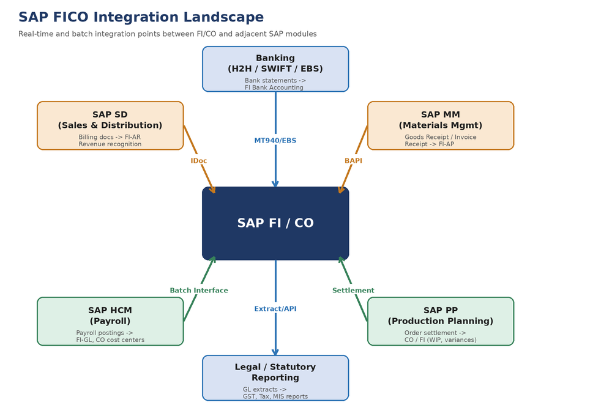
Figure 1: SAP FICO Integration Landscape — FI/CO as the financial hub receiving postings from SD, MM, PP, HCM, Banking, and feeding statutory/legal reporting.

6.2 FI-MM Integration (Procure-to-Pay)
Materials Management drives the majority of Accounts Payable postings. When goods are received against a purchase order, SAP automatically posts a GR/IR (Goods Receipt / Invoice Receipt) clearing entry in FI, based on account determination configured in transaction OBYC. When the vendor invoice is verified (MIRO), the system performs a three-way match (PO, GR, invoice) and clears the GR/IR account, posting the final liability to Accounts Payable.
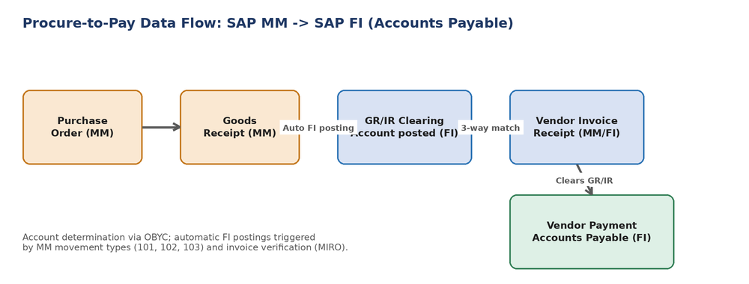
Figure 2: Procure-to-Pay data flow from SAP MM into SAP FI Accounts Payable.
- Trigger events: Goods Receipt (movement types 101/102/103), Invoice Verification (MIRO), Payment Run (F110).
- Account determination: OBYC transaction keys (BSX for stock, WRX for GR/IR clearing, PRD for price differences).
- Mechanism: Real-time synchronous update within the same SAP instance (no external interface required, as MM and FI reside on the same S/4HANA system).

6.3 FI-SD Integration (Order-to-Cash)
Sales & Distribution drives Accounts Receivable postings. When a billing document is released to accounting, SAP automatically creates the customer receivable entry and the corresponding revenue posting, using account determination configured in transaction VKOA (condition technique mapping SD condition types to GL accounts).
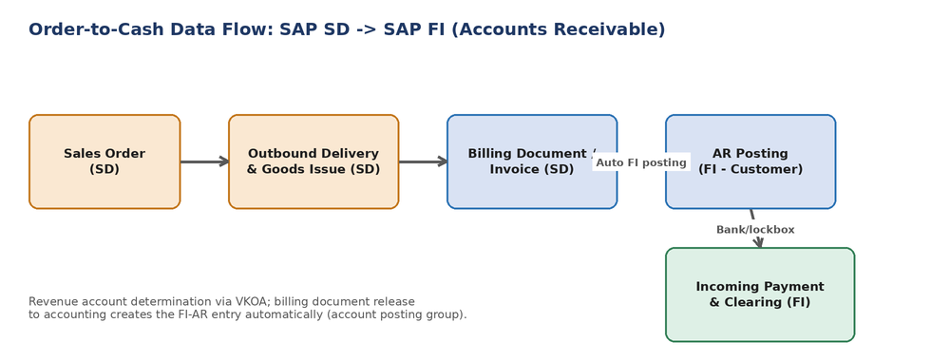
Figure 3: Order-to-Cash data flow from SAP SD into SAP FI Accounts Receivable.
- Trigger events: Goods Issue (delivery), Billing Document creation (VF01), Incoming Payment processing.
- Account determination: VKOA (revenue account determination) and OVFY (reconciliation account per customer).
- Credit management: real-time credit limit check against SAP FI credit exposure before sales order confirmation.

6.4 CO Internal Cost Flow
Within Controlling, primary costs posted in FI flow into cost centers and internal orders, which are then allocated via assessment/distribution cycles and settlement, ultimately feeding Profitability Analysis (COPA) for management reporting.
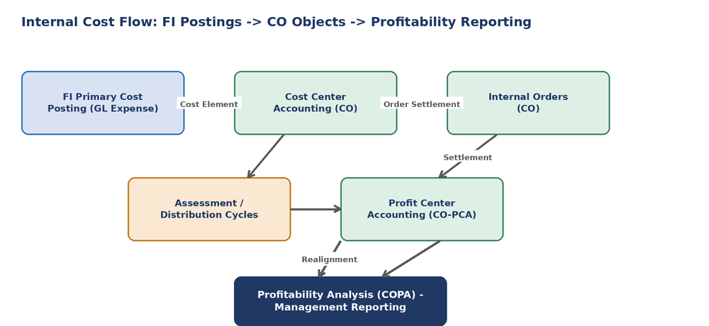
Figure 4: Internal cost flow from FI primary postings through CO cost objects into profitability reporting.
- Primary cost postings: automatic, real-time, driven by GL account posting with cost center/order as a mandatory account assignment.
- Periodic allocations: assessment and distribution cycles executed monthly during period-end close.
- Settlement: internal orders settled to cost centers, assets (AuC), or profitability segments at period end or project completion.

6.5 FI-HCM Integration
Where payroll is processed in SAP HCM (or an external payroll system), payroll results are posted to FI and CO via a payroll posting run, creating expense postings against cost centers derived from the employee's organizational assignment. For this implementation, payroll is processed in a third-party payroll system and integrated via a monthly batch interface.
- Mechanism: Flat-file batch interface (CSV/IDoc) loaded via a custom program into FI using the standard posting interface (BAPI_ACC_DOCUMENT_POST).
- Frequency: Monthly, aligned to the payroll run calendar, with a reconciliation report comparing payroll system totals to FI postings.
- Control: A dedicated suspense/clearing account is used to detect posting mismatches before period-end close.

6.6 Data Exchange Mechanisms Summary
Integration Point | Mechanism | Frequency | Direction
MM -> FI (GR/IR, AP) | Real-time (same system, internal posting) | Real-time | MM -> FI
SD -> FI (Billing, AR) | Real-time (same system, internal posting) | Real-time | SD -> FI
Bank -> FI (Statements) | MT940 file via H2H connectivity / Electronic Bank Statement | Daily | Bank -> FI
FI -> Bank (Payments) | Payment file export (NEFT/RTGS/cheque) via F110 | As per payment run schedule | FI -> Bank
Payroll -> FI/CO | Batch interface (flat file / IDoc) via BAPI posting | Monthly | Payroll -> FI
PP -> CO (Order settlement) | Real-time (same system, internal settlement) | Period-end / real-time | PP -> CO
FI -> Statutory Reporting | GL extract / API to compliance reporting tool | Monthly / on-demand | FI -> External

7. Customization Considerations
The guiding principle is fit-to-standard: customization is used only where standard SAP configuration genuinely cannot meet a validated business requirement. Each customization request identified during Week 1/2 workshops is logged with a business justification and reviewed by the Change Control Board before development.
Gap Identified | Standard SAP Option Evaluated | Customization Decision
Multi-level TDS calculation for composite vendor invoices | Standard withholding tax types support this; no gap | No customization required — standard config
Plant-wise cost center auto-derivation on internal orders | Standard order type + validation/substitution rules (OKC9) | Configuration only — validation/substitution rule, no ABAP
Custom vendor advance ageing report by plant | Standard AP ageing report lacks plant-level advance breakdown | Custom report (Z-report) using SAP Query / ABAP List Viewer
Automated 3-way match exception alerting to procurement team | Standard MM exception list exists but no auto-email | BAdI/User Exit + workflow to trigger email notification
Legacy asset data migration with non-standard depreciation history | LSMW/Migration Cockpit supports standard fields only | Custom migration program (BAPI_FIXEDASSET_OVRTAKE_CREATE wrapper)
All custom developments (Z-programs, BAdIs, user exits) will be documented in a technical specification, peer-reviewed, and subject to unit and regression testing before transport to the QA client.

8. Security and Compliance

8.1 Authorization Concept
Access is governed by a role-based authorization concept built on SAP's standard authorization object model (transaction PFCG), designed around segregation of duties (SoD) principles.
- Roles are defined by job function (AP clerk, AR clerk, cost accountant, plant controller, finance manager, treasury), not by individual user.
- Composite roles combine single roles for users spanning multiple functions, avoiding direct authorization assignment to end users.
- Critical authorization objects restricted: F_BKPF_BUK (company code posting), F_BKPF_BES (posting period), F_KNA1_BUK (customer master), F_LFA1_BUK (vendor master).
- Sensitive transactions (F110 payment run, FB50 GL posting, OB52 period control) restricted to named roles with additional approval workflow.

8.2 Segregation of Duties (SoD)
SoD conflicts are identified and mitigated to reduce fraud risk, particularly around the procure-to-pay and record-to-report cycles.
Conflict | Risk | Mitigation
Vendor master maintenance + Payment run execution | Fraudulent vendor creation and self-payment | Split across two roles; vendor master changes require dual approval (maker-checker)
GL journal posting + Journal approval | Unauthorized or erroneous postings going unchecked | Workflow-based approval for postings above a defined threshold
Goods receipt posting + Invoice verification | Fictitious goods receipt to enable invoice payment | Enforced 3-way match; GR and MIRO restricted to different roles
Asset master creation + Asset retirement/scrapping | Asset misappropriation concealment | Asset changes logged and reviewed monthly by internal audit

8.3 Data Integrity and Audit Trail
- Document change history (CDHDR/CDPOS) retained for all FI/CO master and transaction data changes.
- Field status configuration prevents deletion of postings; corrections are made through reversal documents only, preserving the audit trail.
- Period-end lock (posting period variant) prevents postings to closed periods except by authorized period-end users.
- Table logging enabled for sensitive customizing tables in the production client.

8.4 Compliance Considerations
- Statutory reporting configuration validated against GST, Income Tax, and Companies Act requirements before go-live.
- Data retention and archiving policy defined in line with statutory record-keeping requirements (typically 8 years for financial records in India).
- System access reviews conducted quarterly; dormant user IDs deactivated per the access review policy.
- Encryption in transit (TLS) enforced for all interfaces (banking, payroll); sensitive fields (bank account numbers) masked in non-production clients.

9. Testing and Validation Approach
Each configuration item documented in Sections 4-6 is validated through a structured testing approach before being promoted from the development client to QA and, ultimately, production.
- Unit testing: each configuration item (e.g., a single cost center, a payment method) is tested in isolation immediately after configuration.
- Integration testing: cross-module scenarios (procure-to-pay, order-to-cash, payroll posting) tested end-to-end in the QA client.
- Data migration mock loads: master data (GL accounts, cost centers, vendor/customer, assets) loaded and reconciled against source extracts.
- User Acceptance Testing (UAT): business process owners execute real-world scenarios using test scripts derived from the fit-to-standard workshops.
- Security/SoD testing: authorization roles tested against the SoD matrix using SAP GRC Access Control (or manual SoD review if GRC is not licensed).
All test cases, expected results, and actual results are logged in a test management tool (or a structured spreadsheet where a dedicated tool is unavailable), with formal sign-off required at each stage gate.

10. Risk Mitigation Strategies
The risks below are specific to configuration and integration activities and supplement the project-level risk register established in Week 1.
Risk | Impact | Mitigation Strategy
Incorrect account determination (OBYC/VKOA) causing misposted transactions | High | Peer review of all account determination configuration; dedicated test scenarios covering every transaction type before UAT.
Integration interface failure (bank statement or payroll file) going undetected | High | Automated interface monitoring with failure alerts; daily reconciliation report comparing interface totals to control accounts.
SoD conflicts introduced through role design | Medium | SoD matrix review before role transport; periodic access review post go-live.
Custom development (BAdI/Z-program) introducing defects | Medium | Mandatory code review and regression testing for all custom objects before transport to QA.
Enterprise structure design flaw discovered late (e.g., missing segment) | High | Enterprise structure formally signed off by Finance leadership before sub-module configuration begins.
Configuration not aligned with statutory requirements (GST/TDS) | High | Tax/compliance SME validation checkpoint built into Phase 3 before UAT sign-off.

11. Conclusion
This configuration and integration design document translates the Week 1 project plan into an actionable blueprint for the Realization phase. It defines the enterprise structure, the detailed configuration steps for each FI and CO sub-module, the integration design connecting FI/CO to SD, MM, PP, and HCM, and the security, compliance, and testing disciplines required to deliver a controlled, audit-ready system.
With this design approved, the implementation team can proceed to execute configuration in the development client, beginning with the enterprise structure and General Ledger, followed by the dependent AP, AR, Asset Accounting, and Controlling sub-modules, in line with the sequencing defined in the Week 1 execution phase plan.

