**SRS : Travel Advisor System**

EKTA BHORANIYA - 201501402

PRITHVI PATEL - 201501230

***FACT FINDING TECHNIQUES***

The input and output of the three fact finding techniques used are documented along with thefact finding chart, final list of requirements and target user group.

1. **Background Reading:**

* **Existing Websites or similar online portals:**
* <https://www.tripadvisor.in/>

The site was referred to observe the existing travel advisor web application available.

The idea of comparing the best deals of different booking engines was adopted from here.

Also, many filter options were observed from here.

It just suggest the tourist attractions of a destination. It gave the basic idea of what features and functionalities to expect from the existing site.

* <https://www.makemytrip.com/>

This is a booking engine. Even though booking engine is not being made in our software, it was used to refer to the different types of packages and the filter options.

It doesn't have the feature to give the best options available to tourist to wander to the nearby places the way different bloggers provide. It doesn't plan a trip for such purpose.

It also provided the aspect where user can build a package without even logging in

* **Research Papers**
* URL : <https://www.hindawi.com/journals/cin/2016/1291358/>
  + Title: A Collaborative Location Based Travel Recommendation System through Enhanced Rating Prediction for the Group of Users
  + Authors: Logesh Ravi and Subramaniyaswamy Vairavasundaram

Helped in knowing the model of travel recommendation system

Which are important features: how the filters must be, what are the currently available different websites and how they limit what they suggest.

What different travel advisor systems provide as their facilities

* URL: [http://ieeexplore.ieee.org/document/6765488/](http://ieeexplore.ieee.org/document/6765488/?reload=true)
  + Title: A study for task based recommendation system for travel navigation
  + Authors: J[ason C. Hun](http://ieeexplore.ieee.org/search/searchresult.jsp?searchWithin=%22Authors%22:.QT.Jason%20C.%20Hung.QT.&newsearch=true)g, [Victoria Hsu](http://ieeexplore.ieee.org/search/searchresult.jsp?searchWithin=%22Authors%22:.QT.Victoria%20Hsu.QT.&newsearch=true) , [Martin M. Weng](http://ieeexplore.ieee.org/search/searchresult.jsp?searchWithin=%22Authors%22:.QT.Martin%20M.%20Weng.QT.&newsearch=true)

The idea of navigation based suggestions was adopted.

It was based on the concept of having a human portfolio from which the interests of the user are matched and accordingly the recommendations are shown.

Many specifications related to that model were provided but only the idea was adopted.

1. **Interviews:**

As the system is to be made for the users, and they are the ones whose satisfaction is the prime objective to be achieved, audience needs to interviewed. Interviews were conducted for two types of people, one who had used the system previously and the ones who do not rely on such online travel advisor systems.

1. Interview Plan and Summary for first interview, where the interviewees do not use any online Travel Advisor system

**Travel Advisor: Interview Plan**

**System**: Travel Advisor

**Participants**: Shivangi Kashyap

Drashti Lukhi

Ekta Bhoraniya

Prithvi Patel

**Date:** 27/1/2018 **Time:** 10pm

**Duration:** 25 minutes **Place:** J112, HOR Women, DAIICT

**Purpose of Interview:**

To know the alternatives to the online system, how it is trustworthy and what are general problems faced while using the traditional conventional way.

**Agenda:**

The method by which the trips are planned and what are the purposes of such trips

Reasons for not using the online travel advisor/ booking sites

The factors which help deciding which places to visit or not

**Summary:**

The procedure without online travel advisor system:

The interviewees travelled with their families, and as the holidays of each and every family member do not coincide, they travel for less than a week and that too without much prior planning. They book their flight/train tickets to that destination and explore the place. Their families and they prefer the local guides, visiting famous places and interact with the tourists there to get reviews about some attractions of that destination. Also, the travel system is available easily to them locally.

Not using any travel agency or online travel advisors:

As the places they visit are mostly known to them , they do not require any other person or third party to help them out who add more cost to their trips. Also, they do not randomly choose places, their choice of destination is heavily weighed upon the reviews of their family friends. Generally they try to know about the place beforehand. Thus, they do not require a system suggesting them the places.

Hotel and transportation booking:

Used the conventional method of booking the hotels. Visiting hotel to hotel and then staying at one. Generally, they know about it via a friend. Sometimes they need to compromise as and when they need to stay at a hotel not meeting their standards. The basic requirements from the hotels is just cleanliness, hot water facility and parking facility. Generally plan trips where they use their own vehicle and also eat at random places. In other situations, they book the train/flight using online system. While booking tickets for travelling to and from hostel to home, they generally book it through the actual website of the airlines to avail student privileges, otherwise they know the rates of the flights and use makemytrip.

The interviewees rely on local tour guides and their prior knowledge to visit different places of attraction. Also, based on the reviews of other tourists who happen to visit the same place, they accordingly plan their next plan of action.

If such service is made then when would they be using it:

Such system would generally be used when they do not have their parents around to rely upon (as parents have methods and resources). They would use it have more information about the places and activities when they plan the trips with their friends as they do not want anything to go wrong.

1. Interview Plan and Summary for the second interview, where the interviewees have used online Travel Advisor system

**Travel Advisor: Interview Plan**

**System**: Travel Advisor

**Participants**: Kishan Thesiya

Savan Makadiya

Ekta Bhoraniya

Prithvi Patel

**Date:** 29/1/2018 **Time:** 7pm

**Duration:** 35 minutes **Place:** CEP, DAIICT

**Purpose of Interview:**

Travel experience with online travel advisor and review of already existing travel advisor system. Problems faced and expectation from the system we are designing.

**Agenda:**

Problems faced in booking

Review of service provided

Services that were necessary and any particular complains

Summary:

1. Booking was easy process where the interviewees had created their accounts and booked the trip. Payment was done offline as there were some extra charges like internet handling fees.
2. For packaged tour, itinerary was given beforehand. So, no need to choose place where to go and no need to worry about hotels and food. Also, all the instructions were provided regarding the whole place and what was to be done.
3. One of the good points was, list of necessary things was also given by organization.
4. Second point is there was plan B ready for sudden climate change.
5. Hotels were little lower than expectations at some places.
6. Trip was for students only, so there were activities and proper planning according to that.
7. Places were of an adventure and trekking type, keeping in mind the young travelers
8. It is expected that you provide photos of hotels and places in both packaged and non packaged tours.
9. Interview Plan and Summary for the second interview, where the interviewees are travel agents.

**Travel Advisor: Interview Plan**

**System**: Travel Advisor

**Participants**: Mr. Hemant Patel, Patel Tours and Travels (+91 8866155888)

Ekta Bhoraniya

Prithvi Patel

**Date:** 19/3/2018 **Time:** 6:30pm

**Duration:** 20 minutes **Place:**

**Purpose of Interview:**

To know about how the travel agencies book different services for their customers.

**Agenda:**

The method by which the trips are planned.

Who are the users.

How do they make/plan the tour packages

**Summary:**

Procedure:

With the existence of Online Booking Systems, they book many tickets using that system and there is some commission that they take from the customer for that. Also, they are able to book and sell the railway tickets offline and online both. They generally book the air tickets online but they take extra charges for that. They have a few rental cars which are used for certain packages. They provide the customer with any type of rental vehicle for travel.

For hotel booking, they book the hotels by first asking the preference of the customer, as hotel booking is the process, which generally many customers complain about. Normally, the hotel they book are the ones they have tie up with. For the local tours and some most visited places

they have made the itineraries. Generally, the customers select from these packaged tours. Some prefer to book a rental vehicle and so they have a driver accompanying them. On further asking, we came to know that the driver generally suggests the customers the places like hotels and restaurants. As the driver knows the tourist spots, the customer prefers to travel using the mode of car rental.

The clients that generally contact are the ones who require vehicle services. Mostly the groups who need a big vehicle (20-30 people), other small groups consult for vehicles and the places they travel are generally anywhere in India. The interviewee added that not always they have all the rental vehicles, so they ask other people in their network to provie the vehicles.

Customer satisfaction is their main motto and they are flexible with whatever demands they have. The wide network that is created by them makes their process easy.

1. **Survey:**

The questionnaire was aimed to be surveyed among at least 150 of the users. Out of which, we received 79 responses. The survey was conducted among the student community of DAIICT and the family of the survey conductors. Also, the questionnaire was conducted using the Google Forms, which helped us do better data analysis.

**Questionnaire:**

1. **Age:**

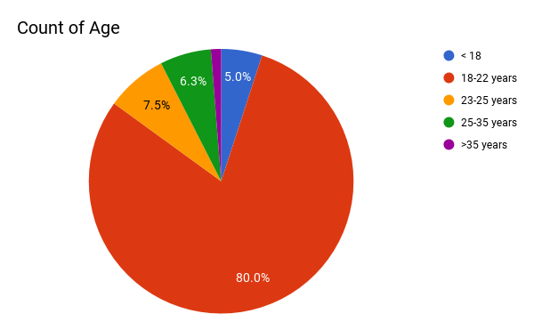

As most of the people surveyed were students of DAIICT, we got the views related to the existing and proposed system from the youths of age group <23 yrs.

1. **How often you go for the trip?**

* More than once in a year / Once every year / Once in 2-3 years

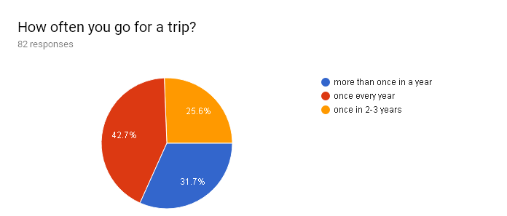

The normal duration for which the target users travel is once in a year. Thus, it can be said that they look for proper rips as they travel the least for holidays. Thus, they expect the most from the booking they make. It is true for the other groups too. Thus, the goal of the system should be to make it more reliable.

1. **Do you prefer to use any online travel advisor to plan any trip( like makemytrip, travelguru, etc ) ?**

* Yes / No / Sometimes

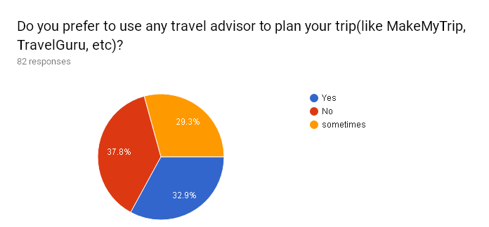

They target users are about 62.2%: the ones who already use existing such systems and the ones who have atleast used them once. Yet the percentage of people preferring to book holidays through travel agencies are more. Thus, the system at least must have the functionalities that prevail today to atleast have 60% users.

1. **What do you prefer, packaged tour or build your own package?**

* Packaged / Build your own package

It is observed from the below chart, that most of the people prefer to build their own packages. Thus, one the functionality of building your own package must be provided very systematically.

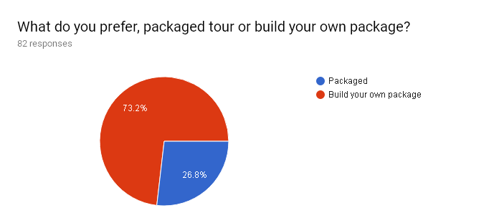

1. **If you are at a place which you are visiting for some other purpose and you have a day to yourself, would you like to plan a proper tour for that day (medium paced tour)?**

* Yes / No / Maybe

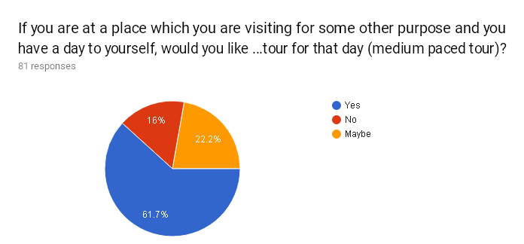

The system needs to have a functionality which suggests them the places nearby the when a user tries to get suggestions for a place. For this, their location will be asked and according to that they will be allowed to plan a one day package of that place, as it is one the desired feature.

1. **With whom you prefer to go?**

* Family / Friends / Alone / Colleagues / others

The most of the trips undertaken by the people is generally a trip with their family or a rip with their friends. As this question allowed to choose many options, the many users also like to plan to go on solo trips. A very few plan tours with their colleagues, thus it can be assumed that they generally will be looking for transportation and hotel booking.

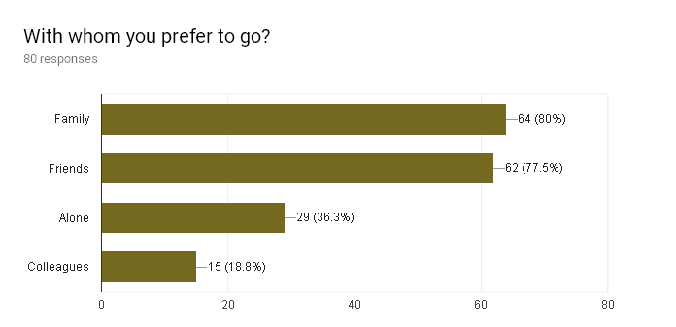

1. **Do you choose places to visit based on users rating and reviews?**

* Yes / No / Maybe

It is a general trend observed among the people, that their travel plans to a place depends on the reviews of that places. Thus, the places suggested must be rated well by the past users who have had visited those places. The confused people would normally read

through the reviews and decide according to other requirements that they desire

. 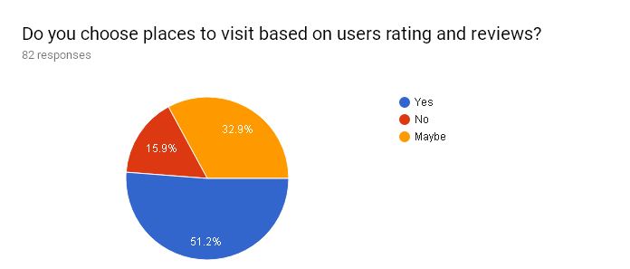

1. **What duration you generally prefer?**

* More than a week / Almost a week / 3-4 days / 0-2 days

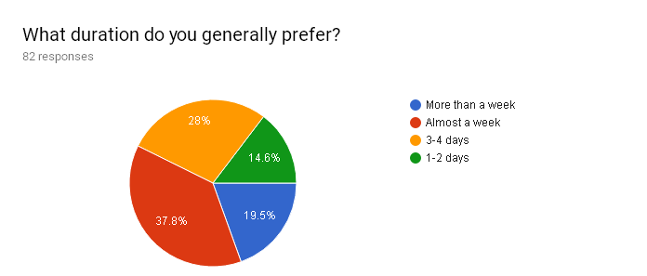

People generally prefer to go for a trip of at most a week. From the chart above, it can be said that according that trend, most of the people prefer their trips for a short duration, which could be public holidays or vacation.

1. **Which traveling mode do you prefer?**

* Flight / Train / Bus / Rental Car

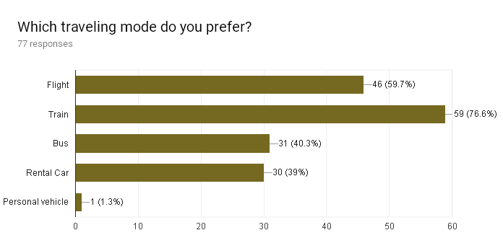

Most of the people plan to commute through trains and planes. Thus, the prices of trains and best deals of flight tickets needs to be suggested.

1. **How would you rate your satisfaction with the money you spent after going to a trip planned and booked by an online travel advisor?**

* Strongly dissatisfied / Dissatisfied / Neutral / Satisfied / Strongly Satisfied

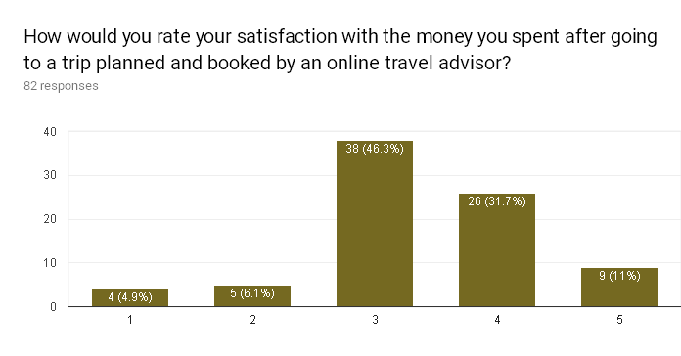

People are not too much satisfied with the online booking sites. Thus, they are not many who use such portals. There are very few who felt satisfied using the online medium.

1. **Based on your past experience, how happy are you with your choice of hotels using online travel advisor ?**

* Strongly disagree / Disagree / Neutral / Agree / Strongly agree

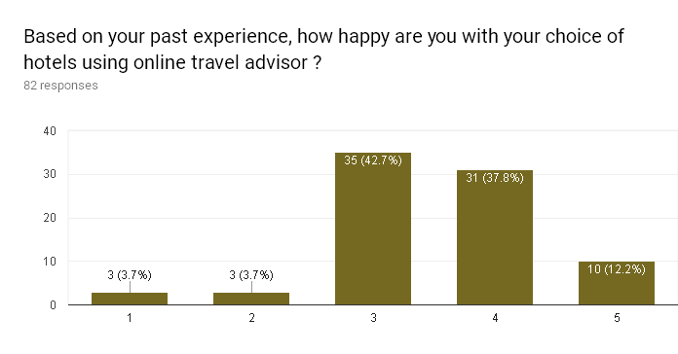

Only very few were not much satisfied with the level of hotels they were suggested, thus the already existing system is not that bad. To get more satisfactory rating, more and more reviewed hotels needs to be suggested. General trend shows that the people agree with their choices.

1. **If we build travel advisor system,what are the some other suggestions you require the system to provide you for better travel experience?**

We conclude some considerable suggestions from all the response. Which are given

below:

* Make user to understand the importance of place by telling some historical facts
* It would be nice if the platform could provide the facility to interact with the people of similar taste
* Cost Optimization system
* Pictures & description of the place, weather charts, best travel time, etc
* Real time GPS based suggestions
* Should be able to suggest plan according to travelling delays
* Make sure that long journey has enough stops to get relaxed

1. **Problems you faced while using any already existing travel advisor**

Here are some general problems faced by users:

* Many complained about the hotels and tourist places not matching the expectations and the photos shown.
* A direct point of contact with the hotel manager was required
* Lack of true information
* Fake photographs
* Facing network problems while accessing the websites
* Hectic schedule in packaged tours

**Fact Finding Chart:**

|  |  |  |  |
| --- | --- | --- | --- |
| **Objective** | **Technique** | **Subject(s)** | **Time Commitment** |
| Get background on the existing online travel advisor system | Background Reading | Online existing websites, research papers | 8-10 hours |
| To know the alternatives which they trust upon while travelling | Interview | 2 Subjects not using existing online system | 25 minutes |
| To know about how the existing System has been used and how does travel agents book using their network and tie ups | Interview | Travel Agent | 20 minutes |
| To know about the whole procedure, how much time consuming it is, and what were the problems faced. | Interview | 2 Existing Users | 35 minutes |
| To get to know what are general preferences of potential users, their expectations and reasons of dissatisfaction with existing system | Survey | Students of DAIICT, family and friends outside the campus | 3-4 days |

On the basis of the above given fact finding techniques, the following are the potential users and the requirements which the system needs to have.

**Users:**

The categories of the users as can be observed from the survey are:

Based on the facilities to be provided the users are categorized as:

* General/System User (Visitor):
  + Get suggestions of packaged tours and that too group tours that are available on different sites for a particular type of the tour.
  + Has the option of building a package
  + Has the option to get the best deal for booking a flight/ train ticket.
  + Has the option to get best deals for booking hotels.
  + Has the option to read reviews, and look at ratings and explore different places that the tourism database has to provide.
* Potential User:
  + All the above facilities are available to this category of the users.
  + They are the registered users who login to have different privileges.
  + Have the privilege to write a review, post a picture, rate a review/place/ deal.
  + Have the privilege to get location based suggestion for a small trip at a place.
  + According to the location based final map gets suggested the transportation options available to the user(s).

**Requirements:**

Based on the survey conducted and our observations the following are the requirements:

1. Provide information of location of the places (city,state, etc)
2. On the basis of location, suggest places of tourist attractions. Help them plan the tour for a day based on the place they are at.
3. Provide them with the deals on flights, prices of train tickets and per/km rate of private tourist vehicles to compare from.
4. Provide information of transportations available to the places to potential users.
5. Provide information of when to visit place, whether information, some pictures of the place, etc.
6. If historical place, brief description of history and some pictures of the place need to be collected.
7. To suggest how much time generally visitors spend at the particular place selected by user
8. Suggest the already present packages first.
9. Suggest best deals for different hotels and the competitive prices from different booking sites.
10. Package customization based on budget and best deals available on the booking sites for transportation and hotel bookings
11. Suggest places fit for family trips and friends trips first and then provide specific filters
12. Again filtering the places according to the activities that can be performed there : adventurous, city tour, historical exploration, scenic places.
13. All the deals provided would be filtered from the source sites based on the ratings provided by reviewers.