**SoftUni OOP Game Contest**

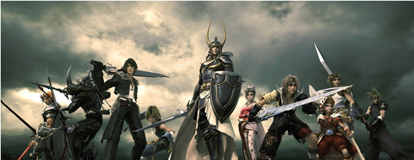

SoftUni is organizing a contest for the best **role playing game** from the OOP teamwork   
projects. The winnig teams will receive a **grand prize**!  
The game shoud be:

* First Bulleted Item.