Trade data sources overview

Eduard Bukin

21 September, 2017

Table of Contents

To download entire report in a file, select the format: PDF Report or Word report.

# Trade classifications

## Harmonized System - HS

Officially, World Customs Organisation (WCO) is responsible for maintenance of the HS classification up to 6 digits. Any extension of the HS classifications beyond 6 digits - so called Tariff - line classification is developed by each country individually.

* [non WCO HS classification search tool](https://www.foreign-trade.com/reference/hscode.htm)
* [another non WCO HS search tool](http://www.findhs.codes/)
* [HS 2017 - definitions and descriptions](http://www.wcoomd.org/en/topics/nomenclature/instrument-and-tools/hs-nomenclature-2017-edition.aspx)
* [Previous HS classifications](http://www.wcoomd.org/en/topics/nomenclature/instrument-and-tools/hs_nomenclature_previous_editions.aspx)

## UN SITC and BEC classifications

United Nations Statistics Division is responsible for maintenance of several classification systems for trade and products. Among them there are Central Product Classification (CPC), Standard International Trade Classification (SITC), Classification by Broad Economic Categories (BEC) and International Standard Industrial Classification of All Economic Activities (ISIC).

* [UN SITC Rev. 3 Detailed structure and explanatory notes](https://unstats.un.org/unsd/cr/registry/regcst.asp?Cl=14)
* [List of all UN classifications](https://unstats.un.org/unsd/cr/registry/regct.asp?Lg=1)
* [UN Correspondancy tables between HS, SITC and BEC](https://unstats.un.org/unsd/trade/classifications/correspondence-tables.asp)
* [Methodology for mapping classifications](https://unstats.un.org/unsd/trade/classifications/corr-notes/HS2017%20conversion%20to%20earlier%20HS%20versions%20and%20other%20classifications.pdf)

## FAO Commodity List

Withing the FAOSTAT FAO uses own system for classifying all commodities. It is called FAO Commodities List (FCL).

* [Overview of all FCL codes](http://www.fao.org/economic/ess/ess-standards/commodity/en/).

# UN Comtrade data

Comtrade is a UN based comprehensive trade data collection and dissemination platform maintained and owned by The United Nations Statistics Division (UNSD). From the FAO building, everyone has full access to all Comtrade services. All information is available on the Comtrade website <https://comtrade.un.org/>.

In Comtrade there are few main options of data access:

* Regular download - manually insert a query in the browser and get a table in the browser or download a .csv file with selected data;
* Bulk download - manually insert short query on a web page, or use the browser command line (address line in the browser) to pass arguments to the server. In return, user will download a zip archive with data that covers trade of selected country (or all countries) in one time period (year or month) and specified coding system (HS as reported, HS2007, HS2012, etc.). Bulk download has an option to download data of all reporters for one period/coding system in file;
* Official and not official data visualization solutions.

## Data availability in Comtrade

To save time before starting analysis, it is always good to know data availability in Comtrade. There are two interfaces for data availability analysis:

* New trade availability visualization tool <https://comtrade.un.org/data/da>, where it is possible to explore one country availability or download (clicking Download button) an extensive .csv file with information about all available data.
* Old outdated interface for data availability per country, commodity, year and other parameters is available at <https://comtrade.un.org/db/mr/daReportersResults.aspx>.

It is also possible to access data availability for the Bulk download. This data is available at the address line call: <http://comtrade.un.org/api//refs/da/view?parameters>. More information [here](https://comtrade.un.org/data/Doc/API#DataAvailabilityRequests).

## Regular download in Comtrade

**Source**

Regular downloads is available here: <https://comtrade.un.org/data/>. This is a query based approach to load Comtrade data selecting a specific range of parameters. With the regular download is it possible to obtain a CSV file, which can be analyzes in excel, R, Stata and other tools.

**How to access data**

For an extensive overview, see the tutorial video below (<https://www.youtube.com/watch?v=oflKZUj2BgE>).

The most common query that will return data that we need in 90% of our analysis is the following:

* Type of product: Goods;
* Frequency: Annual;
* HS: As reported (Most frequently used because it combines all codes that were ever recorded);
* Period: 2014-2016 (Limited up to 5 in regular download);
* Reporter: All, or anything needed;
* Partners: World, or anything needed;
* Trade flow: Import and Export (select Import and Export instead of all to not receive data about re-export and re-import);
* HS (as reported) commodity codes: Total, any 2, 4 and 6 digits code (11, 1101, 110100).

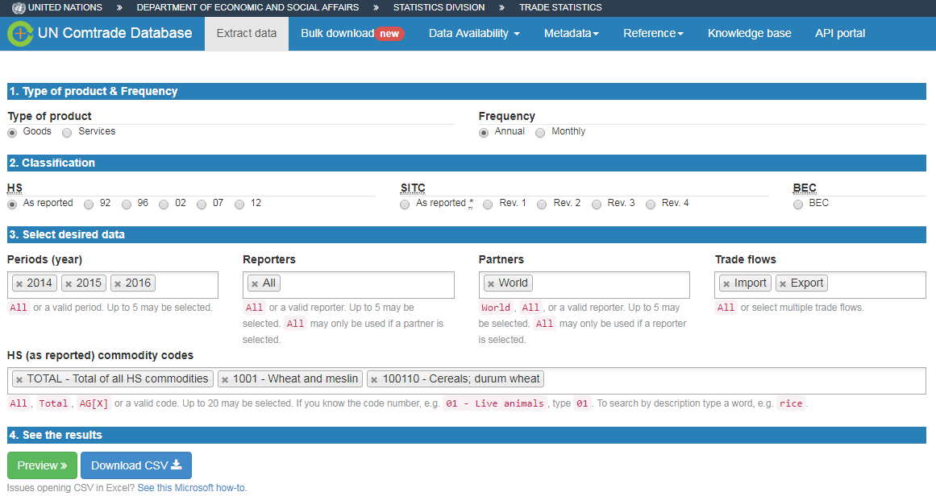

**Data response**

Normally, data is returned in the long format with the variables describing main data dimensions selected above and variables with Trade quantities, Trade value, and units of measurement.

## Bulk download in Comtrade

Comtrade bulk download is available at the web page <https://comtrade.un.org/data/bulk>.

There are two options how to access bulk data in Comtrade:

* Web based query in the browser. Link: <https://comtrade.un.org/data/bulk>;
* API call based approach to load Comtrade data. Link: <https://comtrade.un.org/data/doc/api/bulk/>.

### Web based bulk query

**Source**

Web based query for accessing Comtrade bulk data in the browser is available here: <https://comtrade.un.org/data/bulk>.

First time you need to access it from the FAO buildings in order to authorize your email. Insert your email in the "Enter your email" field and press "Authenticate my IP". After that your email will be saved in the Comtrade database and you will be grated with the access to the bulk download interface (same address <https://comtrade.un.org/data/bulk>).

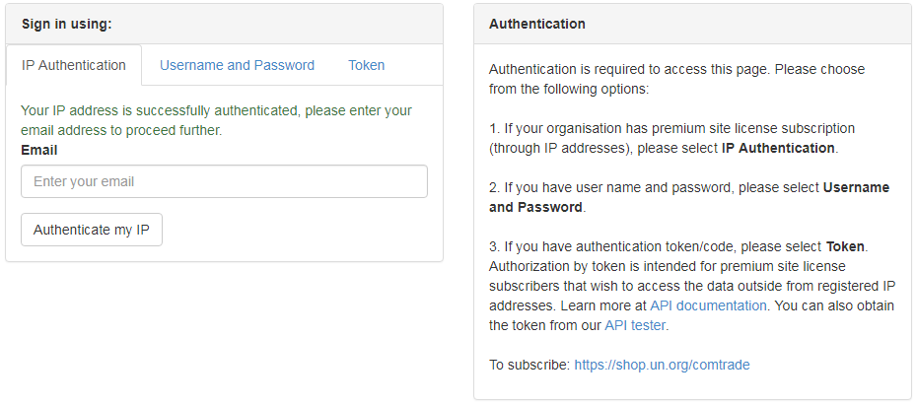

**How to access data**

In order to access Comtrade bulk data on the bulk data access page select required set of parameters. For example, to download bulk commodity statistics for France, select:

* Type of product: Goods;
* Frequency: Annual;
* HS: As reported;
* Period: All;
* Reporter: France (or All - all reporters in one file or any single reporter that you needed);
* Publication data: keep unchanged.

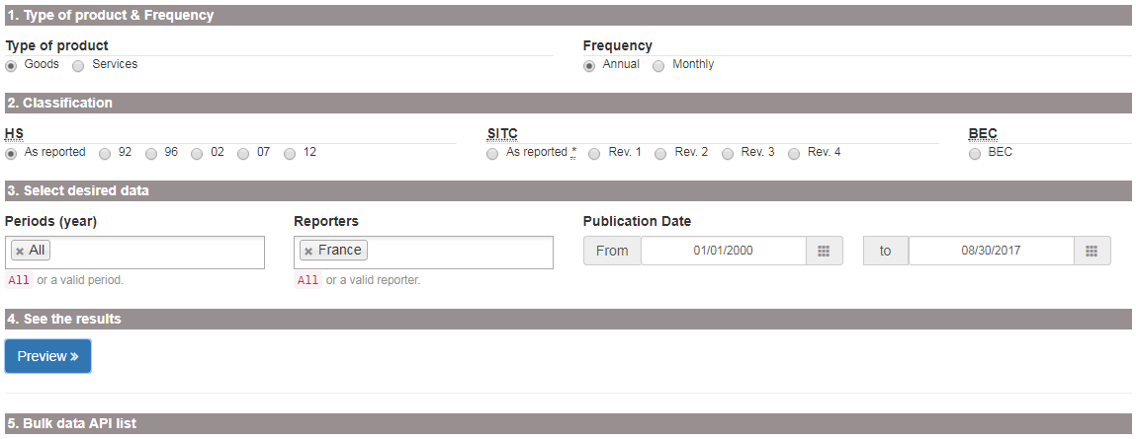

After clicking "Preview" yo will be returned with the list of all bulk data files available for your selection. Clicking on any of them will run the file, clicking on "Show API link" will provide you with the API data request command (see the next subsection) for returning a bulk data file. Be aware that any bulk data file could range in size from 1 to 500 megabyte.

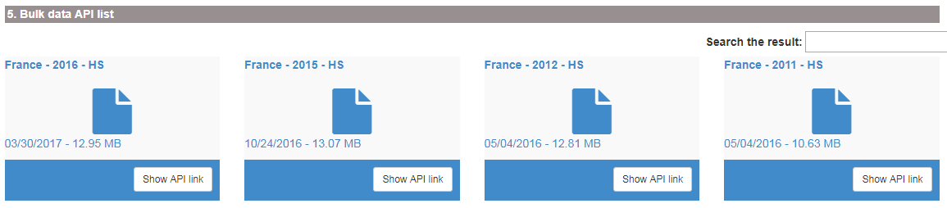

**Data response**

Your browser will download one zip archive with data for a selected country (all countries), period and classification.

**Attention!** Data files could be very. In zipped format file size may range from 1 to 500 megabyte. Un extracted format, file size could be up to 9 gigabytes.

### API bulk query

**Source**

If you do not want to click in the browser, you can use the API for accessing Comtrade data. Extensive explanation about the Comtrade API tools is available here <https://comtrade.un.org/data/doc/api/bulk/>.

**How to access data**

To access Comtrade bulk data with API, we need to construct a request, insert it to the browser command line and run it.

To request a bulk data file we need to use the specific format explained [here](https://comtrade.un.org/data/doc/api/bulk/#DataRequestsDwn). The main idea is to construct a request based on the template http://comtrade.un.org/api/get/bulk/{type}/{freq}/{ps}/{r}/{px}?{token=} specifying correct [parameters](https://comtrade.un.org/data/doc/api/bulk/#DataRequests):

* type - trade type C - Commodities of S - Services;
* freq - frequency A - Annual or M - Monthly;
* ps - period coverage for annual data ps=YYYY - e.g. ps=2010, for monthly ps=YYYY or ps=YYYYMM;
* r - reporter area code - e.g. r=804 or r=All. Extensive list available [here](https://comtrade.un.org/data/cache/reporterAreas.json);
* px - classification, available values are: HS - Harmonized System (HS) as reported, H0-HS 1992, H1-HS 1996, H2-HS 2002, H3-HS 2007, H4-HS 2012 and others [see](https://comtrade.un.org/data/doc/api/bulk/);
* token - optional parameter for data from outside of the authorized network.

For example, we want to request monthly data freq=M of commodities trade type=C for All reporters r=ALL for period January, 2017 ps=201701, in the HS as reporter classification px=HS. The request is <http://comtrade.un.org/api/get/bulk/C/M/201701/ALL/HS>. We insert this request to the browser adders line and download the file.



**Data response**

Your browser will download one zip archive with data for a selected country (all countries), period and classification.

**Attention!** Data files could be very. In zipped format file size may range from 1 to 500 megabyte. Un extracted format, file size could be up to 9 gigabytes.

### Token for data access

To generate an authentication token for the UN Comtrade from the registered IP range (i.e. from the FAO headquarters), we first need to go to the UN Comtrade [authentication page](https://comtrade.un.org/data/auth/login?ReturnUrl=%2Fdata%2Fbulk) and insert our email into the Sign in using: > IP Authentication: field. Pressing Authenticate my IP will ensure we are registered in the UN Comtrade system. Please note, you need to do this only once.

Subsequently we need to go to [comtradePlus.API](https://comtrade.un.org/api/swagger/ui/index#/)and select /getSubUserToken in the Auth section . After inserting the email, which you used to register above, into the corresponding field, press "try it out":

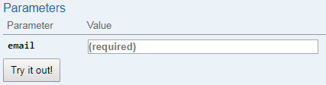

In Response Headers the token will appear as a long string of symbols and characters. This token is to be copied to a secure place and used to access data in some programming cases or in the World Bank WITS database.

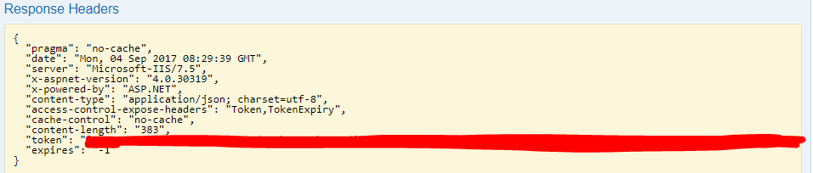

## Data visualization options

UN Comtrade lists several visualization platforms on the page <https://comtrade.un.org/labs/>. Here, we will discuss some of them in more details.

### Comtrade data-explorer

Comtrade data explorer <https://comtrade.un.org/labs/data-explorer/> (unfortunately was not working on 2017-08-31). A tool for visualization of the main trade flows between selected reporters and partners of the selected commodity. Here, you will find a .pdf guidelines on [how to use](https://comtrade.un.org/labs/data-explorer/UserGuide%20UN%20Comtrade%20Analytics.pdf) Comtrade data-explorer.

**Limitations:**

* Commodities are not defined using the HS commodity codes, but as a free text, therefor, it is difficult to understand the meaning behind some commodity names.
* Options of custom-defined aggregates of countries or commodities are not available.

### Bilateral trade exploration tool

BIS trade in goods tool is available at <https://comtrade.un.org/labs/BIS-trade-in-goods/> it allow to visualize trade of a selected good from a selected reporter to all or selected partner.

**Limitations:**

* Commodity coverage is limited to the 2 digits HS commodity description;
* Options of custom-defined aggregates of countries or commodities are not available.

## General Comtrade related information

Official introduction in how to use Comtrade <https://unstats.un.org/unsd/tradekb/Knowledgebase/50049/How-to-use-UN-Comtrade>.

Official "What is Comtrade" page <https://unstats.un.org/unsd/tradekb/Knowledgebase/What-is-UN-Comtrade>.

Old Comtrade data access interface <https://comtrade.un.org/db/default.aspx>.

### Metadata and documentation

Generally, all information related to Comtrade metadata is organised here: <https://unstats.un.org/unsd/tradekb/Knowledgebase/>.

If you are looking for the country specific data publication notes, they are available at <https://comtrade.un.org/db/mr/daPubNoteDetail.aspx> with more information [here](https://unstats.un.org/unsd/tradekb/Knowledgebase/50127/Introduction-of-Publication-Notes-?Keywords=notes). API interface for accessing publication notes is explained [here](https://unstats.un.org/unsd/tradekb/Knowledgebase/50118/Publication-Notes-Via-Web-Service?Keywords=notes) and [here](https://unstats.un.org/unsd/tradekb/Knowledgebase/50117/Explanatory-Notes-Via-Web-Service?Keywords=notes).

### Commodity mapping tables

Mapping tables for conversion between different coding systems (HS 2012 to HS 2002 or SITC) are here: <https://unstats.un.org/unsd/trade/classifications/correspondence-tables.asp>.Please note, that conversions are only available from the most recent coding system to the older version because most of the new coding systems are dis-aggregating previously existing ones.

Detailed information on the statistical classification of the commodities could be found here <https://unstats.un.org/unsd/class/default.asp>.

To convert between the FAOSTAT commodities and HS/SICT classification, see official FAOSTAT conversion tables <http://www.fao.org/economic/ess/ess-standards/commodity/en/> or contact ESS division.

### Country classification

Please note Comtrade, FAOSTAT and UNSD all have different country classification. Although, all of them might be similar, there are some peculiarities in classifying some European countries as well as politically sensitive countries. Clear data classification tables are available at <https://comtrade.un.org/db/mr/rfReportersList.aspx> and <http://www.fao.org/faostat/en/#definitions>.

# World Bank data

World Bank offers great variety of databases on the subject of trade, agriculture and many others. The full list is available [here](https://data.worldbank.org/data-catalog/?tab=topics). We will discuss some selected data sources in more details below. In particular, we will focus on:

* World Integrated Trade Solution (WITS)
* **TCdata360**
* Miscellaneous data sources

## WITS

**Source**

World Integrated Trade Solution is located here: <http://wits.worldbank.org/>. However, this is the guest users interface with the access to simple summary data. If you need to access full capabilities of WITS database, you need to log-in [here](https://wits.worldbank.org/WITS/WITS/Restricted/Login.aspx) (see more details below).

WITS database is a website, that uses trade and tariff data from various sources (UN Comtrade, WTO, World Bank) in order to provide users with the interface for generating own trade statistics and indicators. WITS application also provides tools to perform single and multi-market tariff cut simulations. Extensive description of the methodology, used by WITS is located here: <http://wits.worldbank.org/methodology.html>.

WITS provides multiple ways to access trade, tariff and non-tariff data. It has the following main sections.

* TradeStats: Summary trade, tariff, non-tariffs and development indicators;
* Analytical Databases: Databases derived using official trade data sources;
* Global Preferential Trade Access Database (GPTAD): Search across different preferential trade agreements.

For more information, see this introductory [overview video](http://wits.worldbank.org/videos/tradestatshome.html).

**How to access data**

WITS is a complex tool, however it has a very good set of [learning materials](http://wits.worldbank.org/training.html#). If you have time, you can take an [eLearning course](http://wits.worldbank.org/WITS/Training/player.html), otherwise, it is possible to follow [video tutorials from WITS](http://wits.worldbank.org/trainingVideos.aspx?lang=en).

**Registration and login**

In order to use full capabilities of the WITS database all users need to log-in. The log in page is located [here](https://wits.worldbank.org/WITS/WITS/Restricted/Login.aspx). You can access this page from the main [WITS website](http://wits.worldbank.org), by clicking first 'Register' in the top right corner . Follow all registration instructions. People with the FAO email are allowed to register in WITS and use all available capacities of the database. After you have finished your registration, click 'log in' in the same top-right corner of the [WITS website](http://wits.worldbank.org), enter your email and password and you will log into the WITS database:

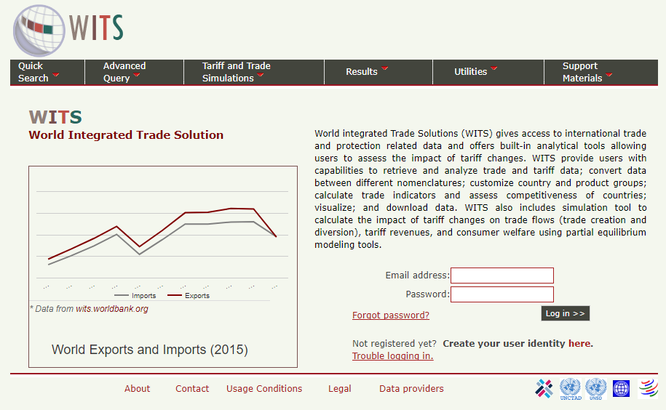

**Other important informatoin**

When the user are logged into WITS, the website offer a greater range of documentation and metadata. In particular:

* WITS data availability report can be explored and generated [here](http://wits.worldbank.org/WITS/WITS/Support%20Materials/ComtradeCatalog.aspx?Page=DataCatalog), it is only possible after log in;
* Reference tables for converting countries, commodities and classifications are [here](http://wits.worldbank.org/referencedata.html);
* Detailed product nomenclature is [here](http://wits.worldbank.org/WITS/WITS/Support%20Materials/CMTNomenclatureandConcordancesList.aspx?Page=ProductNomenclatureandConcordances);
* Comprehensive WITS guide is [here](http://wits.worldbank.org/WITS/WITS/WITSHELP/WITSHelp.htm);
* WITS has a developed API interface for direct data access from a programming environment. More information is available [here](http://wits.worldbank.org/witsapiintro.aspx). Here is the [WITS-API USER GUIDE](http://wits.worldbank.org/data/public/WITSAPI_UserGuide.pdf).

### WITS Trade data

There are two main types of trade data in WITS, (1) UN Comtrade up to 6 digits oh HS classification trade data and (2) UN Comtrade Tariff-line data. To access UN Comtrade data we only need to log in to WITS with our user name (email) and password. However, if we want to extract bulk Comtrade data, we may need to provide our Comtrade data access token (see more details below).

#### Advance query for trade data access

The main tool of generating user-defined trade data reports from the UN Comtrade data in WITS is in using the [Home > Advanced Query > Trade Data (UN Comtrade)](http://wits.worldbank.org/WITS/WITS/AdvanceQuery/RawTradeData/QueryDefinition.aspx?Page=RawTradeData). Here you can select any reporters, partners, commodities, periods, and classification systems in order to generate desirable table with the trade data.

**Important** to note. At this step our queries are limited to the maximum of 100 000 rows. In order to be able to download more than 100 000 rows, you either need to log in from the FAO network, or provide a UN Comtrade token to the WITS database by clicking "click here to activate" on the page [Home > Advanced Query > Trade Data (UN Comtrade)](http://wits.worldbank.org/WITS/WITS/AdvanceQuery/RawTradeData/QueryDefinition.aspx?Page=RawTradeData) and follow the instructions:

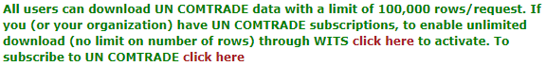

A comprehensive instruction on how to use advanced queries is provided in the WITS [tutorial video](http://wits.worldbank.org/videos/advanced-query.html).

**IMPORTANT about ommodity classfication** Selecting the commodity classification is always tricky, when you want to construct a consistent time series they covers multiple years (5 and more)? you may find that more modern HS classifications will not be available in the past. For tackle this problem you need to switch to the old HS classification, such as HS 2002 or even HS 1992. Be ready, that the coding system in the old HS classifications may differ significant. To overcome this problem, check the [WITS mapping tables](http://wits.worldbank.org/WITS/WITS/Support%20Materials/CMTNomenclatureandConcordancesList.aspx?Page=ProductNomenclatureandConcordances) or [tables of concordance](http://wits.worldbank.org/product_concordance.html).

#### User defined groups of commodities and countries

Tutorial video Highlights both options for user defined grouping of data. The best description of how to create and use the user-defined country and commodity groups is described in the WITS e-learning [here](http://wits.worldbank.org/WITS/Training/player.html) in the sections 20 and 21. Please check them for the guided instructions.

The lists of standard - predefined commodities and country groups are here: <http://wits.worldbank.org/referencedata.html> in the sections Products and Countries.

#### Tariff-line and bulk Comtrade data

WITS offers a user friendly interface for accessing [Tariff-line data (link to the interface)](http://wits.worldbank.org/WITS/WITS/QuickQuery/Trade-ViewAndExportRawData/ViewAndExportRawData.aspx?Page=TradeViewAndExportRawData) and [bulk Comtrade data (link to the interface)](http://wits.worldbank.org/WITS/WITS/AdvanceQuery/BulkExport/BulkExportQueryDefination.aspx?Page=BulkExport). Practically, this interface repeats the one available in the Comtrade. To learn more about how to use it, see:

* [Tariff-line tutorial video](http://wits.worldbank.org/videos/trade%20-%20view-and-export-tariff-line-imports.html);
* [WITS bulk donwload tutorial video](http://wits.worldbank.org/videos/bulk-download-un-comtrade.html).

### Triffs data

WITS Trade and Tariffs data offers access to the UNCTAD and WTO databases and the tariffs data in particular. It is available on the [Home > Advanced Query >Tariff and Trade Analysis](http://wits.worldbank.org/WITS/WITS/AdvanceQuery/TariffAndTradeAnalysis/AdvancedQueryDefinition.aspx?Page=TariffandTradeAnalysis) page. To get to know how to use this data, see [this tutorial video](http://wits.worldbank.org/videos/tariff-advanced-query.html).

It is also possible to download bulk tariff data from the UNCTAD TRAINS database directly from WITS. You need to follow [Home > Advanced Query >Bulk Download (TRAINS)](http://wits.worldbank.org/WITS/WITS/AdvanceQuery/TRAINSBulkExport/TRAINSBulkExportQueryDefination.aspx?Page=TRAINSBulkExport) to access the download interface. For more information, see [tutorial documentation](http://wits.worldbank.org/data/public/Help_BulkDownload_TRAINS.pdf) and [tutorial video](http://wits.worldbank.org/videos/bulk-download-unctad-trains.html) below:

### Trade indicators

The Trade Outcomes Indicators tool lets you to construct numbers of trade indicators that are classified into four dimensions of trade performance: Orientation and Growth, Export Diversification, Export Sophistication, and Export Survival. All calculations are performed by the WITS, according to the [published methodology](http://wits.worldbank.org/WITS/docs/TradeOutcomes-UserManual.pdf) based on the UN Comtrade data.

To see explicit details on how to use Trade Outcomes Indicators, see [this video](http://wits.worldbank.org/videos/trade-outcomes-indicators.html).

## TCdata360

**Source**

**TC**data**360** provides open data on trade and competitiveness. The site aggregates and visualizes data from multiple sources and presents it in tandem with other knowledge and resources. The website is available at <https://tcdata360.worldbank.org/>. At TCdata360 offers a wide range of user friendly instruments for trade data comparison and analysis'.

See this brief guide video:

**How to access data**

This is a purely analytic tool with very intuitive interface. Unfortunately, there are no guides, which would describe all possibilities of data access options. Some main features are explained here: <https://tcdata360.worldbank.org/faq>.

**Developers options**

There are numerous options of data access for developers and different software, so-called API interface. To see more about it visit <https://tcdata360.worldbank.org/tools>.

## Miscellaneous

### Most recent WB researches on trade

* This is the [website](http://econ.worldbank.org/WBSITE/EXTERNAL/EXTDEC/EXTRESEARCH/EXTPROGRAMS/EXTTRADERESEARCH/0,,menuPK:544860~noSURL:Y~pagePK:64168176~piPK:64168140~theSitePK:544849,00.html) dedicated to the ongoing researches on trade conducted by of the World Bank.
* Comprehensive search over the WB researches [is here](http://documents.worldbank.org/curated/en/docsearch).
* Generic website with the modern interface for searching through the WB researches is [here](https://openknowledge.worldbank.org/browse).

### Temporary Trade Barriers Database

The Temporary Trade Barriers Database (TTBD) contains detailed data on more than thirty different national governmentsâ€™ use of policies such as [antidumping (AD)](http://econ.worldbank.org/ttbd/gad/), global safeguards (SG), China-specific transitional safeguard (CSG) measures, and countervailing duties (CVD).

For more information, see the [Temporary Trade Barriers Database and Global Antidumping Database](http://econ.worldbank.org/WBSITE/EXTERNAL/EXTDEC/EXTRESEARCH/EXTPROGRAMS/EXTTRADERESEARCH/0,,contentMDK:22561572~pagePK:64168182~piPK:64168060~theSitePK:544849,00.html).

### Trade costs database

The Trade Costs database provides estimates of bilateral trade costs in agriculture and manufactured goods for the 1995-2015 period. It is built on trade and production data collected in 178 countries.

The database is available [here](http://databank.worldbank.org/data/reports.aspx?source=escap-world-bank-international-trade-costs).

### Interface to access UNCTAD TRAINS data

The [UNCTAD Trade Analysis Information System (TRAINS)](http://unctad.org/en/Pages/DITC/Trade-Analysis/Non-Tariff-Measures/NTMs-trains.aspx) is a comprehensive computerized information system at the HS-based tariff line level (HS 6-digit). The database provides data on trade control measures, including:

* Tariffs;
* Para-tariffs;
* Non-tariff measures;
* Imports by suppliers at HS 6-digit level.

The interface is available [here](http://databank.worldbank.org/data/reports.aspx?source=UNCTAD-~-Trade-Analysis-Information-System-(TRAINS)).

# World Trade Organization data

The [WTO website](https://www.wto.org/english/tratop_e/tariffs_e/tariff_data_e.htm) offers sophisticated options for researching membersâ€™ customs duty rates and in many cases imports. In particular, there are:

* Tariff Analysis Online tool <http://tao.wto.org/>;
* Tariff Download Facility <http://tariffdata.wto.org/>.
* Regional Trade Agreement Information System (RTA-IS) <http://rtais.wto.org/>;
* Trade data time series <http://stat.wto.org/>;
* Miscellaneous information and overview of the all statistical sources of WTO are here: <https://www.wto.org/english/res_e/statis_e/statis_e.htm>.

Both tools allow assess to the same data about the trade policy, collected by WTO. Below, we will discuss both tools in more details.

## Tariff Analysis Online (TAO)

This facility allows you to access the WTO's Integrated Data Base (IDB) and Consolidated Tariff Schedules (CTS) database on-line, select markets and products, compile reports and download data.

**Source**

The TAO tool, could be accessed here: <http://tao.wto.org/?ui=1>.

**How to access data**

The data could be accessed after registration and log in-in. To register, press Click here to register () on the main page of the TAO website. Use registers log in and password to access the database.

The interface of the database is not very intuitive. To understand how to use it, see the [guidlines and help](http://tao.wto.org/help.aspx).

General procedure of data access are the following:

* Prepare a query either in IDB or in CTS databases ;
* Insert main parameters of the query and save it:

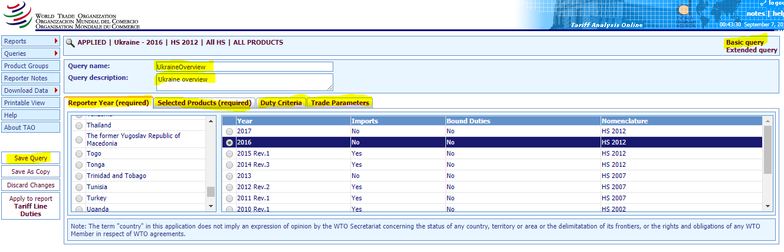

* Click Basic query and select the query you have saved from the Saved Query list.
* Generate the report based on the selected query:

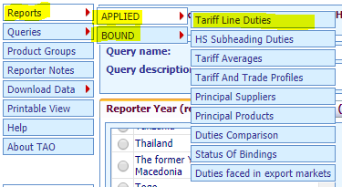

**Data response**

With the present tool, data could be returned as a report in browser or as an exported excel data file. For more information, try to use it, or see the [help](http://tao.wto.org/Help.aspx).

## Tariff Download Facility

**Source**

Tariff Download Facility is located here: <http://tariffdata.wto.org/Default.aspx?culture=en-US>.

**How to access data**

Official guide of how to use the tool is [here](http://tariffdata.wto.org/UserGuide/USERGUIDE_EN.htm)

## Regional Trade Agreement Information System (RTA-IS)

This database contains information on only those agreements that have either been notified, or for which an early announcement has been made, to the WTO.

**Source**

RTA-IS is located here: <http://rtais.wto.org/>

**Data access**

The user interface allows you to access data on RTAs notified to the GATT/WTO in the following way:

* By country/territory;
* By criteria;
* List of all RTAs in force;
* List of early announcements;
* Pre-defined reports and Summary Tables containing WTO Figures on RTAs.

each of the options offers a list of links with more details on each specific agreement.

For more information see the [user guide](http://rtais.wto.org/UserGuide/RTAIS_USER_GUIDE_EN.html).

## WTO measures and notifications

I-TIP Goods provides comprehensive information on non-tariff measures (NTMs) applied by WTO members in merchandise trade. The information includes members' notifications of NTMs as well as information on "specific trade concerns" raised by members at WTO committee meetings. Its aim is to serve the needs of those seeking detailed information on trade policy measures as well as those looking for summary information. It includes links to the WTO's extensive tariff and trade databases, and to DocsOnLine system.

**Source**

The tool is available at <http://i-tip.wto.org/goods/Default.aspx>.

Depends on what you need, select one of GRAPHS over TIME, TABLES by PRODUCTS, TABLES by MEMBERS, or a DETAILED QUERY. See [how to](http://i-tip.wto.org/goods/Forms/HowTo.aspx) for more information.

**Data response**

Data could be downloaded in pdf reports about the notification and measures applied by each country to a specific commodity.

## Trade time series

WTO Statistics Database allows you to retrieve statistical information in the following presentations:

* The Trade Profiles - provide predefined information leaflets on the trade situation of members, observers and other selected economies;
* The Tariff Profiles - provide information on the market access situation of members, observers and other selected economies;
* The Aid for Trade Profiles - provide information on trends of aid for trade, trade costs, trade performance and development for selected Aid for Trade recipients;
* The Time Series section - allows an interactive data retrieval of international trade statistics.

**Sourece**

This data source if available here: <http://stat.wto.org/>

**How to access data**

All data is accessed in the similar way, following intuitive step by step process as on the picture below.

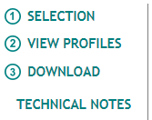

## Miscellaneous information sources

WTO Trade policy Review <https://www.wto.org/english/tratop_e/tpr_e/tpr_e.htm>.

E-ping SPS & TBT notification alert and notification system <http://www.epingalert.org/en>

# International Trade Center data

Trade Map - <http://www.trademap.org/> - provides - in the form of tables, graphs and maps - indicators on export performance, international demand, alternative markets and competitive markets, as well as a directory of importing and exporting companies. Trade Map covers 220 countries and territories and 5300 products of the Harmonized System. The monthly, quarterly and yearly trade flows are available from the most aggregated level to the tariff line level.

**Source**

**How to access data**

**Registration and login**

# CEPII

CEPII is a French research center in international economics which produces studies, research, databases and analyses on the world economy and its evolution. It was founded in 1978 and is part of the network coordinated by the Economic Policy Planning for the Prime Minister. It conducts researches using the databases, models, expertise and international cooperation. CEPII is organized around four research programs. The overview of the CEPII activities is here: <http://www.cepii.fr/CEPII/en/cepii/cepii.asp>. On one of the following links you may find more information about CEPII's [researches](http://www.cepii.fr/CEPII/en/recherche/programmes_scientifiques.asp), [publisations](http://www.cepii.fr/CEPII/en/publications/publicat.asp), [events](http://www.cepii.fr/CEPII/en/evenements/conf.asp) and [data](http://www.cepii.fr/CEPII/en/bdd_modele/bdd_modele.asp).

CEPII gathers and harmonizes data from different sources, produces indicators and statistical measures. Data and figures are available online as well as interactive panorama of 80 countries on [CEPII](http://www.cepii.fr/).

## Relevant data solutions

**HIGHLIGHTS**

* Gravity
* EconMap
* EQCHANGE
* Export Sophistication
* ProdComp
* TradeProd
* Profiles Pays / Country Profiles
* BACI - World trade database
* FDIMap - Foreign Direct Investment database
* RCA - revealed comparative advantage database
* Trade Unit Values (TUV)
* Trade Prices
* World Trade Flows Characterization

**In details**

(Please note, below, we describe only relevant data solutions. In the end we provide information how to access this data)

1. CHELEM - Comptes HarmonisÃ©s sur les Echanges et Lâ€™Economie Mondiale - the CHELEM database [International trade flows, balances of payments and world revenues], developed by the CEPII, has been recognized as one of the most useful tools to analyse global economic trends in a framework combining coherence, exhaustiveness and reliability. Available on line by subscription at: <https://chelem.bvdep.com/>.
2. Geography
   * [GeoDist](http://www.cepii.fr/CEPII/en/bdd_modele/presentation.asp?id=6) provides several geographical variables, in particular bilateral distances measured using city-level data to account for the geographic distribution of population inside each nation. Different measures of bilateral distances are available for 225 countries. For most of them, different calculations of "intra-national distances'' are also available.
   * [Gravity](http://www.cepii.fr/CEPII/en/bdd_modele/presentation.asp?id=8) - CEPII makes available a "square" gravity dataset for all world pairs of countries, for the period 1948 to 2015, allowing the estimation of international flows as a function of GDP, population and trade costs.
   * [Language](http://www.cepii.fr/CEPII/en/bdd_modele/presentation.asp?id=19)
   * Market Potentials - Market Potentials offers six distinct indices of proximity to world markets for more than 150 countries from 1960 to 2009. Since the early 1990sâ€™ international trade analyses has emphasized how proximity to large markets determines economic development and shapes international trade patterns.
3. Macroeconomics
   * [EconMap](http://www.cepii.fr/CEPII/en/bdd_modele/presentation.asp?id=11)
   * [EQCHANGE](http://www.cepii.fr/CEPII/en/bdd_modele/presentation.asp?id=34) - QCHANGE is a global database of annual indicators on effective exchange rates.
   * [Institutional Profiles](http://www.cepii.fr/institutions/EN/ipd.asp) - The "Institutional Profiles Database" (IPD) provides an original measure of countries' institutional characteristics through composite indicators built from perception data. The database was designed in order to facilitate and stimulate research on the relationship between institutions, long-term economic growth and development.
   * [SÃ©ries longues macroÃ©conomiques](http://www.cepii.fr/CEPII/fr/bdd_modele/presentation.asp?id=31)
4. Production & Specialization Indicators
   * [Export Sophistication](http://www.cepii.fr/CEPII/en/bdd_modele/presentation.asp?id=10)
   * [ProdComp](http://www.cepii.fr/CEPII/en/bdd_modele/presentation.asp?id=7) - The ProdComp database allows price and productivity levels to be compared for several countries in the manufacturing sector.
   * [TradeProd](http://www.cepii.fr/CEPII/en/bdd_modele/presentation.asp?id=5) - The TradeProd database proposes bilateral trade, production and protection figures in a compatible industry classification for developed and developing countries.
5. Profiles
   * [Profils Pays / Country Profiles](http://www.cepii.fr/CEPII/en/bdd_modele/presentation.asp?id=30) - Allows to visualise information about countries. so called country profiles. Direct link <http://visualdata.cepii.fr/panorama>.
6. Trade & International Investments
   * [BACI](http://www.cepii.fr/CEPII/en/bdd_modele/presentation.asp?id=1) - BACI is the World trade database developed by the CEPII at a high level of product disaggregation.
   * [FDIMap](http://www.cepii.fr/CEPII/en/bdd_modele/presentation.asp?id=4) - The FDI (Foreign Direct Investment) database provides a worldwide coverage (96 countries of the GTAP 6.2 database for stocks and 70 countries for flows) of harmonized bilateral flows and stocks of FDI for 26 sectors, in line with the Eurostat classification.
   * [Network Trade](http://www.cepii.fr/CEPII/en/bdd_modele/presentation.asp?id=27) - This dataset explores international trade data through the lenses of Network Analysis, in order to visualize the World Trade Network and describe the topology of the network of world trade. The details of such analysis are provided in a companion paper De Benedictis et al (2013).
   * [RCA](http://www.cepii.fr/CEPII/en/bdd_modele/presentation.asp?id=26) - The new RCA database contains revealed comparative advantage measures (RCA) obtained by using the methodology suggested by Costinot et al. (2012) - adjusted to some extend for a proper worldwide comparison of indexes.
   * [Trade Unit Values (TUV)](http://www.cepii.fr/CEPII/en/bdd_modele/presentation.asp?id=2) - The TUV database is a worldwide unit value database developed by the CEPII.
   * [TradePrices](http://www.cepii.fr/CEPII/en/bdd_modele/presentation.asp?id=3) - Export and import price indices can be used to analyse terms of trade, inflation or volume/price elasticities in open economies.
   * [TRADHIST](http://www.cepii.fr/CEPII/en/bdd_modele/presentation.asp?id=32) - This dataset has been built in order to analyze in historical perspective, using gravity equations, the globalization process through bilateral International trade data (see Fouquin and Hugot Working paper nÂ°2016-13, Mai 2016).
   * [World Trade Flows Characterization](http://www.cepii.fr/CEPII/en/bdd_modele/presentation.asp?id=29) - Trade Unit Values, CEPII's database providing a world trade matrix of unit values for more than 230 countries and 5 100 products over the period 2000-2015.
7. Trade Protection
   * [AVEs-Services](http://www.cepii.fr/CEPII/en/bdd_modele/presentation.asp?id=33) - AVE-Services contains ad valorem equivalents of restrictions on cross-border trade in services for 118 countries and 9 sectors, using the GTAP databaseof trade in services for 2011.
   * [MAcMap-HS6](http://www.cepii.fr/CEPII/en/bdd_modele/presentation.asp?id=12) - Market Access Map (MAcMap) provides a disaggregated, exhaustive and bilateral measurement of applied tariff duties.
   * [NTM-MAP](http://www.cepii.fr/CEPII/en/bdd_modele/presentation.asp?id=28) - The CEPII NTM-MAP (Non-Tariff Measures MAP) database contains indicators measuring the incidence of Non-Tariff Measures by using different methodologies and the UNCTAD TRAINS Database as source data.

### How to access data (Generic)

To log in into any of the above mentioned databases, you need to follow a simple procedure:

1. Go to the page of any database, for example RCA;
2. On the right side, under "Download page" click Register and follow the registration procedure. Tick all databases, which you need:

* 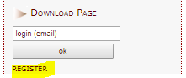 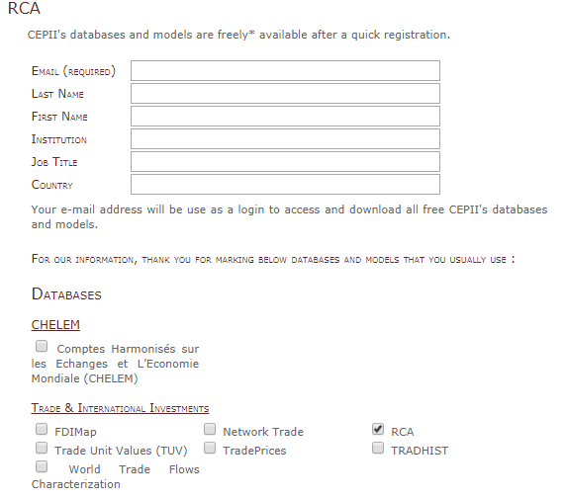

1. Confirm your email in the confirmation email received after completing registration;
2. Log in to the database inserting your email under "Download page" on the right side of the page.
3. After log in in, most of the data is downloaded via links in the xls or stat data files.

### BACI database

BACI is the World trade database developed by the CEPII at a high level of product dis aggregation. To access BACI database, you need to do the following:

1. Go to the BACI website at: <http://www.cepii.fr/CEPII/en/bdd_modele/inscription.asp?id=1>
2. Select REGISTER in the right panel:

* 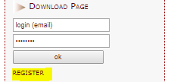

1. Insert all information on the BACI registration page including CT token in the field Authorization code (see [Comtrade](00-comtrade.html) section for more information). After you have inserted everything, press register.

* 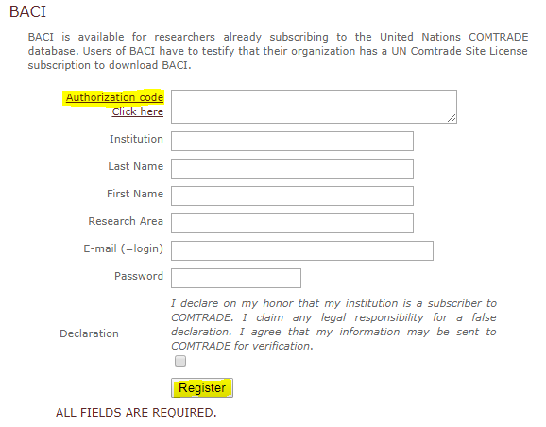

# MIT-Harvard 'Economic Complexity' Solutions

MIT-Harvard 'Economic Complexity' Solutions are rather similar tools for visualizing trade data by reporters, Partners, Commodities and trade flows. Added values of these tools is in their suggestive nature. For example, Observatory of Economic Complexity suggests to the user examples of the research questions and how to answer them. All these tools evolved from the master thesis of Alexander Simoes and a collaborative work at MIT and Harvard

**IMPORTANT!** Data used in the Economic Complexity tools is sourced from the Centre d'Etudes Prospectives et d'Informations Internationales (CEPII) in the BACI Data-set. Economic Complexity Data processing methodology is explained [here](https://github.com/cid-harvard/atlas-data). CEPII BACI methodology of data processing is explained [here](http://www.cepii.fr/CEPII/fr/publications/wp/abstract.asp?NoDoc=2726)

## [The Observatory of Economic Complexity](http://atlas.media.mit.edu/en/)

The Observatory of Economic Complexity - <http://atlas.media.mit.edu/en/> is a tool that allows users to quickly compose a visual narrative about countries and the products they exchange. It was Alexander Simoes' Master Thesis in Media Arts and Sciences at the MIT Media Lab, which you can read here. Source code for the OEC is [here](https://github.com/alexandersimoes/oec).

Introductory Video is available [here](https://vimeo.com/141271203).

The Observatory of Economic Complexity from Lupa Productora on Vimeo.

## [Atlas of economic complexity](http://atlas.cid.harvard.edu)

The Atlas of economic complexity - <http://atlas.cid.harvard.edu> is a powerful interactive tool that enables users to visualize a countryâ€™s total trade, track how these dynamics change over time and explore growth opportunities for more than a hundred countries worldwide. The Atlas online was originally conceived of as a versatile, interactive tool to make trade data not only available, but also usable and to synthesize insights from [research on Economic Complexity](http://atlas.cid.harvard.edu/about/glossary/#economiccomplexity).

## [Globe of economic complexity](http://globe.cid.harvard.edu/)

The Globe - <http://globe.cid.harvard.edu/> is an interactive visualization of economics data. It uses a dot-based representation, where each dot encodes a segment of $100 million worth of exports by countries. As total world exports accumulated to $15.3 trillion in 2012, it plots and animates 153,000 dots to generate geographical maps, node link diagrams and various stacked graphs.

# Miscellaneous data sources

## [Global Trade Atlas (GTA)](https://www.ihs.com/products/maritime-global-trade-atlas.html)

This is a trade data sources (formerly) purchased by FAO and available to the users with the ligin creditentials. To find more information about it, please contact to Adam Prakash.

## [UNCTAR STAT](http://unctadstat.unctad.org/EN/)

Statistical tools maintained and supported by UNCTAD. It gives access to basic and derived indicators built upon common rules, harmonized environment and clear methodology supported by powerful data browsing system.

## [EU Customs data](http://ec.europa.eu/ecip/information_resources/databases/index_en.htm)

The Commission develops and operates several databases in conjunction with Member States' Customs and Taxation Services. The databases are part of the information systems of Taxation and Customs Union. Although VIES has been developed and is operated at a national level, it can also be accessed via this site.