Lab 2 Section 3.1 Outline

Team Black - Strome InFusion

ODU CS 411 W

1. Functional Requirements (Bliss)  
   The requirements necessary to build a functional prototype that will prove the viability of a solution to Strome Entrepreneurial Center’s lack of ability to make, maintain, and track connections. Each of the following sections will address specific portions of the digital solution, how they will be used, and their constraints.
   1. Database (Bliss)  
      Implementing a PostgreSQL database provides a structured format for saving, editing, and accessing data for a given concept of the prototype. Data elements stored within the database will be constrained to specific data types and formats. The following schema shows the tables and their primary and foreign keys.

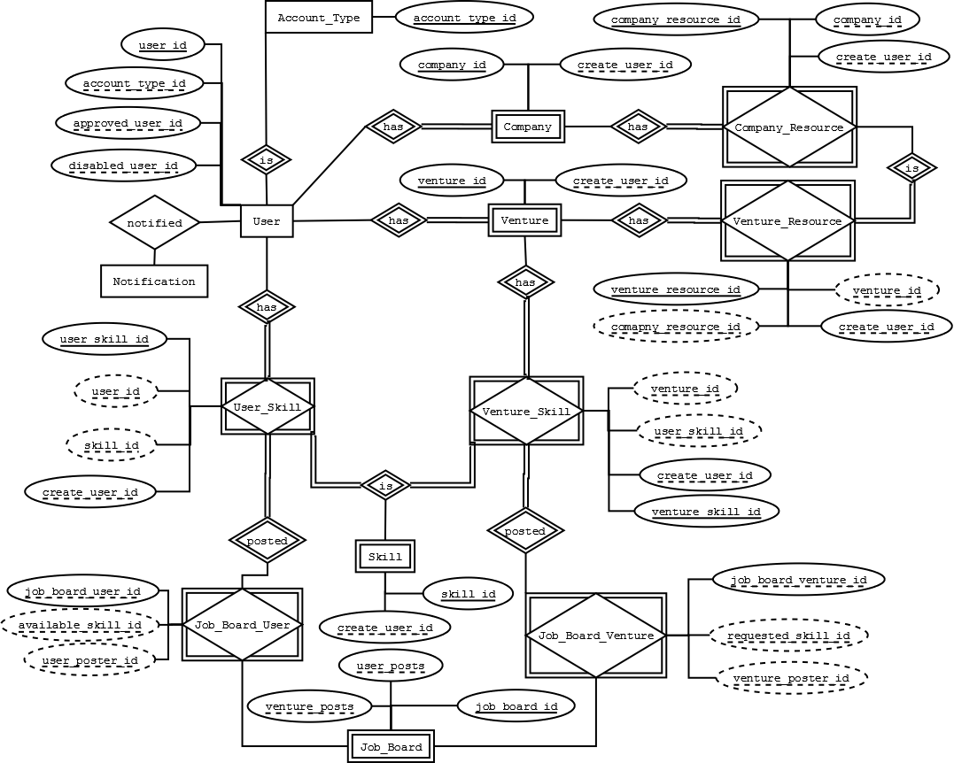

* + 1. User Table (Strong)  
       Data on user shall be saved in the following format:

|  |  |  |  |  |  |
| --- | --- | --- | --- | --- | --- |
| **Attribute** | **Datatype** | **Key** | **Requirement** | **Null** | **Notes** |
| user_id | int | Primary key | Must auto-increment starting at 1 | Not Null |  |
| last_name | varchar |  |  | Not Null |  |
| first_name | varchar |  |  | Not Null |  |
| email | varchar |  | Must be unique | Not Null |  |
| password | varchar |  |  | Not Null |  |
| register_dttm | date |  |  | Null | Populated after email verification |
| create_dttm | date |  | Must default to SYSDATE when record is created | Not Null |  |
| account_type_id | int | Foreign key to Accout_Type (acount_type_id) |  | Not Null |  |
| approved_dttm | date |  |  | Null | Null value assumes user is not approved |
| approved_user_id | int | Foreign key to User (user_id) |  | Null |  |
| disabled_dttm | date |  |  | Null | Null value assumes user is active |
| disabled_user_id | int | Foreign key to User (user_id) |  | Null |  |
| gcm_token | varchar |  |  |  |  |

Space left intentionally blank.

* + 1. User Account Types (Strong)  
       Data on user_account shall be saved in the following format:

|  |  |  |  |  |  |
| --- | --- | --- | --- | --- | --- |
| **Attribute** | **Datatype** | **Key** | **Requirement** | **Null** | **Notes** |
| account_type_id | int | Primary key | Must auto-increment starting at 1 | Not Null |  |
| name | varchar |  | Must be unique | Not Null |  |
| description | varchar |  |  | Null |  |

* + 1. Ventures (Bliss)  
       Data on venture shall be saved in the following format:

|  |  |  |  |  |  |
| --- | --- | --- | --- | --- | --- |
| **Attribute** | **Datatype** | **Key** | **Requirement** | **Null** | **Notes** |
| venture_id | int | Primary key | Must auto-increment starting at 1 | Not Null |  |
| description | varchar |  |  | Null |  |
| create_user_id | int | Foreign key to User (user_id) |  | Not Null |  |
| create_dttm | date |  | Must default to SYSDATE when record is created | Not Null |  |
| public_info | varchar |  |  | Null |  |
| approved_dttm | date |  |  | Null |  |
| approved_user_id | int | Foreign key to User (user_id) |  | Null |  |

Space left intentionally blank.

* + 1. Skills (Bliss)  
       Data on skill shall be saved in the following format:

|  |  |  |  |  |  |
| --- | --- | --- | --- | --- | --- |
| **Attribute** | **Datatype** | **Key** | **Requirement** | **Null** | **Notes** |
| skill_id | int | Primary key | Must auto-increment starting at 1 | Not Null |  |
| name | varchar |  | Must be unique | Not Null | i.e. Web Developer |
| description | varchar |  |  | Null |  |
| create_dttm | date |  | Must default to SYSDATE when record is created | Not Null |  |
| create_user_id | int | Foreign key to User (user_id) |  | Not Null |  |

* + 1. User Skill (Bliss)  
       Data on user_skill shall be saved in the following format:

|  |  |  |  |  |  |
| --- | --- | --- | --- | --- | --- |
| **Attribute** | **Datatype** | **Key** | **Requirement** | **Null** | **Notes** |
| user_skill_id | int | Primary key | Must auto-increment starting at 1 | Not Null |  |
| user_id | int | Foreign key to User (user_id), partial key (user_id, skill_id) |  | Not Null |  |
| skill_id | int | Foreign key to Skill (skill_id), partial key (user_id, skill_id) |  | Not Null |  |
| create_dttm | date |  | Must default to SYSDATE when record is created | Not Null |  |
| create_user_id | int | Foreign key to User (user_id) |  | Not Null |  |

Space left intentionally blank.

* + 1. Venture Skill (Bliss)  
       Data on venture_skill shall be saved in the following format:

|  |  |  |  |  |  |
| --- | --- | --- | --- | --- | --- |
| **Attribute** | **Datatype** | **Key** | **Requirements** | **Null** | **Notes** |
| venture_skill_id | int | Primary key | Must auto-increment starting at 1 | Not Null |  |
| venture_id | int | Foreign key to Venture (venture_id), partial key (venture_id, user_skill_id) |  | Not Null |  |
| user_skill_id | int | Foreign key to User_Skill (user_skill_id), partial key (venture_id, user_skill_id) |  | Not Null |  |
| create_dttm | date |  | Must default to SYSDATE when record is created | Not Null |  |
| create_user_id | int | Foreign key to User (user_id) |  | Not Null |  |

* + 1. Companies (Bliss)  
       Data on company shall be saved in the following format:

|  |  |  |  |  |  |
| --- | --- | --- | --- | --- | --- |
| **Attribute** | **Datatype** | **Key** | **Requirements** | **Null** | **Notes** |
| company_id | int | Primary key | Must auto-increment starting at 1 | Not Null |  |
| name | varchar |  | Must be unique | Not Null | i.e. Olive Garden |
| description | varchar |  |  | Null |  |
| create_dttm | date |  | Must default to SYSDATE when record is created | Not Null |  |
| create_user_id | int | Foreign key to User (user_id) |  | Not Null |  |

Space left intentionally blank.

* + 1. Company Resources (Bliss)  
       Data on company_resource shall be saved in the following format:

|  |  |  |  |  |  |
| --- | --- | --- | --- | --- | --- |
| **Attribute** | **Datatype** | **Key** | **Requirements** | **Null** | **Notes** |
| company_resource_id | int | Primary key | Must auto-increment starting at 1 | Not Null |  |
| name | varchar |  | Must be unique | Not Null | i.e. Kitchen Space |
| description | varchar |  |  |  |  |
| company_id | int | Foreign key to Company (company_id) |  |  |  |
| create_dttm | date |  | Must default to SYSDATE when record is created |  |  |
| create_user_id | int | Foreign key to User (user_id) |  |  |  |

* + 1. Venture Resources (Bliss)  
       Data on venture_resource shall be saved in the following format:

|  |  |  |  |  |  |
| --- | --- | --- | --- | --- | --- |
| **Attribute** | **Datatype** | **Key** | **Requirements** | **Null** | **Notes** |
| venture_resource_id | int | Primary key | Must auto-increment starting at 1 | Not Null |  |
| venture_id | int | Foreign key to Venture (venture_id), partial key (venture_id, resource_id) |  | Not Null |  |
| company_resource_id | int | Foreign key to Company_Resource (company_resource_id), partial key (venture_id, company_resource_id) |  | Not Null |  |
| create_dttm | date |  | Must default to SYSDATE when record is created | Not Null |  |
| create_user_id | int | Foreign key to User (user_id) |  | Not Null |  |

Space left intentionally blank.

* + 1. Job Board (Strong)  
       Data on job_board shall be saved in the following format:

|  |  |  |  |  |  |
| --- | --- | --- | --- | --- | --- |
| **Attribute** | **Datatype** | **Key** | **Requirements** | **Null** | **Notes** |
| job_board_id | int | Primary key | Most auto-increment starting at 1 | Not Null |  |
| user_posts | int | Foreign key to Job_Board_Users (job_board_user_id) |  |  |  |
| venture_posts | int | Foreign key to Job_Board_Venture (job_board_venture_id) |  |  |  |

* + 1. Job Board Users (Strong)  
       Data on notification shall be saved in the following format:

|  |  |  |  |  |  |
| --- | --- | --- | --- | --- | --- |
| **Attribute** | **Datatype** | **Key** | **Requirements** | **Null** | **Notes** |
| job_board_user_id | int | Foreign key to Job_Board(job_board_id) | Most auto-increment starting at 1 | Not Null |  |
| available_skill_id | int | Foreign key to Skill(skill_id), partial key (user_id, skill_id) |  |  |  |
| user_poster_id | int | Foreign key to User(user_id), partial key (skill_id, user_id) |  |  |  |

* + 1. Job Board Ventures (Strong)  
       Data on notification shall be saved in the following format:

|  |  |  |  |  |  |
| --- | --- | --- | --- | --- | --- |
| **Attribute** | **Datatype** | **Key** | **Requirements** | **Null** | **Notes** |
| job_board_venture_id | int | Foreign key to Job_Board(job_board_id) | Most auto-increment starting at 1 | Not Null |  |
| requested_skill_id | int | Foreign key to Skill(skill_id), partial key (venture_id, skill_id) |  |  |  |
| venture_poster_id | int | Foreign key to User(user_id), partial key (skill_id, venture_id) |  |  |  |

Space left intentionally blank.

* + 1. Notification (Strong)  
       Data on notification shall be saved in the following format:

|  |  |  |  |  |  |
| --- | --- | --- | --- | --- | --- |
| **Attribute** | **Datatype** | **Key** | **Requirements** | **Null** | **Notes** |
| notification_id | int |  | Must auto-increment starting at 1 | Not Null |  |
| message | varchar |  |  | Not Null |  |
| read_dttm | date |  |  | Null | Null values assumes message not read |
| create_dttm | date |  | Must default to SYSDATE when record is created | Not Null |  |
| create_user_id | int | Foreign key to User (user_id) |  | Not Null |  |
| to_user_id | int | Foreign key to User (user_id) |  | Not Null |  |

* 1. Web Service (API) (John S)  
     The Web service shall support the front end of the application by providing an interface for common functions of the database. The web service shall restrict access to data contained in the database based on the specifications of the Access Control Table.
     1. User Services
        1. User Registration/Create
        2. User Login
        3. Profile Lookup
        4. User Edit
        5. Register mobile application
        6. User Profile Associate Skill
        7. User Profile Remove Skill
        8. User Profile Notifications Lookup
        9. Retrieve Users with Skill
        10. Approve User
     2. Venture Services
        1. Create New Venture
        2. Lookup Venture
        3. Edit Venture Information
        4. Request Meeting
        5. Add User Membership
        6. Remove User Membership
     3. Companies
        1. Create Company
        2. Modify Company
        3. Offer Resource
        4. Remove Resource Offering
        5. Add Resource Request
        6. Remove Resource Request
     4. Resources
        1. New Resource
        2. New Resource Request
        3. Search for Resource
     5. Notifications (John S)
        1. Create New Notification  
           Shall create a new unread notification targeting a list of users.
        2. Get Unread Notifications  
           Shall provide the authenticated user with a list of notifications that have not yet been read by the user.
        3. Get All Notifications  
           Shall retrieve all notifications for the authenticated user with a flag for whether or not that user has read the notification.
        4. Read Notification  
           Shall mark a pending notification of the authenticated user as read.
     6. Admin
        1. Add Domain Whitelist
        2. Remove Domain Whitelist
        3. Add Test User
        4. Deactivate Test User

|  |  |  |  |
| --- | --- | --- | --- |
|  | **SEC Staff** | **ODU Student** | **External Company** |
| **General** |  |  |  |
| Automatic Registration |  |  |  |
| Send Notifications |  |  |  |
| View Notifications |  |  |  |
| Create User |  |  |  |
| Add SEC Staff |  |  |  |
| Add/Remove Domain Whitelist |  |  |  |
|  |  |  |  |
| **Student** |  |  |  |
| View Student Profile |  |  |  |
| View Student Skills |  |  |  |
| Add Skill |  |  |  |
| Delete Skill |  |  |  |
|  |  |  |  |
| **Venture** |  |  |  |
| Search Venture |  |  |  |
| View Venture |  |  |  |
| Request Venture |  |  |  |
| View Venture Skills |  |  |  |
| Add/Remove Members |  |  |  |
| Edit Venture Details |  |  |  |
| Approve Venture |  |  |  |
| Delete Venture |  |  |  |
| Approve Join Venture Request |  |  |  |
| Request Skills/Resoures |  |  |  |
| Request to Join Venture |  |  |  |
|  |  |  |  |
| **Company** |  |  |  |
| Search Companies |  |  |  |
| View Company Profile |  |  |  |
| Edit Company Profile |  |  |  |
| Add Company Resource |  |  |  |
| Remove Company Resource |  |  |  |
| Approve Company |  |  |  |
| Delete Company Profile |  |  |  |
|  |  |  |  |
| **Job Board** |  |  |  |
| Search Job Board |  |  |  |
| View Job Board Listing |  |  |  |
| Post to Job Board |  |  |  |
| Remove Posted Listing |  |  |  |
| Report Spam |  |  |  |
| View Spam Reports |  |  |  |
| Remove Job Board Listing |  |  |  |

Figure ??: Access Control Table, green indicates the action is accepted, red indicates it is not allowed, and yellow indicates a scenario with pre-requisites.

* 1. Web Interface (John S)  
     The web interface shall provide users with a front end interface for interacting with data accessible via the web service (Section 3.1.2). The interface must be well optimized and tested to work with mobile devices. The interface must also adapt in order to only show features allowed by the Access Control Table.
     1. Users
        1. Registration
        2. Login
        3. Profile
        4. Profile Edit
     2. Ventures
        1. Create
        2. Modify
        3. Profile
     3. Job Board
        1. Resource Search
        2. Resource Request
        3. Resource Offer
     4. Companies
        1. Create
        2. Modify
        3. Profile
     5. Notifications (John S)
        1. Unread Notifications  
           Shall be indicated by an icon and number on all pages that can be expanded in order to mark notifications as read.
        2. Read notifications   
           A notifications page shall allow the user to view all notifications including previously read notifications. Read/Unread notifications must be indicated as such.
     6. Administration
        1. Edit User Whitelist
        2. Test User Create
        3. Send Notification
  2. Notifications (John S)  
     Notifications shall alert users that something needs their attention after they have closed the application. There shall be two methods outside of the user interface mentioned in section 3.1.3.5 that will service this purpose.
     1. Digest Email
        1. Automatically Subscribed  
           Notifications by email shall be sent as a digest email which includes all unread notifications once per week.
        2. Unsubscribe  
           All emails shall include a direct link to unsubscribe from the weekly digest emails.
     2. Push  
        Users who access the service using the downloadable android application shall receive notifications via push notification service.
        1. Register Mobile Device  
           On first launch the device shall be registered to receive pushes from the web service in real time as events occur.
        2. Receive Notification  
           Notifications sent by the web services shall be received by the device to display a native notification which on click links to the relevant page in the application and marks the notification as read.