Lab 2 Section 3.1 Outline

Team Black - Strome InFusion

ODU CS 411 W

* 1. Functional Requirements (Bliss)  
     The requirements necessary to build a functional prototype that will prove the viability of a solution to Strome Entrepreneurial Center’s lack of ability to make, maintain, and track connections. Each of the following sections will address specific portions of the digital solution, how they will be used, and their constraints.
     1. Database (Bliss)  
        Implementing a PostgreSQL database provides a structured format for saving, editing, and accessing data for a given concept of the prototype. Figure 1 shows the tables and their primary and foreign keys. Data shall be saved to meet the following requirements and formats:

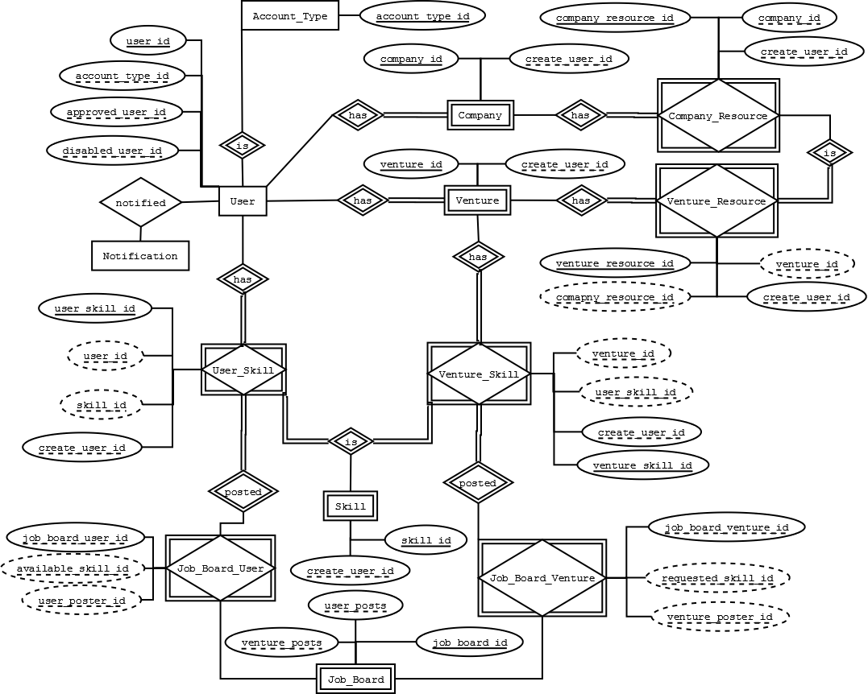

*Figure 10*. Database schema of tables and keys.

* + - 1. User Table (Strong)

|  |  |  |  |  |  |
| --- | --- | --- | --- | --- | --- |
| **Attribute** | **Datatype** | **Key** | **Requirement** | **Null** | **Notes** |
| user_id | BigSerial | Primary key | Must auto-increment starting at 1 | Not Null |  |
| last_name | Text |  |  | Not Null |  |
| first_name | Text |  |  | Not Null |  |
| email | Text |  | Must be unique | Not Null |  |
| password | Text |  |  | Not Null |  |
| register_dttm | Timestamp |  |  | Null | Populated after email verification |
| create_dttm | Timestamp |  | Must default to SYSDATE when record is created | Not Null |  |
| account_type_id | Integer | Foreign key to Accout_Type (acount_type_id) |  | Not Null |  |
| approved_dttm | Timestamp |  |  | Null | Null value assumes user is not approved |
| approved_user_id | Integer | Foreign key to User (user_id) |  | Null |  |
| disabled_dttm | Timestamp |  |  | Null | Null value assumes user is active |
| disabled_user_id | Integer | Foreign key to User (user_id) |  | Null |  |
| gcm_token | Text |  |  | Null |  |

*Table 2*. User table for database.

Space left intentionally blank.

* + - 1. User Account Types (Strong)

|  |  |  |  |  |  |
| --- | --- | --- | --- | --- | --- |
| **Attribute** | **Datatype** | **Key** | **Requirement** | **Null** | **Notes** |
| account_type_id | BigSerial | Primary key | Must auto-increment starting at 1 | Not Null |  |
| name | Text |  | Must be unique | Not Null |  |
| description | Text |  |  | Null |  |

*Table 3*. User account types table for database.

* + - 1. Ventures (Bliss)

|  |  |  |  |  |  |
| --- | --- | --- | --- | --- | --- |
| **Attribute** | **Datatype** | **Key** | **Requirement** | **Null** | **Notes** |
| venture_id | BigSerial | Primary key | Must auto-increment starting at 1 | Not Null |  |
| description | Text |  |  | Null |  |
| create_user_id | Integer | Foreign key to User (user_id) |  | Not Null |  |
| create_dttm | Timestamp |  | Must default to SYSDATE when record is created | Not Null |  |
| public_info | Text |  |  | Null |  |
| approved_dttm | Timestamp |  |  | Null |  |
| approved_user_id | Integer | Foreign key to User (user_id) |  | Null |  |

*Table 4*. Ventures table for database.

* + - 1. Skills (Bliss)

|  |  |  |  |  |  |
| --- | --- | --- | --- | --- | --- |
| **Attribute** | **Datatype** | **Key** | **Requirement** | **Null** | **Notes** |
| skill_id | BigSerial | Primary key | Must auto-increment starting at 1 | Not Null |  |
| name | Text |  | Must be unique | Not Null | i.e. Web Developer |
| description | Text |  |  | Null |  |
| create_dttm | Timestamp |  | Must default to SYSDATE when record is created | Not Null |  |
| create_user_id | Integer | Foreign key to User (user_id) |  | Not Null |  |

*Table 5.* Skills table for database.

Space left intentionally blank.

* + - 1. User Skill (Bliss)

|  |  |  |  |  |  |
| --- | --- | --- | --- | --- | --- |
| **Attribute** | **Datatype** | **Key** | **Requirement** | **Null** | **Notes** |
| user_skill_id | BigSerial | Primary key | Must auto-increment starting at 1 | Not Null |  |
| user_id | Integer | Foreign key to User (user_id), partial key (user_id, skill_id) |  | Not Null |  |
| skill_id | Integer | Foreign key to Skill (skill_id), partial key (user_id, skill_id) |  | Not Null |  |
| create_dttm | Timestamp |  | Must default to SYSDATE when record is created | Not Null |  |
| create_user_id | Integer | Foreign key to User (user_id) |  | Not Null |  |

*Table 6*. User skills table for database.

* + - 1. Venture Skill (Bliss)

|  |  |  |  |  |  |
| --- | --- | --- | --- | --- | --- |
| **Attribute** | **Datatype** | **Key** | **Requirements** | **Null** | **Notes** |
| venture_skill_id | BigSerial | Primary key | Must auto-increment starting at 1 | Not Null |  |
| venture_id | Integer | Foreign key to Venture (venture_id), partial key (venture_id, user_skill_id) |  | Not Null |  |
| user_skill_id | Integer | Foreign key to User_Skill (user_skill_id), partial key (venture_id, user_skill_id) |  | Not Null |  |
| create_dttm | Timestamp |  | Must default to SYSDATE when record is created | Not Null |  |
| create_user_id | Integer | Foreign key to User (user_id) |  | Not Null |  |

*Table 7.* Venture skills table for database.

Space left intentionally blank.

* + - 1. Companies (Bliss)

|  |  |  |  |  |  |
| --- | --- | --- | --- | --- | --- |
| **Attribute** | **Datatype** | **Key** | **Requirements** | **Null** | **Notes** |
| company_id | BigSerial | Primary key | Must auto-increment starting at 1 | Not Null |  |
| name | Text |  | Must be unique | Not Null | i.e. Olive Garden |
| description | Text |  |  | Null |  |
| create_dttm | Timestamp |  | Must default to SYSDATE when record is created | Not Null |  |
| create_user_id | Integer | Foreign key to User (user_id) |  | Not Null |  |

*Table 8.* Companies table for database.

* + - 1. Company Resources (Bliss)

|  |  |  |  |  |  |
| --- | --- | --- | --- | --- | --- |
| **Attribute** | **Datatype** | **Key** | **Requirements** | **Null** | **Notes** |
| company_resource_id | BigSerial | Primary key | Must auto-increment starting at 1 | Not Null |  |
| name | Text |  | Must be unique | Not Null | i.e. Kitchen Space |
| description | Text |  |  |  |  |
| company_id | Integer | Foreign key to Company (company_id) |  |  |  |
| create_dttm | Timestamp |  | Must default to SYSDATE when record is created |  |  |
| create_user_id | Integer | Foreign key to User (user_id) |  |  |  |

*Table 9.* Company resources table for database.

Space left intentionally blank.

* + - 1. Venture Resources (Bliss)

|  |  |  |  |  |  |
| --- | --- | --- | --- | --- | --- |
| **Attribute** | **Datatype** | **Key** | **Requirements** | **Null** | **Notes** |
| venture_resource_id | BigSerial | Primary key | Must auto-increment starting at 1 | Not Null |  |
| venture_id | Integer | Foreign key to Venture (venture_id), partial key (venture_id, resource_id) |  | Not Null |  |
| company_resource_id | Integer | Foreign key to Company_Resource (company_resource_id), partial key (venture_id, company_resource_id) |  | Not Null |  |
| create_dttm | Timestamp |  | Must default to SYSDATE when record is created | Not Null |  |
| create_user_id | Integer | Foreign key to User (user_id) |  | Not Null |  |

*Table 10.* Venture resources table for database.

* + - 1. Job Board (Strong)

|  |  |  |  |  |  |
| --- | --- | --- | --- | --- | --- |
| **Attribute** | **Datatype** | **Key** | **Requirements** | **Null** | **Notes** |
| job_board_id | BigSerial | Primary key | Most auto-increment starting at 1 | Not Null |  |
| user_posts | Integer | Foreign key to Job_Board_Users (job_board_user_id) |  |  |  |
| venture_posts | Integer | Foreign key to Job_Board_Venture (job_board_venture_id) |  |  |  |

*Table 11.* Job board table for database.

Space left intentionally blank.

* + - 1. Job Board Users (Strong)

|  |  |  |  |  |  |
| --- | --- | --- | --- | --- | --- |
| **Attribute** | **Datatype** | **Key** | **Requirements** | **Null** | **Notes** |
| job_board_user_id | BigSerial | Foreign key to Job_Board(job_board_id) | Most auto-increment starting at 1 | Not Null |  |
| available_skill_id | Integer | Foreign key to Skill(skill_id), partial key (user_id, skill_id) |  |  |  |
| user_poster_id | Integer | Foreign key to User(user_id), partial key (skill_id, user_id) |  |  |  |

*Table 12.* Job board users table for database.

* + - 1. Job Board Ventures (Strong)

|  |  |  |  |  |  |
| --- | --- | --- | --- | --- | --- |
| **Attribute** | **Datatype** | **Key** | **Requirements** | **Null** | **Notes** |
| job_board_venture_id | BigSerial | Foreign key to Job_Board(job_board_id) | Most auto-increment starting at 1 | Not Null |  |
| requested_skill_id | Integer | Foreign key to Skill(skill_id), partial key (venture_id, skill_id) |  |  |  |
| venture_poster_id | Integer | Foreign key to User(user_id), partial key (skill_id, venture_id) |  |  |  |

*Table 13.* Job board ventures table for database.

Space left intentionally blank.

* + - 1. Notification (Strong)

|  |  |  |  |  |  |
| --- | --- | --- | --- | --- | --- |
| **Attribute** | **Datatype** | **Key** | **Requirements** | **Null** | **Notes** |
| notification_id | BigSerial |  | Must auto-increment starting at 1 | Not Null |  |
| message | Text |  |  | Not Null |  |
| read_dttm | Timestamp |  |  | Null | Null values assumes message not read |
| create_dttm | Timestamp |  | Must default to SYSDATE when record is created | Not Null |  |
| create_user_id | Integer | Foreign key to User (user_id) |  | Not Null |  |
| to_user_id | Integer | Foreign key to User (user_id) |  | Not Null |  |

*Table 14.* Notifications table for database.

* + 1. Web Service (API) (John S.)  
       The Web service shall support the front end of the application by providing an interface for common functions of the database. The web service shall restrict access to data contained in the database based on the specifications of the Access Control Table, as shown in Table 1.
       1. User Services (John S.)  
          User services shall provide any logged in user with the ability to
          1. Register  
             Shall allow a visitor to register as a SI user
          2. Midas Login  
             Shall allow a visitor to login using their Midas credentials
          3. SI Login  
             Shall allow a visitor to login as an SI user
          4. Lookup User Profile  
             Shall lookup information about a single user
          5. Edit User Profile  
             Shall modify a single user profile
          6. Push Notification Registration  
             Shall register a device to a user for google cloud messaging
          7. User Profile Associate Skill  
             Shall add a skill to a user profile
          8. User Profile Remove Skill  
             Shall remove a skill from a user profile
          9. User Profile Notifications Lookup  
             Shall retrieve unread notifications for a user
          10. Retrieve Users with Skill  
              Shall return a list of users with a specified skill
       2. Venture Services (Shawn)

Venture services shall provide any logged in user the ability to

* + - * 1. Create a new venture

Shall create a new venture to modify

* + - * 1. Lookup an existing venture

Shall lookup existing ventures user has created in order to perform various operations upon them

* + - * 1. Edit ventures the user owns

Shall modify the current venture projects they own

Update progress of current venture

Add user roles for users involved in current venture

Request companies join current venture

Manipulate privacy settings of venture profile

* + - * 1. Request a meeting with SEC personnel

Shall request meetings with SEC mentors to discuss various aspects of current venture

* + - * 1. Request a meeting with Company personnel associated with current venture

Shall request meetings with company mentors associated with current venture or request help for specific parts of the venture

* + - * 1. Add other users to current venture

Shall add other SEC, Company, or Student users to current venture as members in various roles to assist in current venture

* + - * 1. Remove other users from current ventures

Shall remove a user who is no longer involved in current venture

* + - * 1. Request a company resource

Shall request a resource posted by a Company as an available resource to venture needs

* + - * 1. Add resource request

Shall add a specific resource need to current venture through the Job Board

* + - * 1. Remove resource request

Shall remove a specific resource need to current venture through the Job Board

* + - 1. Company Services (Shawn)

Company services shall provide companies various means to manage their involvement in SI by

* + - * 1. Creating a  Company

Shall create a profile for a company to be represented in SI in various roles

* + - * 1. Modifying a Company

Shall modify current company profile to reflect various aspects of the company

Update company information

Update company users

Add a venture company is associated with

Remove a venture company is associated with

Manipulate privacy settings of company profile

* + - * 1. Offering Resources

Shall offer resources

* + - * 1. Removing a Resource Offering

Shall remove resources offered to SI ventures

* + - 1. Resources Services (Shawn)

Resources service provides an interface for users to

* + - * 1. Create a new resource

Shall make a new resource

* + - * 1. Create a new resource request

Shall create a request for a specific resource and post to job board

* + - * 1. Search for Resource

Shall search through database to find specific resources available

* + - * 1. Notification Services (John S.)   
           Notification services shall provide an interface to

Create New Notification  
Shall create a new unread notification targeting a list of users.

Get Unread Notifications  
Shall provide the authenticated user with a list of notifications that have not yet been read by the user

Get All Notifications  
Shall retrieve all notifications for the authenticated user with a flag for whether or not that user has read the notification

Read Notification  
Shall mark a pending notification of the authenticated user as read

Send Aggregate Email  
Shall send an email message containing any unread notifications to that user’s email address

* + - 1. Admin Services(Shawn)

Admin services shall provide an interface to.

* + - * 1. Add Domain Whitelist

Shall add specific domains to a whitelist to allow for quicker registration under that domain

* + - * 1. Remove Domain Whitelist

Shall remove specific domains from the whitelist for any reason

* + - * 1. Add Test User

Shall add a test user for SEC Admin to manipulate

* + - * 1. Approve User

Shall approve user for full access to SI based on user type

* + - * 1. Deactivate Test User

Shall remove test user once SEC Admin no longer needs said user

* + - * 1. Remove User

Shall remove a user from SI for any reason

RED restricted access

Yellow requires prerequisites

Green allowed

|  |  |  |  |
| --- | --- | --- | --- |
|  | **SEC Staff** | **ODU Student** | **External Company** |
| **General** |  |  |  |
| Automatic Registration |  |  |  |
| Send Notifications |  |  |  |
| View Notifications |  |  |  |
| Create User |  |  |  |
| Add SEC Staff |  |  |  |
| Add/Remove Domain Whitelist |  |  |  |
|  |  |  |  |
| **Student** |  |  |  |
| View Student Profile |  |  |  |
| View Student Skills |  |  |  |
| Add Skill |  |  |  |
| Delete Skill |  |  |  |
|  |  |  |  |
| **Venture** |  |  |  |
| Search Venture |  |  |  |
| View Venture |  |  |  |
| Request Venture |  |  |  |
| View Venture Skills |  |  |  |
| Add/Remove Members |  |  |  |
| Edit Venture Details |  |  |  |
| Approve Venture |  |  |  |
| Delete Venture |  |  |  |
| Approve Join Venture Request |  |  |  |
| Request Skills/Resources |  |  |  |
| Request to Join Venture |  |  |  |
|  |  |  |  |
| **Company** |  |  |  |
| Search Companies |  |  |  |
| View Company Profile |  |  |  |
| Edit Company Profile |  |  |  |
| Add Company Resource |  |  |  |
| Remove Company Resource |  |  |  |
| Approve Company |  |  |  |
| Delete Company Profile |  |  |  |
|  |  |  |  |
| **Job Board** |  |  |  |
| Search Job Board |  |  |  |
| View Job Board Listing |  |  |  |
| Post to Job Board |  |  |  |
| Remove Posted Listing |  |  |  |
| Report Spam |  |  |  |
| View Spam Reports |  |  |  |
| Remove Job Board Listing |  |  |  |

*Table 15*. Access Control Table, green indicates the action is accepted, red indicates it is not allowed, and yellow indicates a scenario with pre-requisites.

* + 1. Web Application Interface (John S)  
       The web interface shall provide users with a front end interface for interacting with data accessible via the web service (Section 3.1.2). The interface must be well optimized and tested to work with mobile devices. The interface must also adapt in order to only show features allowed by the Access Control Table, as shown in Table 1.
       1. Users (Matthew)
          1. Registration

A registration page will allow users to register a new account with the Strome Entrepreneurial Center by supplying their first name, last name, and either a valid ODU email address or another email address that has been preapproved the Strome Entrepreneurial Center

* + - * 1. Login

A login page will allow users to login to their accounts using their email address and a password that is initially supplied to them that they can change once logged in for the first time, assuming that they are properly registered first

* + - * 1. Profile

Each user will have an individual profile page that will be visible to all other registered users that will include details about who they are, and what assets and abilities they would be able to supply to a venture

* + - * 1. Profile Edit

Each user will have the ability to edit their own personal profile

* + - 1. Ventures (Matthew)
         1. Create

Student and Staff users will be able to create new venture resources.

* + - * 1. Modify

Users will be able to modify venture resources and their respective profiles that they have created or that they have been given permission to modify.

* + - * 1. Profile

Every venture will have its own profile page that all users will be able to view that will give important information on what the venture is, and what it needs to be successful

* + - 1. Job Board (Matthew)
         1. Skill Search

Registered users will be able to search through a job board listing for jobs that they are skilled in

* + - * 1. Skill Request

Strome Entrepreneurial Center staff and approved students and companies will be able to post requests for resources on the job board

* + - * 1. Skill Offer

Registered users will be able to post themselves as resources on the job board listing what skills they are capable of

* + - * 1. Companies (Matthew)

Create

Strome Entrepreneurial Center staff and preapproved external company users will be able to create company resources

Modify

Users will be able to modify company resources that they have created or that they have been given approval to modify

Profile

Every company resource created will have its own profile page detailing information about that company and what sort of resources they need

* + - 1. Notifications (John S.)  
         Notifications shall provide the user with an indicator in order to bring the user’s attention back into the application’s front end
         1. Unread Notifications  
            Shall be indicated by an icon and number on all pages that can be expanded in order to mark notifications as read.
         2. Read notifications   
            A notifications page shall allow the user to view all notifications including previously read notifications. Read/Unread notifications must be indicated as such
      2. Administration (Shawn)

Administration allows SEC user to have control over other users’ access and accounts

* + - * 1. Edit User Whitelist

Shall create whitelist rules for specific domains, edit current whitelist to add or remove a domain, or create whitelist for specific email addresses

* + - * 1. Test User Create

Shall create a test user for SEC user to learn how SI works, teach others how SI works, or to test some functionality of SI. Shall also be able to remove Test user once done

* + - * 1. Pending User Requests

Shall grant or deny access to new users that are not on whitelist

* + - * 1. Send Notification

Shall send notifications through notification system to any or all users or create special user groups to send notifications to for any purpose

* + - 1. Notifications (John S.)  
         Notifications shall alert users that something needs their attention after they have closed the application. There shall be two methods outside of the web application’s user interface mentioned in section 3.1.3.5
         1. Aggregate Email  
            Aggregate emails shall summarize the previous week’s unread notifications

Weekly Job  
Notifications by email shall be sent as an aggregate email which includes all unread notifications of the previous week

Deep Link  
Each notification item in the aggregate email shall link to a related page in the application

Unsubscribe  
All emails shall include a direct link to unsubscribe from the weekly aggregate emails

* + - * 1. Mobile Application  
           Users who access the service using the downloadable android application shall receive notifications via push notification service and have access to
        2. Register Mobile Device  
           On first launch the device shall be registered to receive pushes notifications

Receive Notification  
Notifications sent by the web services shall be received by the device to

Notify  
Shall display a native notification

Deep Link  
On tap shall link the user to a related page in the application

Mark as Read  
On tap shall mark the notification as read

* + - * 1. Web View  
           The webview shall provide the same user experience as in section 3.1.3 but launched as an android application