Lab 2 – Strome InFusion Specification Outline

Team Black

CS411W

Professor Brunelle

October 27, 2015

Version 1.1

Table of Contents

1.               Introduction

1.1.   Purpose

1.2.   Scope

1.3.   Definitions, Acronyms, and Abbreviations

1.4.   References

1.5.   Overview

2.               General Description

2.1.   Prototype Architecture

2.2.   Prototype Functional Description

2.3.   Extended Interfaces

List of Figures

Figure 1. Major component diagram.

Figure 2. GUI sitemap

Figure 3. Solution flow.

Figure 4. User registration.

Figure 5. Meeting request.

Figure 6. User to venture or company authentication.

Figure 7. Job board page.

Figure 8. Push notifications on mobile.

Figure 9. Landing page mockup.

Figure 10. Database schema of tables and keys.

List of Tables

Table 1. Real world model versus prototype.

Table 2. User table for database.

Table 3. User account types table for database.

Table 4. Ventures table for database.

Table 5. Skills table for database.

Table 6. User skills table for database.

Table 7. Venture skills table for database.

Table 8. Companies table for database.

Table 9. Company resources table for database.

Table 10. Venture resources table for database.

Table 11. Job board table for database.

Table 12. Job board users table for database.

Table 13. Job board ventures table for database.

Table 14. Notifications table for database.

Table 15. Access control table.

1.               Introduction (Chris)

        The Strome Entrepreneurial Center is a place for students, faculty, staff, and alumni to get help with starting a business or an existing business. However the Strome Entrepreneurial Center lacks the ability to connect with students, maintain those connections, and build connections between the users of the facility and ventures.

1.1.   Purpose (Will)

        Strome Infusion will give students the ability to connect with the Strome Entrepreneurial Center, other students, and external companies.  Through these connections they will be able to find the necessary skillsets and resources to make their entrepreneurial ventures a success.

1.2.   Scope (Pat)

  The Strome Entrepreneurial Center is a resource for Old Dominion University students, faculty, staff, and alumni, Strome InFusion can be used anyone in those groups.  Additionally, members of the local entrepreneurial community are welcome to help members of the Strome Entrepreneurial Center and will have access to Strome InFusion. Staff of the Strome Entrepreneurial Center will have elevated access to the system.

1.3.   Definitions, Acronyms, and Abbreviations

        Technical terms, acronyms, and abbreviations and what they mean.

1.4.   References

        Sources used for the purposes of writing the paper.

1.5.   Overview (Chris)

        An explanation of Strome Infusion’s prototype architecture, functionality, and interfaces.

Space left intentionally blank.

2.               General Description (Chris)

The breakdown of the following sections and what they will cover.

2.1.   Prototype Architecture (Matthew)

A description of the major components of Strome Infusion and the programming languages and frameworks that they are built on. This includes: the database, website application, and mobile application.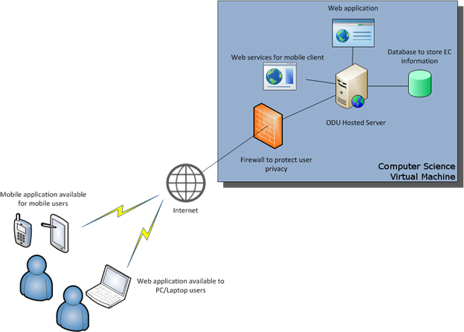

*Figure 1.* Major component diagram.

Space left intentionally blank.

2.2.   Prototype Functional Description (Will)

A description of the individual working components of the prototype.  This will include the following:

1.   Creating ventures and companies

2.   Registering skills and resources

3.   Requesting skills and resources to join a venture

4.   Requesting to be added to a venture

5.   Requesting a meetings with a mentor

6.   Posting to the job board.

Space left intentionally blank.

2.3.   Extended Interfaces (John S)

A description of extended services that the application shall use to interact with the end user. This includes the following:

1. Push Notifications
2. Midas Login
3. Email Notifications and registration

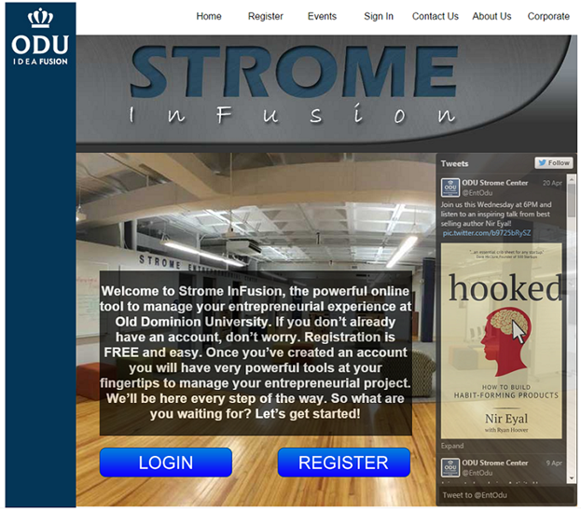  
*Figure 9.* Landing page mockup.