Jesse Yang (23307563), Qichong Huang (23311085)

# Shallows Explanation

## Explanation

The Shallows task can be briefly concluded as ***finding the shortest path***. Though there are few differences between Shallows and normal shortest path problem, the basic idea of solution is almost the same.

Firstly, find the ***starting point***, in this case, will be the origin port. Step1

Then, we ***add lines*** which depart port is the origin port. Step2

Next, we add more lines which connect the lines added in step2. Step3

At the end, we have create ***all possible routines*** that starts with origin port and end with every port. Find out the ”shortest path” Step4

While connecting ports, update the information in results array.

At the beginning of our solution, we create an array results[ ] to store the result. And it will be initialized with 0.

Then, we use a for loop to find every line which depart with origin port. And we store the depth in the corresponding position of results[ ]. And count the number of lines we find in this step.

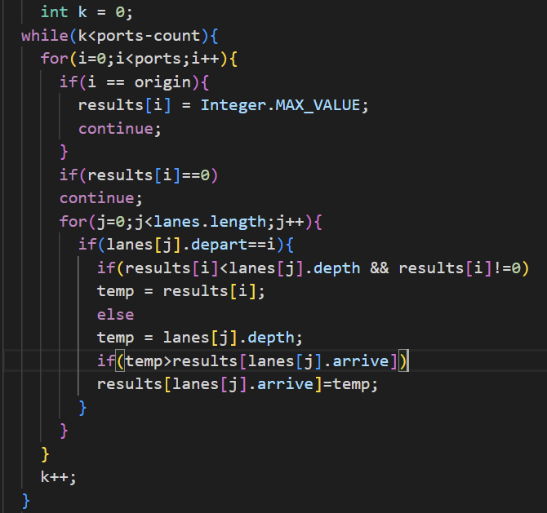

For the example given,

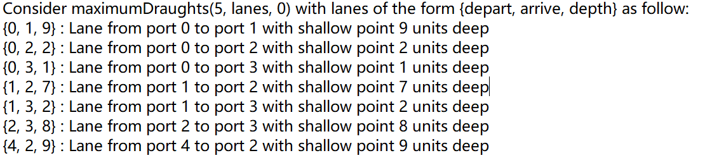

Now we have results[ ] which contain {0,9,2,1,0}

Meaning that:

0-0：0

0-1：9

0-2：2

0-3：1

0-4：0

And we define 0-0 as interger.maxsize

Then, we ignore all ***non-existed routines*** (for now) , in this case we use

0-1：9

0-2：2

0-3：1

Next, for port =1, we find every line that connect to port1:

{1, 2, 7} : Lane from port 1 to port 2 with shallow point 7 units deep

{1, 3, 2} : Lane from port 1 to port 3 with shallow point 2 units deep

We now have

0-1-2 = 0-2：7

0-1-3 = 0-3：2

The results[ ] will be updated according to this:

0-1：9

0-2：7

0-3：2

Also, we repeat this process for port = 2, 3.

That’s what ***nested for loops*** do in the code above.

If there is a routine which make port 0 connect to a new port (port = 4), we also update that in result array.

And we need a ***big while loop*** to include all of this, which will circle for the number of “non-existed routines”. (Considering ***the worst case***) Cause after each time we finish the nested loops, the origin ports might now be able to ***reach to a new port***, meaning that those “non-existed routines” perhaps are now existed.

At the end we return the results[ ].

# Time complexity

*O(P^2 L)*