**ECAVI – Installation Guide**

# ADOxx Metamodelling Platform Installation

1. Download Link (v1.5): <https://www.adoxx.org/live/download-15>
2. Installation Code Request: <https://www.adoxx.org/live/installation-code>
3. Installation Instructions for using ADOxx v1.5 with Windows: <https://www.adoxx.org/live/installation-guide-15>
4. Installation Instructions for using ADOxx v1.5 with MacOS: <https://www.adoxx.org/live/installation-guide-mac-os>

# The ECAVI library - Setup

1. Open the ADOxx Development Toolkit and log in   
   (usually, USERNAME: “Admin”, PASSWORD: “password”)
2. From the Menu choose the *Library Management* option and then click on the *Management* Button.

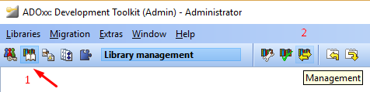

1. Add the ECAVI library to the platform:
   1. Download the ECAVI library (.abl): <https://drive.google.com/drive/folders/1TezDhLK9N7UBVZlr4nd5kTPsRoBT0nyW>  
      (Leave the link open, you will need it later)
   2. On the Library Management window choose Import and Browse to the .abl file downloaded.
   3. On the prompt to create a default model group click Yes.
2. Go back to the starting window and choose the *User Management* option and then click on the *User list* button.

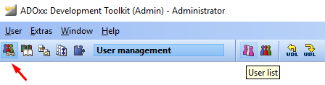

1. Add a new user:
   1. Use a username and password of your choosing
   2. On the Application Library dropdown menu choose the ECAVI Library
   3. Click on the *User Group* button and double click on the *ADOxx* group to add your created user to it.

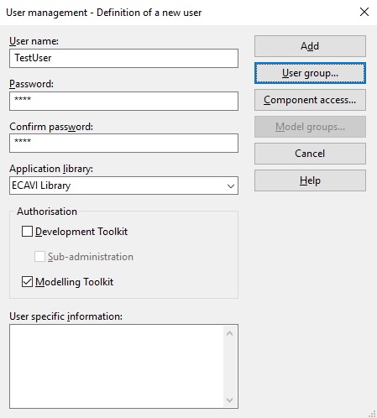

* 1. Click OK and then Add.

1. The ECAVI library is now ready to use.

# The ECAVI Library – Usage

1. Open the ADOxx Modelling Toolkit.
2. Login with the credentials of the user you created.
3. In order to use the library there are a few extra steps needed, to setup some of the needed files
   1. Go to the ADOxx Installation Directory. Must be something like:   
      *C:\Program Files (x86)\BOC\ADOxx15_EN_SA*
   2. Create a folder called “ECAVI” and in that folder download the files “*DEC.lp*” & “*ADOxx_External_XML_Translator.jar*” found in the Google Drive link given earlier.
   3. Then, download the Clingo solver from <http://potassco.sourceforge.net/> and extract the files included in the zip into the “ECAVI” folder.
4. You are now ready to use the ECAVI tool.