iCAST 2017 Registration Instructions for the Authors
The 8th International Conference on Awareness Science and Technology (iCAST 2017)
- REGISTRATION GUIDELINES
The following steps are provided to help you in the registration for the iCAST 2017 conference. Please follow all STEPs to ensure that the registration process is completed successfully.

Step 1: About iCAST 2017 Registration Fee
- The author may pay the registration fee by either US dollar or NT dollar, and the exchange rate is fixed at USD : NTD = 1 : 30.
- Notices:
  - For each paper, at least one author should register with “Regular Registration” by October 1, 2017 accompanied with paper ID#, which shall be obtained upon the submission of papers.
  - Each regular registration includes 1 conference digest, 1 USB drive proceeding, and access to all sessions, coffee breaks, and banquet.
  - Each student registration (non-author) includes all of the items in regular registration except the banquet.
  - IEEE/TACE/TESII/TAWIC/CCISA/TAAI member registration: To qualify for the member rate your IEEE/TACE/TESII/TAWIC/CCISA/TAAI membership will be required.
  - Student registration: To qualify for the student rate, a proof of current full-time student status (i.e., the system will request a copy of student card or certification from university) will be required. In addition, student registration means that he/she is not an author.
- Registration Fee
Category | Sub-Category | Early Registration (until Sep. 15, 2017) | Standard Registration (until Sep. 20, 2017) | Late Registration(until Oct. 01, 2017)
Regular registration | Non-IEEE/TACE/TESII/TAWIC/  CCISA/TAAI member | US$500  (NT$15,000) | US$550  (NT$16,500) | US$600  (NT$18,000)
 | IEEE/TACE/  TESII/TAWIC/CCISA/TAAI member | US$450  (NT$13,500) | US$500  (NT$15,000) | US$550  (NT$16,500)
Student registration  (non-author) | US$300 (NT$9,000)
Additional publication fee | Each additional paper charge is US$400 (NT$12,000).  Note that one author is limited to register at most three papers.
Over-length page charge  (max 2 pages/paper) | For papers of more than 6 pages, the page charge is US$40 (NT$1,200) per additional page.
Additional banquet ticket | Each additional ticket banquet is charged US$30 (NT$900).

Step 2: iCAST 2017 Registration System
Please complete the following steps for registration:
Step 2-1: Enter the registration system
- Enter the iCAST 2017 registration site: http://eform.iis.sinica.edu.tw/url/icast2017/reg
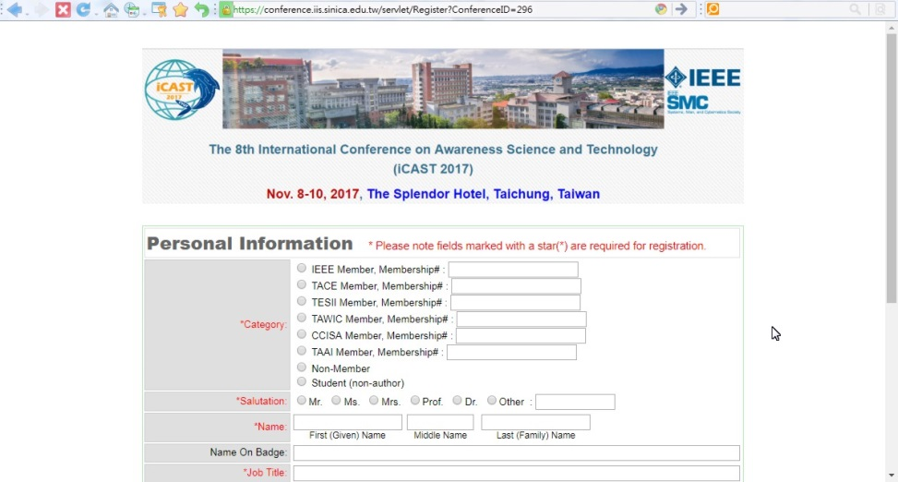
- Fill in Personal Information
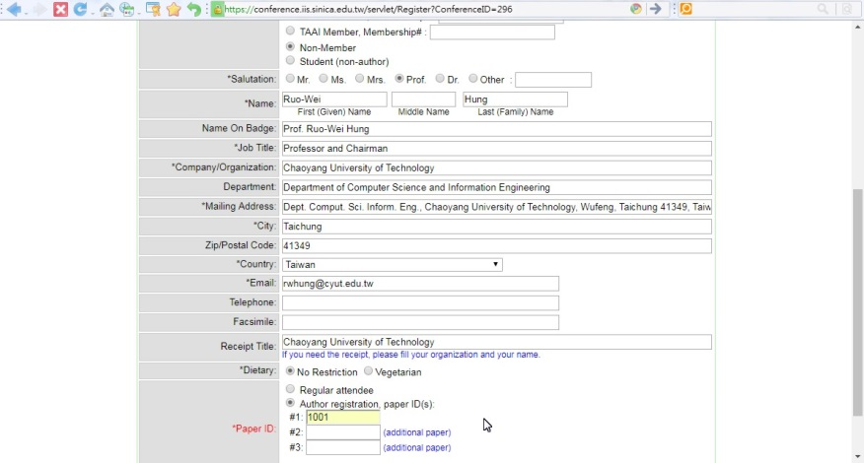
Note: An author registration should select “Author registration, paper ID(s):” and enter the paper ID.
- Display Registration Information
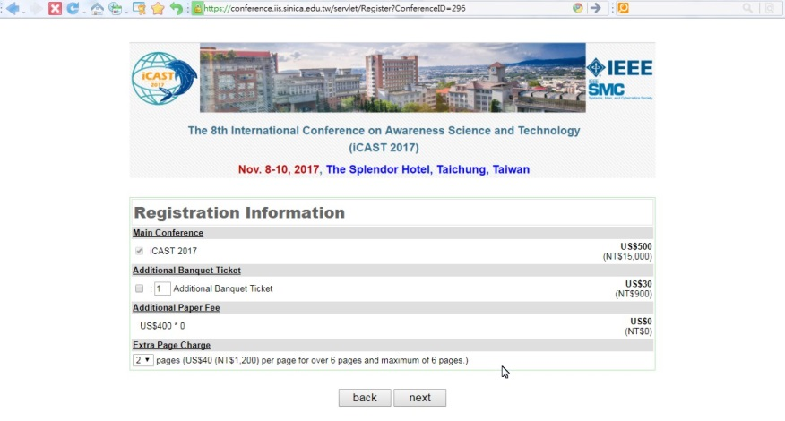
(2-1) Display Registration fee
(2-2) Fill in additional banquet ticket if it is necessary
(2-3) Display “Additional Paper Fee” (each additional paper charge is USD$400 (NTD$12,000) and one author is to register at most three papers)
(2-4) Select the total extra over-length page size in “Extra Page Charge”:
- each additional paper charge is US$400 (NT$12,000).
- the length of each final camera-ready paper is 4-6 pages.
- a maximum of 2 extra pages is permitted with over-length payment, US$40 (NT$1,200) per page.
- if the author registers 3 papers, then the maximum total extra over-length page size is 6. Note that the size of each paper is at most 8.
- Data Confirmation and Payment Method selection
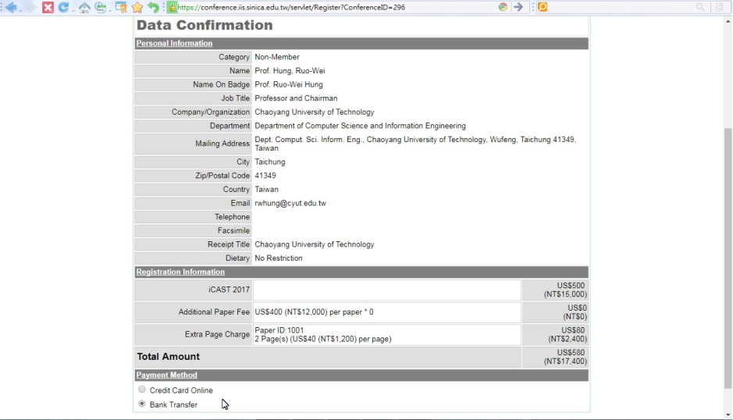

Step 2-2: Payment Method
- Credit Card Online:
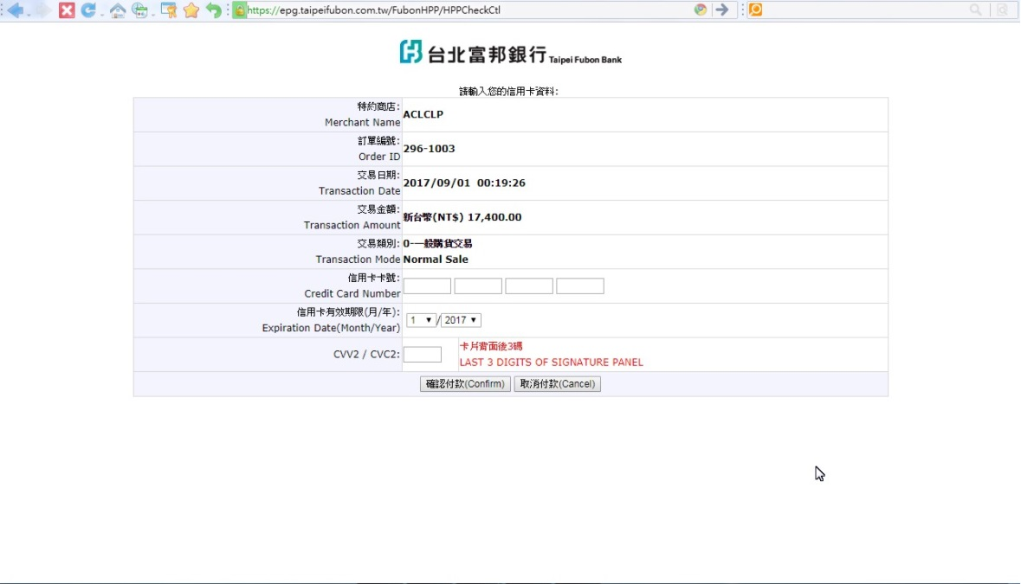
- Fill in your credit card information and confirm the payment.
- After confirming the payment by credit card, you we will see the following “Registration Sheet” on your browser:

- Then you will receive a confirmation email as follows:

- After iCAST 2017 Finance Committee verify your payment, you will receive an email as follows:
In this time, you have completed the registration for iCAST 2017.

- Bank Transfer: (This payment method is more suitable for Taiwan authors)
- iCAST 2017 Registration Sheet: (The completion of registration)
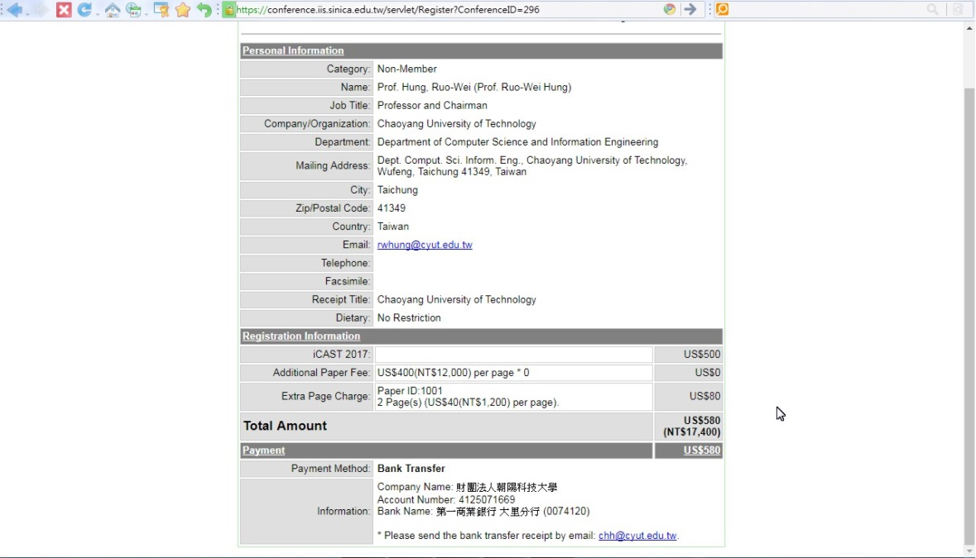
6
- The iCAST 2017 bank information is shown as follows:
- Company Name: 財團法人朝陽科技大學
- Account Number: 41250716696
- Bank Name: 第一商業銀行 大里分行 (0074120)
- Please remark the “Paper ID” when you pay the register fee by bank transfer.
- After paying the registration fee by bank transfer, please email the receipt of remittance to chh@cyut.edu.tw in 5 days.

- When you complete the above registration steps, you will receive an email from the finance committee as follows:
6

After completing the above steps, please remember to upload the final camera-ready paper for iCAST 2017 (http://eform.iis.sinica.edu.tw/url/icast2017/submit).
We appreciate your attendance in iCAST 2017 and we believe you have a wonderful and exciting stay in Taichung City, Taiwan. We are looking forward to meeting you at the conference. Thanks again.

Important Dates:
Submission deadline of final camera-ready papers: September 15, 2017
Deadline for registration: October 01, 2017
iCAST 2017 conference: Nov. 8-10, 2017

