**CSSP Desktop**

Objectives of CSSP Desktop are **Speed**, **Available Offline**, **Security**, **Continuity**, **Bilingual** and **Empowering Users**.

CSSP Desktop

Microsoft Azure Storage

wmon01dtchlebl

CSSPDB database

and CSSPWebTools

Create and send .gz file to Azure

ECCC Firewall

CSSP Web APIs Local

CSSP Client (Angular) Web

User

Computer

Starts

Need file

Store in memory

Manage local files

See detail below

File requested

Request file

View info on web page

Manage local files

Provide file

yes

no

Once a day for now

Is file localized

Check Azure for changed file

once

Provide file

Download from Azure

Provide file

yes

no

Localize file

Send Changes

Send Changes (is coming soon)

Send Changes

Send Local CSSP Database

Microsoft Azure Storage

Read local database stored on Azure and Sync with

wmon01dtchlebl

CSSPDB database



Internet required

No Internet required

file changed

Approval by designated ECCC staff

**Speed**

Speed is probably the most important aspect of this new CSSP Desktop application. Compared to the existing CSSP Web Tools currently being used inside ECCC, it’s probably more than 100 times faster while reducing internet traffic considerably. Its design and the use of Azure as a file storage and provider has allowed us to improve the performance substantially from its previous version.

**Available Offline**

One of the crucial requirements is to be able to use the application in the field where no internet connection is readily available. In order to do this the user can pre-download all required files from Azure with a single click. These files are automatically stored on the user local hard drive for future use. The users are then able to bring their laptop in the field and use it as if they were connected to the internet once all the required files are on the user hard drive

**Security**

Having some sensitive data (presumably) within our database requires some level of access control for different users and no access at all to the others. All information stored in Azure is only available to allowed users and is password protected. In order to be able to use CSSP Desktop, an Administrator of the system need to provide access to the user (done once). All users can only use CSSP Desktop with a unique email and password. In no time can outside user access Azure stored information without the CSSP Desktop application working in the background.

**Continuity**

In no time should the existing CSSP Web Tools be out of service while this new version (CSSP Desktop) is being created and implemented. The fact that the CSSP Web Tools is being used by many ECCC staff across the country and on a regular basis is a critical application for ECCC delivery of the Canadian Shellfish Sanitation Program (CSSP) with its departmental partners (DFO and CFIA).

**Bilingual**

CSSP Desktop is, like its predecessor, fully bilingual. The user has the ability to work in the language of their choice. Changing from one language to another is done with one click and the application does not have to be restarted of reloaded.

**Empowering Users**

User should have access to all their data and have all the tools to manage it. They should also feel empowered while using CSSP Desktop. In no time should they have to rely on an external person or a techy to accomplish their daily tasks. At the end of the full implementation of CSSP Desktop, the user should see the application as the go to tools for numerous components of their yearly tasks. Like being able to produce reports or partial reports with a single click. Setup and run modelling scenarios. Add and manage sanitary surveys related information. Quickly calculate the statistics required to proposed closures to DFO. Etc.

**Explaining the moving parts of CSSP Desktop**

The CSSP Desktop is really 3 applications in one. We have the conductor (CSSP Desktop) responsible for orchestrating the other 2 (CSSP Web APIs Local and CSSP Client). It’s also the application managing all the updates which will be coming in the future. This is the application that is being installed from the web site <https://csspdesktopinstall.azurewebsites.net/> . It is a windows form application with basic visuals to help the user navigate through required login and future updates. It looks like:

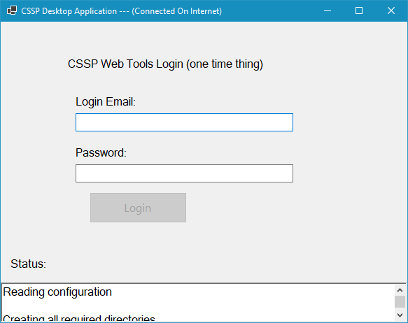 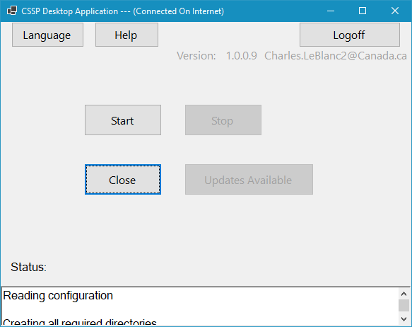

Once you have logged in you will see another screen to help with updates and other application. Once you have click on the Start button, CSSP Desktop automatically starts CSSP Web APIs Local and CSSP Client. The first is an actual web server running on the user computer in the background. Its main purpose is to wait and provide the user with information/files when needed. The second (CSSP Client) is just a web page that is provided by the background web server (CSSP Web APIs Local).

**CSSP Web APIs Local**

This background web Application Programing Interface (API) which runs locally is responsible for receiving commands from the user via the web (CSSP Client) and converting all this into something the user can use. So, it will receive a request and do everything necessary to reply back something to the user. Sometime it will be sending a file (json, picture, report, excel, etc.). But before that, it will verify if the file is already downloaded from Azure in order to limit the traffic to and from Azure Storage. It is also responsible for managing and knowing which file is already localized, which files need to be redownloaded because Azure has a newer copy. It is also responsible for sending error message when needed. No visual for this application. However, if you want to find out if it’s running you can open the task manager (Ctrl+Shift+ESC) and look for CSSPWebAPIsLocal within the list of running applications. You will find it under the running application CSSPDesktop.

**CSSP Client**

This is really the web page showing all the data, information and files. This web frontend is the visual for the user. It’s where the user can see all the data and can uses inputs fields and buttons to send commands to CSSP Web APIs Local. In order to accelerate the whole system even more, this web page is designed with the capability to use browser memory to reduce the number of reload the web page needs to do. So, it will only reload the information/file if not already in memory. You will feel like home, because the visual is very similar to the visual of CSSP Web Tools (see image below).

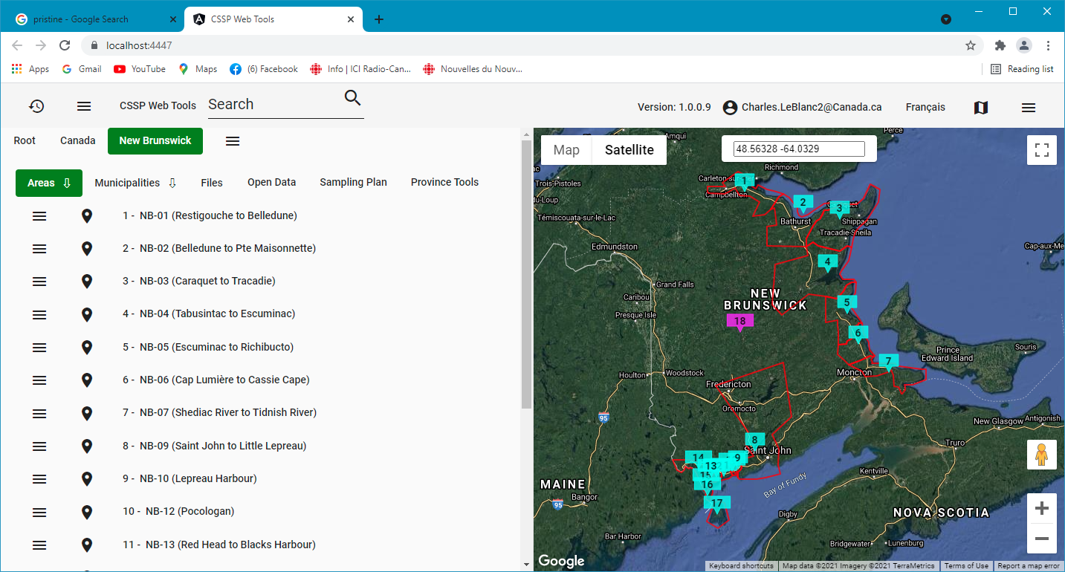

At this time the CSSP Web Tools continues to be the official data/information manager, it is also the location where the official CSSP database resides (inside the firewall of ECCC). In the future this database will be hosted by Azure. The CSSP Web Tools is also responsible for the creation of all the .gz files (compressed .json files) which are all together a replica of the database in the shape of compress .json files. At the beginning and for continuity with the CSSP Web Tools, the .gz files are created every day at midnight. Only the files that changed are actually sent to Microsoft Azure Storage.

The CSSP Client, which is actually a web page, is the visual via web. All information sent to the web page is done with the CSSP Web APIs Local application which works in tandem with the CSSP Client. All files are stored locally before being sent to the web page. CSSP Web APIs Local take cares of managing all the Azure files and local files in order to only download required files once. It has a mechanism to check Azure Storage to verify if the file changed since the last download. If it did change then it is also responsible to localize the file, which is downloading the file and storing it on the user computer for later use. CSSP Client also manage memory in the browser so accelerate the reading and parsing of the .json files.

Although at this time, the user will not have the capability to change the information using CSSP Desktop, future version will allow this. Taking advantage of changing everything local by using an empty replica of the server CSSP database. All changes will reside locally until the user decides to send all the changes at once to Azure. Some other application will read the database file just sent and synchronize it with the original/master database. Here, we might need a mechanism or an extra level of validation from ECCC staff, where new or changed information would be verified and validated by a few designated individuals within ECCC. This would keep the master database pristine.

One of the major differences between CSSP Web Tools and CSSP Desktop is the way the information is being transferred and parsed. For the CSSP Web Tools, all information is digested on the server side. That is, html pages are created by reading the database and generating an html file that is then being sent to the client. This is done every time the user browses to another page. Some of these pages can be large like the Analysis pages which can go up to 1 MB. The downside to this way of doing thing is also that the database is heavily solicited and has to work very hard all the time as more and more people need access the site and browse the information. This way of doing things was the standard way for many years, and web developers were just asking for bigger and faster computers/servers to satisfy the ever-growing need for large amount of information.

Lately, however, with the help of multinational companies like Google and Microsoft, better ways and tools are now available to reduce the web traffic considerably. Google is pushing something call “Angular” which is a JavaScript based framework which can be downloaded to the browser once at the biggening of the browsing session. It’s responsible for downloading and parsing .json files into html documents for which the browser can then show to users. Just this part already reduced the amount of information being transferred from the servers to the user computer/browser. To make this part even more streamlined, we do not request the information from the database directly but via .json files which are created only once and stored on Microsoft Azure Storage. This also greatly limits the stress put on the ECCC servers and databases. So rather than creating these files every time a user request it, they are already created and all that needs to be done is to provide the file. These files could be stored anywhere. For now, and because of speed and low cost, we opted to stored them in the cloud (Azure). To satisfy the need for users to be able to work on their data without internet, and also reduce the number of times a particular file needs to be downloaded, local storage on the user computer hard drive is being used to temporary store Azure files that are needed or will be needed while working in the field.

Next steps, CSSP Desktop will eventually replace the CSSP Web Tools, CSSP Pollution Source Input Tool and the CSSP Water Quality Input Tool. We also hope that the new COTS will also provide some of these features to SWCP and freshwater staff.