Water balance model 2.0 User guide

Before executing the water balance model, a few preliminary steps must be taken to install essential components. All steps will be described in detail in the guide. Please take note of the steps to avoid any further problems.

We strongly suggest using the provided flash drive to keep your entire file at one place. If you need the results, please copy the needed file where you need it.

The following procedure will allow the installation of Miniconda on your disk. Miniconda will manage the python environment of the model. For more info on Miniconda: <https://docs.conda.io/en/latest/miniconda.html>

# 1.Installation of miniconda and WBM environnement dependencies

Step 1: Miniconda Installation:

The installation procedure will install miniconda in your user folder:

If your user is in this case *Champouxo* the miniconda will be installed in

C:\Users\ChampouxO

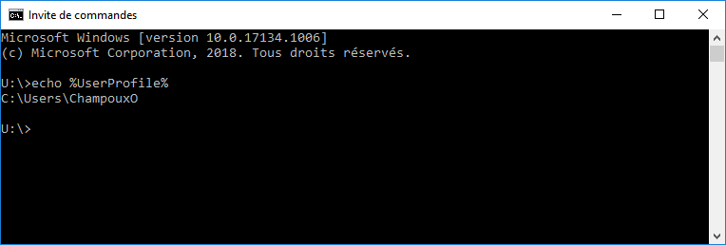

1-Open the install folder of the usb stick

You should see something like this

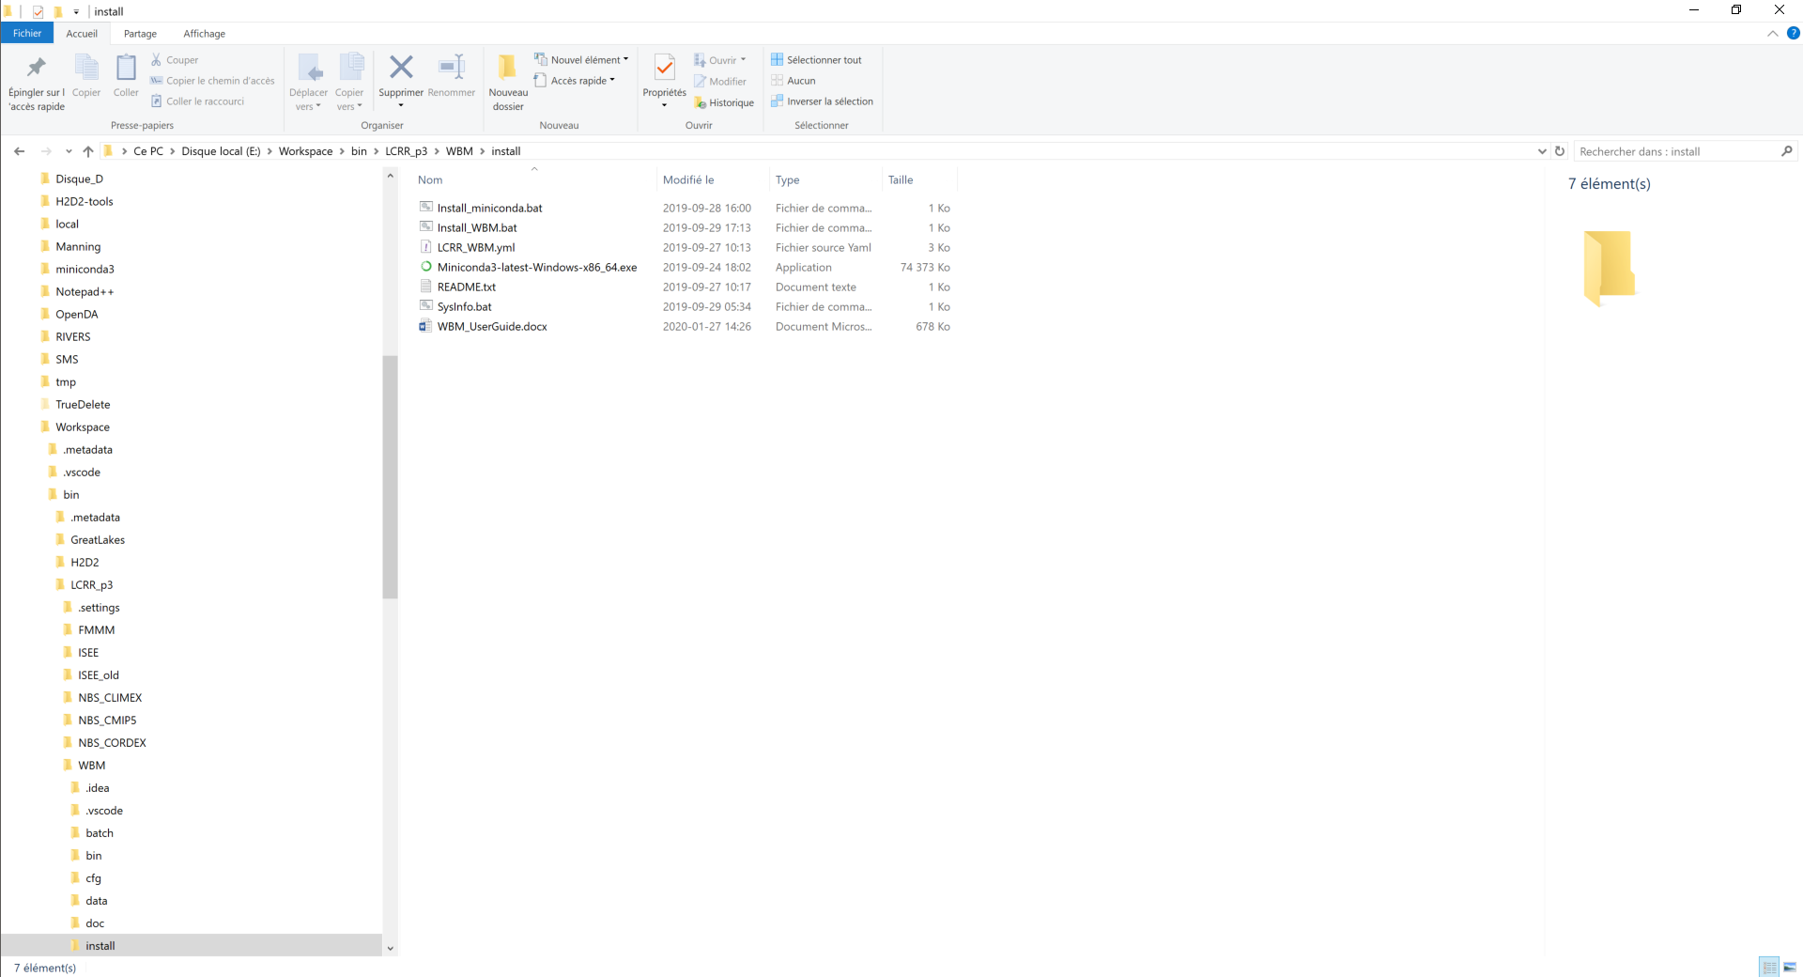

##################################

Click on Install_miniconda.bat. You should see something like this. IT CAN TAKE SOME TIMES. PLEASE WAIT UNTIL THE WINDOW CLOSES ITSELF.

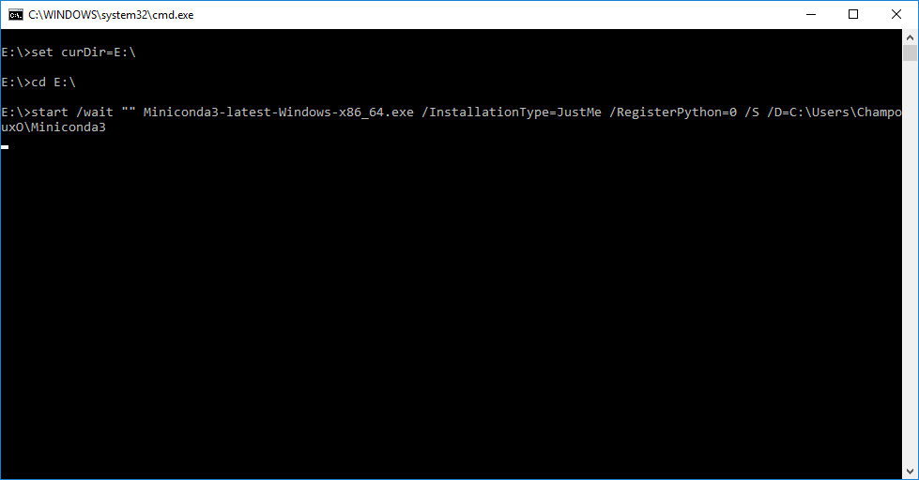

After the miniconda installation you can go here:

C:\Users\<my user name>\Miniconda3 and you should see a lot of files.

Step 2: Water balance model computing environnement

Go back to the flash drive folder and click on Install_WBM.bat

This will install all the dependency that the WBM needs to run. PLEASE DON’T CLOSE THE WINDOW

You should see something like:

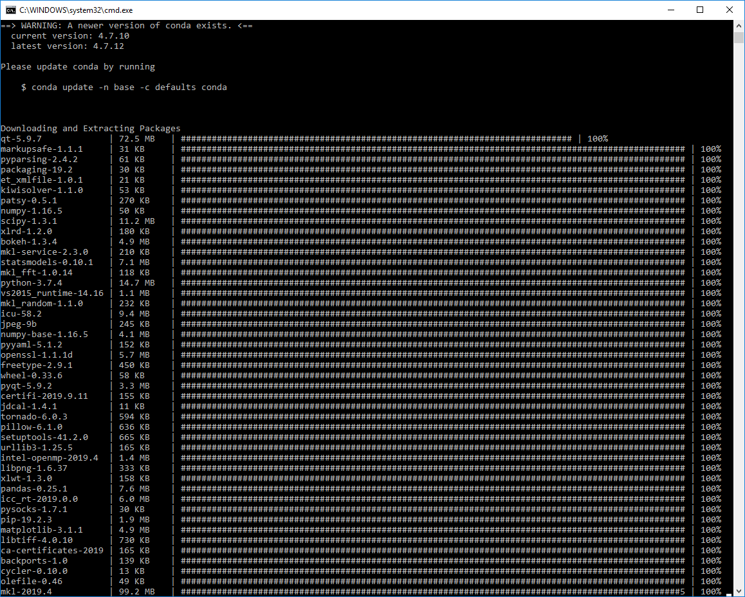

# 2. Water balance model file and folders structure

The folder and file structure of the WBM should be presented in order to better understand which files can be modified and which ones should not be modified or moved.

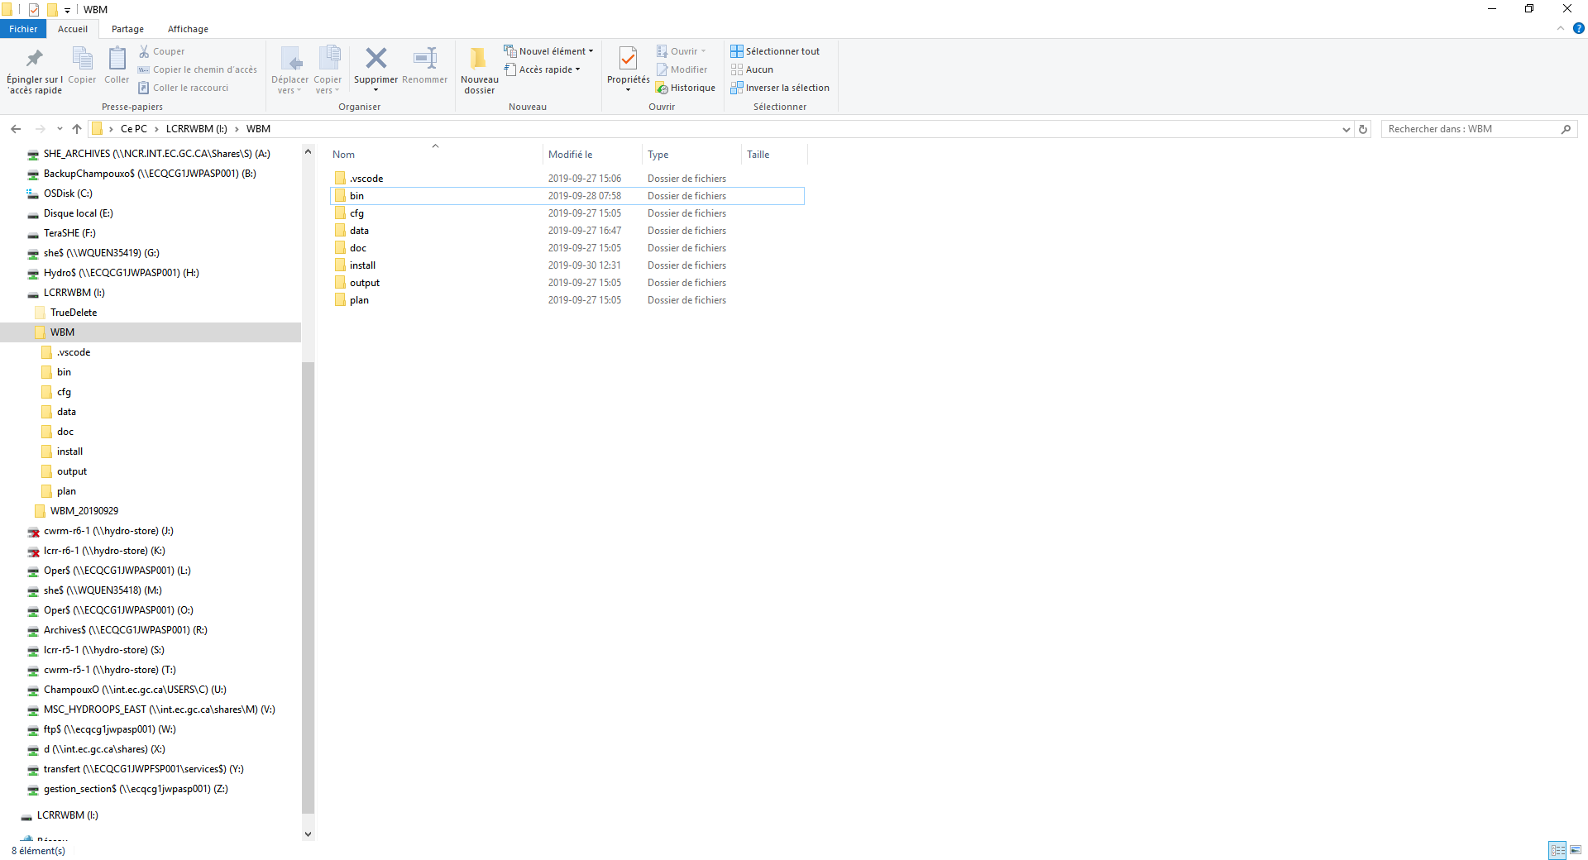

The files are located inside several folders.

##############################################

\bin

The bin folder is where all the python scripts are located. This folder **SHOULD NOT BE MODIFIED** in any way.

\cfg

The cfg folder is where the configuration files of the model must be stored. The configuration file is **THE ONLY FILE** you should modify to run the model

\data

The data folder contains two subfolders the \hydraulics one and the \NBS one

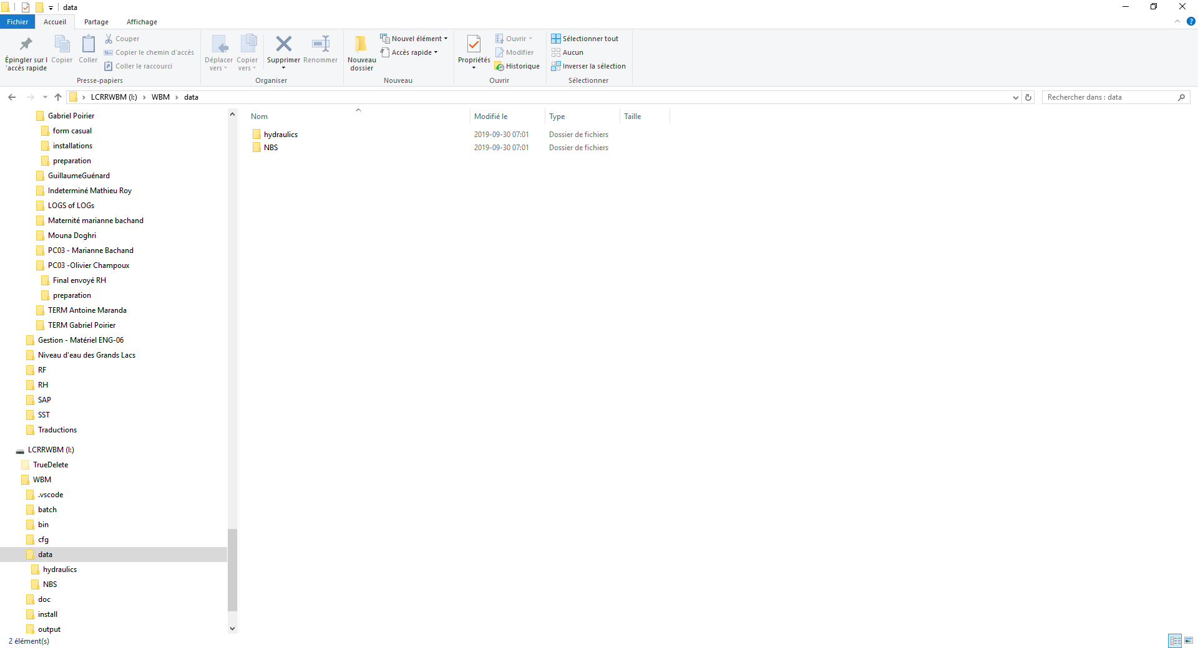

The \data\hydraulics contains the files to compute the hydraulic geometry. The cross-section files and the evolution of the friction (manning) are stored in this folder. Those basics files **SHOULD NOT BE MODIFIED.** However, if you want to test other cross-section parameters or friction evolution, you should store your files here.

The \data\NBS contains the files with the Net Basin supply values. Those basics files **SHOULD NOT BE MODIFIED.** However, if you want to test other NBS you should store your files here. You also find in this folder the Lake Champlain water level-volume relationship. This file **SHOULD NOT BE MODIFIED**